AI ACADEMY · WORKBOOK · ai-3/22

Requests Responses and JSON
Project: Verified Study Buddy

01. Recall and choose your starting point
Try the recall before opening notes. Then use a different colour or a labelled second line to correct your explanation.

Tools and APIs
Without opening the old lesson, explain one key idea from Tools and APIs. Give an example and a mistake that the idea helps you avoid.

My remembered idea, example and correction
________________________________________________________________
________________________________________________________________
________________________________________________________________

User Need and AI Contribution
Without opening the old lesson, explain one key idea from User Need and AI Contribution. Give an example and a mistake that the idea helps you avoid.

My remembered idea, example and correction
________________________________________________________________
________________________________________________________________
________________________________________________________________

Verify Numbers and Dates
Without opening the old lesson, explain one key idea from Verify Numbers and Dates. Give an example and a mistake that the idea helps you avoid.

My remembered idea, example and correction
________________________________________________________________
________________________________________________________________
________________________________________________________________

02. Practise with fading help
Use W2: Separate failures for JSON and interface contracts. Record the answer once; the lesson and workbook refer to the same attempt.
Given inputs | Procedure I chose | Middle steps | Result and check

The step I completed without help, and the hint I needed
________________________________________________________________
________________________________________________________________
________________________________________________________________

03. Individual reasoning check
Use the worked case for JSON and interface contracts. Proposed explanation: “A successful run proves the conclusion”. Decide whether this explanation is supported. Point to the step or supplied fact that decides; explain your repair if needed.

My explanation before partner discussion
________________________________________________________________
________________________________________________________________
________________________________________________________________
________________________________________________________________

04. Independent transfer case

Independent case: Specify independently
Define a JSON contract for {"label": "Box", "count": 4}: nonempty text label, integer count 0 through 10. Give a valid case, a wrong-type case and a missing-field case with expected acceptance.

My independent explanation, trace and limits
________________________________________________________________
________________________________________________________________
________________________________________________________________
________________________________________________________________
________________________________________________________________
________________________________________________________________
________________________________________________________________
Attempt this case before feedback. Record any help. Earlier examples below are further practice; a case already practised with feedback cannot establish fresh transfer.

05. Your learning target
Request id=7 returns status=200 and {"id":8,"pages":90}. Explain why a successful status is insufficient and specify the handling.

06. Solve the given case
Request is for B7; response is {"id":"B7","pages":120}. Another response has malformed JSON.
What checks precede use?
Show your trace, calculation or evidence

Write or draw your reasoning and evidence.
________________________________________________________________
________________________________________________________________
________________________________________________________________
________________________________________________________________
________________________________________________________________

07. Check a changed case
An API returns {"ok":false,"error":"not_found"}. Your app tries to display response.title. What should it do instead?
My independent answer and reason

Write or draw your reasoning and evidence.
________________________________________________________________
________________________________________________________________
________________________________________________________________
________________________________________________________________
________________________________________________________________

Week 22 Test and reflect

08. Design a revealing test
Create a changed input, boundary case or missing-information case. Write the expected answer or safe response before testing.
Test record | My evidence
Changed input or condition
Expected answer or fallback
Observed result
Why the result occurred

09. Project checkpoint
Use a stable request/response contract between interface, retriever, model, and verifier.
The project change and evidence I will keep

Write or draw your reasoning and evidence.
________________________________________________________________
________________________________________________________________
________________________________________________________________
________________________________________________________________
________________________________________________________________

10. Self check
I can explain the mechanism. I can show evidence. I can handle a changed case. I can name a limit. Mark each as not yet, with help or independently, and attach supporting work.
Teacher review ____________________ Next step ____________________

11. Transfer practice from the original programme
Request id=7 returns status=200 and {"id":8,"pages":90}. Explain why a successful status is insufficient and specify the handling.

My independently reasoned answer
________________________________________________________________
________________________________________________________________
________________________________________________________________
________________________________________________________________
________________________________________________________________
________________________________________________________________
________________________________________________________________
Record support used: none, hint or teacher explanation.

12. W1 Translate a value
What Python value does JSON null become? What JSON value represents Python True?

My reasoning and evidence
________________________________________________________________
________________________________________________________________
________________________________________________________________
________________________________________________________________
________________________________________________________________
________________________________________________________________

13. W2 Separate failures
Classify {"minutes": "5"} and {minutes: 5} as valid JSON text or malformed JSON.

My reasoning and evidence
________________________________________________________________
________________________________________________________________
________________________________________________________________
________________________________________________________________
________________________________________________________________
________________________________________________________________

14. W3 Repair the interface
A parser accepts a JSON list then crashes on .get. What check belongs before field access?

My reasoning and evidence
________________________________________________________________
________________________________________________________________
________________________________________________________________
________________________________________________________________
________________________________________________________________
________________________________________________________________

15. W4 Specify independently
Define a JSON contract for {"label": "Box", "count": 4}: nonempty text label, integer count 0 through 10. Give a valid case, a wrong-type case and a missing-field case with expected acceptance.

My reasoning and evidence
________________________________________________________________
________________________________________________________________
________________________________________________________________
________________________________________________________________
________________________________________________________________
________________________________________________________________
________________________________________________________________
________________________________________________________________

16. W5 Limit parsing
A JSON record parses successfully. Does that prove its observation is correct?

My reasoning and evidence
________________________________________________________________
________________________________________________________________
________________________________________________________________
________________________________________________________________
________________________________________________________________
________________________________________________________________

17. Feedback, return check and learning record
Evidence | My record
Worked alone / hint / model
First step I repaired and why
New case checked later; date and result
What I can now explain without notes
One remaining question
Revisit this idea with your teacher after a delay. Familiarity is different from explaining and using it on a changed case.

18. Pictorial case practice: Requests Responses and JSON
A lunch-count response must satisfy a declared JSON contract.
The toy response has exactly class_code text and portions integer 0..30. Example: {"class_code":"R8","portions": 12}.
All inputs and outcomes in this worked example are invented classroom data; no real model run is claimed.
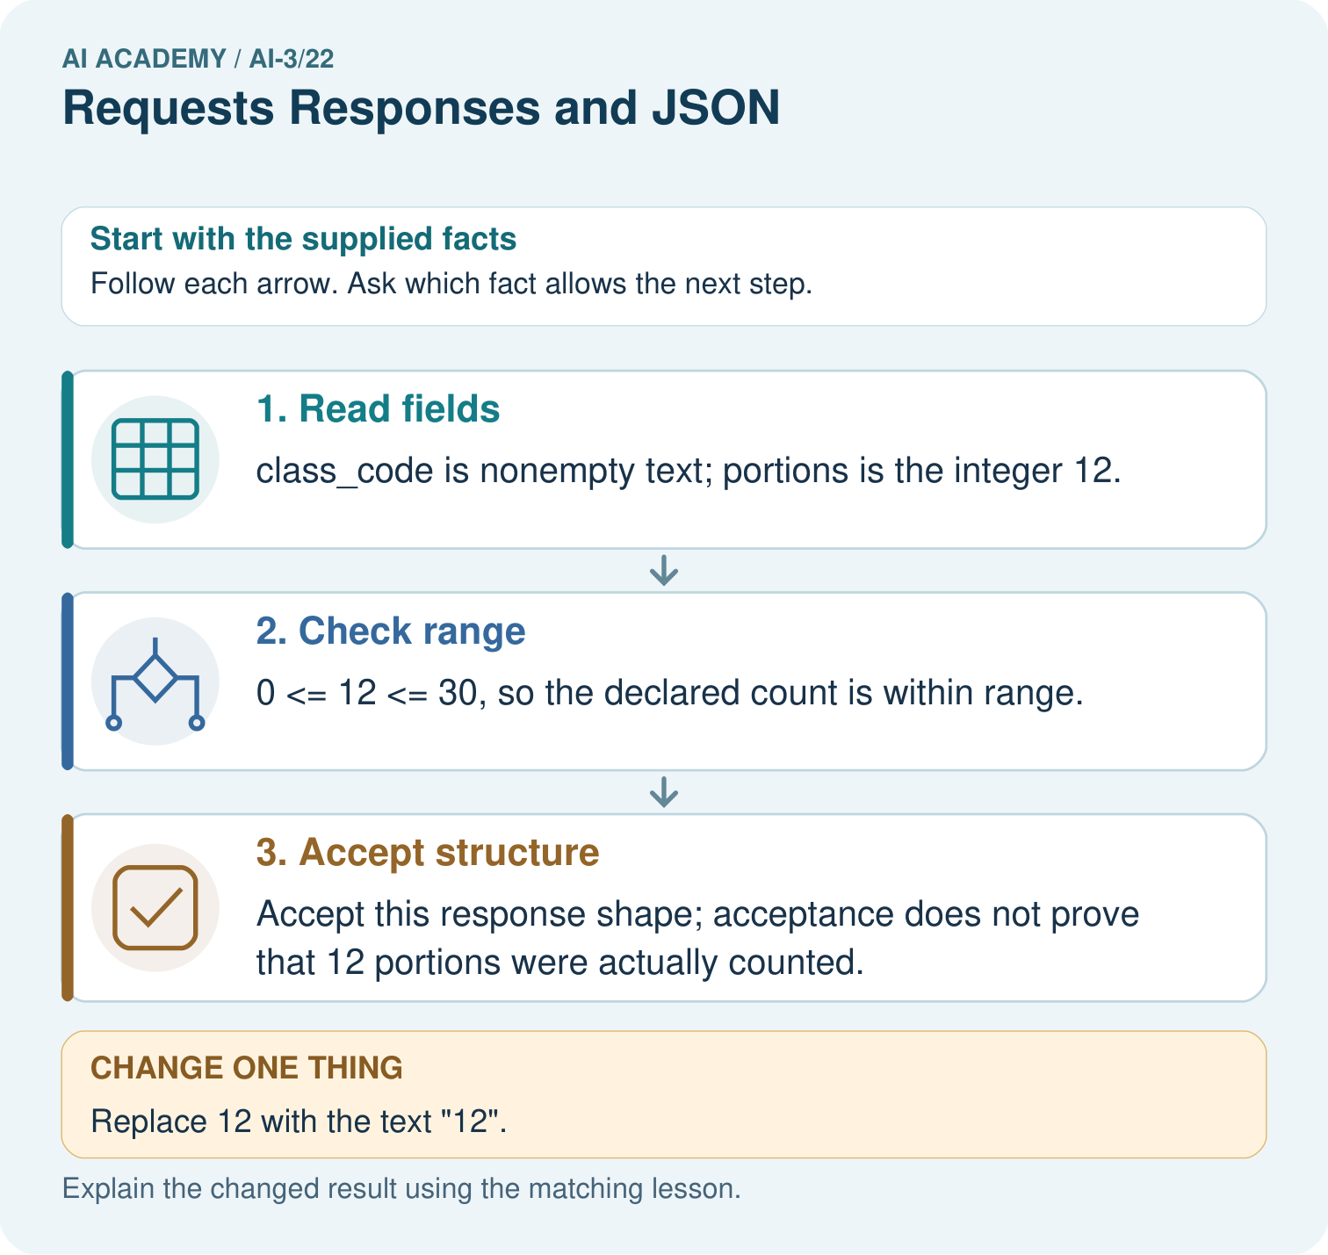
Would converting the text silently prove the source count is correct? Point to the relevant step in the picture, then write the changed result and the rule or evidence that supports it.

My picture-based explanation and changed-case prediction
________________________________________________________________
________________________________________________________________
________________________________________________________________
________________________________________________________________
________________________________________________________________
________________________________________________________________
Support used: alone / hint / worked example. This record is practice evidence.
Project connection: For your Verified Study Buddy, save the input, procedure, observed result and limitation of this check. Label this worked example as practice; use a different, previously unreviewed case when checking independent understanding.

19. Project portfolio milestone
Project: Verified Study Buddy
Current milestone: Evaluate and revise. Compare with your starting method, explain errors and record a justified revision.
For your Verified Study Buddy, save the input, procedure, observed result and limitation of this check. Label this worked example as practice; use a different, previously unreviewed case when checking independent understanding.
Evidence to keep | My record
This week’s input and deciding step
Prediction and actual result (or labelled paper trace)
One change since the previous checkpoint and why
One error or limit and the next test

Explain what this week adds to your project. Reuse last week’s record rather than starting again.
________________________________________________________________
________________________________________________________________
________________________________________________________________
________________________________________________________________
________________________________________________________________

