AI ACADEMY · WORKBOOK · ai-3/26

Evaluation Sets
Project: Verified Study Buddy

01. Recall and choose your starting point
Try the recall before opening notes. Then use a different colour or a labelled second line to correct your explanation.

Quality Rubrics
Without opening the old lesson, explain one key idea from Quality Rubrics. Give an example and a mistake that the idea helps you avoid.

My remembered idea, example and correction
________________________________________________________________
________________________________________________________________
________________________________________________________________

Block to Python Bridge
Without opening the old lesson, explain one key idea from Block to Python Bridge. Give an example and a mistake that the idea helps you avoid.

My remembered idea, example and correction
________________________________________________________________
________________________________________________________________
________________________________________________________________

Conversation State and Memory
Without opening the old lesson, explain one key idea from Conversation State and Memory. Give an example and a mistake that the idea helps you avoid.

My remembered idea, example and correction
________________________________________________________________
________________________________________________________________
________________________________________________________________

02. Practise with fading help
Use W2: Trace the worked case for System evaluation sets. Record the answer once; the lesson and workbook refer to the same attempt.
Given inputs | Procedure I chose | Middle steps | Result and check

The step I completed without help, and the hint I needed
________________________________________________________________
________________________________________________________________
________________________________________________________________

03. Individual reasoning check
Use the worked case for System evaluation sets. Proposed explanation: “The worked result establishes every future case”. Decide whether this explanation is supported. Point to the step or supplied fact that decides; explain your repair if needed.

My explanation before partner discussion
________________________________________________________________
________________________________________________________________
________________________________________________________________
________________________________________________________________

04. Independent transfer case

Independent case: Changed independent case
Approved notes: Robotics Tuesday Room2; Art Wednesday Room5. Requests: “Where does the club meet?” and “Who leads drama?” An unversioned added note says Robotics Room3. Design checks and safe responses.

My independent explanation, trace and limits
________________________________________________________________
________________________________________________________________
________________________________________________________________
________________________________________________________________
________________________________________________________________
________________________________________________________________
________________________________________________________________
Attempt this case before feedback. Record any help. Earlier examples below are further practice; a case already practised with feedback cannot establish fresh transfer.

05. Your learning target
A test set contains ten easy questions with direct answers in the notes. Add three different kinds of cases that probe fallback behaviour and define expected outcomes.

06. Solve the given case
Ten evaluation questions are easy definitions; none lacks a source.
What is untested?
Show your trace, calculation or evidence

Write or draw your reasoning and evidence.
________________________________________________________________
________________________________________________________________
________________________________________________________________
________________________________________________________________
________________________________________________________________

07. Check a changed case
You improve a prompt after reading every test question. Can those questions still provide an untouched final evaluation? Propose a repair.
My independent answer and reason

Write or draw your reasoning and evidence.
________________________________________________________________
________________________________________________________________
________________________________________________________________
________________________________________________________________
________________________________________________________________

Week 26 Test and reflect

08. Design a revealing test
Create a changed input, boundary case or missing-information case. Write the expected answer or safe response before testing.
Test record | My evidence
Changed input or condition
Expected answer or fallback
Observed result
Why the result occurred

09. Project checkpoint
Maintain a balanced eval set covering utility, grounding, format, privacy, and safety.
The project change and evidence I will keep

Write or draw your reasoning and evidence.
________________________________________________________________
________________________________________________________________
________________________________________________________________
________________________________________________________________
________________________________________________________________

10. Self check
I can explain the mechanism. I can show evidence. I can handle a changed case. I can name a limit. Mark each as not yet, with help or independently, and attach supporting work.
Teacher review ____________________ Next step ____________________

11. Transfer practice from the original programme
A test set contains ten easy questions with direct answers in the notes. Add three different kinds of cases that probe fallback behaviour and define expected outcomes.

My independently reasoned answer
________________________________________________________________
________________________________________________________________
________________________________________________________________
________________________________________________________________
________________________________________________________________
________________________________________________________________
________________________________________________________________
Record support used: none, hint or teacher explanation.

12. W1 Explain the mechanism
Explain the weekly mechanism in your own words. Use the worked scenario to name its input, decision rule and output.

My reasoning and evidence
________________________________________________________________
________________________________________________________________
________________________________________________________________
________________________________________________________________
________________________________________________________________
________________________________________________________________

13. W2 Trace the worked case
Ten cases include six answerable and four missing-evidence cases. System answers five answerable correctly and abstains appropriately on three missing cases. Show the intermediate steps and give the conclusion with its scope.

My reasoning and evidence
________________________________________________________________
________________________________________________________________
________________________________________________________________
________________________________________________________________
________________________________________________________________
________________________________________________________________
________________________________________________________________

14. W3 Audit the limit
A report omits this qualification: Evaluation coverage limits the claim; prompts tuned on these cases need new reserved final cases. Explain how omitting it could change a reader's interpretation, and write an accurate replacement.

My reasoning and evidence
________________________________________________________________
________________________________________________________________
________________________________________________________________
________________________________________________________________
________________________________________________________________
________________________________________________________________

15. W4 Apply a new case independently
Twelve cases: eight answerable, four unanswerable. Correct answers six; appropriate abstentions two. Compute separate and combined pass rates.

My reasoning and evidence
________________________________________________________________
________________________________________________________________
________________________________________________________________
________________________________________________________________
________________________________________________________________
________________________________________________________________
________________________________________________________________
________________________________________________________________

16. W5 Design a revealing follow-up
For the worked scenario, propose one additional case that could reveal a failure, describe its expected outcome before running it, and explain what would need to remain fixed for a fair comparison. Do not reuse W4 as a new final test after receiving feedback.

My reasoning and evidence
________________________________________________________________
________________________________________________________________
________________________________________________________________
________________________________________________________________
________________________________________________________________
________________________________________________________________
________________________________________________________________

17. Ranking and retrieval evaluation — W1 Explain the mechanism
Explain the weekly mechanism in your own words. Use the worked scenario to name its input, decision rule and output.

My reasoning and evidence
________________________________________________________________
________________________________________________________________
________________________________________________________________
________________________________________________________________
________________________________________________________________
________________________________________________________________

18. Ranking and retrieval evaluation — W2 Trace the worked case
Relevant documents are A, C, E. Top three results A, B, C contain two relevant items. Show the intermediate steps and give the conclusion with its scope.

My reasoning and evidence
________________________________________________________________
________________________________________________________________
________________________________________________________________
________________________________________________________________
________________________________________________________________
________________________________________________________________
________________________________________________________________

19. Ranking and retrieval evaluation — W3 Audit the limit
A report omits this qualification: Known judgments may be incomplete; a score over one query does not establish coverage over all queries. Explain how omitting it could change a reader's interpretation, and write an accurate replacement.

My reasoning and evidence
________________________________________________________________
________________________________________________________________
________________________________________________________________
________________________________________________________________
________________________________________________________________
________________________________________________________________

20. Ranking and retrieval evaluation — W4 Apply a new case independently
Relevant set A, D, F, G; top three A, B, D. Compute precision and recall. Explain which omitted records affect recall.

My reasoning and evidence
________________________________________________________________
________________________________________________________________
________________________________________________________________
________________________________________________________________
________________________________________________________________
________________________________________________________________
________________________________________________________________
________________________________________________________________

21. Ranking and retrieval evaluation — W5 Design a revealing follow-up
For the worked scenario, propose one additional case that could reveal a failure, describe its expected outcome before running it, and explain what would need to remain fixed for a fair comparison. Do not reuse W4 as a new final test after receiving feedback.

My reasoning and evidence
________________________________________________________________
________________________________________________________________
________________________________________________________________
________________________________________________________________
________________________________________________________________
________________________________________________________________
________________________________________________________________

22. Feedback, return check and learning record
Evidence | My record
Worked alone / hint / model
First step I repaired and why
New case checked later; date and result
What I can now explain without notes
One remaining question
Revisit this idea with your teacher after a delay. Familiarity is different from explaining and using it on a changed case.

23. Pictorial case practice: Evaluation Sets
Design an evaluation set that checks answering and appropriate uncertainty separately.
Six toy questions: three have source answers and three do not. Results: 2 supported answers out of 3; 3 correct “not in source” responses out of 3.
All inputs and outcomes in this worked example are invented classroom data; no real model run is claimed.
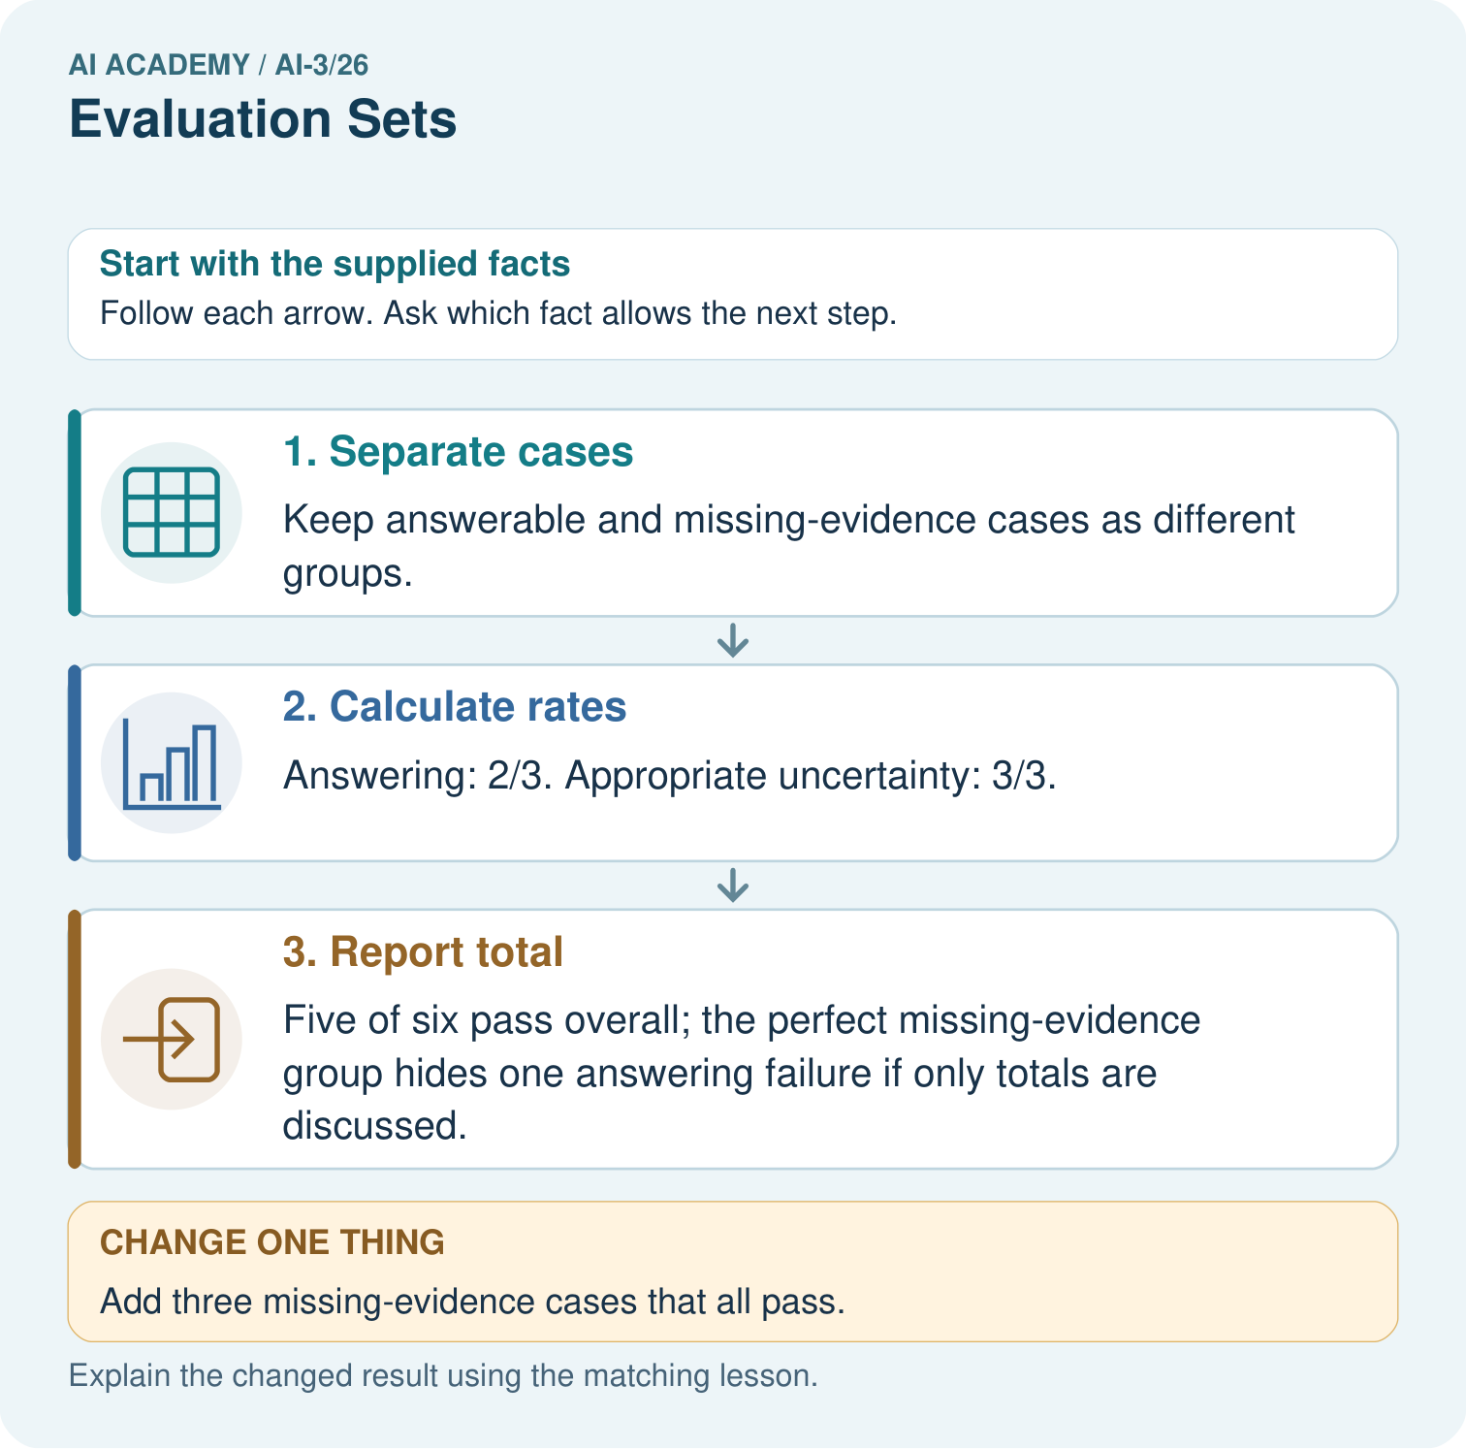
Did the added cases demonstrate better answering? Point to the relevant step in the picture, then write the changed result and the rule or evidence that supports it.

My picture-based explanation and changed-case prediction
________________________________________________________________
________________________________________________________________
________________________________________________________________
________________________________________________________________
________________________________________________________________
________________________________________________________________
Support used: alone / hint / worked example. This record is practice evidence.
Project connection: For your Verified Study Buddy, save the input, procedure, observed result and limitation of this check. Label this worked example as practice; use a different, previously unreviewed case when checking independent understanding.

24. Project portfolio milestone
Project: Verified Study Buddy
Current milestone: Prepare the demonstration. Gather reproducible instructions, evidence, access checks and remaining limitations.
For your Verified Study Buddy, save the input, procedure, observed result and limitation of this check. Label this worked example as practice; use a different, previously unreviewed case when checking independent understanding.
Evidence to keep | My record
This week’s input and deciding step
Prediction and actual result (or labelled paper trace)
One change since the previous checkpoint and why
One error or limit and the next test

Explain what this week adds to your project. Reuse last week’s record rather than starting again.
________________________________________________________________
________________________________________________________________
________________________________________________________________
________________________________________________________________
________________________________________________________________

