AI ACADEMY · WORKBOOK · ai-4/2

Features, Labels, Targets
Project: Responsible Plant Classifier

01. Recall and choose your starting point
Try the recall before opening notes. Then use a different colour or a labelled second line to correct your explanation.

The ML Lifecycle
Without opening the old lesson, explain one key idea from The ML Lifecycle. Give an example and a mistake that the idea helps you avoid.

My remembered idea, example and correction
________________________________________________________________
________________________________________________________________
________________________________________________________________

02. Practise with fading help
Use W2: Trace the feature contract for Features labels and prediction time. Record the answer once; the lesson and workbook refer to the same attempt.
Given inputs | Procedure I chose | Middle steps | Result and check

The step I completed without help, and the hint I needed
________________________________________________________________
________________________________________________________________
________________________________________________________________

03. Individual reasoning check
Use the worked case for Features labels and prediction time. Proposed explanation: “Every stored column is a feature”. Decide whether this explanation is supported. Point to the step or supplied fact that decides; explain your repair if needed.

My explanation before partner discussion
________________________________________________________________
________________________________________________________________
________________________________________________________________
________________________________________________________________

04. Independent transfer case

Independent case: Audit a new task independently
A fictional robot predicts at dispatch whether a parcel trip will take more than 10 minutes. Fields are route_steps and queue_at_dispatch captured at dispatch, trip_id for tracking, arrival_minutes measured after arrival, and slow = 1 when arrival_minutes > 10. Specify inputs, order, target and exclusions. For a past trip with steps 30, queue 2, arrival 10, give features and label. For a new trip with steps 24 and queue 0, give features and explain whether slow is known.

My independent explanation, trace and limits
________________________________________________________________
________________________________________________________________
________________________________________________________________
________________________________________________________________
________________________________________________________________
________________________________________________________________
________________________________________________________________
Attempt this case before feedback. Record any help. Earlier examples below are further practice; a case already practised with feedback cannot establish fresh transfer.

05. Your learning target
A table has leaf length, edge type and verified species. A model predicts species using all three columns. Identify leakage and a legitimate input set.

06. Solve the given case
Rows contain leaf length, edge type and healthy/spotted label.
Identify features, target and prediction-time inputs.
Show your trace, calculation or evidence

Write or draw your reasoning and evidence.
________________________________________________________________
________________________________________________________________
________________________________________________________________
________________________________________________________________
________________________________________________________________

07. Check a changed case
A row contains leaf_length_cm=8, leaf_width_cm=3 and species=fern. For predicting species, identify two features and the target.
My independent answer and reason

Write or draw your reasoning and evidence.
________________________________________________________________
________________________________________________________________
________________________________________________________________
________________________________________________________________
________________________________________________________________

Week 2 Test and reflect

08. Design a revealing test
Create a changed input, boundary case or missing-information case. Write the expected answer or safe response before testing.
Test record | My evidence
Changed input or condition
Expected answer or fallback
Observed result
Why the result occurred

09. Project checkpoint
Define the Plant Classifier target and a first feature list; record units, allowed values, collection method, and availability time.
The project change and evidence I will keep

Write or draw your reasoning and evidence.
________________________________________________________________
________________________________________________________________
________________________________________________________________
________________________________________________________________
________________________________________________________________

10. Self check
I can explain the mechanism. I can show evidence. I can handle a changed case. I can name a limit. Mark each as not yet, with help or independently, and attach supporting work.
Teacher review ____________________ Next step ____________________

11. Transfer practice from the original programme
A table has leaf length, edge type and verified species. A model predicts species using all three columns. Identify leakage and a legitimate input set.

My independently reasoned answer
________________________________________________________________
________________________________________________________________
________________________________________________________________
________________________________________________________________
________________________________________________________________
________________________________________________________________
________________________________________________________________
Record support used: none, hint or teacher explanation.

12. W1 Assign the roles
For the worked loan table, identify the two candidate features, the target label and the tracking field. Explain why days_to_return is not a predictor.

My reasoning and evidence
________________________________________________________________
________________________________________________________________
________________________________________________________________
________________________________________________________________
________________________________________________________________
________________________________________________________________

13. W2 Trace the feature contract
A completed loan has pages 96, queue_at_checkout 4 and days_to_return 14. Give the ordered feature list and target. Then state what changes if it took 15 days instead.

My reasoning and evidence
________________________________________________________________
________________________________________________________________
________________________________________________________________
________________________________________________________________
________________________________________________________________
________________________________________________________________

14. W3 Repair a misleading score
A model has every test prediction correct after using pages and days_to_return. A learner says a separate test set makes this valid. Explain the flaw and repair the inputs.

My reasoning and evidence
________________________________________________________________
________________________________________________________________
________________________________________________________________
________________________________________________________________
________________________________________________________________
________________________________________________________________

15. W4 Audit a new task independently
A fictional robot predicts at dispatch whether a parcel trip will take more than 10 minutes. Fields are route_steps and queue_at_dispatch captured at dispatch, trip_id for tracking, arrival_minutes measured after arrival, and slow = 1 when arrival_minutes > 10. Specify inputs, order, target and exclusions. For a past trip with steps 30, queue 2, arrival 10, give features and label. For a new trip with steps 24 and queue 0, give features and explain whether slow is known.

My reasoning and evidence
________________________________________________________________
________________________________________________________________
________________________________________________________________
________________________________________________________________
________________________________________________________________
________________________________________________________________
________________________________________________________________
________________________________________________________________

16. W5 Handle an unavailable input
For the robot task, a dataset stores queue_now at export time but has no saved queue_at_dispatch. Can you rename that field to make it usable? State a defensible next step.

My reasoning and evidence
________________________________________________________________
________________________________________________________________
________________________________________________________________
________________________________________________________________
________________________________________________________________
________________________________________________________________

17. Feedback, return check and learning record
Evidence | My record
Worked alone / hint / model
First step I repaired and why
New case checked later; date and result
What I can now explain without notes
One remaining question
Revisit this idea with your teacher after a delay. Familiarity is different from explaining and using it on a changed case.

18. Pictorial case practice: Features, Labels, Targets
Choose features that exist when a plant prediction must be made.
Predict next-week wilting at today’s photo capture. Available fields: today_light, today_soil_moisture, plant_id; next_week_wilt is the target recorded later.
All inputs and outcomes in this worked example are invented classroom data; no real model run is claimed.
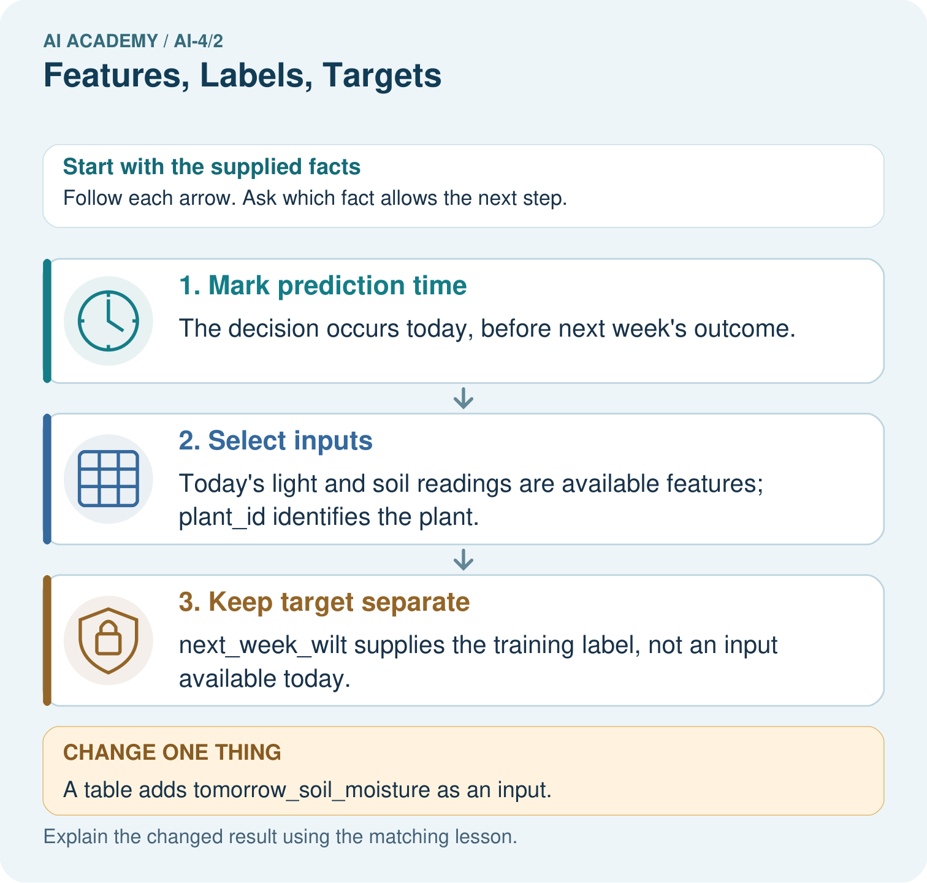
Why can a historical table contain a field that is an invalid input? Point to the relevant step in the picture, then write the changed result and the rule or evidence that supports it.

My picture-based explanation and changed-case prediction
________________________________________________________________
________________________________________________________________
________________________________________________________________
________________________________________________________________
________________________________________________________________
________________________________________________________________
Support used: alone / hint / worked example. This record is practice evidence.
Project connection: For your Responsible Plant Classifier, save the input, procedure, observed result and limitation of this check. Label this worked example as practice; use a different, previously unreviewed case when checking independent understanding.

19. Project portfolio milestone
Project: Responsible Plant Classifier
Current milestone: Frame the need. Name the user, the problem, allowed inputs and a safe simple starting method.
For your Responsible Plant Classifier, save the input, procedure, observed result and limitation of this check. Label this worked example as practice; use a different, previously unreviewed case when checking independent understanding.
Evidence to keep | My record
This week’s input and deciding step
Prediction and actual result (or labelled paper trace)
One change since the previous checkpoint and why
One error or limit and the next test

Explain what this week adds to your project. Reuse last week’s record rather than starting again.
________________________________________________________________
________________________________________________________________
________________________________________________________________
________________________________________________________________
________________________________________________________________

