AI ACADEMY · WORKBOOK · ai-4/3

Classification or Regression?
Project: Responsible Plant Classifier

01. Recall and choose your starting point
Try the recall before opening notes. Then use a different colour or a labelled second line to correct your explanation.

Features, Labels, Targets
Without opening the old lesson, explain one key idea from Features, Labels, Targets. Give an example and a mistake that the idea helps you avoid.

My remembered idea, example and correction
________________________________________________________________
________________________________________________________________
________________________________________________________________

02. Practise with fading help
Use W2: Trace both checks for Classification and regression. Record the answer once; the lesson and workbook refer to the same attempt.
Given inputs | Procedure I chose | Middle steps | Result and check

The step I completed without help, and the hint I needed
________________________________________________________________
________________________________________________________________
________________________________________________________________

03. Individual reasoning check
Use the worked case for Classification and regression. Proposed explanation: “Numbers always mean regression”. Decide whether this explanation is supported. Point to the step or supplied fact that decides; explain your repair if needed.

My explanation before partner discussion
________________________________________________________________
________________________________________________________________
________________________________________________________________
________________________________________________________________

04. Independent transfer case

Independent case: Compare new evidence independently
For three fictional print jobs, actual completion times are 4, 5 and 9 minutes; estimates are 6, 5 and 8 minutes in matching order. Slow means more than 5 minutes. Write actual and predicted category lists, count correct categories, calculate each absolute error and the mean error in minutes. State what each result measures.

My independent explanation, trace and limits
________________________________________________________________
________________________________________________________________
________________________________________________________________
________________________________________________________________
________________________________________________________________
________________________________________________________________
________________________________________________________________
Attempt this case before feedback. Record any help. Earlier examples below are further practice; a case already practised with feedback cannot establish fresh transfer.

05. Your learning target
System A predicts class codes 0=oak,1=maple. System B predicts leaf area in cm². Name the task types and explain why code 1 is not 'one more species' than code 0.

06. Solve the given case
Task A predicts healthy/spotted; B predicts next week's height in cm.
Choose task and output types.
Show your trace, calculation or evidence

Write or draw your reasoning and evidence.
________________________________________________________________
________________________________________________________________
________________________________________________________________
________________________________________________________________
________________________________________________________________

07. Check a changed case
Task A predicts whether a plant is fern or grass. Task B predicts its height in centimetres. Which is classification and which is regression?
My independent answer and reason

Write or draw your reasoning and evidence.
________________________________________________________________
________________________________________________________________
________________________________________________________________
________________________________________________________________
________________________________________________________________

Week 3 Test and reflect

08. Design a revealing test
Create a changed input, boundary case or missing-information case. Write the expected answer or safe response before testing.
Test record | My evidence
Changed input or condition
Expected answer or fallback
Observed result
Why the result occurred

09. Project checkpoint
Confirm whether Plant Classifier predicts a health category or a numerical severity score; document why.
The project change and evidence I will keep

Write or draw your reasoning and evidence.
________________________________________________________________
________________________________________________________________
________________________________________________________________
________________________________________________________________
________________________________________________________________

10. Self check
I can explain the mechanism. I can show evidence. I can handle a changed case. I can name a limit. Mark each as not yet, with help or independently, and attach supporting work.
Teacher review ____________________ Next step ____________________

11. Transfer practice from the original programme
System A predicts class codes 0=oak,1=maple. System B predicts leaf area in cm². Name the task types and explain why code 1 is not 'one more species' than code 0.

My independently reasoned answer
________________________________________________________________
________________________________________________________________
________________________________________________________________
________________________________________________________________
________________________________________________________________
________________________________________________________________
________________________________________________________________
Record support used: none, hint or teacher explanation.

12. W1 Classify the target meaning
At dispatch, identify the task for predicting route type coded 1 or 2, duration in whole minutes, and whether duration exceeds 10 minutes. Explain your choices.

My reasoning and evidence
________________________________________________________________
________________________________________________________________
________________________________________________________________
________________________________________________________________
________________________________________________________________
________________________________________________________________

13. W2 Trace both checks
For actual 14 minutes and estimate 12 minutes, calculate absolute error and both slow categories using greater than 10. Explain why a correct category does not mean an exact duration.

My reasoning and evidence
________________________________________________________________
________________________________________________________________
________________________________________________________________
________________________________________________________________
________________________________________________________________
________________________________________________________________

14. W3 Repair a category average
Indoor is coded 1 and outdoor is coded 2. Someone averages predictions and reports route type 1.5 as an accurate halfway category. Explain the problem and name an appropriate check.

My reasoning and evidence
________________________________________________________________
________________________________________________________________
________________________________________________________________
________________________________________________________________
________________________________________________________________
________________________________________________________________

15. W4 Compare new evidence independently
For three fictional print jobs, actual completion times are 4, 5 and 9 minutes; estimates are 6, 5 and 8 minutes in matching order. Slow means more than 5 minutes. Write actual and predicted category lists, count correct categories, calculate each absolute error and the mean error in minutes. State what each result measures.

My reasoning and evidence
________________________________________________________________
________________________________________________________________
________________________________________________________________
________________________________________________________________
________________________________________________________________
________________________________________________________________
________________________________________________________________
________________________________________________________________

16. W5 Specify a useful output
A user needs the arrival duration in minutes, but a report gives only slow or not slow. What task should be specified, and what information was lost by the category output?

My reasoning and evidence
________________________________________________________________
________________________________________________________________
________________________________________________________________
________________________________________________________________
________________________________________________________________
________________________________________________________________

17. Feedback, return check and learning record
Evidence | My record
Worked alone / hint / model
First step I repaired and why
New case checked later; date and result
What I can now explain without notes
One remaining question
Revisit this idea with your teacher after a delay. Familiarity is different from explaining and using it on a changed case.

18. Pictorial case practice: Classification or Regression?
Distinguish predicting growth height from predicting a growth category.
Actual heights are [4, 7, 9] cm; estimates are [5, 6, 10] cm. Tall means strictly greater than 6 cm.
All inputs and outcomes in this worked example are invented classroom data; no real model run is claimed.
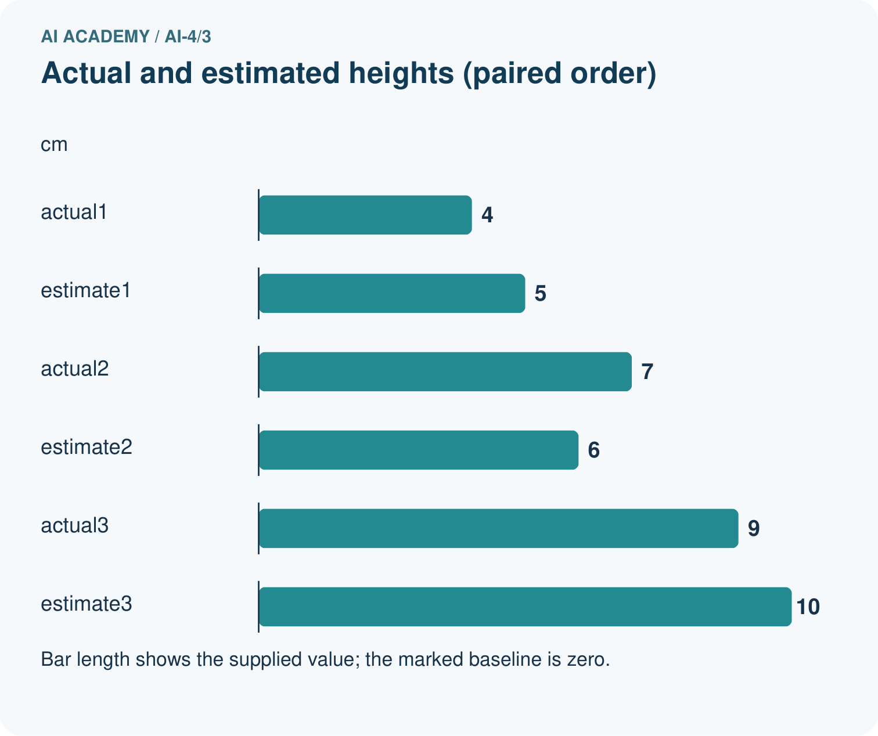
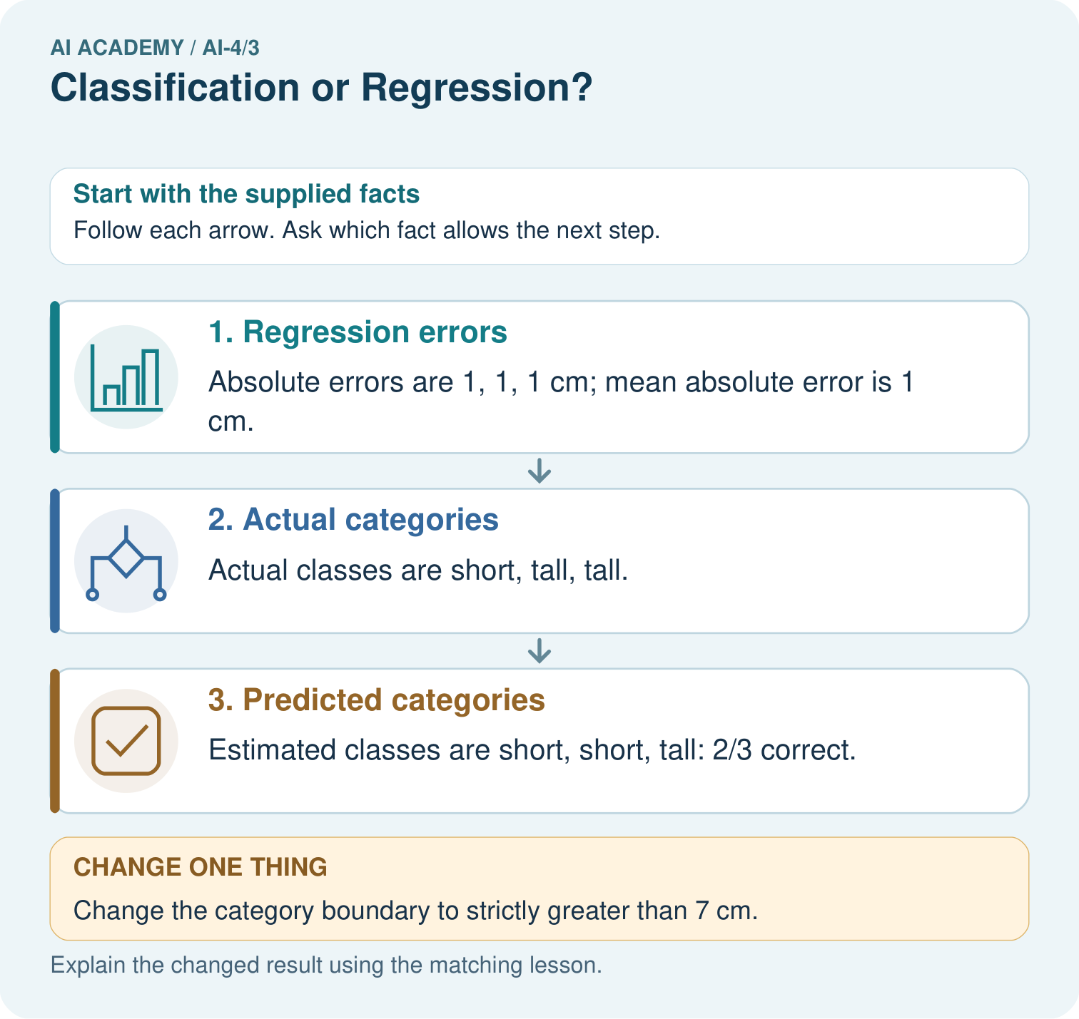
Did regression MAE improve when the boundary changed? Point to the relevant step in the picture, then write the changed result and the rule or evidence that supports it.

My picture-based explanation and changed-case prediction
________________________________________________________________
________________________________________________________________
________________________________________________________________
________________________________________________________________
________________________________________________________________
________________________________________________________________
Support used: alone / hint / worked example. This record is practice evidence.
Project connection: For your Responsible Plant Classifier, save the input, procedure, observed result and limitation of this check. Label this worked example as practice; use a different, previously unreviewed case when checking independent understanding.

19. Project portfolio milestone
Project: Responsible Plant Classifier
Current milestone: Frame the need. Name the user, the problem, allowed inputs and a safe simple starting method.
For your Responsible Plant Classifier, save the input, procedure, observed result and limitation of this check. Label this worked example as practice; use a different, previously unreviewed case when checking independent understanding.
Evidence to keep | My record
This week’s input and deciding step
Prediction and actual result (or labelled paper trace)
One change since the previous checkpoint and why
One error or limit and the next test

Explain what this week adds to your project. Reuse last week’s record rather than starting again.
________________________________________________________________
________________________________________________________________
________________________________________________________________
________________________________________________________________
________________________________________________________________

