AI ACADEMY · WORKBOOK · ai-4/5

Inspect Before Modeling
Project: Responsible Plant Classifier

01. Recall and choose your starting point
Try the recall before opening notes. Then use a different colour or a labelled second line to correct your explanation.

Python and Table Readiness
Without opening the old lesson, explain one key idea from Python and Table Readiness. Give an example and a mistake that the idea helps you avoid.

My remembered idea, example and correction
________________________________________________________________
________________________________________________________________
________________________________________________________________

Features, Labels, Targets
Without opening the old lesson, explain one key idea from Features, Labels, Targets. Give an example and a mistake that the idea helps you avoid.

My remembered idea, example and correction
________________________________________________________________
________________________________________________________________
________________________________________________________________

02. Practise with fading help
Use W2: Interpret the audit counts for Dataset inspection and cards. Record the answer once; the lesson and workbook refer to the same attempt.
Given inputs | Procedure I chose | Middle steps | Result and check

The step I completed without help, and the hint I needed
________________________________________________________________
________________________________________________________________
________________________________________________________________

03. Individual reasoning check
Use the worked case for Dataset inspection and cards. Proposed explanation: “A complete card certifies data quality”. Decide whether this explanation is supported. Point to the step or supplied fact that decides; explain your repair if needed.

My explanation before partner discussion
________________________________________________________________
________________________________________________________________
________________________________________________________________
________________________________________________________________

04. Independent transfer case

Independent case: Inspect and document independently
A new fictional indoor trip export has (P,4), (Q,None), (Q,None), (R,-1), (S,6), (T,0), with durations in minutes and the same schema. Count raw rows, distinct IDs, missing durations, negative durations and extra ID occurrences. Identify overlap. Draft a short dataset card stating source, row meaning, unit, findings, unchanged version and one excluded use.

My independent explanation, trace and limits
________________________________________________________________
________________________________________________________________
________________________________________________________________
________________________________________________________________
________________________________________________________________
________________________________________________________________
________________________________________________________________
Attempt this case before feedback. Record any help. Earlier examples below are further practice; a case already practised with feedback cannot establish fresh transfer.

05. Your learning target
A table contains 8 cm, -2 cm, missing and two copies of the same leaf photo. Propose a separate inspection for each issue.

06. Solve the given case
Lengths include 5 cm, blank and -3 cm, plus a duplicate photo row.
Name checks and a deletion risk.
Show your trace, calculation or evidence

Write or draw your reasoning and evidence.
________________________________________________________________
________________________________________________________________
________________________________________________________________
________________________________________________________________
________________________________________________________________

07. Check a changed case
A table has height_cm values 12, 15, -8 and a blank. Identify two issues and a suitable first action.
My independent answer and reason

Write or draw your reasoning and evidence.
________________________________________________________________
________________________________________________________________
________________________________________________________________
________________________________________________________________
________________________________________________________________

Week 5 Test and reflect

08. Design a revealing test
Create a changed input, boundary case or missing-information case. Write the expected answer or safe response before testing.
Test record | My evidence
Changed input or condition
Expected answer or fallback
Observed result
Why the result occurred

09. Project checkpoint
Audit the Plant Classifier table and attach a data-quality report before any baseline or model is trained.
The project change and evidence I will keep

Write or draw your reasoning and evidence.
________________________________________________________________
________________________________________________________________
________________________________________________________________
________________________________________________________________
________________________________________________________________

10. Self check
I can explain the mechanism. I can show evidence. I can handle a changed case. I can name a limit. Mark each as not yet, with help or independently, and attach supporting work.
Teacher review ____________________ Next step ____________________

11. Transfer practice from the original programme
A table contains 8 cm, -2 cm, missing and two copies of the same leaf photo. Propose a separate inspection for each issue.

My independently reasoned answer
________________________________________________________________
________________________________________________________________
________________________________________________________________
________________________________________________________________
________________________________________________________________
________________________________________________________________
________________________________________________________________
Record support used: none, hint or teacher explanation.

12. W1 Define the row and source
For Robot practice v1, state what one row is intended to represent, the source, the unit and the meaning of None.

My reasoning and evidence
________________________________________________________________
________________________________________________________________
________________________________________________________________
________________________________________________________________
________________________________________________________________
________________________________________________________________

13. W2 Interpret the audit counts
Explain each number in 5 4 2 1. How many extra ID occurrences are there, and how many rows belong to a repeated-ID group?

My reasoning and evidence
________________________________________________________________
________________________________________________________________
________________________________________________________________
________________________________________________________________
________________________________________________________________
________________________________________________________________

14. W3 Reject an unsupported correction
A learner changes None to 0 and -2 to 2, then reports a clean dataset. Explain why this is not a justified repair and what record should be kept.

My reasoning and evidence
________________________________________________________________
________________________________________________________________
________________________________________________________________
________________________________________________________________
________________________________________________________________
________________________________________________________________

15. W4 Inspect and document independently
A new fictional indoor trip export has (P,4), (Q,None), (Q,None), (R,-1), (S,6), (T,0), with durations in minutes and the same schema. Count raw rows, distinct IDs, missing durations, negative durations and extra ID occurrences. Identify overlap. Draft a short dataset card stating source, row meaning, unit, findings, unchanged version and one excluded use.

My reasoning and evidence
________________________________________________________________
________________________________________________________________
________________________________________________________________
________________________________________________________________
________________________________________________________________
________________________________________________________________
________________________________________________________________
________________________________________________________________

16. W5 State an evidence gap
Someone duplicates each row ten times and claims the export now covers more kinds of trips. Explain what changed and what did not.

My reasoning and evidence
________________________________________________________________
________________________________________________________________
________________________________________________________________
________________________________________________________________
________________________________________________________________
________________________________________________________________

17. Units conversions and data provenance — W1 Retain the source
Name four pieces of information to keep for Log A and its conversion.

My reasoning and evidence
________________________________________________________________
________________________________________________________________
________________________________________________________________
________________________________________________________________
________________________________________________________________
________________________________________________________________

18. Units conversions and data provenance — W2 Convert precisely
Convert 150 seconds and 30 seconds to minutes without rounding to whole numbers.

My reasoning and evidence
________________________________________________________________
________________________________________________________________
________________________________________________________________
________________________________________________________________
________________________________________________________________
________________________________________________________________

19. Units conversions and data provenance — W3 Repair a comparison
A report claims 120 seconds exceeds 3 minutes because 120 > 3. Correct it.

My reasoning and evidence
________________________________________________________________
________________________________________________________________
________________________________________________________________
________________________________________________________________
________________________________________________________________
________________________________________________________________

20. Units conversions and data provenance — W4 Normalize independently
Create records for 240 seconds, 1.5 minutes and 60 seconds. Derive minutes while keeping raw data. State the values and their total.

My reasoning and evidence
________________________________________________________________
________________________________________________________________
________________________________________________________________
________________________________________________________________
________________________________________________________________
________________________________________________________________
________________________________________________________________
________________________________________________________________

21. Units conversions and data provenance — W5 Handle an unknown unit
A record contains value 8 and unit ticks with no conversion rule. Should you assume seconds?

My reasoning and evidence
________________________________________________________________
________________________________________________________________
________________________________________________________________
________________________________________________________________
________________________________________________________________
________________________________________________________________

22. Feedback, return check and learning record
Evidence | My record
Worked alone / hint / model
First step I repaired and why
New case checked later; date and result
What I can now explain without notes
One remaining question
Revisit this idea with your teacher after a delay. Familiarity is different from explaining and using it on a changed case.

23. Pictorial case practice: Inspect Before Modeling
Spot a duplicate, an impossible value and a valid boundary before fitting.
Toy heights table: A=3, B=5, B=5, C=-2, D=0 cm. Each plant should have exactly one nonnegative height record.
All inputs and outcomes in this worked example are invented classroom data; no real model run is claimed.
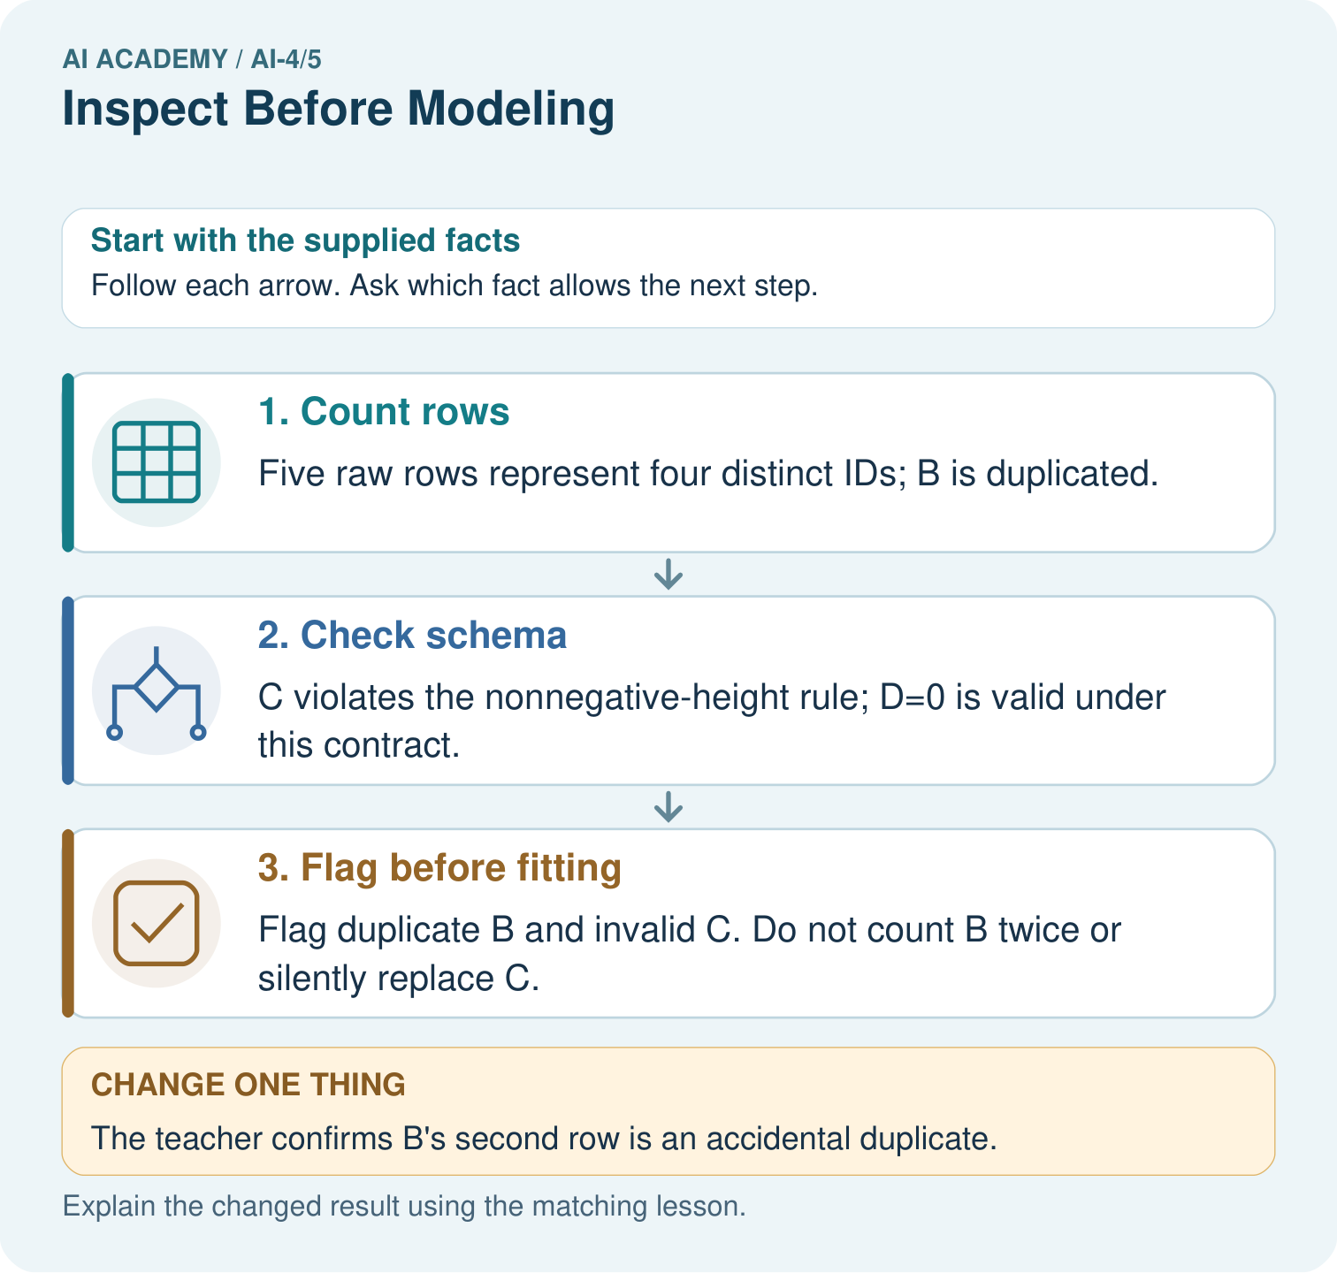
Which original information should the inspection log preserve? Point to the relevant step in the picture, then write the changed result and the rule or evidence that supports it.

My picture-based explanation and changed-case prediction
________________________________________________________________
________________________________________________________________
________________________________________________________________
________________________________________________________________
________________________________________________________________
________________________________________________________________
Support used: alone / hint / worked example. This record is practice evidence.
Project connection: For your Responsible Plant Classifier, save the input, procedure, observed result and limitation of this check. Label this worked example as practice; use a different, previously unreviewed case when checking independent understanding.

24. Project portfolio milestone
Project: Responsible Plant Classifier
Current milestone: Frame the need. Name the user, the problem, allowed inputs and a safe simple starting method.
For your Responsible Plant Classifier, save the input, procedure, observed result and limitation of this check. Label this worked example as practice; use a different, previously unreviewed case when checking independent understanding.
Evidence to keep | My record
This week’s input and deciding step
Prediction and actual result (or labelled paper trace)
One change since the previous checkpoint and why
One error or limit and the next test

Explain what this week adds to your project. Reuse last week’s record rather than starting again.
________________________________________________________________
________________________________________________________________
________________________________________________________________
________________________________________________________________
________________________________________________________________

