AI ACADEMY · WORKBOOK · ai-4/6

Label Quality
Project: Responsible Plant Classifier

01. Recall and choose your starting point
Try the recall before opening notes. Then use a different colour or a labelled second line to correct your explanation.

Inspect Before Modeling
Without opening the old lesson, explain one key idea from Inspect Before Modeling. Give an example and a mistake that the idea helps you avoid.

My remembered idea, example and correction
________________________________________________________________
________________________________________________________________
________________________________________________________________

Classification or Regression?
Without opening the old lesson, explain one key idea from Classification or Regression?. Give an example and a mistake that the idea helps you avoid.

My remembered idea, example and correction
________________________________________________________________
________________________________________________________________
________________________________________________________________

02. Practise with fading help
Use W2: Interpret agreement for Label definitions and disagreement. Record the answer once; the lesson and workbook refer to the same attempt.
Given inputs | Procedure I chose | Middle steps | Result and check

The step I completed without help, and the hint I needed
________________________________________________________________
________________________________________________________________
________________________________________________________________

03. Individual reasoning check
Use the worked case for Label definitions and disagreement. Proposed explanation: “Agreement is accuracy”. Decide whether this explanation is supported. Point to the step or supplied fact that decides; explain your repair if needed.

My explanation before partner discussion
________________________________________________________________
________________________________________________________________
________________________________________________________________
________________________________________________________________

04. Independent transfer case

Independent case: Apply the process independently
New pairs are P blocked/blocked, Q clear/blocked, R review/review, S clear/clear, T blocked/clear. P has an object inside; Q touches the line; R is partly hidden; S has all objects outside a fully visible lane; T has an object inside. Count agreement including review. Apply v1 to all five. Then report agreement on the original pairs excluding any review status, with its denominator and limitation.

My independent explanation, trace and limits
________________________________________________________________
________________________________________________________________
________________________________________________________________
________________________________________________________________
________________________________________________________________
________________________________________________________________
________________________________________________________________
Attempt this case before feedback. Record any help. Earlier examples below are further practice; a case already practised with feedback cannot establish fresh transfer.

05. Your learning target
Two labelers agree on 16 of 20 leaves. Both used a rule that mistakenly calls shadows 'spots'. Compute agreement and explain why it does not establish correct labels.

06. Solve the given case
Two annotators disagree on three of ten leaves, especially mild spotting.
Improve label quality.
Show your trace, calculation or evidence

Write or draw your reasoning and evidence.
________________________________________________________________
________________________________________________________________
________________________________________________________________
________________________________________________________________
________________________________________________________________

07. Check a changed case
Two labelers assign different species to the same image. Should you silently pick the label that helps the model score? Describe a better process.
My independent answer and reason

Write or draw your reasoning and evidence.
________________________________________________________________
________________________________________________________________
________________________________________________________________
________________________________________________________________
________________________________________________________________

Week 6 Test and reflect

08. Design a revealing test
Create a changed input, boundary case or missing-information case. Write the expected answer or safe response before testing.
Test record | My evidence
Changed input or condition
Expected answer or fallback
Observed result
Why the result occurred

09. Project checkpoint
Write the Plant Classifier label guide with positive, negative, borderline, and not-labelable examples.
The project change and evidence I will keep

Write or draw your reasoning and evidence.
________________________________________________________________
________________________________________________________________
________________________________________________________________
________________________________________________________________
________________________________________________________________

10. Self check
I can explain the mechanism. I can show evidence. I can handle a changed case. I can name a limit. Mark each as not yet, with help or independently, and attach supporting work.
Teacher review ____________________ Next step ____________________

11. Transfer practice from the original programme
Two labelers agree on 16 of 20 leaves. Both used a rule that mistakenly calls shadows 'spots'. Compute agreement and explain why it does not establish correct labels.

My independently reasoned answer
________________________________________________________________
________________________________________________________________
________________________________________________________________
________________________________________________________________
________________________________________________________________
________________________________________________________________
________________________________________________________________
Record support used: none, hint or teacher explanation.

12. W1 Use the boundary and review rules
Under rule v1, label a wheel touching the boundary, an object entirely outside a fully visible lane, and a partly hidden lane. Explain the evidence for each.

My reasoning and evidence
________________________________________________________________
________________________________________________________________
________________________________________________________________
________________________________________________________________
________________________________________________________________
________________________________________________________________

13. W2 Interpret agreement
Explain the output 2 4 for A through D. State the fraction and percent, whether review is included, and why this is not model accuracy.

My reasoning and evidence
________________________________________________________________
________________________________________________________________
________________________________________________________________
________________________________________________________________
________________________________________________________________
________________________________________________________________

14. W3 Write a decision log
For B and C, record original labels, visible evidence, rule version and reviewed decision. Explain why the original labels should remain available.

My reasoning and evidence
________________________________________________________________
________________________________________________________________
________________________________________________________________
________________________________________________________________
________________________________________________________________
________________________________________________________________

15. W4 Apply the process independently
New pairs are P blocked/blocked, Q clear/blocked, R review/review, S clear/clear, T blocked/clear. P has an object inside; Q touches the line; R is partly hidden; S has all objects outside a fully visible lane; T has an object inside. Count agreement including review. Apply v1 to all five. Then report agreement on the original pairs excluding any review status, with its denominator and limitation.

My reasoning and evidence
________________________________________________________________
________________________________________________________________
________________________________________________________________
________________________________________________________________
________________________________________________________________
________________________________________________________________
________________________________________________________________
________________________________________________________________

16. W5 Draft and test a label rule
Write a short v1 labeling instruction covering blocked, clear, the touching boundary and review. Add one boundary example. Explain why three people voting clear cannot settle a hidden lane.

My reasoning and evidence
________________________________________________________________
________________________________________________________________
________________________________________________________________
________________________________________________________________
________________________________________________________________
________________________________________________________________

17. Feedback, return check and learning record
Evidence | My record
Worked alone / hint / model
First step I repaired and why
New case checked later; date and result
What I can now explain without notes
One remaining question
Revisit this idea with your teacher after a delay. Familiarity is different from explaining and using it on a changed case.

18. Pictorial case practice: Label Quality
Write a label rule that resolves the visible boundary case.
Toy spotted-leaf rule: at least one fully visible brown spot means spotted; occluded leaves require review. X has one visible spot; Y has none; Z is half hidden.
All inputs and outcomes in this worked example are invented classroom data; no real model run is claimed.
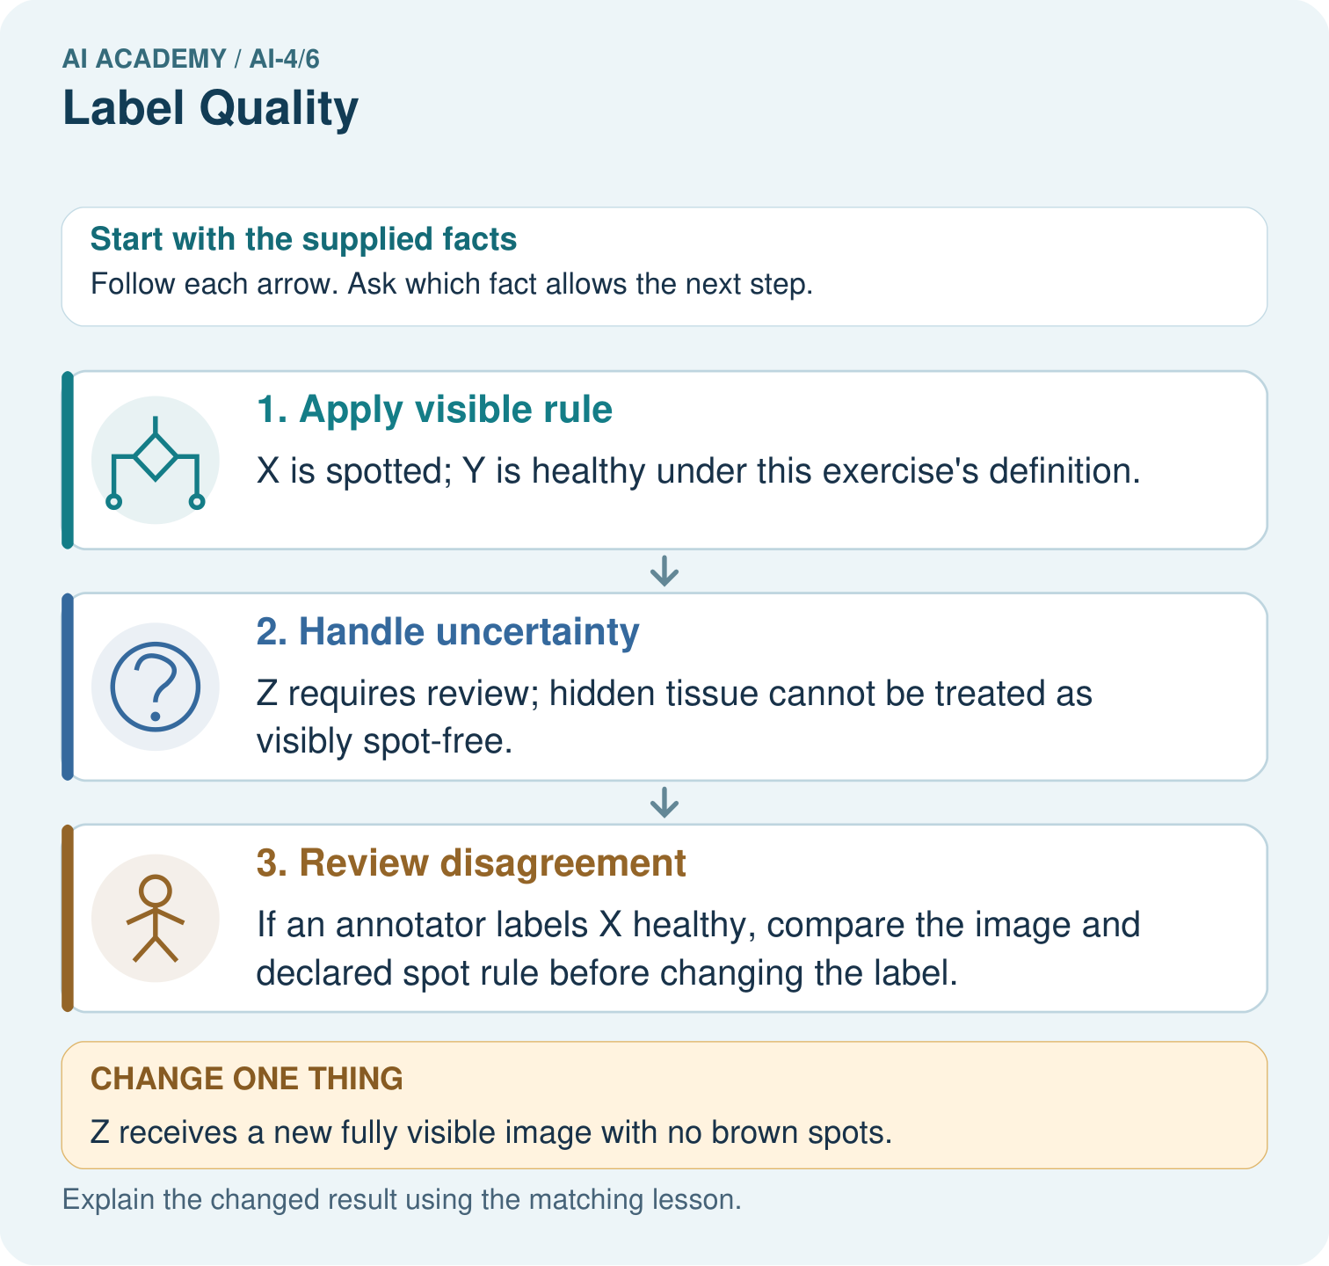
Why should two annotators not vote away Z’s missing evidence? Point to the relevant step in the picture, then write the changed result and the rule or evidence that supports it.

My picture-based explanation and changed-case prediction
________________________________________________________________
________________________________________________________________
________________________________________________________________
________________________________________________________________
________________________________________________________________
________________________________________________________________
Support used: alone / hint / worked example. This record is practice evidence.
Project connection: For your Responsible Plant Classifier, save the input, procedure, observed result and limitation of this check. Label this worked example as practice; use a different, previously unreviewed case when checking independent understanding.

19. Project portfolio milestone
Project: Responsible Plant Classifier
Current milestone: Frame the need. Name the user, the problem, allowed inputs and a safe simple starting method.
For your Responsible Plant Classifier, save the input, procedure, observed result and limitation of this check. Label this worked example as practice; use a different, previously unreviewed case when checking independent understanding.
Evidence to keep | My record
This week’s input and deciding step
Prediction and actual result (or labelled paper trace)
One change since the previous checkpoint and why
One error or limit and the next test

Explain what this week adds to your project. Reuse last week’s record rather than starting again.
________________________________________________________________
________________________________________________________________
________________________________________________________________
________________________________________________________________
________________________________________________________________

