AI ACADEMY · WORKBOOK · ai-4/13

Train a Classifier
Project: Responsible Plant Classifier

01. Recall and choose your starting point
Try the recall before opening notes. Then use a different colour or a labelled second line to correct your explanation.

Nearest Neighbors
Without opening the old lesson, explain one key idea from Nearest Neighbors. Give an example and a mistake that the idea helps you avoid.

My remembered idea, example and correction
________________________________________________________________
________________________________________________________________
________________________________________________________________

Baselines First
Without opening the old lesson, explain one key idea from Baselines First. Give an example and a mistake that the idea helps you avoid.

My remembered idea, example and correction
________________________________________________________________
________________________________________________________________
________________________________________________________________

Sampling and Intended Use
Without opening the old lesson, explain one key idea from Sampling and Intended Use. Give an example and a mistake that the idea helps you avoid.

My remembered idea, example and correction
________________________________________________________________
________________________________________________________________
________________________________________________________________

02. Practise with fading help
Use W2: Trace and score the saved run for A reproducible classifier pipeline. Record the answer once; the lesson and workbook refer to the same attempt.
Given inputs | Procedure I chose | Middle steps | Result and check

The step I completed without help, and the hint I needed
________________________________________________________________
________________________________________________________________
________________________________________________________________

03. Individual reasoning check
Use the worked case for A reproducible classifier pipeline. Proposed explanation: “A pipeline prevents every leak automatically”. Decide whether this explanation is supported. Point to the step or supplied fact that decides; explain your repair if needed.

My explanation before partner discussion
________________________________________________________________
________________________________________________________________
________________________________________________________________
________________________________________________________________

04. Independent transfer case

Independent case: Build and trace a fresh fitted state
Use P (0,60) blocked, Q (20,20) clear, R (20,60) clear as new training rows. Fit the same pipeline. Predict validation queries (2,28),(18,56),(4,12) with references blocked,clear,blocked. Give fitted minima and ranges, transformed queries, selected IDs, predictions, accuracy and training-majority baseline.

My independent explanation, trace and limits
________________________________________________________________
________________________________________________________________
________________________________________________________________
________________________________________________________________
________________________________________________________________
________________________________________________________________
________________________________________________________________
Attempt this case before feedback. Record any help. Earlier examples below are further practice; a case already practised with feedback cannot establish fresh transfer.

05. Your learning target
Training: spots 0:H,2:H,4:S,6:S. Compare rules S if spots>=1,>=3,>=5. Choose by training accuracy, then predict held-out 1:H and 5:S without revising. Report both stages.

06. Solve the given case
Training is (0,H),(1,H),(4,S),(5,S). Candidate rule predicts S for spots>=3. Held-out cases are (2,H),(3,S).
Apply the rule and distinguish fitting from inference.
Show your trace, calculation or evidence

Write or draw your reasoning and evidence.
________________________________________________________________
________________________________________________________________
________________________________________________________________
________________________________________________________________
________________________________________________________________

07. Check a changed case
A classifier fits on rows 1–80 and is evaluated on those same rows. Its accuracy is 100%. What additional evidence is needed before claiming generalization?
My independent answer and reason

Write or draw your reasoning and evidence.
________________________________________________________________
________________________________________________________________
________________________________________________________________
________________________________________________________________
________________________________________________________________

Week 13 Test and reflect

08. Design a revealing test
Create a changed input, boundary case or missing-information case. Write the expected answer or safe response before testing.
Test record | My evidence
Changed input or condition
Expected answer or fallback
Observed result
Why the result occurred

09. Project checkpoint
Train Plant Classifier v1 without opening the final test labels during model choice; save the experiment record.
The project change and evidence I will keep

Write or draw your reasoning and evidence.
________________________________________________________________
________________________________________________________________
________________________________________________________________
________________________________________________________________
________________________________________________________________

10. Self check
I can explain the mechanism. I can show evidence. I can handle a changed case. I can name a limit. Mark each as not yet, with help or independently, and attach supporting work.
Teacher review ____________________ Next step ____________________

11. Transfer practice from the original programme
Training: spots 0:H,2:H,4:S,6:S. Compare rules S if spots>=1,>=3,>=5. Choose by training accuracy, then predict held-out 1:H and 5:S without revising. Report both stages.

My independently reasoned answer
________________________________________________________________
________________________________________________________________
________________________________________________________________
________________________________________________________________
________________________________________________________________
________________________________________________________________
________________________________________________________________
Record support used: none, hint or teacher explanation.

12. W1 Separate fit predict and evaluate
List what fit learns or stores, what predict takes as input, and what evaluation compares. State where the validation reference labels belong.

My reasoning and evidence
________________________________________________________________
________________________________________________________________
________________________________________________________________
________________________________________________________________
________________________________________________________________
________________________________________________________________

13. W2 Trace and score the saved run
Give the IDs and labels printed for V1,V2,V3. Use references clear,blocked,clear to calculate accuracy and the training-majority baseline. Which error should repeat in an unchanged rerun?

My reasoning and evidence
________________________________________________________________
________________________________________________________________
________________________________________________________________
________________________________________________________________
________________________________________________________________
________________________________________________________________

14. W3 Repair an incomplete run record
A classmate saves only k=1 and a score of 2/3. Name the information needed to reproduce this run. Explain why the same score alone is insufficient.

My reasoning and evidence
________________________________________________________________
________________________________________________________________
________________________________________________________________
________________________________________________________________
________________________________________________________________
________________________________________________________________

15. W4 Build and trace a fresh fitted state
Use P (0,60) blocked, Q (20,20) clear, R (20,60) clear as new training rows. Fit the same pipeline. Predict validation queries (2,28),(18,56),(4,12) with references blocked,clear,blocked. Give fitted minima and ranges, transformed queries, selected IDs, predictions, accuracy and training-majority baseline.

My reasoning and evidence
________________________________________________________________
________________________________________________________________
________________________________________________________________
________________________________________________________________
________________________________________________________________
________________________________________________________________
________________________________________________________________
________________________________________________________________

16. W5 Diagnose pipeline misuse
Explain and repair three mistakes: predict receives an already scaled query; fit receives training plus validation rows; a query uses brightness before distance. Does repeating each mistaken run make it valid?

My reasoning and evidence
________________________________________________________________
________________________________________________________________
________________________________________________________________
________________________________________________________________
________________________________________________________________
________________________________________________________________

17. Searching candidate rules — W1 State the search before running it
Write the rule direction, equality behavior, candidate cutoffs and tie policy. Identify what humans supplied and what fitting selects.

My reasoning and evidence
________________________________________________________________
________________________________________________________________
________________________________________________________________
________________________________________________________________
________________________________________________________________
________________________________________________________________

18. Searching candidate rules — W2 Trace the training mistakes
List errors for cutoffs 3, 5 and 7 on the worked training rows. Identify the mistaken row for each imperfect candidate. Which cutoff is stored?

My reasoning and evidence
________________________________________________________________
________________________________________________________________
________________________________________________________________
________________________________________________________________
________________________________________________________________
________________________________________________________________

19. Searching candidate rules — W3 Audit the boundary and comparison
What happens at distance 5 if prediction uses < instead of <= with cutoff 5? Explain why the search uses a strict < for error counts even though prediction uses <= for distance.

My reasoning and evidence
________________________________________________________________
________________________________________________________________
________________________________________________________________
________________________________________________________________
________________________________________________________________
________________________________________________________________

20. Searching candidate rules — W4 Search and evaluate independently
New training rows are (1,blocked), (3,clear), (5,blocked), (7,clear). Try cutoffs 2,4,6, using the same direction and smaller-cutoff tie policy. Give every training error count and select a cutoff. Validation rows are (2,blocked), (4,blocked), (6,clear), (8,clear). List the selected rule’s predictions and score. Compare with the training-majority baseline using clear on ties.

My reasoning and evidence
________________________________________________________________
________________________________________________________________
________________________________________________________________
________________________________________________________________
________________________________________________________________
________________________________________________________________
________________________________________________________________
________________________________________________________________

21. Searching candidate rules — W5 Limit the claim
The worked rule fits training perfectly but ties the baseline on validation accuracy. Explain why neither result proves it is the best possible model. Name two details to keep in the experiment record.

My reasoning and evidence
________________________________________________________________
________________________________________________________________
________________________________________________________________
________________________________________________________________
________________________________________________________________
________________________________________________________________

22. Feedback, return check and learning record
Evidence | My record
Worked alone / hint / model
First step I repaired and why
New case checked later; date and result
What I can now explain without notes
One remaining question
Revisit this idea with your teacher after a delay. Familiarity is different from explaining and using it on a changed case.

23. Pictorial case practice: Train a Classifier
Separate a reproducible fitted pipeline from merely displaying predictions.
Toy training lengths are [2, 6] cm with labels [healthy, spotted]. Pipeline converts cm to mm, then uses k=1 absolute distance. Query is 5 cm.
All inputs and outcomes in this worked example are invented classroom data; no real model run is claimed.
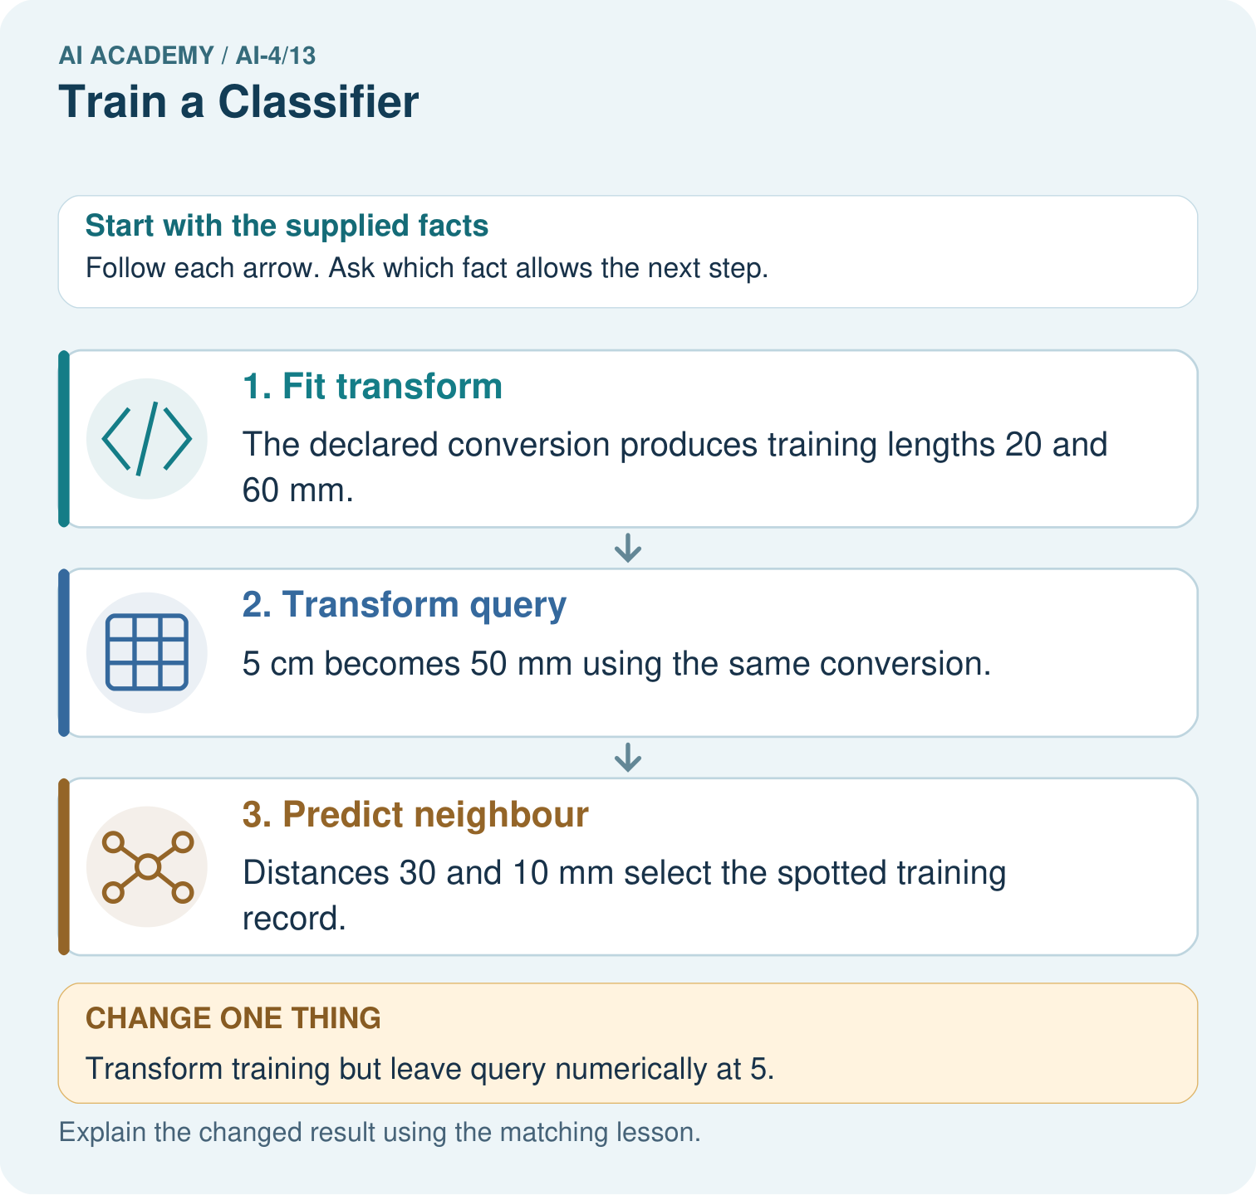
Which pipeline record would help another team reproduce the result? Point to the relevant step in the picture, then write the changed result and the rule or evidence that supports it.

My picture-based explanation and changed-case prediction
________________________________________________________________
________________________________________________________________
________________________________________________________________
________________________________________________________________
________________________________________________________________
________________________________________________________________
Support used: alone / hint / worked example. This record is practice evidence.
Project connection: For your Responsible Plant Classifier, save the input, procedure, observed result and limitation of this check. Label this worked example as practice; use a different, previously unreviewed case when checking independent understanding.

24. Project portfolio milestone
Project: Responsible Plant Classifier
Current milestone: Test changed cases. Keep normal, boundary and failure cases; compare expected and observed results.
For your Responsible Plant Classifier, save the input, procedure, observed result and limitation of this check. Label this worked example as practice; use a different, previously unreviewed case when checking independent understanding.
Evidence to keep | My record
This week’s input and deciding step
Prediction and actual result (or labelled paper trace)
One change since the previous checkpoint and why
One error or limit and the next test

Explain what this week adds to your project. Reuse last week’s record rather than starting again.
________________________________________________________________
________________________________________________________________
________________________________________________________________
________________________________________________________________
________________________________________________________________

