AI ACADEMY · WORKBOOK · ai-4/17

Precision and Recall
Project: Responsible Plant Classifier

01. Recall and choose your starting point
Try the recall before opening notes. Then use a different colour or a labelled second line to correct your explanation.

Accuracy and Imbalance
Without opening the old lesson, explain one key idea from Accuracy and Imbalance. Give an example and a mistake that the idea helps you avoid.

My remembered idea, example and correction
________________________________________________________________
________________________________________________________________
________________________________________________________________

Scores and Calibration Intuition
Without opening the old lesson, explain one key idea from Scores and Calibration Intuition. Give an example and a mistake that the idea helps you avoid.

My remembered idea, example and correction
________________________________________________________________
________________________________________________________________
________________________________________________________________

Decision Trees
Without opening the old lesson, explain one key idea from Decision Trees. Give an example and a mistake that the idea helps you avoid.

My remembered idea, example and correction
________________________________________________________________
________________________________________________________________
________________________________________________________________

02. Practise with fading help
Use W2: Calculate both ratios for Precision recall and denominators. Record the answer once; the lesson and workbook refer to the same attempt.
Given inputs | Procedure I chose | Middle steps | Result and check

The step I completed without help, and the hint I needed
________________________________________________________________
________________________________________________________________
________________________________________________________________

03. Individual reasoning check
Use the worked case for Precision recall and denominators. Proposed explanation: “A final answer is enough”. Decide whether this explanation is supported. Point to the step or supplied fact that decides; explain your repair if needed.

My explanation before partner discussion
________________________________________________________________
________________________________________________________________
________________________________________________________________
________________________________________________________________

04. Independent transfer case

Independent case: Apply independently
Use [[8, 2],[3, 6]]. Give TP, FP, FN, precision, recall and accuracy.

My independent explanation, trace and limits
________________________________________________________________
________________________________________________________________
________________________________________________________________
________________________________________________________________
________________________________________________________________
________________________________________________________________
________________________________________________________________
Attempt this case before feedback. Record any help. Earlier examples below are further practice; a case already practised with feedback cannot establish fresh transfer.

05. Your learning target
TP=9,FP=3,FN=6,TN=12. Compute precision and recall. What happens to precision when a system predicts no positives?

06. Solve the given case
Positive is spotted: TP=8, FP=2, FN=4.
Compute precision and recall.
Show your trace, calculation or evidence

Write or draw your reasoning and evidence.
________________________________________________________________
________________________________________________________________
________________________________________________________________
________________________________________________________________
________________________________________________________________

07. Check a changed case
With disease positive, TP=6, FP=2 and FN=4. Calculate precision and recall, showing both denominators.
My independent answer and reason

Write or draw your reasoning and evidence.
________________________________________________________________
________________________________________________________________
________________________________________________________________
________________________________________________________________
________________________________________________________________

Week 17 Test and reflect

08. Design a revealing test
Create a changed input, boundary case or missing-information case. Write the expected answer or safe response before testing.
Test record | My evidence
Changed input or condition
Expected answer or fallback
Observed result
Why the result occurred

09. Project checkpoint
Set a Plant Classifier review threshold and explain which error type it prioritizes and who makes the final decision.
The project change and evidence I will keep

Write or draw your reasoning and evidence.
________________________________________________________________
________________________________________________________________
________________________________________________________________
________________________________________________________________
________________________________________________________________

10. Self check
I can explain the mechanism. I can show evidence. I can handle a changed case. I can name a limit. Mark each as not yet, with help or independently, and attach supporting work.
Teacher review ____________________ Next step ____________________

11. Transfer practice from the original programme
TP=9,FP=3,FN=6,TN=12. Compute precision and recall. What happens to precision when a system predicts no positives?

My independently reasoned answer
________________________________________________________________
________________________________________________________________
________________________________________________________________
________________________________________________________________
________________________________________________________________
________________________________________________________________
________________________________________________________________
Record support used: none, hint or teacher explanation.

12. W1 Identify the groups
For the worked matrix, give predicted-positive and reference-positive totals.

My reasoning and evidence
________________________________________________________________
________________________________________________________________
________________________________________________________________
________________________________________________________________
________________________________________________________________
________________________________________________________________

13. W2 Calculate both ratios
Calculate precision, recall and accuracy for the worked matrix.

My reasoning and evidence
________________________________________________________________
________________________________________________________________
________________________________________________________________
________________________________________________________________
________________________________________________________________
________________________________________________________________

14. W3 Handle no flags
Explain precision and recall for [[16, 0],[4, 0]].

My reasoning and evidence
________________________________________________________________
________________________________________________________________
________________________________________________________________
________________________________________________________________
________________________________________________________________
________________________________________________________________

15. W4 Apply independently
Use [[8, 2],[3, 6]]. Give TP, FP, FN, precision, recall and accuracy.

My reasoning and evidence
________________________________________________________________
________________________________________________________________
________________________________________________________________
________________________________________________________________
________________________________________________________________
________________________________________________________________
________________________________________________________________
________________________________________________________________

16. W5 Limit a claim
A team reports recall 100 percent but hides precision and counts. What is missing?

My reasoning and evidence
________________________________________________________________
________________________________________________________________
________________________________________________________________
________________________________________________________________
________________________________________________________________
________________________________________________________________

17. Feedback, return check and learning record
Evidence | My record
Worked alone / hint / model
First step I repaired and why
New case checked later; date and result
What I can now explain without notes
One remaining question
Revisit this idea with your teacher after a delay. Familiarity is different from explaining and using it on a changed case.

18. Pictorial case practice: Precision and Recall
Put precision and recall denominators on the picture instead of memorising names.
Positive means spotted. TP=6, FP=2, FN=4, TN=8 in twenty fictional leaves.
All inputs and outcomes in this worked example are invented classroom data; no real model run is claimed.
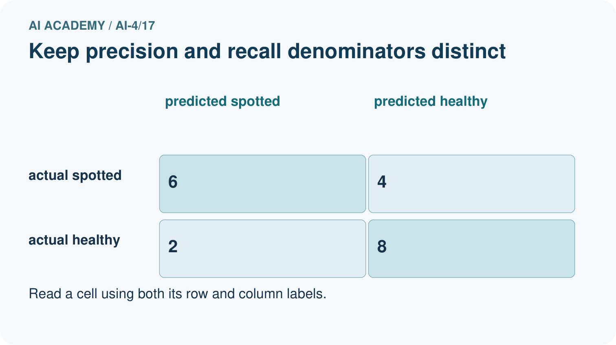
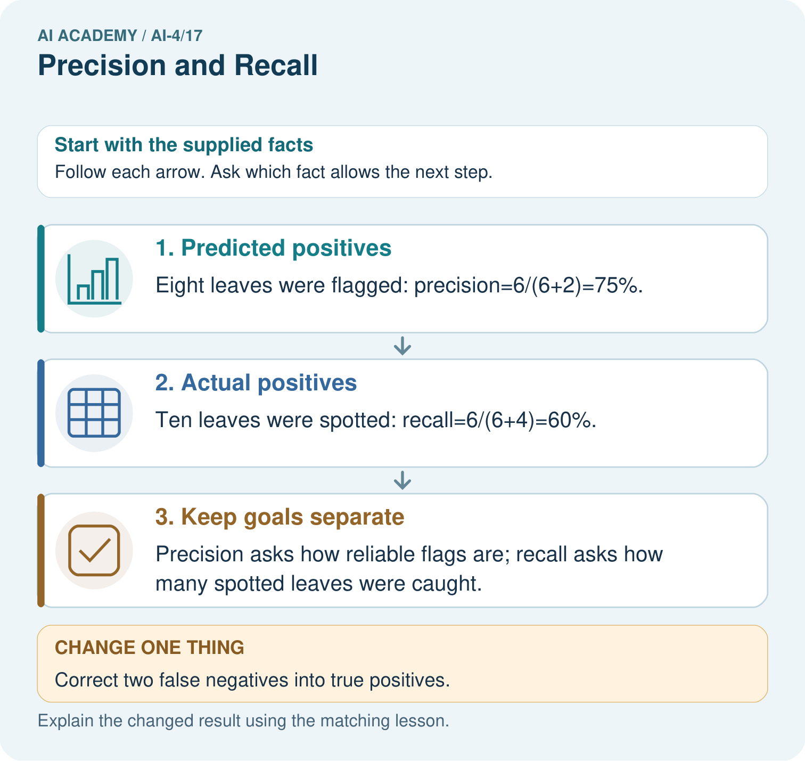
Were the original precision and recall denominators the same? Point to the relevant step in the picture, then write the changed result and the rule or evidence that supports it.

My picture-based explanation and changed-case prediction
________________________________________________________________
________________________________________________________________
________________________________________________________________
________________________________________________________________
________________________________________________________________
________________________________________________________________
Support used: alone / hint / worked example. This record is practice evidence.
Project connection: For your Responsible Plant Classifier, save the input, procedure, observed result and limitation of this check. Label this worked example as practice; use a different, previously unreviewed case when checking independent understanding.

19. Project portfolio milestone
Project: Responsible Plant Classifier
Current milestone: Test changed cases. Keep normal, boundary and failure cases; compare expected and observed results.
For your Responsible Plant Classifier, save the input, procedure, observed result and limitation of this check. Label this worked example as practice; use a different, previously unreviewed case when checking independent understanding.
Evidence to keep | My record
This week’s input and deciding step
Prediction and actual result (or labelled paper trace)
One change since the previous checkpoint and why
One error or limit and the next test

Explain what this week adds to your project. Reuse last week’s record rather than starting again.
________________________________________________________________
________________________________________________________________
________________________________________________________________
________________________________________________________________
________________________________________________________________

