AI ACADEMY · WORKBOOK · ai-4/20

Mean, Median, and Baselines
Project: Responsible Plant Classifier

01. Recall and choose your starting point
Try the recall before opening notes. Then use a different colour or a labelled second line to correct your explanation.

Regression and Residuals
Without opening the old lesson, explain one key idea from Regression and Residuals. Give an example and a mistake that the idea helps you avoid.

My remembered idea, example and correction
________________________________________________________________
________________________________________________________________
________________________________________________________________

Precision and Recall
Without opening the old lesson, explain one key idea from Precision and Recall. Give an example and a mistake that the idea helps you avoid.

My remembered idea, example and correction
________________________________________________________________
________________________________________________________________
________________________________________________________________

Scores and Calibration Intuition
Without opening the old lesson, explain one key idea from Scores and Calibration Intuition. Give an example and a mistake that the idea helps you avoid.

My remembered idea, example and correction
________________________________________________________________
________________________________________________________________
________________________________________________________________

02. Practise with fading help
Use W2: Score separately for Constant prediction baselines. Record the answer once; the lesson and workbook refer to the same attempt.
Given inputs | Procedure I chose | Middle steps | Result and check

The step I completed without help, and the hint I needed
________________________________________________________________
________________________________________________________________
________________________________________________________________

03. Individual reasoning check
Use the worked case for Constant prediction baselines. Proposed explanation: “A final answer is enough”. Decide whether this explanation is supported. Point to the step or supplied fact that decides; explain your repair if needed.

My explanation before partner discussion
________________________________________________________________
________________________________________________________________
________________________________________________________________
________________________________________________________________

04. Independent transfer case

Independent case: Apply independently
Training [1, 3, 5, 15], evaluation [3, 9]. Fit both constants and calculate MAE.

My independent explanation, trace and limits
________________________________________________________________
________________________________________________________________
________________________________________________________________
________________________________________________________________
________________________________________________________________
________________________________________________________________
________________________________________________________________
Attempt this case before feedback. Record any help. Earlier examples below are further practice; a case already practised with feedback cannot establish fresh transfer.

05. Your learning target
For training targets [1,3,11], compute mean and median constant baselines. Compare total absolute training error for each. Where must final performance be measured?

06. Solve the given case
Training heights are 2,4,12 cm. Compare constant mean and median baselines.
Compute both and training absolute errors.
Show your trace, calculation or evidence

Write or draw your reasoning and evidence.
________________________________________________________________
________________________________________________________________
________________________________________________________________
________________________________________________________________
________________________________________________________________

07. Check a changed case
For training heights 2, 3 and 10 cm, calculate mean and median. Which constant is less influenced by the high value?
My independent answer and reason

Write or draw your reasoning and evidence.
________________________________________________________________
________________________________________________________________
________________________________________________________________
________________________________________________________________
________________________________________________________________

Week 20 Test and reflect

08. Design a revealing test
Create a changed input, boundary case or missing-information case. Write the expected answer or safe response before testing.
Test record | My evidence
Changed input or condition
Expected answer or fallback
Observed result
Why the result occurred

09. Project checkpoint
Document any numeric baseline used in Plant Classifier feature checks, including unit, distribution, and outlier decision.
The project change and evidence I will keep

Write or draw your reasoning and evidence.
________________________________________________________________
________________________________________________________________
________________________________________________________________
________________________________________________________________
________________________________________________________________

10. Self check
I can explain the mechanism. I can show evidence. I can handle a changed case. I can name a limit. Mark each as not yet, with help or independently, and attach supporting work.
Teacher review ____________________ Next step ____________________

11. Transfer practice from the original programme
For training targets [1,3,11], compute mean and median constant baselines. Compare total absolute training error for each. Where must final performance be measured?

My independently reasoned answer
________________________________________________________________
________________________________________________________________
________________________________________________________________
________________________________________________________________
________________________________________________________________
________________________________________________________________
________________________________________________________________
Record support used: none, hint or teacher explanation.

12. W1 Fit two constants
Find the mean and median of the worked training targets.

My reasoning and evidence
________________________________________________________________
________________________________________________________________
________________________________________________________________
________________________________________________________________
________________________________________________________________
________________________________________________________________

13. W2 Score separately
Calculate MAE for both baselines on [4, 8].

My reasoning and evidence
________________________________________________________________
________________________________________________________________
________________________________________________________________
________________________________________________________________
________________________________________________________________
________________________________________________________________

14. W3 Inspect an extreme value
Replace 12 by 40. What changes?

My reasoning and evidence
________________________________________________________________
________________________________________________________________
________________________________________________________________
________________________________________________________________
________________________________________________________________
________________________________________________________________

15. W4 Apply independently
Training [1, 3, 5, 15], evaluation [3, 9]. Fit both constants and calculate MAE.

My reasoning and evidence
________________________________________________________________
________________________________________________________________
________________________________________________________________
________________________________________________________________
________________________________________________________________
________________________________________________________________
________________________________________________________________
________________________________________________________________

16. W5 Prevent leakage
Why not predict the evaluation mean as the baseline?

My reasoning and evidence
________________________________________________________________
________________________________________________________________
________________________________________________________________
________________________________________________________________
________________________________________________________________
________________________________________________________________

17. Feedback, return check and learning record
Evidence | My record
Worked alone / hint / model
First step I repaired and why
New case checked later; date and result
What I can now explain without notes
One remaining question
Revisit this idea with your teacher after a delay. Familiarity is different from explaining and using it on a changed case.

18. Pictorial case practice: Mean, Median, and Baselines
Fit two constant height baselines and compare them on held-out examples.
Training heights [2, 4, 6, 20] cm. Evaluation heights [4, 10] cm. Fit constants only from training.
All inputs and outcomes in this worked example are invented classroom data; no real model run is claimed.
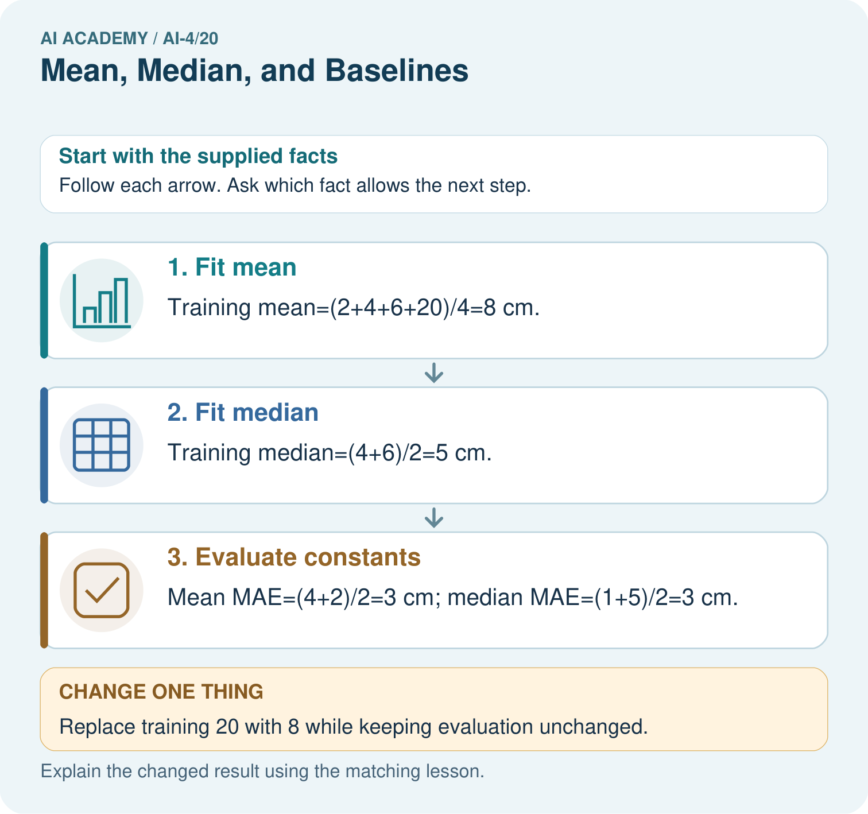
Does either original baseline win under evaluation MAE? Point to the relevant step in the picture, then write the changed result and the rule or evidence that supports it.

My picture-based explanation and changed-case prediction
________________________________________________________________
________________________________________________________________
________________________________________________________________
________________________________________________________________
________________________________________________________________
________________________________________________________________
Support used: alone / hint / worked example. This record is practice evidence.
Project connection: For your Responsible Plant Classifier, save the input, procedure, observed result and limitation of this check. Label this worked example as practice; use a different, previously unreviewed case when checking independent understanding.

19. Project portfolio milestone
Project: Responsible Plant Classifier
Current milestone: Evaluate and revise. Compare with your starting method, explain errors and record a justified revision.
For your Responsible Plant Classifier, save the input, procedure, observed result and limitation of this check. Label this worked example as practice; use a different, previously unreviewed case when checking independent understanding.
Evidence to keep | My record
This week’s input and deciding step
Prediction and actual result (or labelled paper trace)
One change since the previous checkpoint and why
One error or limit and the next test

Explain what this week adds to your project. Reuse last week’s record rather than starting again.
________________________________________________________________
________________________________________________________________
________________________________________________________________
________________________________________________________________
________________________________________________________________

