AI ACADEMY · WORKBOOK · ai-4/21

Absolute Error and MAE
Project: Responsible Plant Classifier

01. Recall and choose your starting point
Try the recall before opening notes. Then use a different colour or a labelled second line to correct your explanation.

Mean, Median, and Baselines
Without opening the old lesson, explain one key idea from Mean, Median, and Baselines. Give an example and a mistake that the idea helps you avoid.

My remembered idea, example and correction
________________________________________________________________
________________________________________________________________
________________________________________________________________

Error Analysis
Without opening the old lesson, explain one key idea from Error Analysis. Give an example and a mistake that the idea helps you avoid.

My remembered idea, example and correction
________________________________________________________________
________________________________________________________________
________________________________________________________________

Confusion Matrix
Without opening the old lesson, explain one key idea from Confusion Matrix. Give an example and a mistake that the idea helps you avoid.

My remembered idea, example and correction
________________________________________________________________
________________________________________________________________
________________________________________________________________

02. Practise with fading help
Use W2: Compute squared loss for Absolute and squared loss. Record the answer once; the lesson and workbook refer to the same attempt.
Given inputs | Procedure I chose | Middle steps | Result and check

The step I completed without help, and the hint I needed
________________________________________________________________
________________________________________________________________
________________________________________________________________

03. Individual reasoning check
Use the worked case for Absolute and squared loss. Proposed explanation: “A final answer is enough”. Decide whether this explanation is supported. Point to the step or supplied fact that decides; explain your repair if needed.

My explanation before partner discussion
________________________________________________________________
________________________________________________________________
________________________________________________________________
________________________________________________________________

04. Independent transfer case

Independent case: Apply independently
Residuals [-2, 0, 4] m: calculate MAE MSE RMSE and the result of converting to cm.

My independent explanation, trace and limits
________________________________________________________________
________________________________________________________________
________________________________________________________________
________________________________________________________________
________________________________________________________________
________________________________________________________________
________________________________________________________________
Attempt this case before feedback. Record any help. Earlier examples below are further practice; a case already practised with feedback cannot establish fresh transfer.

05. Your learning target
Actual=[3,8,10], predicted=[5,5,11]. Compute signed residuals and MAE. A student averages residuals and gets zero; is that MAE?

06. Solve the given case
Actual=[3,5,9], predicted=[2,7,6] cm.
Calculate MAE.
Show your trace, calculation or evidence

Write or draw your reasoning and evidence.
________________________________________________________________
________________________________________________________________
________________________________________________________________
________________________________________________________________
________________________________________________________________

07. Check a changed case
Actual heights are 4, 8 and 10 cm; predictions are 5, 6 and 13 cm. Calculate absolute errors and MAE.
My independent answer and reason

Write or draw your reasoning and evidence.
________________________________________________________________
________________________________________________________________
________________________________________________________________
________________________________________________________________
________________________________________________________________

Week 21 Test and reflect

08. Design a revealing test
Create a changed input, boundary case or missing-information case. Write the expected answer or safe response before testing.
Test record | My evidence
Changed input or condition
Expected answer or fallback
Observed result
Why the result occurred

09. Project checkpoint
Use MAE correctly in the optional growth model; keep classifier and regression metrics clearly separated.
The project change and evidence I will keep

Write or draw your reasoning and evidence.
________________________________________________________________
________________________________________________________________
________________________________________________________________
________________________________________________________________
________________________________________________________________

10. Self check
I can explain the mechanism. I can show evidence. I can handle a changed case. I can name a limit. Mark each as not yet, with help or independently, and attach supporting work.
Teacher review ____________________ Next step ____________________

11. Transfer practice from the original programme
Actual=[3,8,10], predicted=[5,5,11]. Compute signed residuals and MAE. A student averages residuals and gets zero; is that MAE?

My independently reasoned answer
________________________________________________________________
________________________________________________________________
________________________________________________________________
________________________________________________________________
________________________________________________________________
________________________________________________________________
________________________________________________________________
Record support used: none, hint or teacher explanation.

12. W1 Compute MAE
Calculate MAE for the worked residuals.

My reasoning and evidence
________________________________________________________________
________________________________________________________________
________________________________________________________________
________________________________________________________________
________________________________________________________________
________________________________________________________________

13. W2 Compute squared loss
Give MSE and RMSE with units.

My reasoning and evidence
________________________________________________________________
________________________________________________________________
________________________________________________________________
________________________________________________________________
________________________________________________________________
________________________________________________________________

14. W3 Compare patterns
Why do [0, 0, 6] and [2, 2, 2] have equal MAE but unequal MSE?

My reasoning and evidence
________________________________________________________________
________________________________________________________________
________________________________________________________________
________________________________________________________________
________________________________________________________________
________________________________________________________________

15. W4 Apply independently
Residuals [-2, 0, 4] m: calculate MAE MSE RMSE and the result of converting to cm.

My reasoning and evidence
________________________________________________________________
________________________________________________________________
________________________________________________________________
________________________________________________________________
________________________________________________________________
________________________________________________________________
________________________________________________________________
________________________________________________________________

16. W5 Choose honestly
A team switches from MSE to MAE only after seeing a bad large error. What should be reported?

My reasoning and evidence
________________________________________________________________
________________________________________________________________
________________________________________________________________
________________________________________________________________
________________________________________________________________
________________________________________________________________

17. Feedback, return check and learning record
Evidence | My record
Worked alone / hint / model
First step I repaired and why
New case checked later; date and result
What I can now explain without notes
One remaining question
Revisit this idea with your teacher after a delay. Familiarity is different from explaining and using it on a changed case.

18. Pictorial case practice: Absolute Error and MAE
Compare absolute and squared error without losing track of units.
Residuals are [-1, 2, 3] cm. Use MAE=mean absolute residual and MSE=mean squared residual.
All inputs and outcomes in this worked example are invented classroom data; no real model run is claimed.
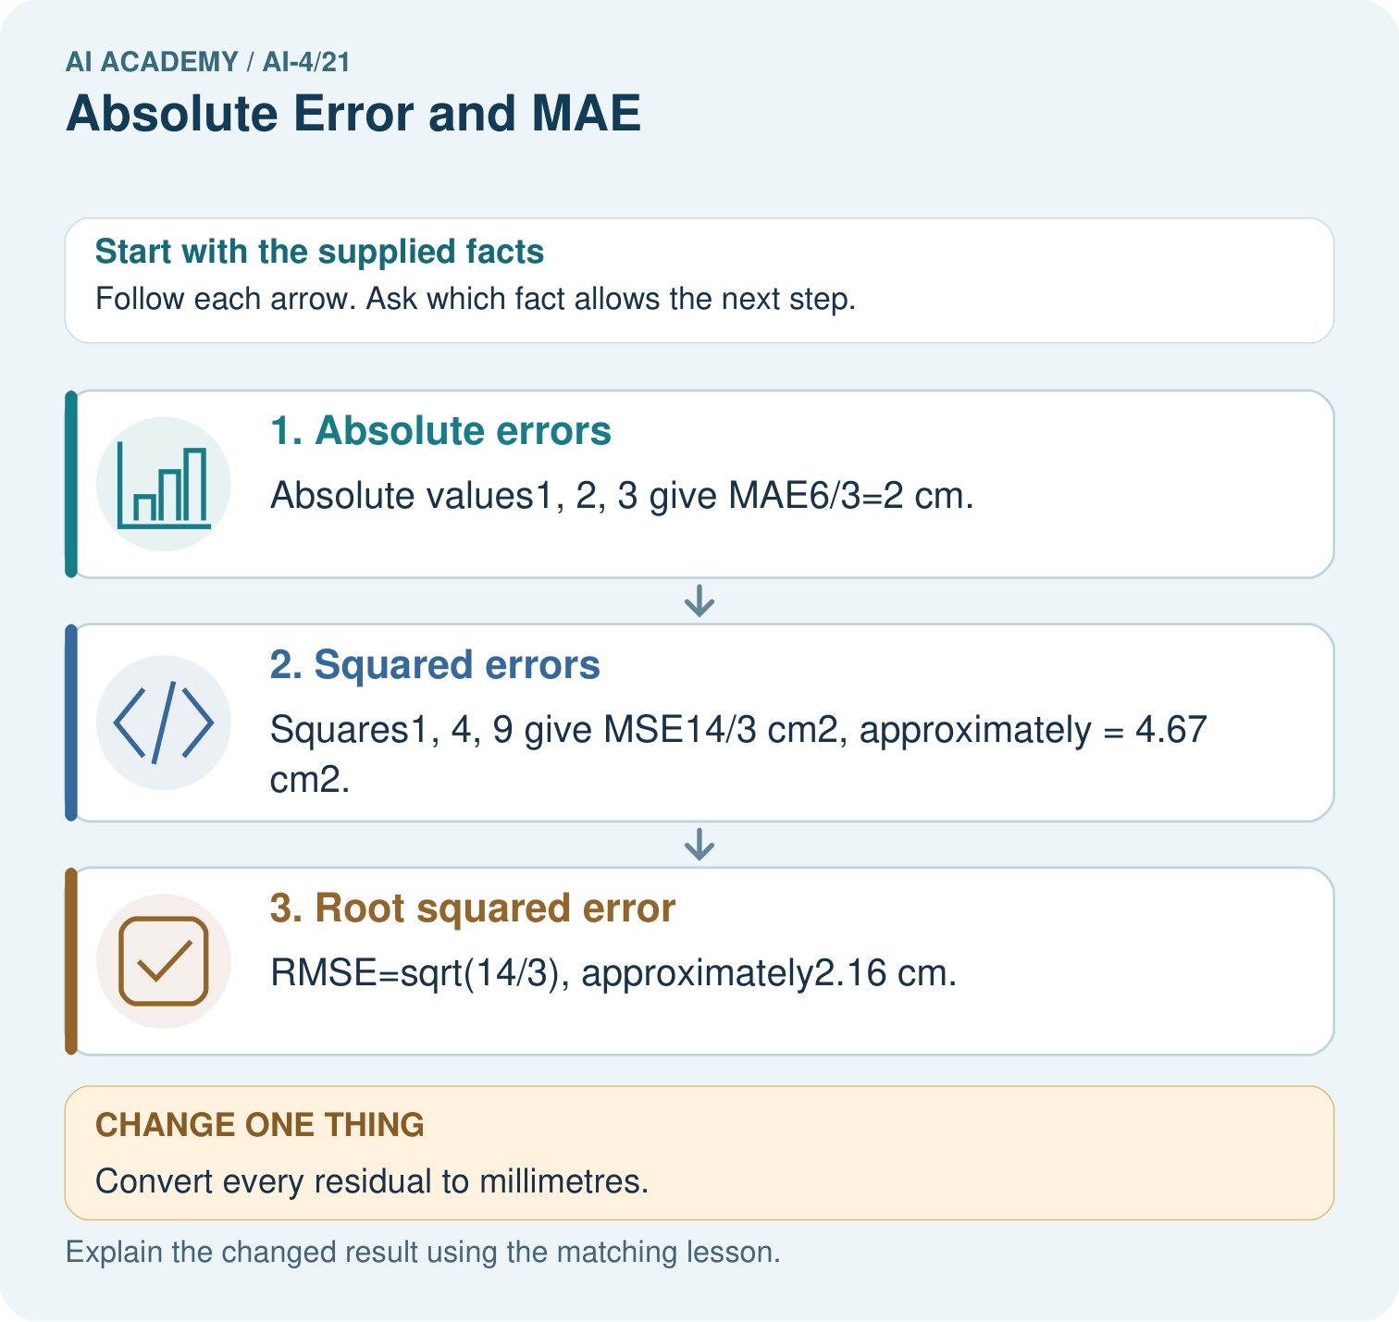
Why is quoting MSE as4.67 cm misleading? Point to the relevant step in the picture, then write the changed result and the rule or evidence that supports it.

My picture-based explanation and changed-case prediction
________________________________________________________________
________________________________________________________________
________________________________________________________________
________________________________________________________________
________________________________________________________________
________________________________________________________________
Support used: alone / hint / worked example. This record is practice evidence.
Project connection: For your Responsible Plant Classifier, save the input, procedure, observed result and limitation of this check. Label this worked example as practice; use a different, previously unreviewed case when checking independent understanding.

19. Project portfolio milestone
Project: Responsible Plant Classifier
Current milestone: Evaluate and revise. Compare with your starting method, explain errors and record a justified revision.
For your Responsible Plant Classifier, save the input, procedure, observed result and limitation of this check. Label this worked example as practice; use a different, previously unreviewed case when checking independent understanding.
Evidence to keep | My record
This week’s input and deciding step
Prediction and actual result (or labelled paper trace)
One change since the previous checkpoint and why
One error or limit and the next test

Explain what this week adds to your project. Reuse last week’s record rather than starting again.
________________________________________________________________
________________________________________________________________
________________________________________________________________
________________________________________________________________
________________________________________________________________

