AI ACADEMY · WORKBOOK · ai-4/23

Hold Out Test Data
Project: Responsible Plant Classifier

01. Recall and choose your starting point
Try the recall before opening notes. Then use a different colour or a labelled second line to correct your explanation.

Train a Regression Model
Without opening the old lesson, explain one key idea from Train a Regression Model. Give an example and a mistake that the idea helps you avoid.

My remembered idea, example and correction
________________________________________________________________
________________________________________________________________
________________________________________________________________

Mean, Median, and Baselines
Without opening the old lesson, explain one key idea from Mean, Median, and Baselines. Give an example and a mistake that the idea helps you avoid.

My remembered idea, example and correction
________________________________________________________________
________________________________________________________________
________________________________________________________________

Precision and Recall
Without opening the old lesson, explain one key idea from Precision and Recall. Give an example and a mistake that the idea helps you avoid.

My remembered idea, example and correction
________________________________________________________________
________________________________________________________________
________________________________________________________________

02. Practise with fading help
Use W2: Compare a baseline for Final testing and honest claims. Record the answer once; the lesson and workbook refer to the same attempt.
Given inputs | Procedure I chose | Middle steps | Result and check

The step I completed without help, and the hint I needed
________________________________________________________________
________________________________________________________________
________________________________________________________________

03. Individual reasoning check
Use the worked case for Final testing and honest claims. Proposed explanation: “A final answer is enough”. Decide whether this explanation is supported. Point to the step or supplied fact that decides; explain your repair if needed.

My explanation before partner discussion
________________________________________________________________
________________________________________________________________
________________________________________________________________
________________________________________________________________

04. Independent transfer case

Independent case: Apply independently
A new frozen test has TN 7 FP 1 FN 2 TP 2. Calculate accuracy, precision and recall and state a bounded claim.

My independent explanation, trace and limits
________________________________________________________________
________________________________________________________________
________________________________________________________________
________________________________________________________________
________________________________________________________________
________________________________________________________________
________________________________________________________________
Attempt this case before feedback. Record any help. Earlier examples below are further practice; a case already practised with feedback cannot establish fresh transfer.

05. Your learning target
After seeing test errors, a team adjusts its threshold and reports the improved score on that same test. Rename the set's role and describe an honest final report if no new data exists.

06. Solve the given case
A final-test folder has twenty leaves; its labels are opened weekly to choose models.
Is it still untouched?
Show your trace, calculation or evidence

Write or draw your reasoning and evidence.
________________________________________________________________
________________________________________________________________
________________________________________________________________
________________________________________________________________
________________________________________________________________

07. Check a changed case
You inspect final test failures, change features to fix them and report the new score on that same test set as untouched. What is wrong?
My independent answer and reason

Write or draw your reasoning and evidence.
________________________________________________________________
________________________________________________________________
________________________________________________________________
________________________________________________________________
________________________________________________________________

Week 23 Test and reflect

08. Design a revealing test
Create a changed input, boundary case or missing-information case. Write the expected answer or safe response before testing.
Test record | My evidence
Changed input or condition
Expected answer or fallback
Observed result
Why the result occurred

09. Project checkpoint
Seal the Plant Classifier final test IDs and labels; record who may open them and at which release gate.
The project change and evidence I will keep

Write or draw your reasoning and evidence.
________________________________________________________________
________________________________________________________________
________________________________________________________________
________________________________________________________________
________________________________________________________________

10. Self check
I can explain the mechanism. I can show evidence. I can handle a changed case. I can name a limit. Mark each as not yet, with help or independently, and attach supporting work.
Teacher review ____________________ Next step ____________________

11. Transfer practice from the original programme
After seeing test errors, a team adjusts its threshold and reports the improved score on that same test. Rename the set's role and describe an honest final report if no new data exists.

My independently reasoned answer
________________________________________________________________
________________________________________________________________
________________________________________________________________
________________________________________________________________
________________________________________________________________
________________________________________________________________
________________________________________________________________
Record support used: none, hint or teacher explanation.

12. W1 Calculate a final report
Calculate the worked accuracy, precision and recall with denominators.

My reasoning and evidence
________________________________________________________________
________________________________________________________________
________________________________________________________________
________________________________________________________________
________________________________________________________________
________________________________________________________________

13. W2 Compare a baseline
Why does 75 percent versus 70 percent not settle deployment?

My reasoning and evidence
________________________________________________________________
________________________________________________________________
________________________________________________________________
________________________________________________________________
________________________________________________________________
________________________________________________________________

14. W3 Handle a revision
The team changes a threshold after reading test errors. How should it label later results?

My reasoning and evidence
________________________________________________________________
________________________________________________________________
________________________________________________________________
________________________________________________________________
________________________________________________________________
________________________________________________________________

15. W4 Apply independently
A new frozen test has TN 7 FP 1 FN 2 TP 2. Calculate accuracy, precision and recall and state a bounded claim.

My reasoning and evidence
________________________________________________________________
________________________________________________________________
________________________________________________________________
________________________________________________________________
________________________________________________________________
________________________________________________________________
________________________________________________________________
________________________________________________________________

16. W5 Report a failure
One planned case returns no prediction. What must the report retain?

My reasoning and evidence
________________________________________________________________
________________________________________________________________
________________________________________________________________
________________________________________________________________
________________________________________________________________
________________________________________________________________

17. Feedback, return check and learning record
Evidence | My record
Worked alone / hint / model
First step I repaired and why
New case checked later; date and result
What I can now explain without notes
One remaining question
Revisit this idea with your teacher after a delay. Familiarity is different from explaining and using it on a changed case.

18. Pictorial case practice: Hold Out Test Data
Open the final hold-out only after recording the frozen model choice.
Frozen plant classifier evaluates12 new grouped leaves: TP 3, FN 1, FP 2, TN 6. Positive means spotted.
All inputs and outcomes in this worked example are invented classroom data; no real model run is claimed.
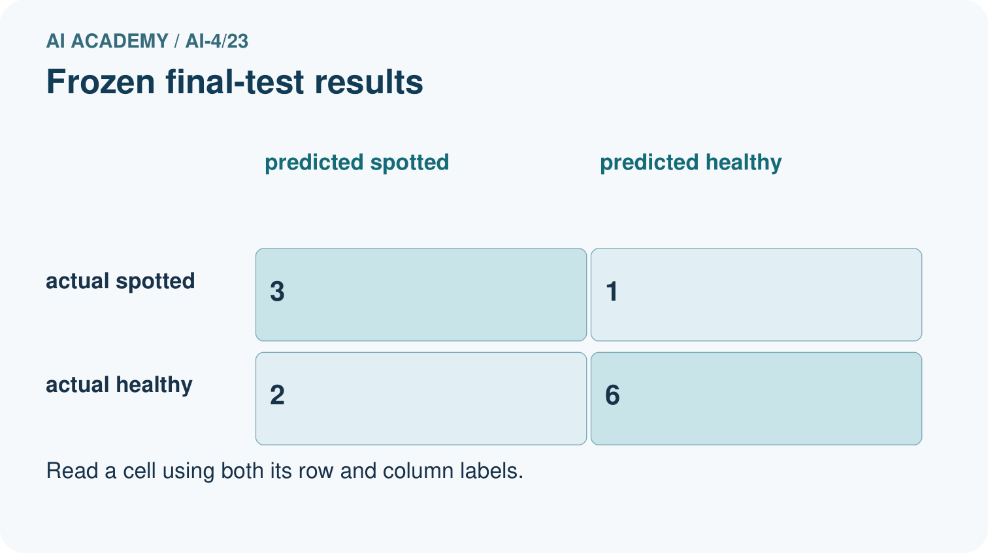
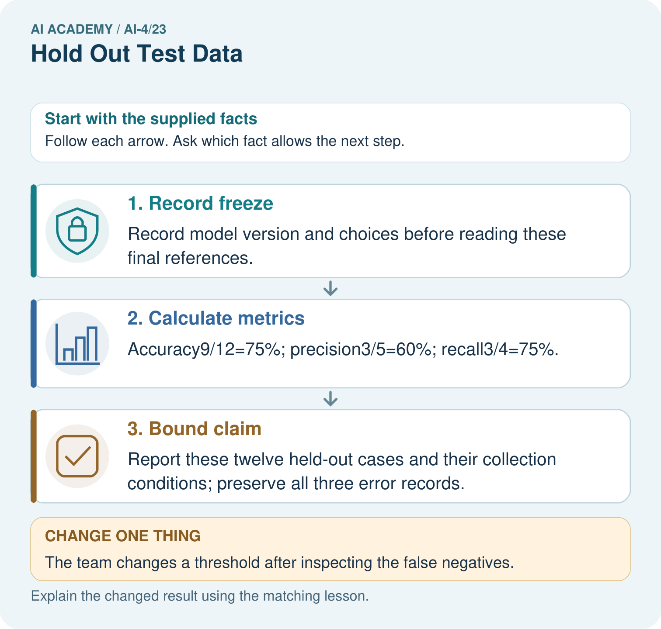
What is needed for an honest final claim about the revised version? Point to the relevant step in the picture, then write the changed result and the rule or evidence that supports it.

My picture-based explanation and changed-case prediction
________________________________________________________________
________________________________________________________________
________________________________________________________________
________________________________________________________________
________________________________________________________________
________________________________________________________________
Support used: alone / hint / worked example. This record is practice evidence.
Project connection: For your Responsible Plant Classifier, save the input, procedure, observed result and limitation of this check. Label this worked example as practice; use a different, previously unreviewed case when checking independent understanding.

19. Project portfolio milestone
Project: Responsible Plant Classifier
Current milestone: Evaluate and revise. Compare with your starting method, explain errors and record a justified revision.
For your Responsible Plant Classifier, save the input, procedure, observed result and limitation of this check. Label this worked example as practice; use a different, previously unreviewed case when checking independent understanding.
Evidence to keep | My record
This week’s input and deciding step
Prediction and actual result (or labelled paper trace)
One change since the previous checkpoint and why
One error or limit and the next test

Explain what this week adds to your project. Reuse last week’s record rather than starting again.
________________________________________________________________
________________________________________________________________
________________________________________________________________
________________________________________________________________
________________________________________________________________

