AI ACADEMY · WORKBOOK · ai-4/33

Model Cards and Human Review
Project: Responsible Plant Classifier

01. Recall and choose your starting point
Try the recall before opening notes. Then use a different colour or a labelled second line to correct your explanation.

Proxy Features and Fairness
Without opening the old lesson, explain one key idea from Proxy Features and Fairness. Give an example and a mistake that the idea helps you avoid.

My remembered idea, example and correction
________________________________________________________________
________________________________________________________________
________________________________________________________________

Improve Generalization
Without opening the old lesson, explain one key idea from Improve Generalization. Give an example and a mistake that the idea helps you avoid.

My remembered idea, example and correction
________________________________________________________________
________________________________________________________________
________________________________________________________________

Overfitting
Without opening the old lesson, explain one key idea from Overfitting. Give an example and a mistake that the idea helps you avoid.

My remembered idea, example and correction
________________________________________________________________
________________________________________________________________
________________________________________________________________

02. Practise with fading help
Use W2: Check arithmetic for Model cards and review. Record the answer once; the lesson and workbook refer to the same attempt.
Given inputs | Procedure I chose | Middle steps | Result and check

The step I completed without help, and the hint I needed
________________________________________________________________
________________________________________________________________
________________________________________________________________

03. Individual reasoning check
Use the worked case for Model cards and review. Proposed explanation: “A final answer is enough”. Decide whether this explanation is supported. Point to the step or supplied fact that decides; explain your repair if needed.

My explanation before partner discussion
________________________________________________________________
________________________________________________________________
________________________________________________________________
________________________________________________________________

04. Independent transfer case

Independent case: Apply independently
Review this card: model v 2, 90 percent accurate, works for every school. No dataset size, split or baseline is given. Write a correction request with a bounded replacement claim.

My independent explanation, trace and limits
________________________________________________________________
________________________________________________________________
________________________________________________________________
________________________________________________________________
________________________________________________________________
________________________________________________________________
________________________________________________________________
Attempt this case before feedback. Record any help. Earlier examples below are further practice; a case already practised with feedback cannot establish fresh transfer.

05. Your learning target
Draft five model-card headings for a classroom leaf classifier. Why must the card state that its labels are classroom categories rather than professional plant diagnosis?

06. Solve the given case
A model card says healthy/spotted,80% accuracy only.
Add responsible-use evidence.
Show your trace, calculation or evidence

Write or draw your reasoning and evidence.
________________________________________________________________
________________________________________________________________
________________________________________________________________
________________________________________________________________
________________________________________________________________

07. Check a changed case
A model card says 90% accuracy but gives no intended use, data conditions or human-review rule. What should be added before classroom use?
My independent answer and reason

Write or draw your reasoning and evidence.
________________________________________________________________
________________________________________________________________
________________________________________________________________
________________________________________________________________
________________________________________________________________

Week 33 Test and reflect

08. Design a revealing test
Create a changed input, boundary case or missing-information case. Write the expected answer or safe response before testing.
Test record | My evidence
Changed input or condition
Expected answer or fallback
Observed result
Why the result occurred

09. Project checkpoint
Complete the Plant Classifier model card and require teacher sign-off before any classroom demonstration.
The project change and evidence I will keep

Write or draw your reasoning and evidence.
________________________________________________________________
________________________________________________________________
________________________________________________________________
________________________________________________________________
________________________________________________________________

10. Self check
I can explain the mechanism. I can show evidence. I can handle a changed case. I can name a limit. Mark each as not yet, with help or independently, and attach supporting work.
Teacher review ____________________ Next step ____________________

11. Transfer practice from the original programme
Draft five model-card headings for a classroom leaf classifier. Why must the card state that its labels are classroom categories rather than professional plant diagnosis?

My independently reasoned answer
________________________________________________________________
________________________________________________________________
________________________________________________________________
________________________________________________________________
________________________________________________________________
________________________________________________________________
________________________________________________________________
Record support used: none, hint or teacher explanation.

12. W1 Draft a purpose
Write an intended-use and non-use statement for the worked card.

My reasoning and evidence
________________________________________________________________
________________________________________________________________
________________________________________________________________
________________________________________________________________
________________________________________________________________
________________________________________________________________

13. W2 Check arithmetic
Verify the worked accuracy, precision and recall.

My reasoning and evidence
________________________________________________________________
________________________________________________________________
________________________________________________________________
________________________________________________________________
________________________________________________________________
________________________________________________________________

14. W3 Find missing evidence
A card says fair and reliable but provides only accuracy. Request three additions.

My reasoning and evidence
________________________________________________________________
________________________________________________________________
________________________________________________________________
________________________________________________________________
________________________________________________________________
________________________________________________________________

15. W4 Apply independently
Review this card: model v 2, 90 percent accurate, works for every school. No dataset size, split or baseline is given. Write a correction request with a bounded replacement claim.

My reasoning and evidence
________________________________________________________________
________________________________________________________________
________________________________________________________________
________________________________________________________________
________________________________________________________________
________________________________________________________________
________________________________________________________________
________________________________________________________________

16. W5 Maintain the record
What should change in a card after a threshold revision?

My reasoning and evidence
________________________________________________________________
________________________________________________________________
________________________________________________________________
________________________________________________________________
________________________________________________________________
________________________________________________________________

17. Feedback, return check and learning record
Evidence | My record
Worked alone / hint / model
First step I repaired and why
New case checked later; date and result
What I can now explain without notes
One remaining question
Revisit this idea with your teacher after a delay. Familiarity is different from explaining and using it on a changed case.

18. Pictorial case practice: Model Cards and Human Review
Write a model card whose performance statement can be traced to a concrete evaluation.
Toy v = 3 classifier scored16/20 on five unseen plants with four views each, under indoor tablet lighting. Baseline scored14/20.
All inputs and outcomes in this worked example are invented classroom data; no real model run is claimed.
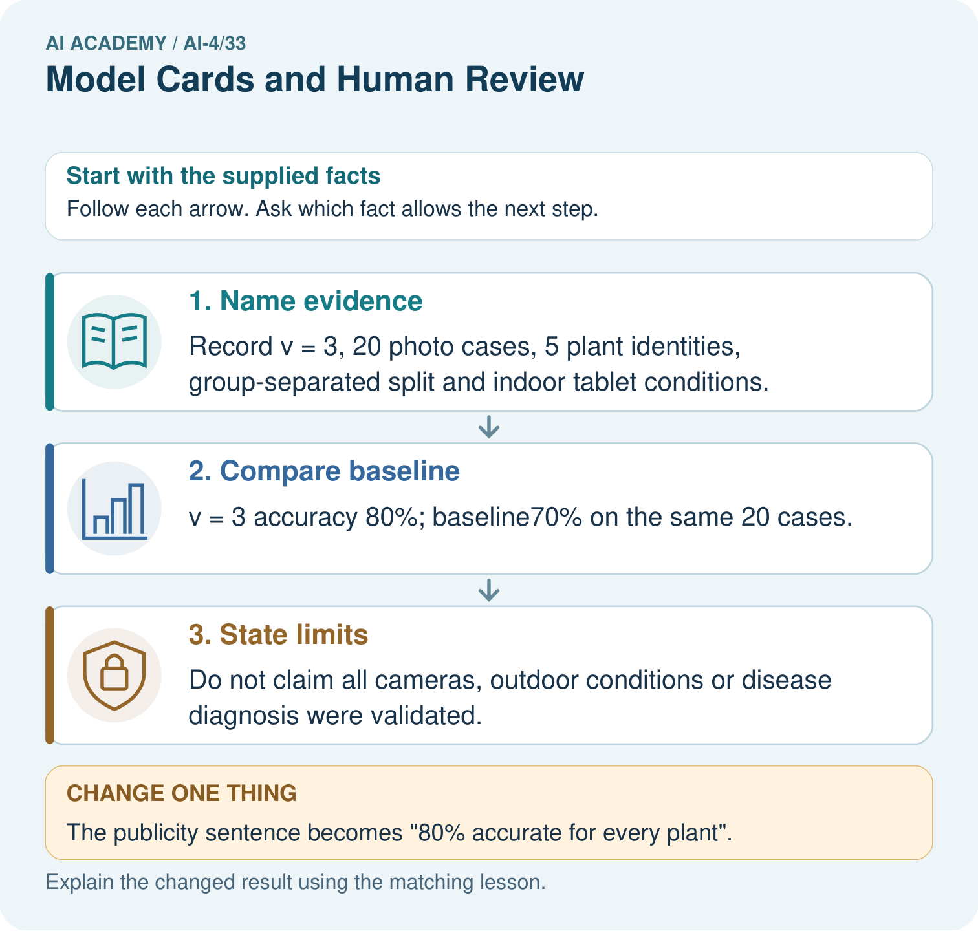
Write a bounded replacement for the publicity sentence. Point to the relevant step in the picture, then write the changed result and the rule or evidence that supports it.

My picture-based explanation and changed-case prediction
________________________________________________________________
________________________________________________________________
________________________________________________________________
________________________________________________________________
________________________________________________________________
________________________________________________________________
Support used: alone / hint / worked example. This record is practice evidence.
Project connection: For your Responsible Plant Classifier, save the input, procedure, observed result and limitation of this check. Label this worked example as practice; use a different, previously unreviewed case when checking independent understanding.

19. Project portfolio milestone
Project: Responsible Plant Classifier
Current milestone: Present and defend. Demonstrate the system, explain one failure and justify the next improvement with evidence.
For your Responsible Plant Classifier, save the input, procedure, observed result and limitation of this check. Label this worked example as practice; use a different, previously unreviewed case when checking independent understanding.
Evidence to keep | My record
This week’s input and deciding step
Prediction and actual result (or labelled paper trace)
One change since the previous checkpoint and why
One error or limit and the next test

Explain what this week adds to your project. Reuse last week’s record rather than starting again.
________________________________________________________________
________________________________________________________________
________________________________________________________________
________________________________________________________________
________________________________________________________________

