AI ACADEMY · WORKBOOK · ai-4/34

Capstone Dataset and Baseline
Project: Responsible Plant Classifier

01. Recall and choose your starting point
Try the recall before opening notes. Then use a different colour or a labelled second line to correct your explanation.

Model Cards and Human Review
Without opening the old lesson, explain one key idea from Model Cards and Human Review. Give an example and a mistake that the idea helps you avoid.

My remembered idea, example and correction
________________________________________________________________
________________________________________________________________
________________________________________________________________

Subgroup Performance
Without opening the old lesson, explain one key idea from Subgroup Performance. Give an example and a mistake that the idea helps you avoid.

My remembered idea, example and correction
________________________________________________________________
________________________________________________________________
________________________________________________________________

Learning Curves
Without opening the old lesson, explain one key idea from Learning Curves. Give an example and a mistake that the idea helps you avoid.

My remembered idea, example and correction
________________________________________________________________
________________________________________________________________
________________________________________________________________

02. Practise with fading help
Use W2: Define fields for Capstone data and requirements. Record the answer once; the lesson and workbook refer to the same attempt.
Given inputs | Procedure I chose | Middle steps | Result and check

The step I completed without help, and the hint I needed
________________________________________________________________
________________________________________________________________
________________________________________________________________

03. Individual reasoning check
Use the worked case for Capstone data and requirements. Proposed explanation: “A final answer is enough”. Decide whether this explanation is supported. Point to the step or supplied fact that decides; explain your repair if needed.

My explanation before partner discussion
________________________________________________________________
________________________________________________________________
________________________________________________________________
________________________________________________________________

04. Independent transfer case

Independent case: Apply independently
A proposed 80-row dataset has 40 related pairs, and the team splits individual rows randomly then uses pair ID as a feature. Revise its plan.

My independent explanation, trace and limits
________________________________________________________________
________________________________________________________________
________________________________________________________________
________________________________________________________________
________________________________________________________________
________________________________________________________________
________________________________________________________________
Attempt this case before feedback. Record any help. Earlier examples below are further practice; a case already practised with feedback cannot establish fresh transfer.

05. Your learning target
A capstone has two views of each of 40 leaves. Specify a 24/8/8 leaf split and baseline procedure. When may final labels be consulted?

06. Solve the given case
Capstone has60 independent leaves, several photos per leaf, healthy/spotted labels.
Plan grouping and baseline.
Show your trace, calculation or evidence

Write or draw your reasoning and evidence.
________________________________________________________________
________________________________________________________________
________________________________________________________________
________________________________________________________________
________________________________________________________________

07. Check a changed case
Your capstone dataset includes duplicate photographs in both training and validation. What should be repaired before measuring the baseline?
My independent answer and reason

Write or draw your reasoning and evidence.
________________________________________________________________
________________________________________________________________
________________________________________________________________
________________________________________________________________
________________________________________________________________

Week 34 Test and reflect

08. Design a revealing test
Create a changed input, boundary case or missing-information case. Write the expected answer or safe response before testing.
Test record | My evidence
Changed input or condition
Expected answer or fallback
Observed result
Why the result occurred

09. Project checkpoint
Publish the frozen Plant Classifier design-and-data bundle with version IDs and approval record.
The project change and evidence I will keep

Write or draw your reasoning and evidence.
________________________________________________________________
________________________________________________________________
________________________________________________________________
________________________________________________________________
________________________________________________________________

10. Self check
I can explain the mechanism. I can show evidence. I can handle a changed case. I can name a limit. Mark each as not yet, with help or independently, and attach supporting work.
Teacher review ____________________ Next step ____________________

11. Transfer practice from the original programme
A capstone has two views of each of 40 leaves. Specify a 24/8/8 leaf split and baseline procedure. When may final labels be consulted?

My independently reasoned answer
________________________________________________________________
________________________________________________________________
________________________________________________________________
________________________________________________________________
________________________________________________________________
________________________________________________________________
________________________________________________________________
Record support used: none, hint or teacher explanation.

12. W1 State a question
Write a bounded question and a non-use statement for the supplied task.

My reasoning and evidence
________________________________________________________________
________________________________________________________________
________________________________________________________________
________________________________________________________________
________________________________________________________________
________________________________________________________________

13. W2 Define fields
Explain why record ID, group ID and measured width have different roles.

My reasoning and evidence
________________________________________________________________
________________________________________________________________
________________________________________________________________
________________________________________________________________
________________________________________________________________
________________________________________________________________

14. W3 Set criteria
Name three acceptance criteria that do not require the candidate to win.

My reasoning and evidence
________________________________________________________________
________________________________________________________________
________________________________________________________________
________________________________________________________________
________________________________________________________________
________________________________________________________________

15. W4 Apply independently
A proposed 80-row dataset has 40 related pairs, and the team splits individual rows randomly then uses pair ID as a feature. Revise its plan.

My reasoning and evidence
________________________________________________________________
________________________________________________________________
________________________________________________________________
________________________________________________________________
________________________________________________________________
________________________________________________________________
________________________________________________________________
________________________________________________________________

16. W5 Prepare a fallback
What should the team do if it cannot obtain a valid untouched final test?

My reasoning and evidence
________________________________________________________________
________________________________________________________________
________________________________________________________________
________________________________________________________________
________________________________________________________________
________________________________________________________________

17. Capstone models and baselines — W1 Build the baseline
State the worked training-majority rule and validation accuracy.

My reasoning and evidence
________________________________________________________________
________________________________________________________________
________________________________________________________________
________________________________________________________________
________________________________________________________________
________________________________________________________________

18. Capstone models and baselines — W2 Evaluate the candidate
Compute the worked candidate accuracy, precision and recall.

My reasoning and evidence
________________________________________________________________
________________________________________________________________
________________________________________________________________
________________________________________________________________
________________________________________________________________
________________________________________________________________

19. Capstone models and baselines — W3 Explain the tradeoff
Compare errors rather than only headline accuracy.

My reasoning and evidence
________________________________________________________________
________________________________________________________________
________________________________________________________________
________________________________________________________________
________________________________________________________________
________________________________________________________________

20. Capstone models and baselines — W4 Apply independently
Training 18 clear/6 blocked; validation baseline[[9, 0],[3, 0]], candidate[[8, 1],[1, 2]]. Calculate accuracy for each and candidate precision/recall.

My reasoning and evidence
________________________________________________________________
________________________________________________________________
________________________________________________________________
________________________________________________________________
________________________________________________________________
________________________________________________________________
________________________________________________________________
________________________________________________________________

21. Capstone models and baselines — W5 Freeze evidence
List what must be saved before the teacher releases final-test labels.

My reasoning and evidence
________________________________________________________________
________________________________________________________________
________________________________________________________________
________________________________________________________________
________________________________________________________________
________________________________________________________________

22. Feedback, return check and learning record
Evidence | My record
Worked alone / hint / model
First step I repaired and why
New case checked later; date and result
What I can now explain without notes
One remaining question
Revisit this idea with your teacher after a delay. Familiarity is different from explaining and using it on a changed case.

23. Pictorial case practice: Capstone Dataset and Baseline
Plan the plant capstone around independent groups and a baseline before collecting more rows.
Toy proposed dataset: 8 plants, 3 photos each. Development groupsA–F; final groupsG, H. Target is visible-spot status, with review for hidden leaves.
All inputs and outcomes in this worked example are invented classroom data; no real model run is claimed.
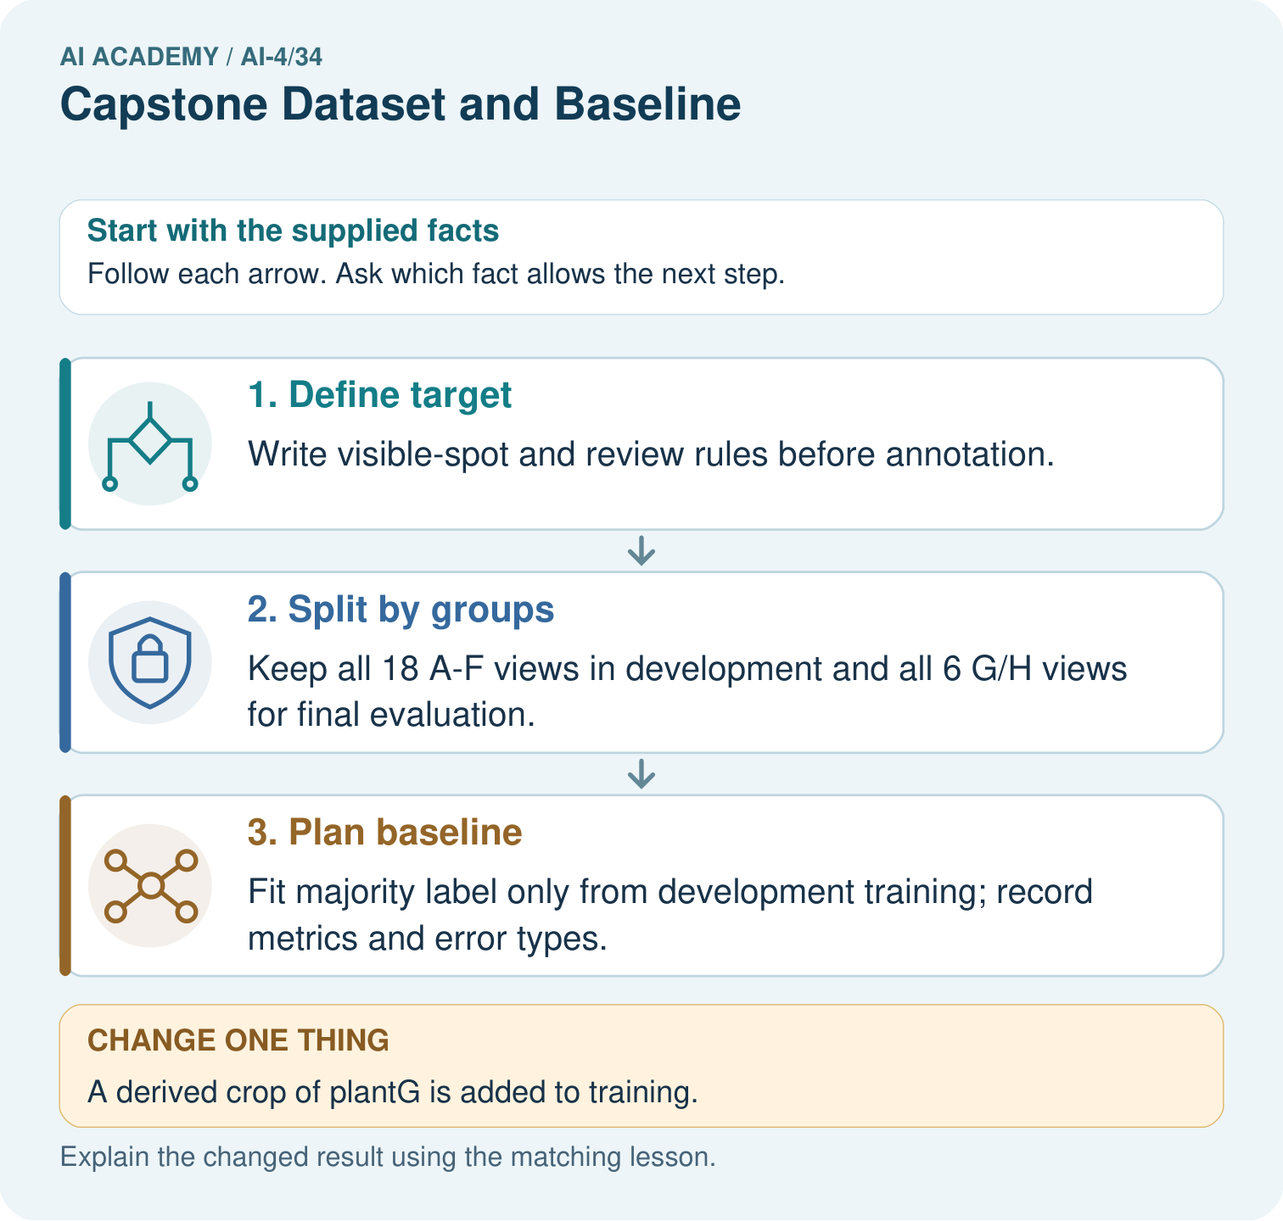
What provenance field prevents the crop from appearing independent? Point to the relevant step in the picture, then write the changed result and the rule or evidence that supports it.

My picture-based explanation and changed-case prediction
________________________________________________________________
________________________________________________________________
________________________________________________________________
________________________________________________________________
________________________________________________________________
________________________________________________________________
Support used: alone / hint / worked example. This record is practice evidence.
Project connection: For your Responsible Plant Classifier, save the input, procedure, observed result and limitation of this check. Label this worked example as practice; use a different, previously unreviewed case when checking independent understanding.

24. Project portfolio milestone
Project: Responsible Plant Classifier
Current milestone: Present and defend. Demonstrate the system, explain one failure and justify the next improvement with evidence.
For your Responsible Plant Classifier, save the input, procedure, observed result and limitation of this check. Label this worked example as practice; use a different, previously unreviewed case when checking independent understanding.
Evidence to keep | My record
This week’s input and deciding step
Prediction and actual result (or labelled paper trace)
One change since the previous checkpoint and why
One error or limit and the next test

Explain what this week adds to your project. Reuse last week’s record rather than starting again.
________________________________________________________________
________________________________________________________________
________________________________________________________________
________________________________________________________________
________________________________________________________________

