AI ACADEMY · WORKBOOK · ai-5/3

Bias terms and decision boundaries
Project: Image-pattern Network Investigation

01. Recall and choose your starting point
Try the recall before opening notes. Then use a different colour or a labelled second line to correct your explanation.

Dot products and weighted sums
Without opening the old lesson, explain one key idea from Dot products and weighted sums. Give an example and a mistake that the idea helps you avoid.

My remembered idea, example and correction
________________________________________________________________
________________________________________________________________
________________________________________________________________

02. Practise with fading help
Use W2: Plot and label the boundary for Bias terms and decision boundaries. Record the answer once; the lesson and workbook refer to the same attempt.
Given inputs | Procedure I chose | Middle steps | Result and check

The step I completed without help, and the hint I needed
________________________________________________________________
________________________________________________________________
________________________________________________________________

03. Individual reasoning check
Use the worked case for Bias terms and decision boundaries. Proposed explanation: “Add bias to each contribution”. Decide whether this explanation is supported. Point to the step or supplied fact that decides; explain your repair if needed.

My explanation before partner discussion
________________________________________________________________
________________________________________________________________
________________________________________________________________
________________________________________________________________

04. Independent transfer case

Independent case: Analyse a new model independently
A new model has w = [-1, 2], b = -2, inputs [u, v] and class 1 when z >= 0. Calculate scores and classes for [2, 1], [2, 2], [2, 3]. Write the boundary as v in terms of u. Then change only b to 0 and recompute [2, 1].

My independent explanation, trace and limits
________________________________________________________________
________________________________________________________________
________________________________________________________________
________________________________________________________________
________________________________________________________________
________________________________________________________________
________________________________________________________________
Attempt this case before feedback. Record any help. Earlier examples below are further practice; a case already practised with feedback cannot establish fresh transfer.

05. W1 Trace the bias once
Use z = 2 times width - height - 3 at [5, 4]. Give the weighted sum, bias, final score and prediction under z >= 0.

My reasoning and evidence
________________________________________________________________
________________________________________________________________
________________________________________________________________
________________________________________________________________
________________________________________________________________
________________________________________________________________

06. W2 Plot and label the boundary
For the worked model, find boundary points at width 2 and width 4. Test [4, 4] and [4, 6] to identify the class on each side.

My reasoning and evidence
________________________________________________________________
________________________________________________________________
________________________________________________________________
________________________________________________________________
________________________________________________________________
________________________________________________________________

07. W3 Check the equality rule
At [3, 3], compare prediction under z >= 0 with prediction under z > 0. Does changing this comparison move the zero line?

My reasoning and evidence
________________________________________________________________
________________________________________________________________
________________________________________________________________
________________________________________________________________
________________________________________________________________
________________________________________________________________

08. W4 Analyse a new model independently
A new model has w = [-1, 2], b = -2, inputs [u, v] and class 1 when z >= 0. Calculate scores and classes for [2, 1], [2, 2], [2, 3]. Write the boundary as v in terms of u. Then change only b to 0 and recompute [2, 1].

My reasoning and evidence
________________________________________________________________
________________________________________________________________
________________________________________________________________
________________________________________________________________
________________________________________________________________
________________________________________________________________
________________________________________________________________
________________________________________________________________

09. W5 Require evidence of improvement
A teammate says that raising b must improve the model because all scores rise. What information is needed before accepting an improvement claim?

My reasoning and evidence
________________________________________________________________
________________________________________________________________
________________________________________________________________
________________________________________________________________
________________________________________________________________
________________________________________________________________

10. Project checkpoint and reflection
Add a labelled bias terms and decision boundaries evidence sheet to Image-pattern Network Investigation. Show how you can calculate a weighted score with a bias term. Use the supplied fictional case and keep its inputs, intermediate steps, calculation or prediction, and limitation. Connect this record to last week’s record; a matching answer without a trace is insufficient.

My project change, supporting evidence and remaining limit
________________________________________________________________
________________________________________________________________
________________________________________________________________
________________________________________________________________
________________________________________________________________
________________________________________________________________

11. Feedback, return check and learning record
Evidence | My record
Worked alone / hint / model
First step I repaired and why
New case checked later; date and result
What I can now explain without notes
One remaining question
Revisit this idea with your teacher after a delay. Familiarity is different from explaining and using it on a changed case.

12. Pictorial case practice: Bias terms and decision boundaries
Move a toy boundary with a bias while keeping its input weights fixed.
Score z=2u-v-3; predict class 1 when z>=0. InputsA=[2, 1], B=[1, 1].
All inputs and outcomes in this worked example are invented classroom data; no real model run is claimed.
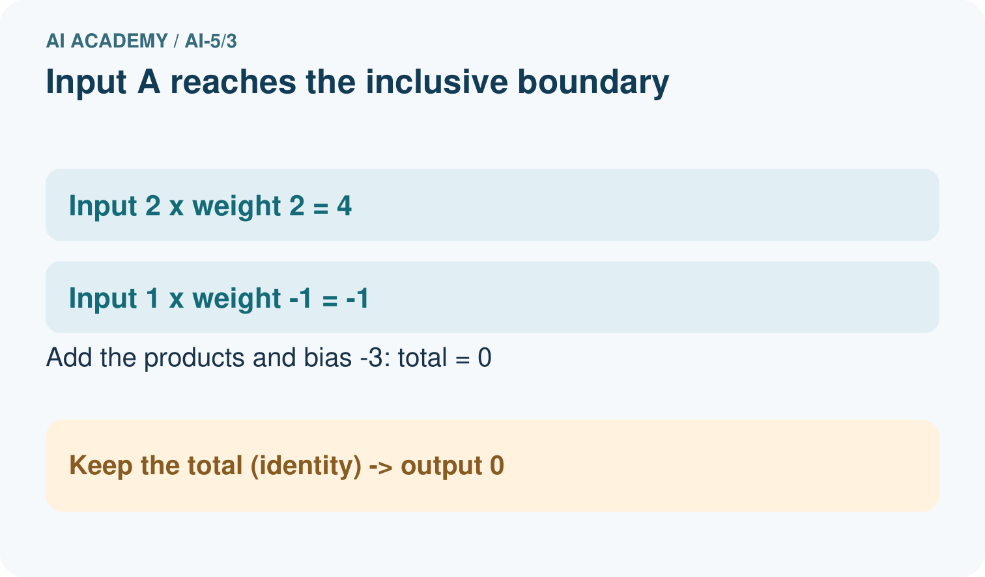
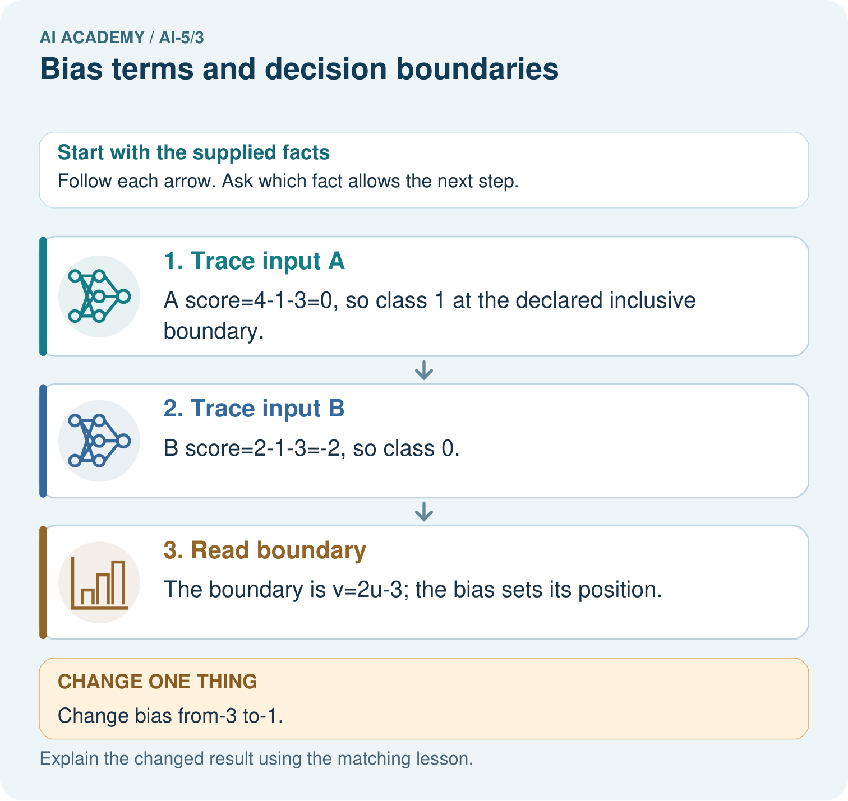
Is B positive under the original or changed model? Point to the relevant step in the picture, then write the changed result and the rule or evidence that supports it.

My picture-based explanation and changed-case prediction
________________________________________________________________
________________________________________________________________
________________________________________________________________
________________________________________________________________
________________________________________________________________
________________________________________________________________
Support used: alone / hint / worked example. This record is practice evidence.
Project connection: For your Image-pattern Network Investigation, save the input, procedure, observed result and limitation of this check. Label this worked example as practice; use a different, previously unreviewed case when checking independent understanding.

13. Project portfolio milestone
Project: Image-pattern Network Investigation
Current milestone: Frame the need. Name the user, the problem, allowed inputs and a safe simple starting method.
For your Image-pattern Network Investigation, save the input, procedure, observed result and limitation of this check. Label this worked example as practice; use a different, previously unreviewed case when checking independent understanding.
Evidence to keep | My record
This week’s input and deciding step
Prediction and actual result (or labelled paper trace)
One change since the previous checkpoint and why
One error or limit and the next test

Explain what this week adds to your project. Reuse last week’s record rather than starting again.
________________________________________________________________
________________________________________________________________
________________________________________________________________
________________________________________________________________
________________________________________________________________

