AI ACADEMY · WORKBOOK · ai-5/6

Forward passes by hand
Project: Image-pattern Network Investigation

01. Recall and choose your starting point
Try the recall before opening notes. Then use a different colour or a labelled second line to correct your explanation.

Composing layers
Without opening the old lesson, explain one key idea from Composing layers. Give an example and a mistake that the idea helps you avoid.

My remembered idea, example and correction
________________________________________________________________
________________________________________________________________
________________________________________________________________

Bias terms and decision boundaries
Without opening the old lesson, explain one key idea from Bias terms and decision boundaries. Give an example and a mistake that the idea helps you avoid.

My remembered idea, example and correction
________________________________________________________________
________________________________________________________________
________________________________________________________________

02. Practise with fading help
Use W2: Locate a bias omission for Forward passes by hand. Record the answer once; the lesson and workbook refer to the same attempt.
Given inputs | Procedure I chose | Middle steps | Result and check

The step I completed without help, and the hint I needed
________________________________________________________________
________________________________________________________________
________________________________________________________________

03. Individual reasoning check
Use the worked case for Forward passes by hand. Proposed explanation: “ReLU means the output cannot be negative”. Decide whether this explanation is supported. Point to the step or supplied fact that decides; explain your repair if needed.

My explanation before partner discussion
________________________________________________________________
________________________________________________________________
________________________________________________________________
________________________________________________________________

04. Independent transfer case

Independent case: Audit a different network independently
Use z1 = x + 1, z2 = 2 - 2x, h = ReLU(z) component by component, and y = 2h1 + h2 - 3. Trace x = 0 and x = 2. A submitted x = 2 trace uses h = [3, -2] and y = 1. Find its first error and correct all later values.

My independent explanation, trace and limits
________________________________________________________________
________________________________________________________________
________________________________________________________________
________________________________________________________________
________________________________________________________________
________________________________________________________________
________________________________________________________________
Attempt this case before feedback. Record any help. Earlier examples below are further practice; a case already practised with feedback cannot establish fresh transfer.

05. W1 Complete a fresh row
Trace x = -1 through the lesson network. Record z, h and y.

My reasoning and evidence
________________________________________________________________
________________________________________________________________
________________________________________________________________
________________________________________________________________
________________________________________________________________
________________________________________________________________

06. W2 Locate a bias omission
At x = 3 a trace gives z = [5, -1], h = [5, 0] and y = 5. Identify the first incorrect stage and repair it.

My reasoning and evidence
________________________________________________________________
________________________________________________________________
________________________________________________________________
________________________________________________________________
________________________________________________________________
________________________________________________________________

07. W3 Check both boundaries
Trace x = 0.5 and x = 2. Which hidden score is zero in each case?

My reasoning and evidence
________________________________________________________________
________________________________________________________________
________________________________________________________________
________________________________________________________________
________________________________________________________________
________________________________________________________________

08. W4 Audit a different network independently
Use z1 = x + 1, z2 = 2 - 2x, h = ReLU(z) component by component, and y = 2h1 + h2 - 3. Trace x = 0 and x = 2. A submitted x = 2 trace uses h = [3, -2] and y = 1. Find its first error and correct all later values.

My reasoning and evidence
________________________________________________________________
________________________________________________________________
________________________________________________________________
________________________________________________________________
________________________________________________________________
________________________________________________________________
________________________________________________________________
________________________________________________________________

09. W5 Limit a passing test
Explain why testing only x = 1 in the lesson model may miss a hidden-order swap.

My reasoning and evidence
________________________________________________________________
________________________________________________________________
________________________________________________________________
________________________________________________________________
________________________________________________________________
________________________________________________________________

10. Project checkpoint and reflection
Add a labelled forward passes by hand evidence sheet to Image-pattern Network Investigation. Show how you can record scores and activations in dependency order. Use the supplied fictional case and keep its inputs, intermediate steps, calculation or prediction, and limitation. Connect this record to last week’s record; a matching answer without a trace is insufficient.

My project change, supporting evidence and remaining limit
________________________________________________________________
________________________________________________________________
________________________________________________________________
________________________________________________________________
________________________________________________________________
________________________________________________________________

11. Feedback, return check and learning record
Evidence | My record
Worked alone / hint / model
First step I repaired and why
New case checked later; date and result
What I can now explain without notes
One remaining question
Revisit this idea with your teacher after a delay. Familiarity is different from explaining and using it on a changed case.

12. Pictorial case practice: Forward passes by hand
Audit a forward pass by writing every value at its correct stage.
Toy scalar network z=2x-1, h=ReLU(z), y=-h+4. Trace x=0 and x=2.
All inputs and outcomes in this worked example are invented classroom data; no real model run is claimed.
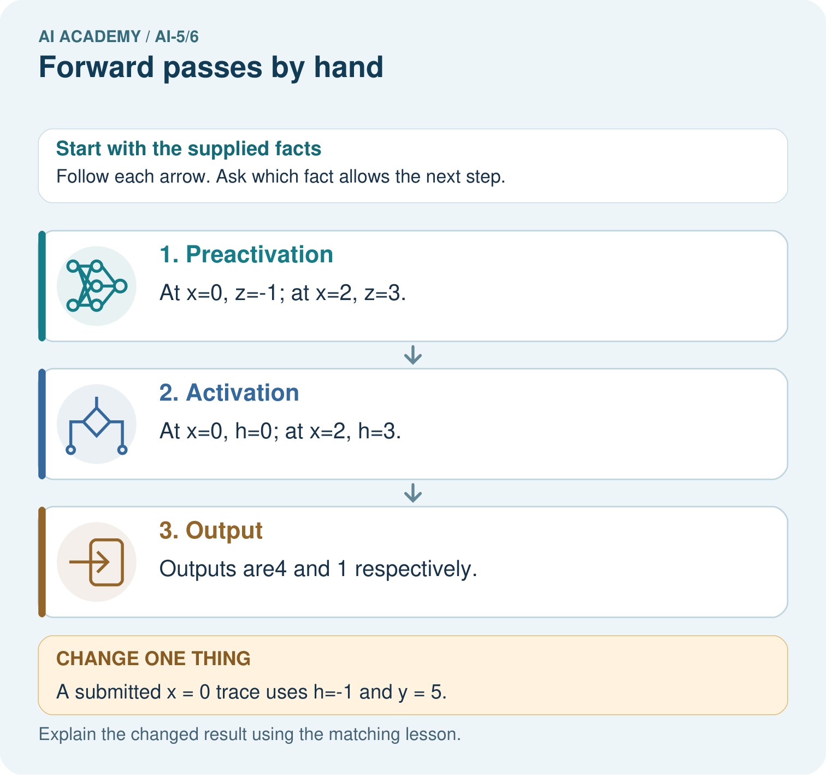
Why should feedback identify h before correcting only y? Point to the relevant step in the picture, then write the changed result and the rule or evidence that supports it.

My picture-based explanation and changed-case prediction
________________________________________________________________
________________________________________________________________
________________________________________________________________
________________________________________________________________
________________________________________________________________
________________________________________________________________
Support used: alone / hint / worked example. This record is practice evidence.
Project connection: For your Image-pattern Network Investigation, save the input, procedure, observed result and limitation of this check. Label this worked example as practice; use a different, previously unreviewed case when checking independent understanding.

13. Project portfolio milestone
Project: Image-pattern Network Investigation
Current milestone: Frame the need. Name the user, the problem, allowed inputs and a safe simple starting method.
For your Image-pattern Network Investigation, save the input, procedure, observed result and limitation of this check. Label this worked example as practice; use a different, previously unreviewed case when checking independent understanding.
Evidence to keep | My record
This week’s input and deciding step
Prediction and actual result (or labelled paper trace)
One change since the previous checkpoint and why
One error or limit and the next test

Explain what this week adds to your project. Reuse last week’s record rather than starting again.
________________________________________________________________
________________________________________________________________
________________________________________________________________
________________________________________________________________
________________________________________________________________

