AI ACADEMY · WORKBOOK · ai-5/8

Loss functions
Project: Image-pattern Network Investigation

01. Recall and choose your starting point
Try the recall before opening notes. Then use a different colour or a labelled second line to correct your explanation.

Parameters and architecture
Without opening the old lesson, explain one key idea from Parameters and architecture. Give an example and a mistake that the idea helps you avoid.

My remembered idea, example and correction
________________________________________________________________
________________________________________________________________
________________________________________________________________

Composing layers
Without opening the old lesson, explain one key idea from Composing layers. Give an example and a mistake that the idea helps you avoid.

My remembered idea, example and correction
________________________________________________________________
________________________________________________________________
________________________________________________________________

Dot products and weighted sums
Without opening the old lesson, explain one key idea from Dot products and weighted sums. Give an example and a mistake that the idea helps you avoid.

My remembered idea, example and correction
________________________________________________________________
________________________________________________________________
________________________________________________________________

02. Practise with fading help
Use W2: Expose cancellation for Loss functions. Record the answer once; the lesson and workbook refer to the same attempt.
Given inputs | Procedure I chose | Middle steps | Result and check

The step I completed without help, and the hint I needed
________________________________________________________________
________________________________________________________________
________________________________________________________________

03. Individual reasoning check
Use the worked case for Loss functions. Proposed explanation: “Average residual is the loss”. Decide whether this explanation is supported. Point to the step or supplied fact that decides; explain your repair if needed.

My explanation before partner discussion
________________________________________________________________
________________________________________________________________
________________________________________________________________
________________________________________________________________

04. Independent transfer case

Independent case: Compare an unfamiliar evaluation independently
Targets are [0, 2, 4]. Model A predicts [1, 2, 3]; model B predicts [0, 2, 2]. Calculate both MSEs and identify the better model under MSE on these cases. Calculate mean absolute errors too. State what changes in the conclusion.

My independent explanation, trace and limits
________________________________________________________________
________________________________________________________________
________________________________________________________________
________________________________________________________________
________________________________________________________________
________________________________________________________________
________________________________________________________________
Attempt this case before feedback. Record any help. Earlier examples below are further practice; a case already practised with feedback cannot establish fresh transfer.

05. W1 Calculate a loss
For targets [2, 4] and predictions [1, 6], record residuals, squares and MSE.

My reasoning and evidence
________________________________________________________________
________________________________________________________________
________________________________________________________________
________________________________________________________________
________________________________________________________________
________________________________________________________________

06. W2 Expose cancellation
Targets [0, 4] have predictions [2, 2]. Compare mean residual and MSE.

My reasoning and evidence
________________________________________________________________
________________________________________________________________
________________________________________________________________
________________________________________________________________
________________________________________________________________
________________________________________________________________

07. W3 Check the denominator
A learner totals squared errors 1, 0, 9 and divides by 2 because there are two nonzero errors. Correct the MSE.

My reasoning and evidence
________________________________________________________________
________________________________________________________________
________________________________________________________________
________________________________________________________________
________________________________________________________________
________________________________________________________________

08. W4 Compare an unfamiliar evaluation independently
Targets are [0, 2, 4]. Model A predicts [1, 2, 3]; model B predicts [0, 2, 2]. Calculate both MSEs and identify the better model under MSE on these cases. Calculate mean absolute errors too. State what changes in the conclusion.

My reasoning and evidence
________________________________________________________________
________________________________________________________________
________________________________________________________________
________________________________________________________________
________________________________________________________________
________________________________________________________________
________________________________________________________________
________________________________________________________________

09. W5 Protect final testing
A team tries ten models and picks the one with the lowest final-test MSE. Can that same result be presented as an untouched final evaluation?

My reasoning and evidence
________________________________________________________________
________________________________________________________________
________________________________________________________________
________________________________________________________________
________________________________________________________________
________________________________________________________________

10. Project checkpoint and reflection
Add a labelled loss functions evidence sheet to Image-pattern Network Investigation. Show how you can calculate per-example squared error and mean squared error. Use the supplied fictional case and keep its inputs, intermediate steps, calculation or prediction, and limitation. Connect this record to last week’s record; a matching answer without a trace is insufficient.

My project change, supporting evidence and remaining limit
________________________________________________________________
________________________________________________________________
________________________________________________________________
________________________________________________________________
________________________________________________________________
________________________________________________________________

11. Feedback, return check and learning record
Evidence | My record
Worked alone / hint / model
First step I repaired and why
New case checked later; date and result
What I can now explain without notes
One remaining question
Revisit this idea with your teacher after a delay. Familiarity is different from explaining and using it on a changed case.

12. Pictorial case practice: Loss functions
Compare candidate losses with the same targets and denominator.
Targets [1, 3]; A predicts [0, 4]; B predicts [1, 5]. Use MSE over both cases.
All inputs and outcomes in this worked example are invented classroom data; no real model run is claimed.
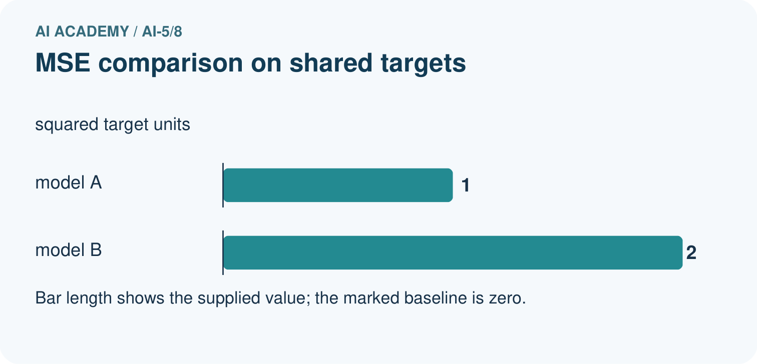
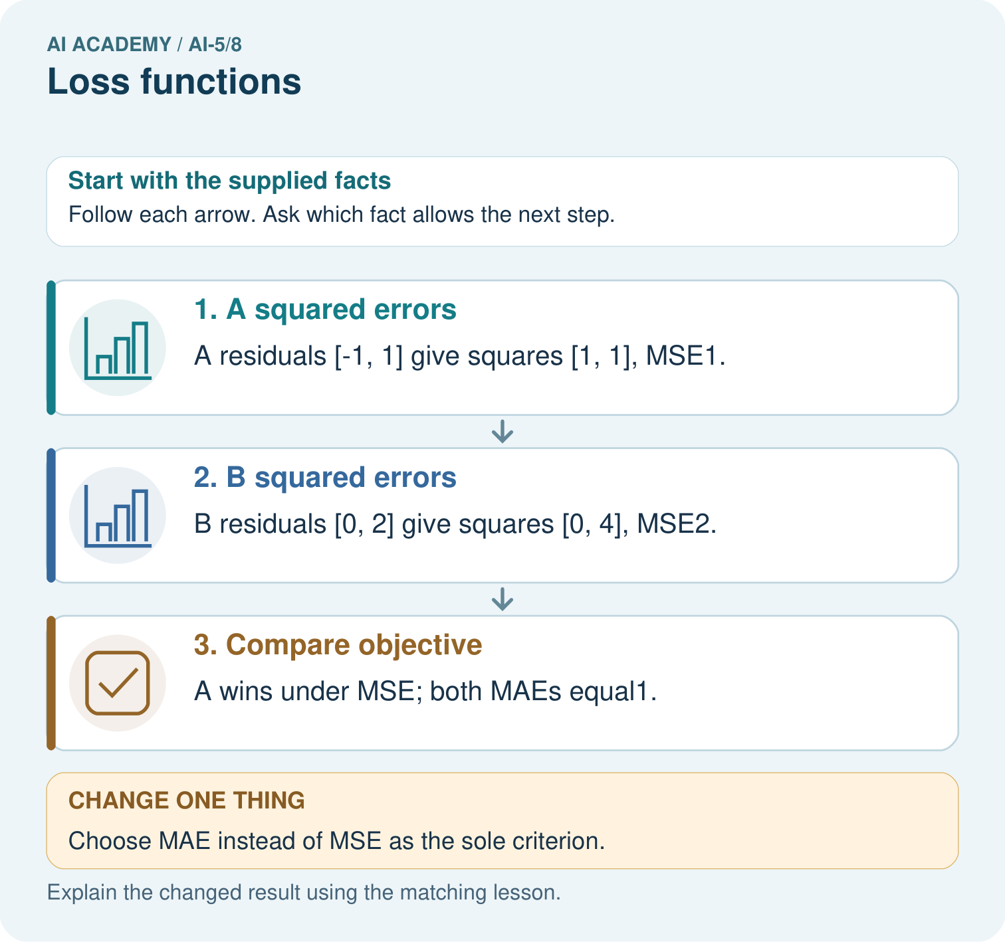
Why must the report name the chosen loss? Point to the relevant step in the picture, then write the changed result and the rule or evidence that supports it.

My picture-based explanation and changed-case prediction
________________________________________________________________
________________________________________________________________
________________________________________________________________
________________________________________________________________
________________________________________________________________
________________________________________________________________
Support used: alone / hint / worked example. This record is practice evidence.
Project connection: For your Image-pattern Network Investigation, save the input, procedure, observed result and limitation of this check. Label this worked example as practice; use a different, previously unreviewed case when checking independent understanding.

13. Project portfolio milestone
Project: Image-pattern Network Investigation
Current milestone: Make a transparent first version. Keep a trace of how one input becomes an output; explain the rule or learned component.
For your Image-pattern Network Investigation, save the input, procedure, observed result and limitation of this check. Label this worked example as practice; use a different, previously unreviewed case when checking independent understanding.
Evidence to keep | My record
This week’s input and deciding step
Prediction and actual result (or labelled paper trace)
One change since the previous checkpoint and why
One error or limit and the next test

Explain what this week adds to your project. Reuse last week’s record rather than starting again.
________________________________________________________________
________________________________________________________________
________________________________________________________________
________________________________________________________________
________________________________________________________________

