AI ACADEMY · WORKBOOK · ai-5/17

Initialisation and reproducibility
Project: Image-pattern Network Investigation

01. Recall and choose your starting point
Try the recall before opening notes. Then use a different colour or a labelled second line to correct your explanation.

Regularisation and early stopping
Without opening the old lesson, explain one key idea from Regularisation and early stopping. Give an example and a mistake that the idea helps you avoid.

My remembered idea, example and correction
________________________________________________________________
________________________________________________________________
________________________________________________________________

Learning rate experiments
Without opening the old lesson, explain one key idea from Learning rate experiments. Give an example and a mistake that the idea helps you avoid.

My remembered idea, example and correction
________________________________________________________________
________________________________________________________________
________________________________________________________________

Updating parameters
Without opening the old lesson, explain one key idea from Updating parameters. Give an example and a mistake that the idea helps you avoid.

My remembered idea, example and correction
________________________________________________________________
________________________________________________________________
________________________________________________________________

02. Practise with fading help
Use W2: Distinguish equality of loss and parameters for Initialisation and reproducibility. Record the answer once; the lesson and workbook refer to the same attempt.
Given inputs | Procedure I chose | Middle steps | Result and check

The step I completed without help, and the hint I needed
________________________________________________________________
________________________________________________________________
________________________________________________________________

03. Individual reasoning check
Use the worked case for Initialisation and reproducibility. Proposed explanation: “The same seed specifies the entire experiment”. Decide whether this explanation is supported. Point to the step or supplied fact that decides; explain your repair if needed.

My explanation before partner discussion
________________________________________________________________
________________________________________________________________
________________________________________________________________
________________________________________________________________

04. Independent transfer case

Independent case: Transfer the starting-value experiment independently
Use J(a) = (a - 3) squared, gradient 2(a - 3), rate 0.25 and two updates. Restart from a = 1, then restart from a = 5. Calculate both traces and final losses. Explain what can be concluded about these two runs.

My independent explanation, trace and limits
________________________________________________________________
________________________________________________________________
________________________________________________________________
________________________________________________________________
________________________________________________________________
________________________________________________________________
________________________________________________________________
Attempt this case before feedback. Record any help. Earlier examples below are further practice; a case already practised with feedback cannot establish fresh transfer.

05. W1 Trace a fresh starting value
For the scalar lesson model, start v = -2 and apply two updates at rate 0.1. Give all three v values and the final training MSE.

My reasoning and evidence
________________________________________________________________
________________________________________________________________
________________________________________________________________
________________________________________________________________
________________________________________________________________
________________________________________________________________

06. W2 Distinguish equality of loss and parameters
The lesson runs starting at 1 and 3 finish with the same training MSE. Give their final v values and explain the equality without calling the models identical.

My reasoning and evidence
________________________________________________________________
________________________________________________________________
________________________________________________________________
________________________________________________________________
________________________________________________________________
________________________________________________________________

07. W3 Audit a seed claim
Both runs use the same seed and generator. Run A assigns the first four draws to its weights. Run B draws a preview number first, then assigns the next four. Must the initial weight arrays match? What should be saved?

My reasoning and evidence
________________________________________________________________
________________________________________________________________
________________________________________________________________
________________________________________________________________
________________________________________________________________
________________________________________________________________

08. W4 Transfer the starting-value experiment independently
Use J(a) = (a - 3) squared, gradient 2(a - 3), rate 0.25 and two updates. Restart from a = 1, then restart from a = 5. Calculate both traces and final losses. Explain what can be concluded about these two runs.

My reasoning and evidence
________________________________________________________________
________________________________________________________________
________________________________________________________________
________________________________________________________________
________________________________________________________________
________________________________________________________________
________________________________________________________________
________________________________________________________________

09. W5 Test repeated correctness
A forward-pass program returns the same wrong answer every run with a fixed seed. Has repeatability verified the implementation? Name two stronger checks.

My reasoning and evidence
________________________________________________________________
________________________________________________________________
________________________________________________________________
________________________________________________________________
________________________________________________________________
________________________________________________________________

10. Project checkpoint and reflection
Add a labelled initialisation and reproducibility evidence sheet to Image-pattern Network Investigation. Show how you can trace how starting values affect a fixed training budget. Use the supplied fictional case and keep its inputs, intermediate steps, calculation or prediction, and limitation. Connect this record to last week’s record; a matching answer without a trace is insufficient.

My project change, supporting evidence and remaining limit
________________________________________________________________
________________________________________________________________
________________________________________________________________
________________________________________________________________
________________________________________________________________
________________________________________________________________

11. Feedback, return check and learning record
Evidence | My record
Worked alone / hint / model
First step I repaired and why
New case checked later; date and result
What I can now explain without notes
One remaining question
Revisit this idea with your teacher after a delay. Familiarity is different from explaining and using it on a changed case.

12. Pictorial case practice: Initialisation and reproducibility
Reproduce two training traces by saving their distinct initial values.
LossJ(a)=(a-2)²; gradient 2(a-2); rate 0.25; two updates. Restart from a = 0 and separately a = 4.
All inputs and outcomes in this worked example are invented classroom data; no real model run is claimed.
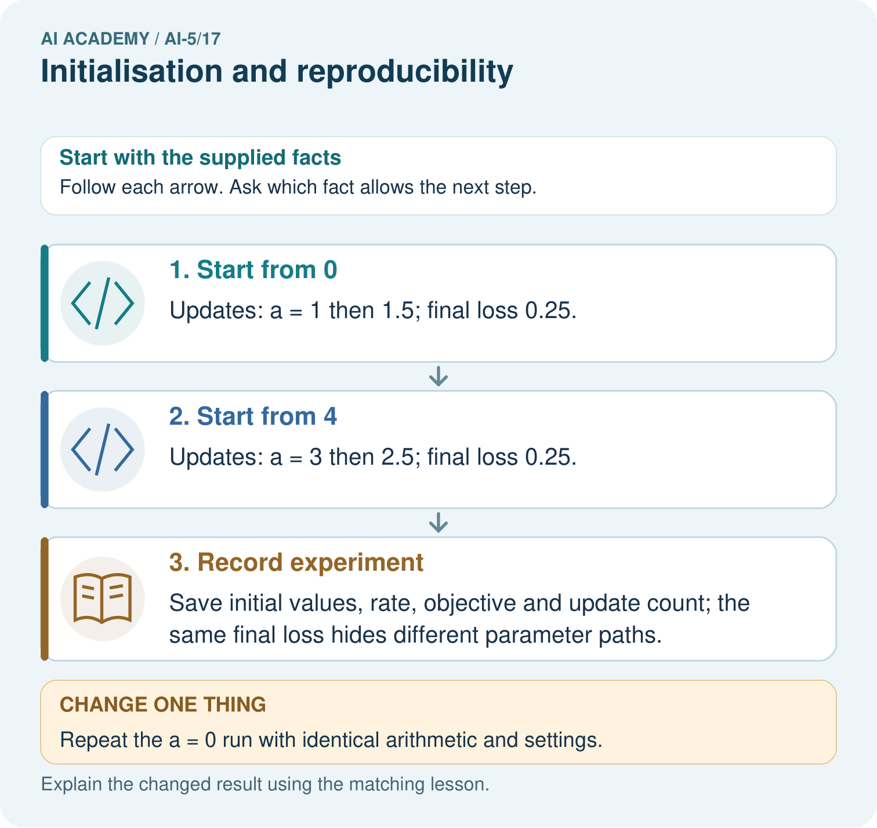
Does the matching final loss mean the parameter values are equal? Point to the relevant step in the picture, then write the changed result and the rule or evidence that supports it.

My picture-based explanation and changed-case prediction
________________________________________________________________
________________________________________________________________
________________________________________________________________
________________________________________________________________
________________________________________________________________
________________________________________________________________
Support used: alone / hint / worked example. This record is practice evidence.
Project connection: For your Image-pattern Network Investigation, save the input, procedure, observed result and limitation of this check. Label this worked example as practice; use a different, previously unreviewed case when checking independent understanding.

13. Project portfolio milestone
Project: Image-pattern Network Investigation
Current milestone: Test changed cases. Keep normal, boundary and failure cases; compare expected and observed results.
For your Image-pattern Network Investigation, save the input, procedure, observed result and limitation of this check. Label this worked example as practice; use a different, previously unreviewed case when checking independent understanding.
Evidence to keep | My record
This week’s input and deciding step
Prediction and actual result (or labelled paper trace)
One change since the previous checkpoint and why
One error or limit and the next test

Explain what this week adds to your project. Reuse last week’s record rather than starting again.
________________________________________________________________
________________________________________________________________
________________________________________________________________
________________________________________________________________
________________________________________________________________

