AI ACADEMY · WORKBOOK · ai-5/21

Convolution as a local operation
Project: Image-pattern Network Investigation

01. Recall and choose your starting point
Try the recall before opening notes. Then use a different colour or a labelled second line to correct your explanation.

Image tensors and channels
Without opening the old lesson, explain one key idea from Image tensors and channels. Give an example and a mistake that the idea helps you avoid.

My remembered idea, example and correction
________________________________________________________________
________________________________________________________________
________________________________________________________________

Debugging shapes and gradients
Without opening the old lesson, explain one key idea from Debugging shapes and gradients. Give an example and a mistake that the idea helps you avoid.

My remembered idea, example and correction
________________________________________________________________
________________________________________________________________
________________________________________________________________

Training and validation curves
Without opening the old lesson, explain one key idea from Training and validation curves. Give an example and a mistake that the idea helps you avoid.

My remembered idea, example and correction
________________________________________________________________
________________________________________________________________
________________________________________________________________

02. Practise with fading help
Use W2: Separate parameters and operations for Convolution as a local operation. Record the answer once; the lesson and workbook refer to the same attempt.
Given inputs | Procedure I chose | Middle steps | Result and check

The step I completed without help, and the hint I needed
________________________________________________________________
________________________________________________________________
________________________________________________________________

03. Individual reasoning check
Use the worked case for Convolution as a local operation. Proposed explanation: “Each window has its own set of learned weights”. Decide whether this explanation is supported. Point to the step or supplied fact that decides; explain your repair if needed.

My explanation before partner discussion
________________________________________________________________
________________________________________________________________
________________________________________________________________
________________________________________________________________

04. Independent transfer case

Independent case: Filter a new image independently
Use image rows [2, 1, 0], [1, 3, 2] and kernel rows [0, 1], [-1, 2]. Use no padding, stride 1 and bias 0. Give the output shape, both four-product sums and the feature map. Then add a shared bias of -5 and apply ReLU.

My independent explanation, trace and limits
________________________________________________________________
________________________________________________________________
________________________________________________________________
________________________________________________________________
________________________________________________________________
________________________________________________________________
________________________________________________________________
Attempt this case before feedback. Record any help. Earlier examples below are further practice; a case already practised with feedback cannot establish fresh transfer.

05. W1 Trace a local sum
Use the lesson image and kernel at window start [0, 1]. List the window rows, four products and output before activation.

My reasoning and evidence
________________________________________________________________
________________________________________________________________
________________________________________________________________
________________________________________________________________
________________________________________________________________
________________________________________________________________

06. W2 Separate parameters and operations
How many shared kernel weights does the lesson use? How many products are computed over all four valid windows? What changes if one shared bias is added?

My reasoning and evidence
________________________________________________________________
________________________________________________________________
________________________________________________________________
________________________________________________________________
________________________________________________________________
________________________________________________________________

07. W3 Check stride and padding
For the lesson image and kernel, give the output shape with no padding and stride 2. Then give the shape with one zero border on each side and stride 1, and calculate that padded map’s top-left output.

My reasoning and evidence
________________________________________________________________
________________________________________________________________
________________________________________________________________
________________________________________________________________
________________________________________________________________
________________________________________________________________

08. W4 Filter a new image independently
Use image rows [2, 1, 0], [1, 3, 2] and kernel rows [0, 1], [-1, 2]. Use no padding, stride 1 and bias 0. Give the output shape, both four-product sums and the feature map. Then add a shared bias of -5 and apply ReLU.

My reasoning and evidence
________________________________________________________________
________________________________________________________________
________________________________________________________________
________________________________________________________________
________________________________________________________________
________________________________________________________________
________________________________________________________________
________________________________________________________________

09. W5 Test a convention error
A program reverses both axes of the lesson kernel to [[1, 0], [-1, 1]]. Compute the top-left output. Does it agree with our declared convention? Explain what the test checks.

My reasoning and evidence
________________________________________________________________
________________________________________________________________
________________________________________________________________
________________________________________________________________
________________________________________________________________
________________________________________________________________

10. Project checkpoint and reflection
Add a labelled convolution as a local operation evidence sheet to Image-pattern Network Investigation. Show how you can compute a local weighted sum at each valid image position. Use the supplied fictional case and keep its inputs, intermediate steps, calculation or prediction, and limitation. Connect this record to last week’s record; a matching answer without a trace is insufficient.

My project change, supporting evidence and remaining limit
________________________________________________________________
________________________________________________________________
________________________________________________________________
________________________________________________________________
________________________________________________________________
________________________________________________________________

11. Feedback, return check and learning record
Evidence | My record
Worked alone / hint / model
First step I repaired and why
New case checked later; date and result
What I can now explain without notes
One remaining question
Revisit this idea with your teacher after a delay. Familiarity is different from explaining and using it on a changed case.

12. Pictorial case practice: Convolution as a local operation
Draw the exact patch-by-patch arithmetic of a local image operation.
Image rows [1, 2, 3],[4, 5, 6]; kernel rows [1, 0],[0,-1]. Use unflipped kernel, no padding, stride1, bias0.
All inputs and outcomes in this worked example are invented classroom data; no real model run is claimed.
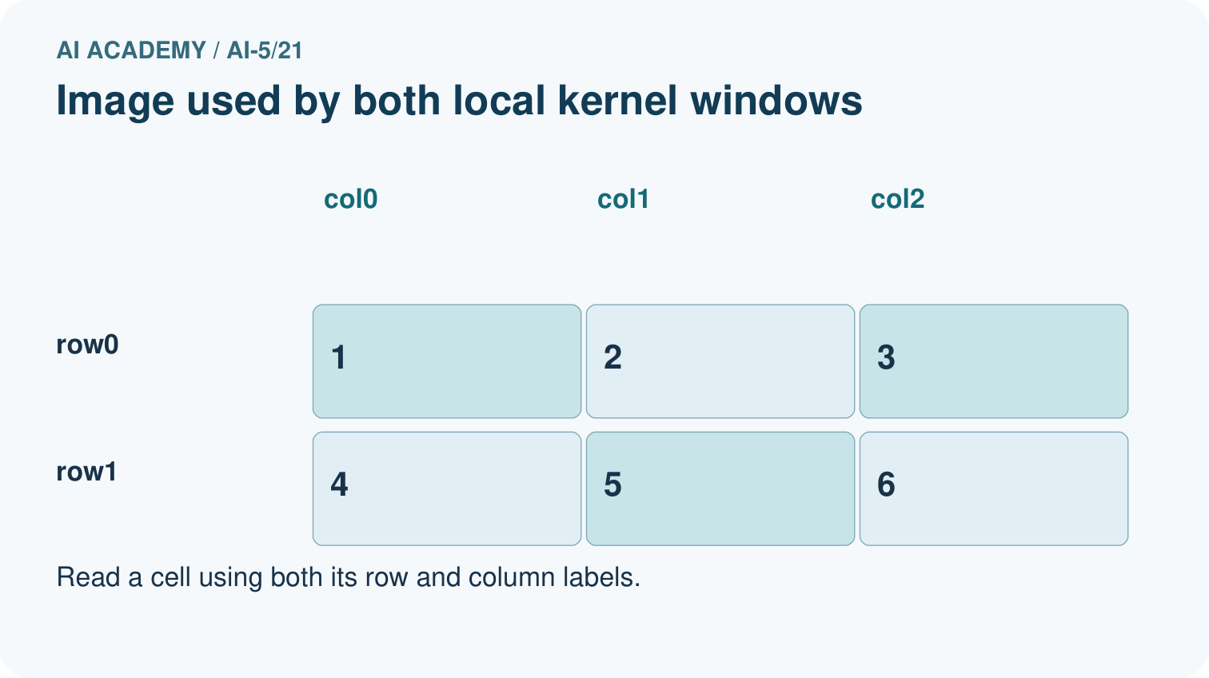
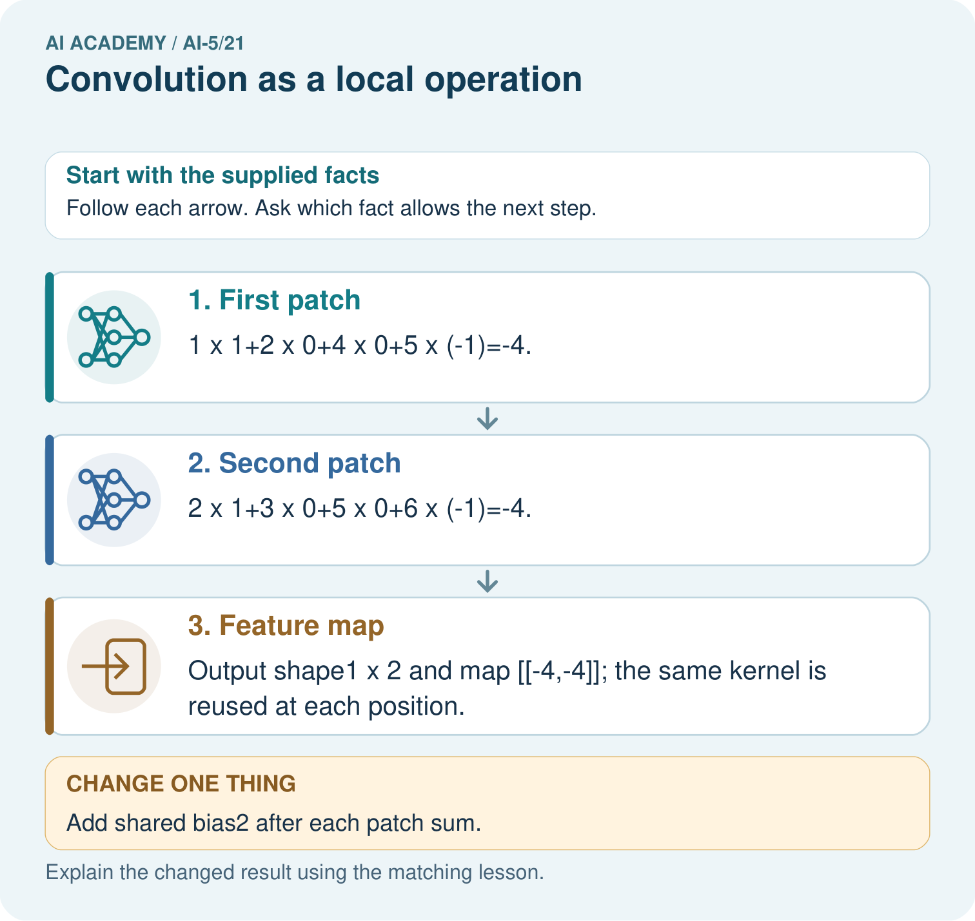
Why is flipping the kernel an implementation change here? Point to the relevant step in the picture, then write the changed result and the rule or evidence that supports it.

My picture-based explanation and changed-case prediction
________________________________________________________________
________________________________________________________________
________________________________________________________________
________________________________________________________________
________________________________________________________________
________________________________________________________________
Support used: alone / hint / worked example. This record is practice evidence.
Project connection: For your Image-pattern Network Investigation, save the input, procedure, observed result and limitation of this check. Label this worked example as practice; use a different, previously unreviewed case when checking independent understanding.

13. Project portfolio milestone
Project: Image-pattern Network Investigation
Current milestone: Evaluate and revise. Compare with your starting method, explain errors and record a justified revision.
For your Image-pattern Network Investigation, save the input, procedure, observed result and limitation of this check. Label this worked example as practice; use a different, previously unreviewed case when checking independent understanding.
Evidence to keep | My record
This week’s input and deciding step
Prediction and actual result (or labelled paper trace)
One change since the previous checkpoint and why
One error or limit and the next test

Explain what this week adds to your project. Reuse last week’s record rather than starting again.
________________________________________________________________
________________________________________________________________
________________________________________________________________
________________________________________________________________
________________________________________________________________

