AI ACADEMY · WORKBOOK · ai-5/33

Capstone hypothesis and baseline
Project: Image-pattern Network Investigation

01. Recall and choose your starting point
Try the recall before opening notes. Then use a different colour or a labelled second line to correct your explanation.

Documenting a network experiment
Without opening the old lesson, explain one key idea from Documenting a network experiment. Give an example and a mistake that the idea helps you avoid.

My remembered idea, example and correction
________________________________________________________________
________________________________________________________________
________________________________________________________________

Dataset shift in neural models
Without opening the old lesson, explain one key idea from Dataset shift in neural models. Give an example and a mistake that the idea helps you avoid.

My remembered idea, example and correction
________________________________________________________________
________________________________________________________________
________________________________________________________________

Similarity and normalisation
Without opening the old lesson, explain one key idea from Similarity and normalisation. Give an example and a mistake that the idea helps you avoid.

My remembered idea, example and correction
________________________________________________________________
________________________________________________________________
________________________________________________________________

02. Practise with fading help
Use W2: Calculate the reference score for Capstone hypothesis and baseline. Record the answer once; the lesson and workbook refer to the same attempt.
Given inputs | Procedure I chose | Middle steps | Result and check

The step I completed without help, and the hint I needed
________________________________________________________________
________________________________________________________________
________________________________________________________________

03. Individual reasoning check
Use the worked case for Capstone hypothesis and baseline. Proposed explanation: “A hypothesis is a result”. Decide whether this explanation is supported. Point to the step or supplied fact that decides; explain your repair if needed.

My explanation before partner discussion
________________________________________________________________
________________________________________________________________
________________________________________________________________
________________________________________________________________

04. Independent transfer case

Independent case: Plan a new case independently
A new task predicts max(0, a*x), with baseline a = 1. Training rows are (1,3) and (2,6); validation rows are (3,9) and (4,12); final rows are sealed. Specify a candidate starting at 1 with learning rate 0.1 and two full-batch updates. Calculate baseline validation MSE and write a strict improvement criterion. Has the candidate succeeded yet?

My independent explanation, trace and limits
________________________________________________________________
________________________________________________________________
________________________________________________________________
________________________________________________________________
________________________________________________________________
________________________________________________________________
________________________________________________________________
Attempt this case before feedback. Record any help. Earlier examples below are further practice; a case already practised with feedback cannot establish fresh transfer.

05. W1 Write the hypothesis
State the prediction rule, baseline, candidate learning rate and update count, comparison data and metric. Write a testable hypothesis.

My reasoning and evidence
________________________________________________________________
________________________________________________________________
________________________________________________________________
________________________________________________________________
________________________________________________________________
________________________________________________________________

06. W2 Calculate the reference score
Compute baseline predictions, errors, squared errors and MSE on V1 and V2. State the denominator.

My reasoning and evidence
________________________________________________________________
________________________________________________________________
________________________________________________________________
________________________________________________________________
________________________________________________________________
________________________________________________________________

07. W3 Audit the plan
A proposal says “try models until the test score looks good”. Identify the missing fixed choices and explain why that test is not independent.

My reasoning and evidence
________________________________________________________________
________________________________________________________________
________________________________________________________________
________________________________________________________________
________________________________________________________________
________________________________________________________________

08. W4 Plan a new case independently
A new task predicts max(0, a*x), with baseline a = 1. Training rows are (1,3) and (2,6); validation rows are (3,9) and (4,12); final rows are sealed. Specify a candidate starting at 1 with learning rate 0.1 and two full-batch updates. Calculate baseline validation MSE and write a strict improvement criterion. Has the candidate succeeded yet?

My reasoning and evidence
________________________________________________________________
________________________________________________________________
________________________________________________________________
________________________________________________________________
________________________________________________________________
________________________________________________________________
________________________________________________________________
________________________________________________________________

09. W5 Preserve the reserved evidence
A partner inspects final labels and changes the learning rate. Explain how to document this and obtain independent evidence.

My reasoning and evidence
________________________________________________________________
________________________________________________________________
________________________________________________________________
________________________________________________________________
________________________________________________________________
________________________________________________________________

10. Project checkpoint and reflection
For Image-pattern Network Investigation, use this week’s independent task as a rehearsal for the final evidence pack: A new task predicts max(0, a*x), with baseline a = 1. Training rows are (1,3) and (2,6); validation rows are (3,9) and (4,12); final rows are sealed. Specify a candidate starting at 1 with learning rate 0.1 and two full-batch updates. Calculate baseline validation MSE and write a strict improvement criterion. Has the candidate succeeded yet? Keep actual observations separate from expected results, preserve failures, compare a baseline and explain the limits.

My project change, supporting evidence and remaining limit
________________________________________________________________
________________________________________________________________
________________________________________________________________
________________________________________________________________
________________________________________________________________
________________________________________________________________

11. Feedback, return check and learning record
Evidence | My record
Worked alone / hint / model
First step I repaired and why
New case checked later; date and result
What I can now explain without notes
One remaining question
Revisit this idea with your teacher after a delay. Familiarity is different from explaining and using it on a changed case.

12. Pictorial case practice: Capstone hypothesis and baseline
A testable image-pattern hypothesis. A team proposes that including the centre-pixel feature improves a small fixed network’s classification of toy image patterns.
Two frozen versions are planned: A uses corner features only; B also uses the centre feature. Eight reserved toy patterns have labels defined before scoring.
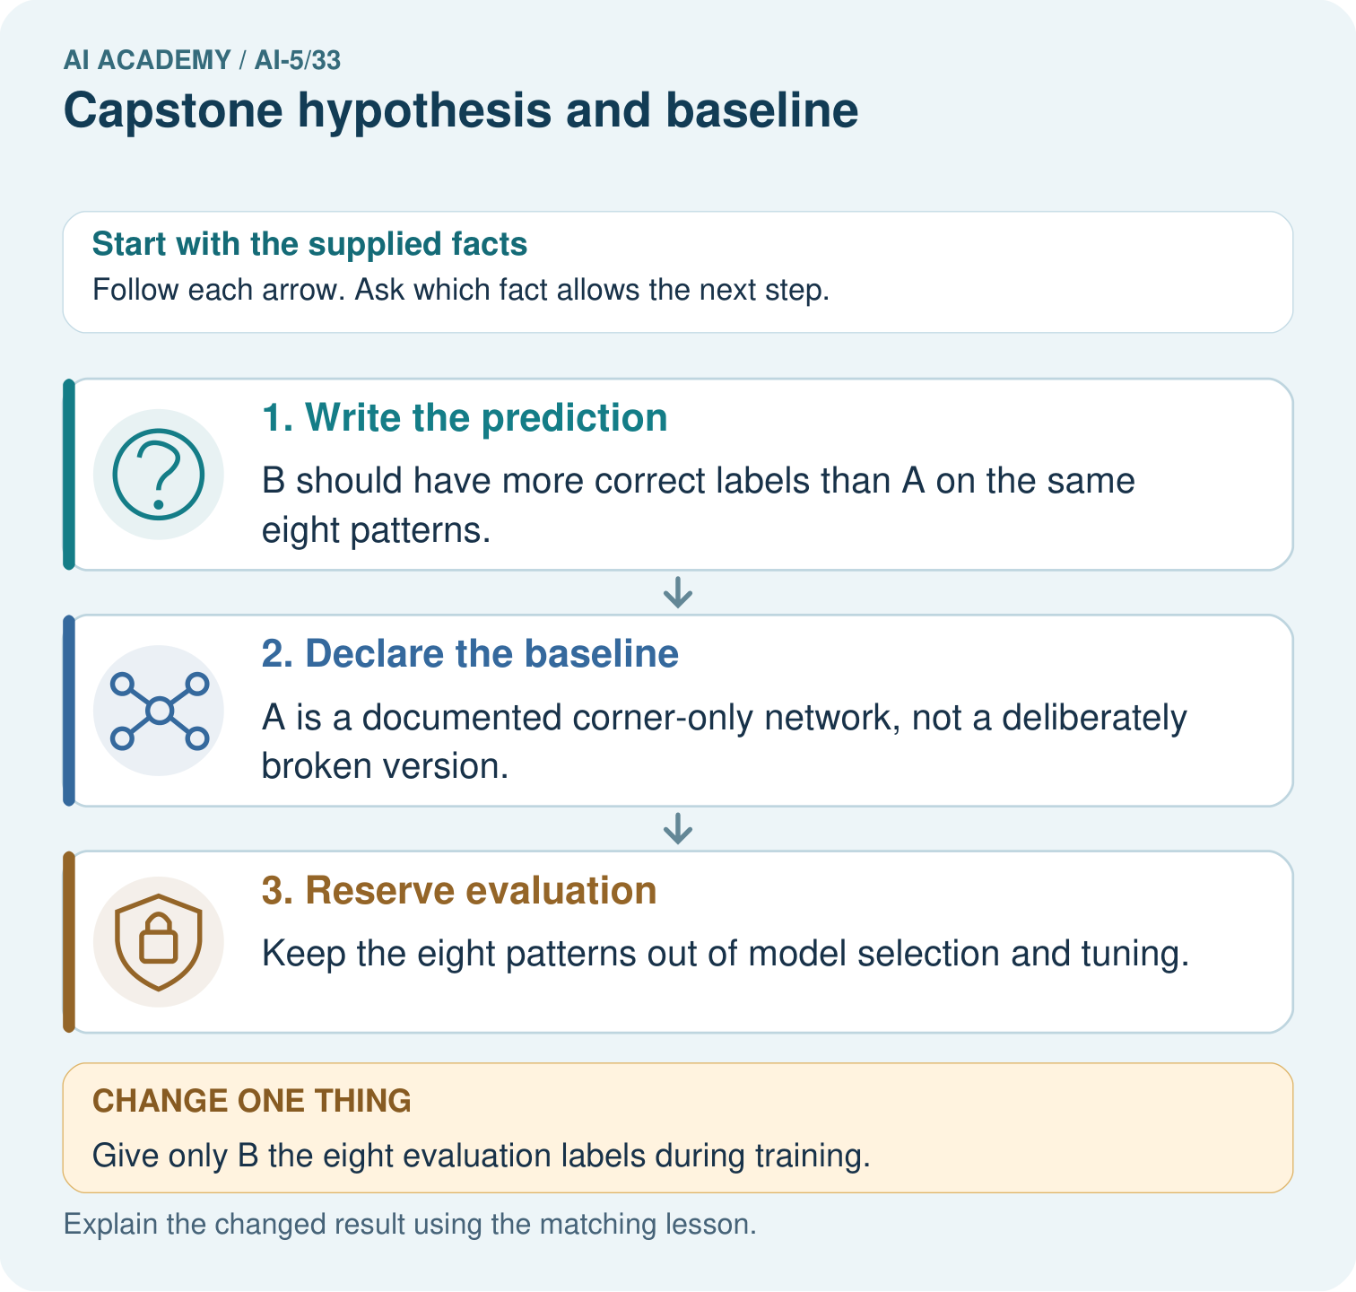
Name the intended change, the baseline and the measured outcome. Why must both versions avoid training on the eight reserved labels?

My picture-based explanation and changed-case prediction
________________________________________________________________
________________________________________________________________
________________________________________________________________
________________________________________________________________
________________________________________________________________
________________________________________________________________
Support used: alone / hint / worked example. This record is practice evidence.
Project connection: For the Image-pattern Network Investigation, save the labelled trace and the changed-case explanation beside the experiment record. State exactly what this example supports before linking it to the wider capstone claim.

13. Project portfolio milestone
Project: Image-pattern Network Investigation
Current milestone: Present and defend. Demonstrate the system, explain one failure and justify the next improvement with evidence.
For the Image-pattern Network Investigation, save the labelled trace and the changed-case explanation beside the experiment record. State exactly what this example supports before linking it to the wider capstone claim.
Evidence to keep | My record
This week’s input and deciding step
Prediction and actual result (or labelled paper trace)
One change since the previous checkpoint and why
One error or limit and the next test

Explain what this week adds to your project. Reuse last week’s record rather than starting again.
________________________________________________________________
________________________________________________________________
________________________________________________________________
________________________________________________________________
________________________________________________________________

