AI ACADEMY · WORKBOOK · ai-5/36

Neural network experiment defense
Project: Image-pattern Network Investigation

01. Recall and choose your starting point
Try the recall before opening notes. Then use a different colour or a labelled second line to correct your explanation.

Capstone limitations and revision
Without opening the old lesson, explain one key idea from Capstone limitations and revision. Give an example and a mistake that the idea helps you avoid.

My remembered idea, example and correction
________________________________________________________________
________________________________________________________________
________________________________________________________________

Capstone hypothesis and baseline
Without opening the old lesson, explain one key idea from Capstone hypothesis and baseline. Give an example and a mistake that the idea helps you avoid.

My remembered idea, example and correction
________________________________________________________________
________________________________________________________________
________________________________________________________________

Dataset shift in neural models
Without opening the old lesson, explain one key idea from Dataset shift in neural models. Give an example and a mistake that the idea helps you avoid.

My remembered idea, example and correction
________________________________________________________________
________________________________________________________________
________________________________________________________________

02. Practise with fading help
Use W2: Defend the result for Neural network experiment defense. Record the answer once; the lesson and workbook refer to the same attempt.
Given inputs | Procedure I chose | Middle steps | Result and check

The step I completed without help, and the hint I needed
________________________________________________________________
________________________________________________________________
________________________________________________________________

03. Individual reasoning check
Use the worked case for Neural network experiment defense. Proposed explanation: “A polished demonstration is an evaluation”. Decide whether this explanation is supported. Point to the step or supplied fact that decides; explain your repair if needed.

My explanation before partner discussion
________________________________________________________________
________________________________________________________________
________________________________________________________________
________________________________________________________________

04. Independent transfer case

Independent case: Defend a new record independently
A separate experiment compares candidates C1 and C2 on two validation rows: MSE 1.5 and 1.0. The written rule selects lower MSE. After freezing C2, four fresh final rows give baseline squared errors 4,9,1,2 and C2 squared errors 1,1,2,0. Compute final MSE and relative reduction. Two condition-B rows are the last two rows; compare baseline and candidate MSE there. State what this record supports and what is unmeasured.

My independent explanation, trace and limits
________________________________________________________________
________________________________________________________________
________________________________________________________________
________________________________________________________________
________________________________________________________________
________________________________________________________________
________________________________________________________________
Attempt this case before feedback. Record any help. Earlier examples below are further practice; a case already practised with feedback cannot establish fresh transfer.

05. W1 Build the evidence inventory
Name eight items needed to check the capstone from question through final result.

My reasoning and evidence
________________________________________________________________
________________________________________________________________
________________________________________________________________
________________________________________________________________
________________________________________________________________
________________________________________________________________

06. W2 Defend the result
State the validation selection and frozen final comparison using their correct metrics and scopes.

My reasoning and evidence
________________________________________________________________
________________________________________________________________
________________________________________________________________
________________________________________________________________
________________________________________________________________
________________________________________________________________

07. W3 Challenge an unsupported claim
A presenter claims the experiment proves neural networks beat fitted lines and use less energy. What evidence is missing?

My reasoning and evidence
________________________________________________________________
________________________________________________________________
________________________________________________________________
________________________________________________________________
________________________________________________________________
________________________________________________________________

08. W4 Defend a new record independently
A separate experiment compares candidates C1 and C2 on two validation rows: MSE 1.5 and 1.0. The written rule selects lower MSE. After freezing C2, four fresh final rows give baseline squared errors 4,9,1,2 and C2 squared errors 1,1,2,0. Compute final MSE and relative reduction. Two condition-B rows are the last two rows; compare baseline and candidate MSE there. State what this record supports and what is unmeasured.

My reasoning and evidence
________________________________________________________________
________________________________________________________________
________________________________________________________________
________________________________________________________________
________________________________________________________________
________________________________________________________________
________________________________________________________________
________________________________________________________________

09. W5 Record the next investigation
Propose a fair next comparison with a fitted signed line. State how to preserve previous evidence and reserve new evaluation.

My reasoning and evidence
________________________________________________________________
________________________________________________________________
________________________________________________________________
________________________________________________________________
________________________________________________________________
________________________________________________________________

10. Project checkpoint and reflection
For Image-pattern Network Investigation, use this week’s independent task as a rehearsal for the final evidence pack: A separate experiment compares candidates C1 and C2 on two validation rows: MSE 1.5 and 1.0. The written rule selects lower MSE. After freezing C2, four fresh final rows give baseline squared errors 4,9,1,2 and C2 squared errors 1,1,2,0. Compute final MSE and relative reduction. Two condition-B rows are the last two rows; compare baseline and candidate MSE there. State what this record supports and what is unmeasured. Keep actual observations separate from expected results, preserve failures, compare a baseline and explain the limits.

My project change, supporting evidence and remaining limit
________________________________________________________________
________________________________________________________________
________________________________________________________________
________________________________________________________________
________________________________________________________________
________________________________________________________________

11. Feedback, return check and learning record
Evidence | My record
Worked alone / hint / model
First step I repaired and why
New case checked later; date and result
What I can now explain without notes
One remaining question
Revisit this idea with your teacher after a delay. Familiarity is different from explaining and using it on a changed case.

12. Pictorial case practice: Neural network experiment defense
Defend an individual network calculation. At the defence, a team shows a single toy neuron before describing the whole image-pattern experiment.
Inputs are [2,1]; weights [0.5,-1]; bias 0.2; activation is ReLU, max(0,z). This is a demonstration, not a probability model.
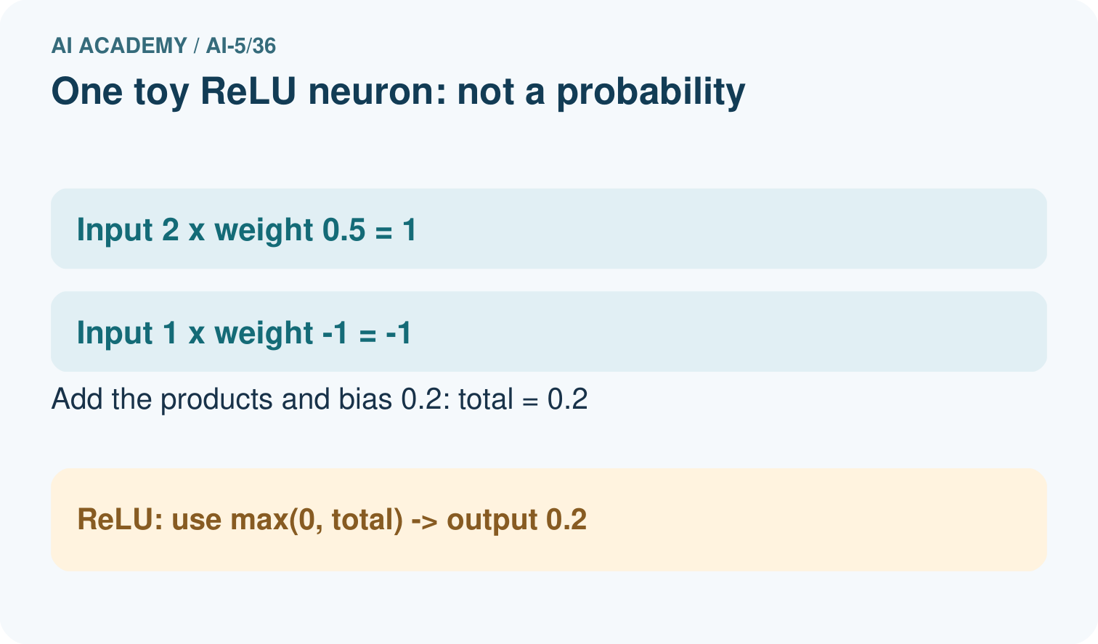
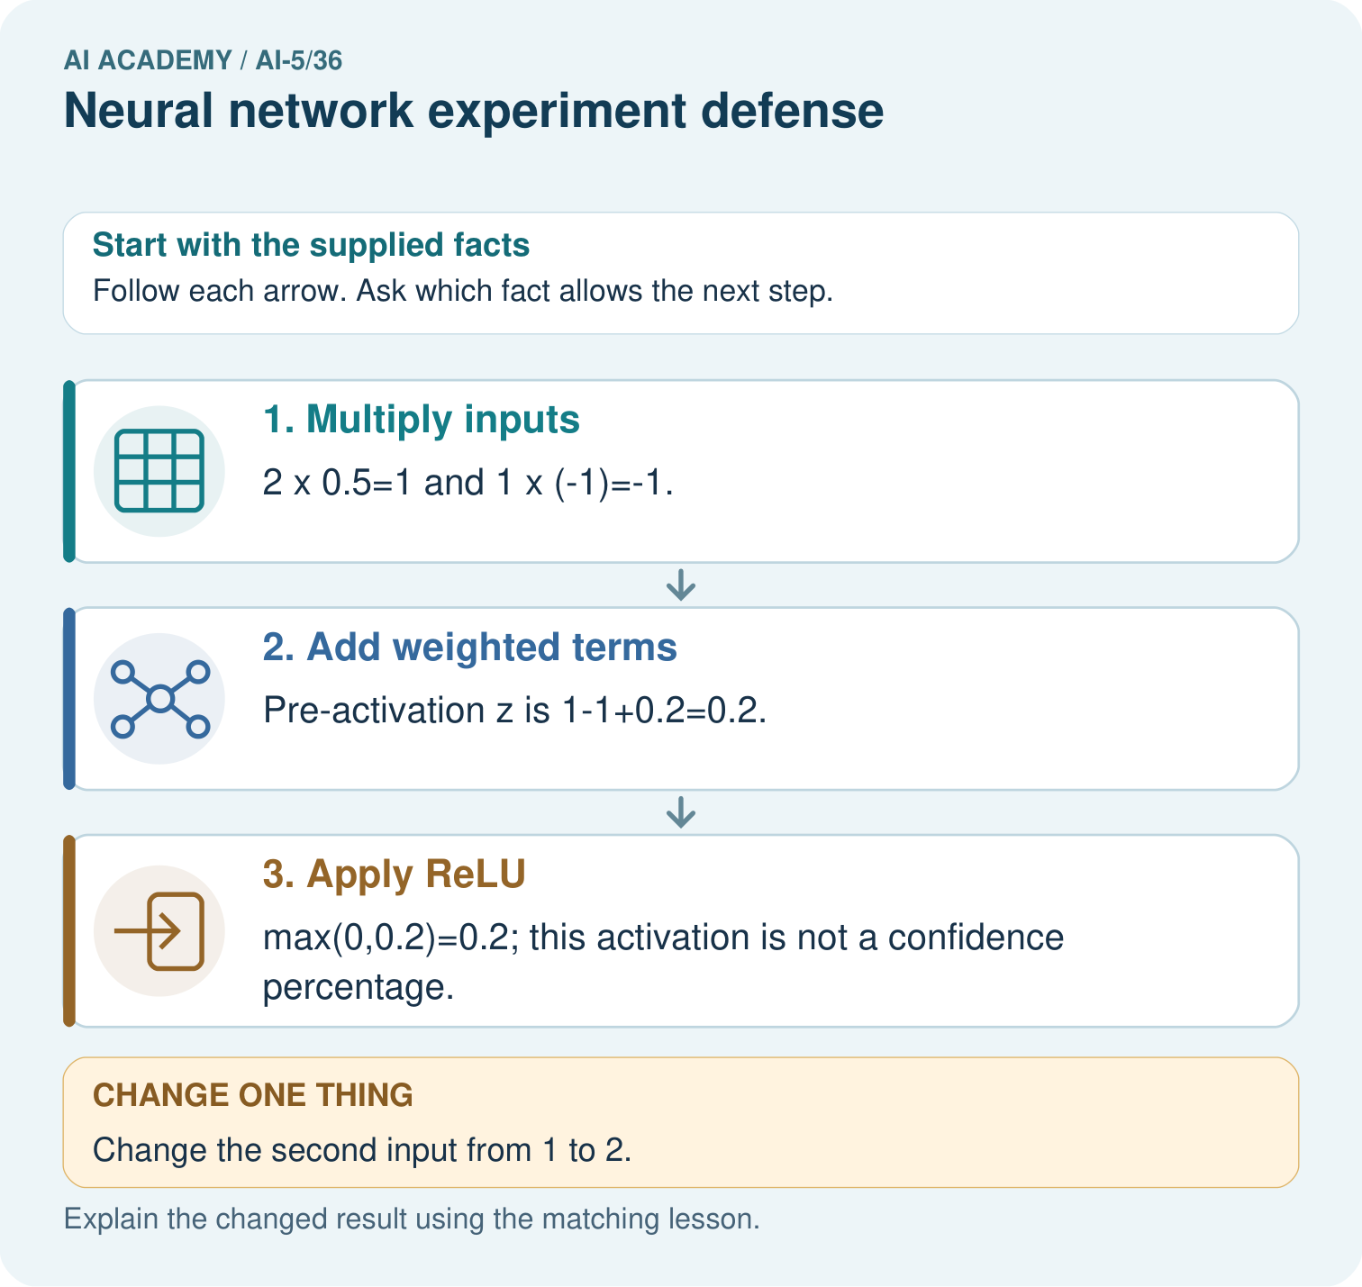
Calculate both weighted terms, z and ReLU output. Predict the changed second input and explain why 0.2 cannot be called 20% accuracy.

My picture-based explanation and changed-case prediction
________________________________________________________________
________________________________________________________________
________________________________________________________________
________________________________________________________________
________________________________________________________________
________________________________________________________________
Support used: alone / hint / worked example. This record is practice evidence.
Project connection: For the Image-pattern Network Investigation, save the labelled trace and the changed-case explanation beside the experiment record. State exactly what this example supports before linking it to the wider capstone claim.

13. Project portfolio milestone
Project: Image-pattern Network Investigation
Current milestone: Present and defend. Demonstrate the system, explain one failure and justify the next improvement with evidence.
For the Image-pattern Network Investigation, save the labelled trace and the changed-case explanation beside the experiment record. State exactly what this example supports before linking it to the wider capstone claim.
Evidence to keep | My record
This week’s input and deciding step
Prediction and actual result (or labelled paper trace)
One change since the previous checkpoint and why
One error or limit and the next test

Explain what this week adds to your project. Reuse last week’s record rather than starting again.
________________________________________________________________
________________________________________________________________
________________________________________________________________
________________________________________________________________
________________________________________________________________

