AI ACADEMY · WORKBOOK · ai-6/23

Deployment environments
Project: Grounded Learning Service

01. Recall and choose your starting point
Try the recall before opening notes. Then use a different colour or a labelled second line to correct your explanation.

Queues and asynchronous work
Without opening the old lesson, explain one key idea from Queues and asynchronous work. Give an example and a mistake that the idea helps you avoid.

My remembered idea, example and correction
________________________________________________________________
________________________________________________________________
________________________________________________________________

Data retention and deletion
Without opening the old lesson, explain one key idea from Data retention and deletion. Give an example and a mistake that the idea helps you avoid.

My remembered idea, example and correction
________________________________________________________________
________________________________________________________________
________________________________________________________________

External side effects and recovery
Without opening the old lesson, explain one key idea from External side effects and recovery. Give an example and a mistake that the idea helps you avoid.

My remembered idea, example and correction
________________________________________________________________
________________________________________________________________
________________________________________________________________

02. Practise with fading help
Use W2: Trace the worked case for Deployment environments. Record the answer once; the lesson and workbook refer to the same attempt.
Given inputs | Procedure I chose | Middle steps | Result and check

The step I completed without help, and the hint I needed
________________________________________________________________
________________________________________________________________
________________________________________________________________

03. Individual reasoning check
Use the worked case for Deployment environments. Proposed explanation: “The worked result establishes every future case”. Decide whether this explanation is supported. Point to the step or supplied fact that decides; explain your repair if needed.

My explanation before partner discussion
________________________________________________________________
________________________________________________________________
________________________________________________________________
________________________________________________________________

04. Independent transfer case

Independent case: Apply a new case independently
Development uses fake records but a production token. What boundary is violated?

My independent explanation, trace and limits
________________________________________________________________
________________________________________________________________
________________________________________________________________
________________________________________________________________
________________________________________________________________
________________________________________________________________
________________________________________________________________
Attempt this case before feedback. Record any help. Earlier examples below are further practice; a case already practised with feedback cannot establish fresh transfer.

05. W1 Explain the mechanism
Explain the weekly mechanism in your own words. Use the worked scenario to name its input, decision rule and output.

My reasoning and evidence
________________________________________________________________
________________________________________________________________
________________________________________________________________
________________________________________________________________
________________________________________________________________
________________________________________________________________

06. W2 Trace the worked case
Staging configuration points to production storage while the interface displays staging. Show the intermediate steps and give the conclusion with its scope.

My reasoning and evidence
________________________________________________________________
________________________________________________________________
________________________________________________________________
________________________________________________________________
________________________________________________________________
________________________________________________________________
________________________________________________________________

07. W3 Audit the limit
A report omits this qualification: Passing staging tests does not prove production limits or operational conditions are identical. Explain how omitting it could change a reader's interpretation, and write an accurate replacement.

My reasoning and evidence
________________________________________________________________
________________________________________________________________
________________________________________________________________
________________________________________________________________
________________________________________________________________
________________________________________________________________

08. W4 Apply a new case independently
Development uses fake records but a production token. What boundary is violated?

My reasoning and evidence
________________________________________________________________
________________________________________________________________
________________________________________________________________
________________________________________________________________
________________________________________________________________
________________________________________________________________
________________________________________________________________
________________________________________________________________

09. W5 Design a revealing follow-up
For the worked scenario, propose one additional case that could reveal a failure, describe its expected outcome before running it, and explain what would need to remain fixed for a fair comparison. Do not reuse W4 as a new final test after receiving feedback.

My reasoning and evidence
________________________________________________________________
________________________________________________________________
________________________________________________________________
________________________________________________________________
________________________________________________________________
________________________________________________________________
________________________________________________________________

10. Project checkpoint and reflection
Add a labelled deployment environments evidence sheet to Grounded Learning Service. Show how you can explain the mechanism and terminology of deployment environments. Use the supplied fictional case and keep its inputs, intermediate steps, calculation or prediction, and limitation. Connect this record to last week’s record; a matching answer without a trace is insufficient.

My project change, supporting evidence and remaining limit
________________________________________________________________
________________________________________________________________
________________________________________________________________
________________________________________________________________
________________________________________________________________
________________________________________________________________

11. Feedback, return check and learning record
Evidence | My record
Worked alone / hint / model
First step I repaired and why
New case checked later; date and result
What I can now explain without notes
One remaining question
Revisit this idea with your teacher after a delay. Familiarity is different from explaining and using it on a changed case.

12. Pictorial case practice: Deployment environments
Separate rehearsal and live service. Staging rehearses a new answer version with fictional records; production serves approved school records.
Staging card names trial room Z; production card names room A. Credentials and stores are separate.
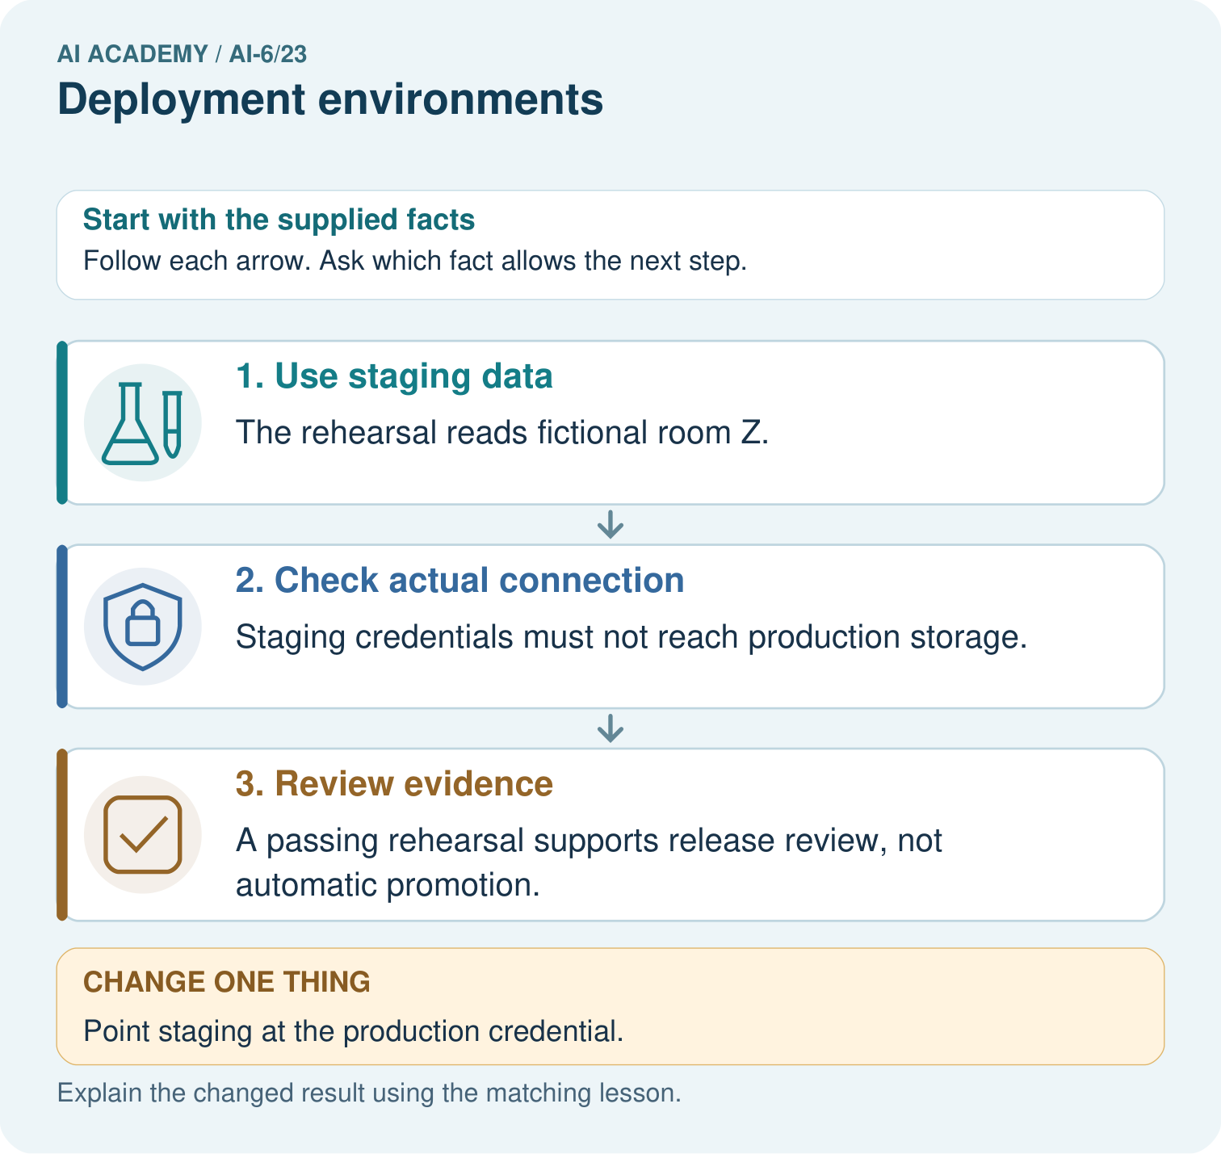
Identify the staging data and credential boundary. Why must the rehearsal stop if its credential reaches production even though the process is labelled staging?

My picture-based explanation and changed-case prediction
________________________________________________________________
________________________________________________________________
________________________________________________________________
________________________________________________________________
________________________________________________________________
________________________________________________________________
Support used: alone / hint / worked example. This record is practice evidence.
Project connection: For the Grounded Learning Service, retain an annotated trace and the changed-case result. Name the contract or evidence that makes the deciding step valid, so another team can review it.

13. Project portfolio milestone
Project: Grounded Learning Service
Current milestone: Evaluate and revise. Compare with your starting method, explain errors and record a justified revision.
For the Grounded Learning Service, retain an annotated trace and the changed-case result. Name the contract or evidence that makes the deciding step valid, so another team can review it.
Evidence to keep | My record
This week’s input and deciding step
Prediction and actual result (or labelled paper trace)
One change since the previous checkpoint and why
One error or limit and the next test

Explain what this week adds to your project. Reuse last week’s record rather than starting again.
________________________________________________________________
________________________________________________________________
________________________________________________________________
________________________________________________________________
________________________________________________________________

