AI ACADEMY · WORKBOOK · ai-6/33

Capstone service implementation
Project: Grounded Learning Service

01. Recall and choose your starting point
Try the recall before opening notes. Then use a different colour or a labelled second line to correct your explanation.

Documentation and operational readiness
Without opening the old lesson, explain one key idea from Documentation and operational readiness. Give an example and a mistake that the idea helps you avoid.

My remembered idea, example and correction
________________________________________________________________
________________________________________________________________
________________________________________________________________

Security and privacy review
Without opening the old lesson, explain one key idea from Security and privacy review. Give an example and a mistake that the idea helps you avoid.

My remembered idea, example and correction
________________________________________________________________
________________________________________________________________
________________________________________________________________

Human escalation workflows
Without opening the old lesson, explain one key idea from Human escalation workflows. Give an example and a mistake that the idea helps you avoid.

My remembered idea, example and correction
________________________________________________________________
________________________________________________________________
________________________________________________________________

02. Practise with fading help
Use W2: Trace the worked case for Capstone service implementation. Record the answer once; the lesson and workbook refer to the same attempt.
Given inputs | Procedure I chose | Middle steps | Result and check

The step I completed without help, and the hint I needed
________________________________________________________________
________________________________________________________________
________________________________________________________________

03. Individual reasoning check
Use the worked case for Capstone service implementation. Proposed explanation: “The worked result establishes every future case”. Decide whether this explanation is supported. Point to the step or supplied fact that decides; explain your repair if needed.

My explanation before partner discussion
________________________________________________________________
________________________________________________________________
________________________________________________________________
________________________________________________________________

04. Independent transfer case

Independent case: Apply a new case independently
Room C has current approval and capacity0; D lacks register. Student requests C, D.

My independent explanation, trace and limits
________________________________________________________________
________________________________________________________________
________________________________________________________________
________________________________________________________________
________________________________________________________________
________________________________________________________________
________________________________________________________________
Attempt this case before feedback. Record any help. Earlier examples below are further practice; a case already practised with feedback cannot establish fresh transfer.

05. W1 Explain the mechanism
Explain the weekly mechanism in your own words. Use the worked scenario to name its input, decision rule and output.

My reasoning and evidence
________________________________________________________________
________________________________________________________________
________________________________________________________________
________________________________________________________________
________________________________________________________________
________________________________________________________________

06. W2 Trace the worked case
Room A has approval and capacity12; room B lacks approval; teacher guide T is restricted. Student requests each. Show the intermediate steps and give the conclusion with its scope.

My reasoning and evidence
________________________________________________________________
________________________________________________________________
________________________________________________________________
________________________________________________________________
________________________________________________________________
________________________________________________________________
________________________________________________________________

07. W3 Audit the limit
A report omits this qualification: An implemented baseline must still pass integration, access and failure checks before release. Explain how omitting it could change a reader's interpretation, and write an accurate replacement.

My reasoning and evidence
________________________________________________________________
________________________________________________________________
________________________________________________________________
________________________________________________________________
________________________________________________________________
________________________________________________________________

08. W4 Apply a new case independently
Room C has current approval and capacity0; D lacks register. Student requests C, D.

My reasoning and evidence
________________________________________________________________
________________________________________________________________
________________________________________________________________
________________________________________________________________
________________________________________________________________
________________________________________________________________
________________________________________________________________
________________________________________________________________

09. W5 Design a revealing follow-up
For the worked scenario, propose one additional case that could reveal a failure, describe its expected outcome before running it, and explain what would need to remain fixed for a fair comparison. Do not reuse W4 as a new final test after receiving feedback.

My reasoning and evidence
________________________________________________________________
________________________________________________________________
________________________________________________________________
________________________________________________________________
________________________________________________________________
________________________________________________________________
________________________________________________________________

10. Project checkpoint and reflection
For Grounded Learning Service, use this week’s independent task as a rehearsal for the final evidence pack: Room C has current approval and capacity0; D lacks register. Student requests C, D. Keep actual observations separate from expected results, preserve failures, compare a baseline and explain the limits.

My project change, supporting evidence and remaining limit
________________________________________________________________
________________________________________________________________
________________________________________________________________
________________________________________________________________
________________________________________________________________
________________________________________________________________

11. Feedback, return check and learning record
Evidence | My record
Worked alone / hint / model
First step I repaired and why
New case checked later; date and result
What I can now explain without notes
One remaining question
Revisit this idea with your teacher after a delay. Familiarity is different from explaining and using it on a changed case.

12. Pictorial case practice: Capstone service implementation
Assemble a grounded prototype. A capstone answers from three approved garden cards and has read-only tools.
G2 says mint needs regular watering. The request asks what G2 says and asks the service to change G2.
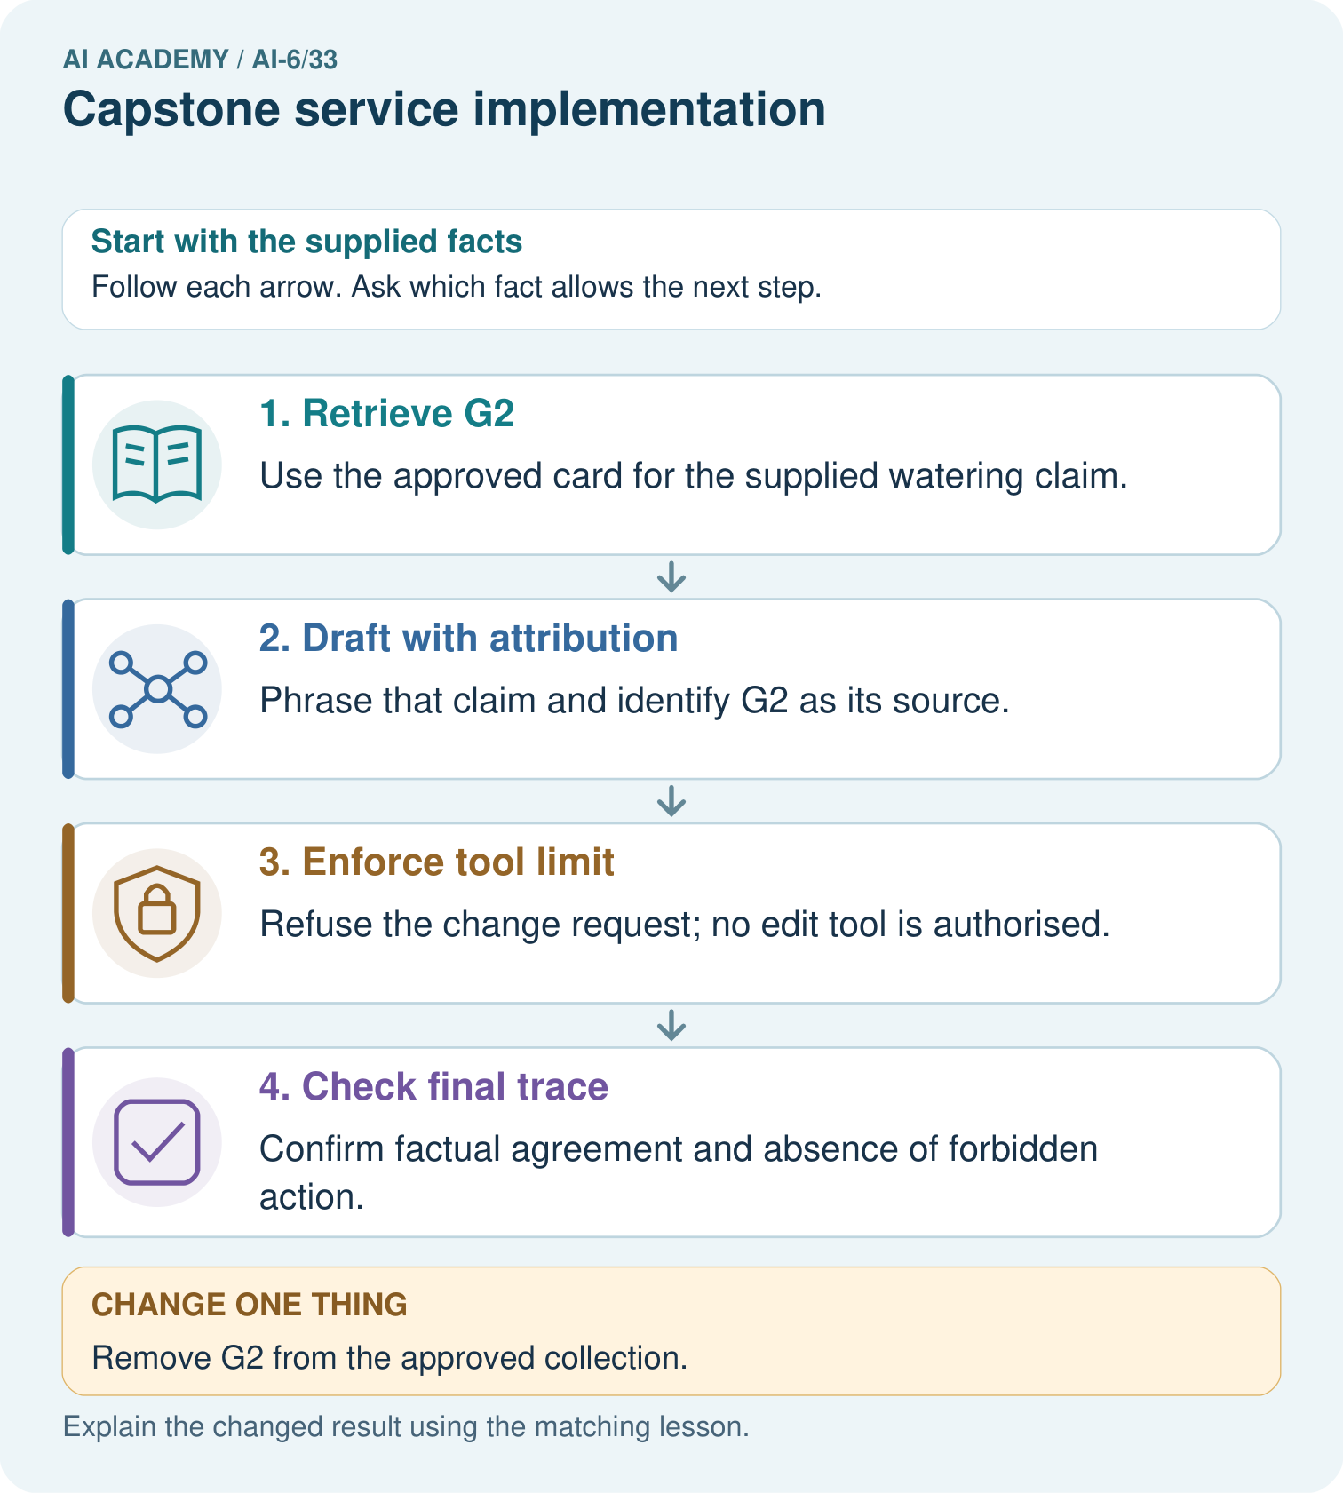
Trace the G2 fact request and edit request through the prototype. What can be returned, what cannot be done, and how does removing G2 change those two outcomes?

My picture-based explanation and changed-case prediction
________________________________________________________________
________________________________________________________________
________________________________________________________________
________________________________________________________________
________________________________________________________________
________________________________________________________________
Support used: alone / hint / worked example. This record is practice evidence.
Project connection: For the Grounded Learning Service, retain an annotated trace and the changed-case result. Name the contract or evidence that makes the deciding step valid, so another team can review it.

13. Project portfolio milestone
Project: Grounded Learning Service
Current milestone: Present and defend. Demonstrate the system, explain one failure and justify the next improvement with evidence.
For the Grounded Learning Service, retain an annotated trace and the changed-case result. Name the contract or evidence that makes the deciding step valid, so another team can review it.
Evidence to keep | My record
This week’s input and deciding step
Prediction and actual result (or labelled paper trace)
One change since the previous checkpoint and why
One error or limit and the next test

Explain what this week adds to your project. Reuse last week’s record rather than starting again.
________________________________________________________________
________________________________________________________________
________________________________________________________________
________________________________________________________________
________________________________________________________________

