AI ACADEMY · WORKBOOK · ai-7/16

Ablation studies
Project: Reproducible AI Research Study

01. Recall and choose your starting point
Try the recall before opening notes. Then use a different colour or a labelled second line to correct your explanation.

Multiple comparisons
Without opening the old lesson, explain one key idea from Multiple comparisons. Give an example and a mistake that the idea helps you avoid.

My remembered idea, example and correction
________________________________________________________________
________________________________________________________________
________________________________________________________________

Effect size and practical importance
Without opening the old lesson, explain one key idea from Effect size and practical importance. Give an example and a mistake that the idea helps you avoid.

My remembered idea, example and correction
________________________________________________________________
________________________________________________________________
________________________________________________________________

Confounders and controls
Without opening the old lesson, explain one key idea from Confounders and controls. Give an example and a mistake that the idea helps you avoid.

My remembered idea, example and correction
________________________________________________________________
________________________________________________________________
________________________________________________________________

02. Practise with fading help
Use W2: Trace the worked case for Ablation studies. Record the answer once; the lesson and workbook refer to the same attempt.
Given inputs | Procedure I chose | Middle steps | Result and check

The step I completed without help, and the hint I needed
________________________________________________________________
________________________________________________________________
________________________________________________________________

03. Individual reasoning check
Use the worked case for Ablation studies. Proposed explanation: “The worked result establishes every future case”. Decide whether this explanation is supported. Point to the step or supplied fact that decides; explain your repair if needed.

My explanation before partner discussion
________________________________________________________________
________________________________________________________________
________________________________________________________________
________________________________________________________________

04. Independent transfer case

Independent case: Apply a new case independently
Full12/15, without A9/15, without B11/15. Compute sample drops and state interaction limit.

My independent explanation, trace and limits
________________________________________________________________
________________________________________________________________
________________________________________________________________
________________________________________________________________
________________________________________________________________
________________________________________________________________
________________________________________________________________
Attempt this case before feedback. Record any help. Earlier examples below are further practice; a case already practised with feedback cannot establish fresh transfer.

05. W1 Explain the mechanism
Explain the weekly mechanism in your own words. Use the worked scenario to name its input, decision rule and output.

My reasoning and evidence
________________________________________________________________
________________________________________________________________
________________________________________________________________
________________________________________________________________
________________________________________________________________
________________________________________________________________

06. W2 Trace the worked case
Full system8/10, without retrieval5/10, without validation7/10; the last permits an unauthorised action. Show the intermediate steps and give the conclusion with its scope.

My reasoning and evidence
________________________________________________________________
________________________________________________________________
________________________________________________________________
________________________________________________________________
________________________________________________________________
________________________________________________________________
________________________________________________________________

07. W3 Audit the limit
A report omits this qualification: Removing a component changes a complete procedure; attribution depends on the controlled design and possible interactions. Explain how omitting it could change a reader's interpretation, and write an accurate replacement.

My reasoning and evidence
________________________________________________________________
________________________________________________________________
________________________________________________________________
________________________________________________________________
________________________________________________________________
________________________________________________________________

08. W4 Apply a new case independently
Full12/15, without A9/15, without B11/15. Compute sample drops and state interaction limit.

My reasoning and evidence
________________________________________________________________
________________________________________________________________
________________________________________________________________
________________________________________________________________
________________________________________________________________
________________________________________________________________
________________________________________________________________
________________________________________________________________

09. W5 Design a revealing follow-up
For the worked scenario, propose one additional case that could reveal a failure, describe its expected outcome before running it, and explain what would need to remain fixed for a fair comparison. Do not reuse W4 as a new final test after receiving feedback.

My reasoning and evidence
________________________________________________________________
________________________________________________________________
________________________________________________________________
________________________________________________________________
________________________________________________________________
________________________________________________________________
________________________________________________________________

10. Project checkpoint and reflection
Add a labelled ablation studies evidence sheet to Reproducible AI Research Study. Show how you can explain the mechanism and terminology of ablation studies. Use the supplied fictional case and keep its inputs, intermediate steps, calculation or prediction, and limitation. Connect this record to last week’s record; a matching answer without a trace is insufficient.

My project change, supporting evidence and remaining limit
________________________________________________________________
________________________________________________________________
________________________________________________________________
________________________________________________________________
________________________________________________________________
________________________________________________________________

11. Feedback, return check and learning record
Evidence | My record
Worked alone / hint / model
First step I repaired and why
New case checked later; date and result
What I can now explain without notes
One remaining question
Revisit this idea with your teacher after a delay. Familiarity is different from explaining and using it on a changed case.

12. Pictorial case practice: Ablation studies
Remove one component at a time. A retrieval pipeline has search plus a relevance filter. A team tests the filter’s contribution.
Full pipeline: 8/10 correct. Filter removed: 6/10 on the same cases, with all other settings fixed.
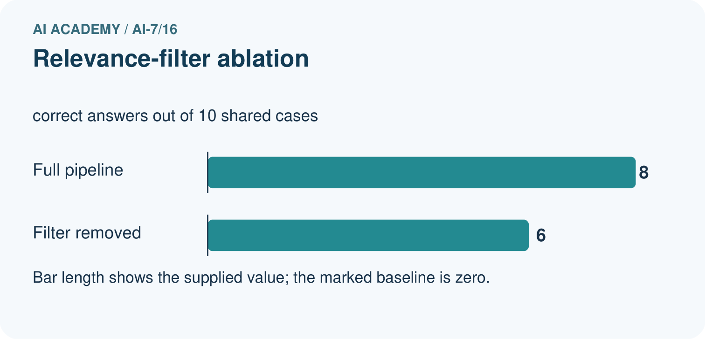
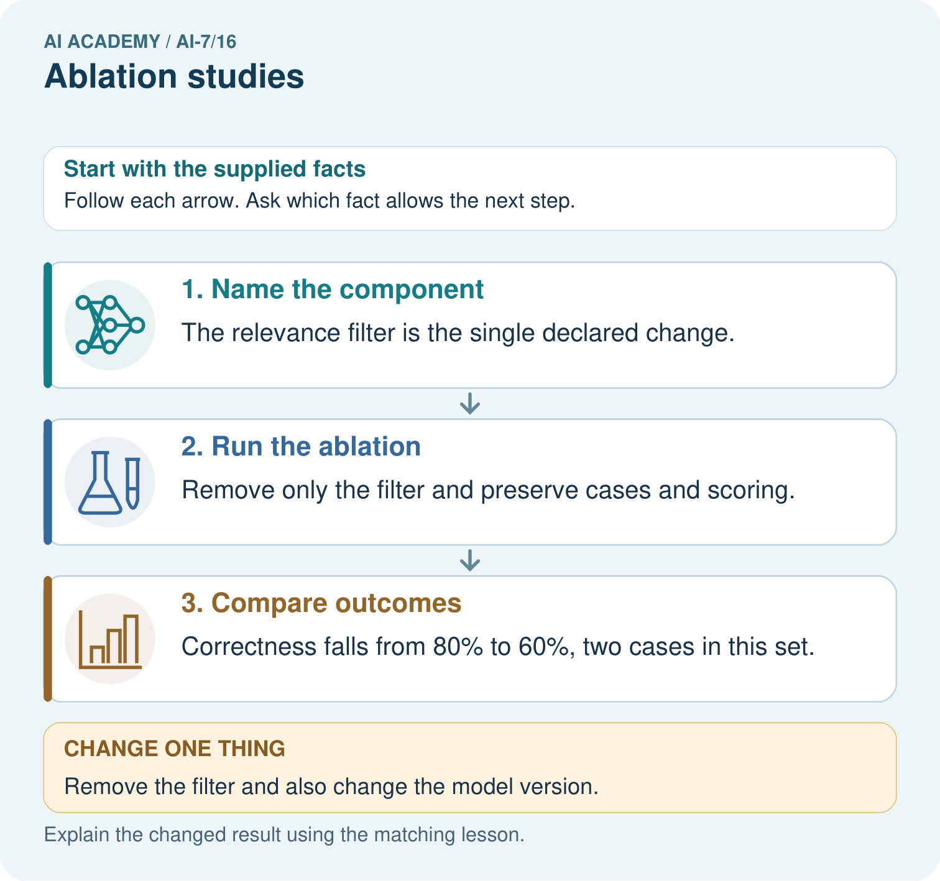
Calculate the filter ablation’s two rates and count change. Which single component is altered, and why does also changing the model prevent isolating the filter?

My picture-based explanation and changed-case prediction
________________________________________________________________
________________________________________________________________
________________________________________________________________
________________________________________________________________
________________________________________________________________
________________________________________________________________
Support used: alone / hint / worked example. This record is practice evidence.
Project connection: For the Reproducible AI Research Study, retain an annotated worked trace and the changed-case reasoning. Connect the claim to its records, units and assumptions so another investigator can challenge or reproduce it.

13. Project portfolio milestone
Project: Reproducible AI Research Study
Current milestone: Test changed cases. Keep normal, boundary and failure cases; compare expected and observed results.
For the Reproducible AI Research Study, retain an annotated worked trace and the changed-case reasoning. Connect the claim to its records, units and assumptions so another investigator can challenge or reproduce it.
Evidence to keep | My record
This week’s input and deciding step
Prediction and actual result (or labelled paper trace)
One change since the previous checkpoint and why
One error or limit and the next test

Explain what this week adds to your project. Reuse last week’s record rather than starting again.
________________________________________________________________
________________________________________________________________
________________________________________________________________
________________________________________________________________
________________________________________________________________

