AI ACADEMY · WORKBOOK · ai-7/32

Peer review and response
Project: Reproducible AI Research Study

01. Recall and choose your starting point
Try the recall before opening notes. Then use a different colour or a labelled second line to correct your explanation.

Writing results and limitations
Without opening the old lesson, explain one key idea from Writing results and limitations. Give an example and a mistake that the idea helps you avoid.

My remembered idea, example and correction
________________________________________________________________
________________________________________________________________
________________________________________________________________

Figures that preserve evidence
Without opening the old lesson, explain one key idea from Figures that preserve evidence. Give an example and a mistake that the idea helps you avoid.

My remembered idea, example and correction
________________________________________________________________
________________________________________________________________
________________________________________________________________

Inspecting failures and anomalies
Without opening the old lesson, explain one key idea from Inspecting failures and anomalies. Give an example and a mistake that the idea helps you avoid.

My remembered idea, example and correction
________________________________________________________________
________________________________________________________________
________________________________________________________________

02. Practise with fading help
Use W2: Trace the worked case for Peer review and response. Record the answer once; the lesson and workbook refer to the same attempt.
Given inputs | Procedure I chose | Middle steps | Result and check

The step I completed without help, and the hint I needed
________________________________________________________________
________________________________________________________________
________________________________________________________________

03. Individual reasoning check
Use the worked case for Peer review and response. Proposed explanation: “The worked result establishes every future case”. Decide whether this explanation is supported. Point to the step or supplied fact that decides; explain your repair if needed.

My explanation before partner discussion
________________________________________________________________
________________________________________________________________
________________________________________________________________
________________________________________________________________

04. Independent transfer case

Independent case: Apply a new case independently
Reviewer notes missing failure counts; author deletes the limitation paragraph. What is an adequate response?

My independent explanation, trace and limits
________________________________________________________________
________________________________________________________________
________________________________________________________________
________________________________________________________________
________________________________________________________________
________________________________________________________________
________________________________________________________________
Attempt this case before feedback. Record any help. Earlier examples below are further practice; a case already practised with feedback cannot establish fresh transfer.

05. W1 Explain the mechanism
Explain the weekly mechanism in your own words. Use the worked scenario to name its input, decision rule and output.

My reasoning and evidence
________________________________________________________________
________________________________________________________________
________________________________________________________________
________________________________________________________________
________________________________________________________________
________________________________________________________________

06. W2 Trace the worked case
Reviewer asks for a fitted-line baseline; author responds that the neural network is advanced, without a comparison. Show the intermediate steps and give the conclusion with its scope.

My reasoning and evidence
________________________________________________________________
________________________________________________________________
________________________________________________________________
________________________________________________________________
________________________________________________________________
________________________________________________________________
________________________________________________________________

07. W3 Audit the limit
A report omits this qualification: Agreement with a reviewer is not required, but a disagreement needs explicit reasoning and evidence. Explain how omitting it could change a reader's interpretation, and write an accurate replacement.

My reasoning and evidence
________________________________________________________________
________________________________________________________________
________________________________________________________________
________________________________________________________________
________________________________________________________________
________________________________________________________________

08. W4 Apply a new case independently
Reviewer notes missing failure counts; author deletes the limitation paragraph. What is an adequate response?

My reasoning and evidence
________________________________________________________________
________________________________________________________________
________________________________________________________________
________________________________________________________________
________________________________________________________________
________________________________________________________________
________________________________________________________________
________________________________________________________________

09. W5 Design a revealing follow-up
For the worked scenario, propose one additional case that could reveal a failure, describe its expected outcome before running it, and explain what would need to remain fixed for a fair comparison. Do not reuse W4 as a new final test after receiving feedback.

My reasoning and evidence
________________________________________________________________
________________________________________________________________
________________________________________________________________
________________________________________________________________
________________________________________________________________
________________________________________________________________
________________________________________________________________

10. Project checkpoint and reflection
Add a labelled peer review and response evidence sheet to Reproducible AI Research Study. Show how you can explain the mechanism and terminology of peer review and response. Use the supplied fictional case and keep its inputs, intermediate steps, calculation or prediction, and limitation. Connect this record to last week’s record; a matching answer without a trace is insufficient.

My project change, supporting evidence and remaining limit
________________________________________________________________
________________________________________________________________
________________________________________________________________
________________________________________________________________
________________________________________________________________
________________________________________________________________

11. Feedback, return check and learning record
Evidence | My record
Worked alone / hint / model
First step I repaired and why
New case checked later; date and result
What I can now explain without notes
One remaining question
Revisit this idea with your teacher after a delay. Familiarity is different from explaining and using it on a changed case.

12. Pictorial case practice: Peer review and response
Respond to a reviewer with evidence. A reviewer asks why four photos of one plant were treated as four independent plants.
The original table contains four views of P1 and four views of P2: eight photos from two plants.
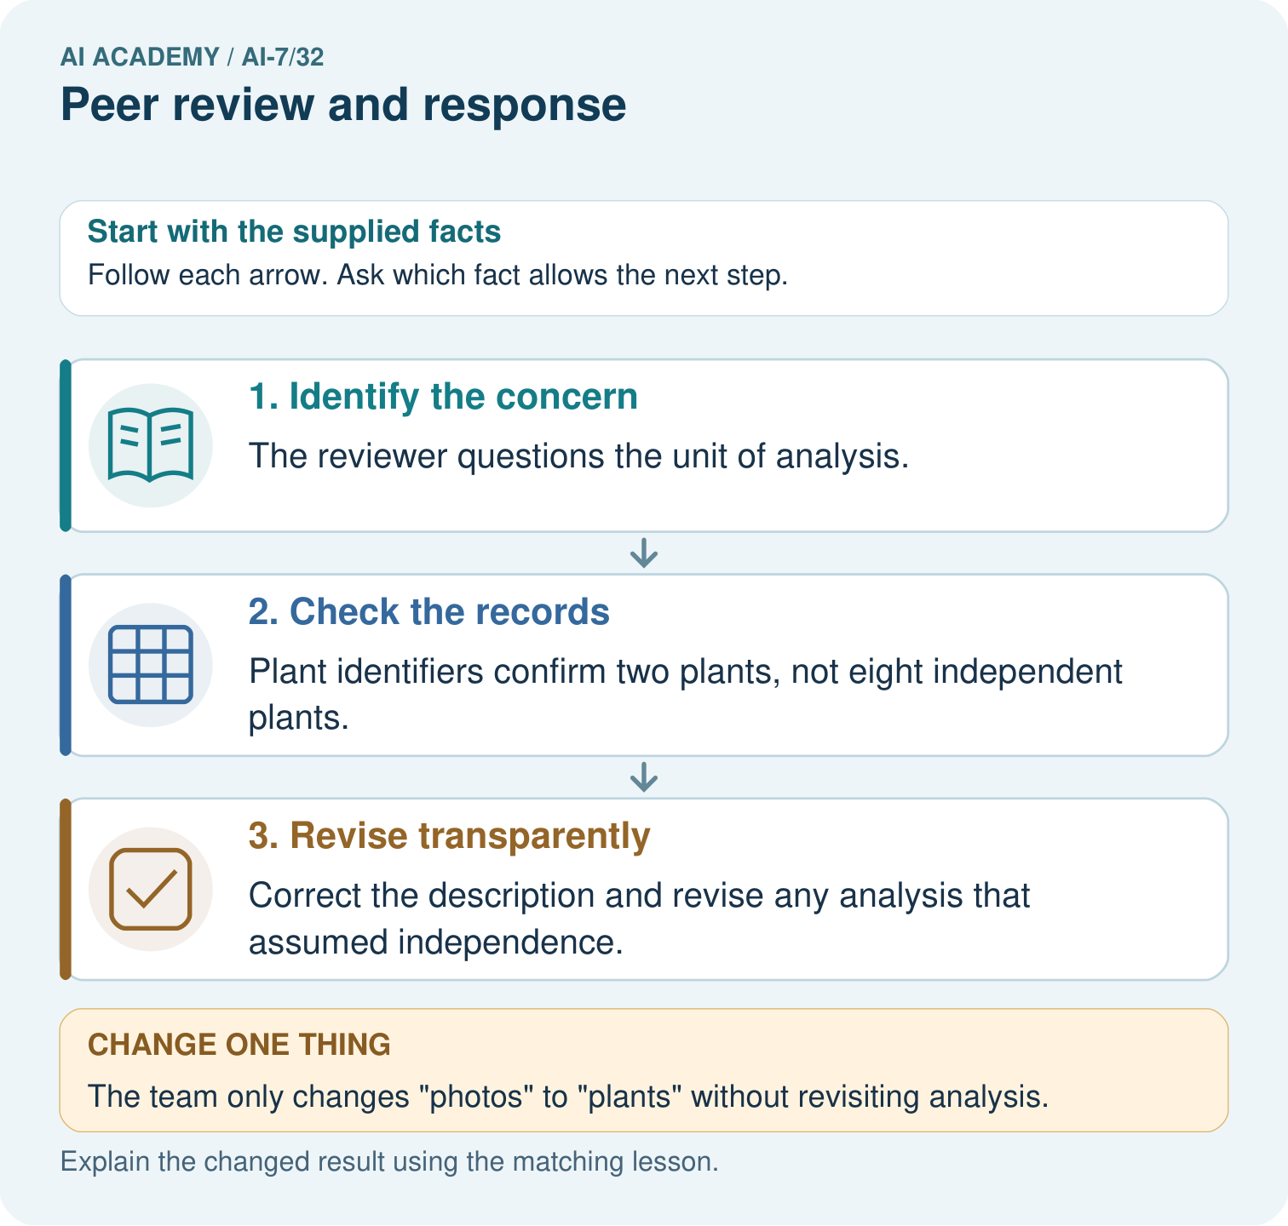
Count photos and underlying plants in the reviewer’s concern. What analysis assumption needs revision, and why does changing only the word photos to plants fail to repair it?

My picture-based explanation and changed-case prediction
________________________________________________________________
________________________________________________________________
________________________________________________________________
________________________________________________________________
________________________________________________________________
________________________________________________________________
Support used: alone / hint / worked example. This record is practice evidence.
Project connection: For the Reproducible AI Research Study, retain an annotated worked trace and the changed-case reasoning. Connect the claim to its records, units and assumptions so another investigator can challenge or reproduce it.

13. Project portfolio milestone
Project: Reproducible AI Research Study
Current milestone: Present and defend. Demonstrate the system, explain one failure and justify the next improvement with evidence.
For the Reproducible AI Research Study, retain an annotated worked trace and the changed-case reasoning. Connect the claim to its records, units and assumptions so another investigator can challenge or reproduce it.
Evidence to keep | My record
This week’s input and deciding step
Prediction and actual result (or labelled paper trace)
One change since the previous checkpoint and why
One error or limit and the next test

Explain what this week adds to your project. Reuse last week’s record rather than starting again.
________________________________________________________________
________________________________________________________________
________________________________________________________________
________________________________________________________________
________________________________________________________________

