AI ACADEMY · WORKBOOK · python-bridge/9

Return values and local state
Project: Python readiness portfolio

01. Recall and choose your starting point
Try the recall before opening notes. Then use a different colour or a labelled second line to correct your explanation.

Functions and arguments
Without opening the old lesson, explain one key idea from Functions and arguments. Give an example and a mistake that the idea helps you avoid.

My remembered idea, example and correction
________________________________________________________________
________________________________________________________________
________________________________________________________________

Loops and trace tables
Without opening the old lesson, explain one key idea from Loops and trace tables. Give an example and a mistake that the idea helps you avoid.

My remembered idea, example and correction
________________________________________________________________
________________________________________________________________
________________________________________________________________

Expressions and operator order
Without opening the old lesson, explain one key idea from Expressions and operator order. Give an example and a mistake that the idea helps you avoid.

My remembered idea, example and correction
________________________________________________________________
________________________________________________________________
________________________________________________________________

02. Practise with fading help
Use W2: Trace separate calls for Return values and local state. Record the answer once; the lesson and workbook refer to the same attempt.
Given inputs | Procedure I chose | Middle steps | Result and check

The step I completed without help, and the hint I needed
________________________________________________________________
________________________________________________________________
________________________________________________________________

03. Individual reasoning check
Use the worked case for Return values and local state. Proposed explanation: “Printing a value returns that value”. Decide whether this explanation is supported. Point to the step or supplied fact that decides; explain your repair if needed.

My explanation before partner discussion
________________________________________________________________
________________________________________________________________
________________________________________________________________
________________________________________________________________

04. Independent transfer case

Independent case: Use returns and keep local state local
Trace both calls and the final expression. If return total is removed from the function, does this final print complete? Would a separate print(total) outside the function have access to its local variable?
def twice(n):
total = 2 * n
return total
first = twice(3)
second = twice(5)
print(first, second, first + second)

My independent explanation, trace and limits
________________________________________________________________
________________________________________________________________
________________________________________________________________
________________________________________________________________
________________________________________________________________
________________________________________________________________
________________________________________________________________
Attempt this case before feedback. Record any help. Earlier examples below are further practice; a case already practised with feedback cannot establish fresh transfer.

05. W1 Separate returning from displaying
Using the correct worked definition, execute result = remaining(15, 6), then doubled = result * 2. State both stored values and what the script displays before a print statement is added.

My reasoning and evidence
________________________________________________________________
________________________________________________________________
________________________________________________________________
________________________________________________________________
________________________________________________________________
________________________________________________________________

06. W2 Trace separate calls
Using the correct definition, store a = remaining(8, 3), b = remaining(8, 8), c = remaining(8, 3). State a, b and c. In a fresh script, explain why print(spaces) outside the function fails.

My reasoning and evidence
________________________________________________________________
________________________________________________________________
________________________________________________________________
________________________________________________________________
________________________________________________________________
________________________________________________________________

07. W3 Repair the returned value
Use the faulty printing version with answer = remaining(11, 2). State the displayed number and the value stored in answer. Explain why print(answer + 1) fails, then repair the function and predict the repaired output.

My reasoning and evidence
________________________________________________________________
________________________________________________________________
________________________________________________________________
________________________________________________________________
________________________________________________________________
________________________________________________________________

08. W4 Build a reusable calculation independently
Each tray holds 5 counters. Define stock(trays, loose) to return the total using a local variable total. Assume nonnegative integer arguments. Store results for (2, 3), (0, 3) and (2, 0). Print the sum of the first two stored results. Predict that output and all three stored values. Call (2, 3) again to check fresh state.

My reasoning and evidence
________________________________________________________________
________________________________________________________________
________________________________________________________________
________________________________________________________________
________________________________________________________________
________________________________________________________________
________________________________________________________________
________________________________________________________________

09. W5 Locate a statement that never runs
A function body has spaces = capacity - used, then return spaces, then print("done"), all at the same indentation. What does answer = remaining(4, 4) store and display? Explain whether the final print can run.

My reasoning and evidence
________________________________________________________________
________________________________________________________________
________________________________________________________________
________________________________________________________________
________________________________________________________________
________________________________________________________________

10. Project checkpoint and reflection
Add a labelled return values and local state evidence sheet to Python readiness portfolio. Show how you can use a returned value in a later calculation. Use the supplied fictional case and keep its inputs, intermediate steps, calculation or prediction, and limitation. Connect this record to last week’s record; a matching answer without a trace is insufficient.

My project change, supporting evidence and remaining limit
________________________________________________________________
________________________________________________________________
________________________________________________________________
________________________________________________________________
________________________________________________________________
________________________________________________________________

11. Feedback, return check and learning record
Evidence | My record
Worked alone / hint / model
First step I repaired and why
New case checked later; date and result
What I can now explain without notes
One remaining question
Revisit this idea with your teacher after a delay. Familiarity is different from explaining and using it on a changed case.

12. Pictorial case practice: Return values and local state
Return values survive their calls. A function returns a local calculation that the caller stores.
Python 3: def extra(a,b): result=a+b; return result. Then first=extra(2,5); second=extra(4,1); print(first,second).
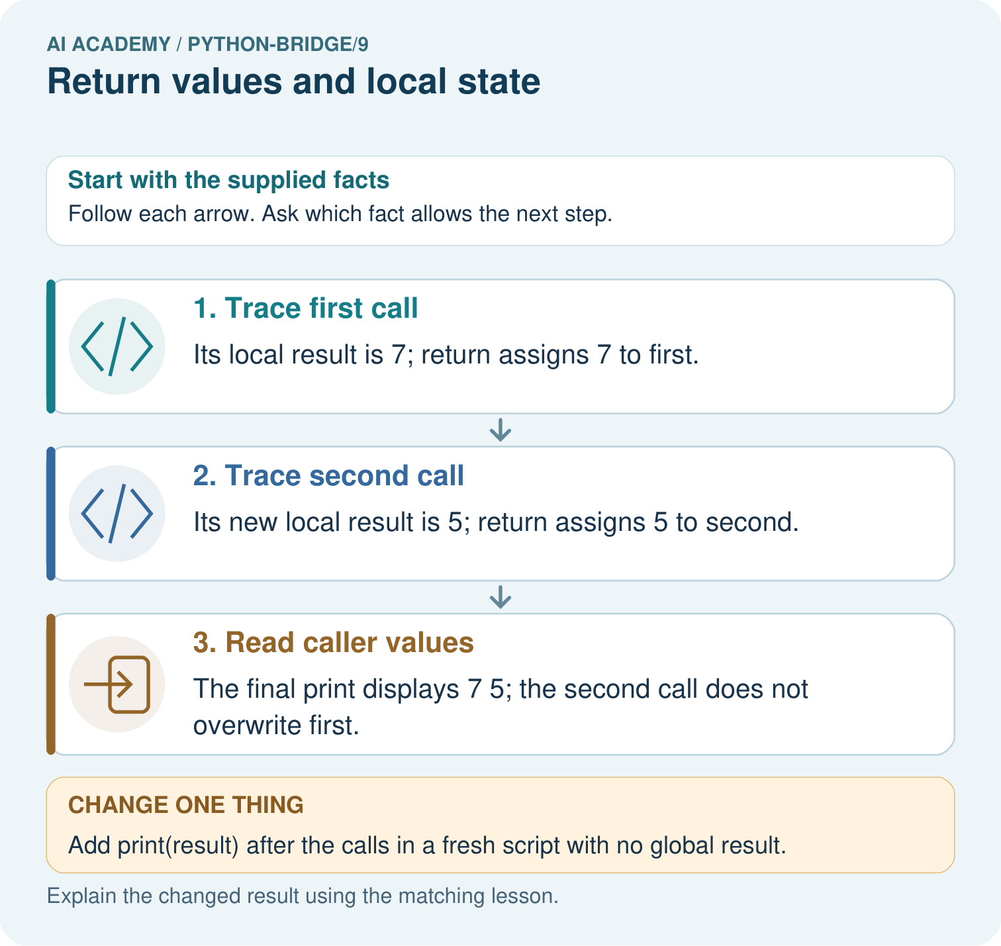
Trace the two returned values and explain why first stays seven. What happens if the caller tries to print result directly?

My picture-based explanation and changed-case prediction
________________________________________________________________
________________________________________________________________
________________________________________________________________
________________________________________________________________
________________________________________________________________
________________________________________________________________
Support used: alone / hint / worked example. This record is practice evidence.
Project connection: For Python readiness before the Responsible Plant Classifier, retain a trace of the values, the predicted outputs and the changed-case explanation. Use actual Python 3 results to check the prediction after reasoning first.

13. Project portfolio milestone
Project: Python readiness portfolio
Current milestone: Python readiness portfolio. Keep runnable code, predictions, actual outputs, one repaired error and an explanation of a function on changed inputs.
For Python readiness before the Responsible Plant Classifier, retain a trace of the values, the predicted outputs and the changed-case explanation. Use actual Python 3 results to check the prediction after reasoning first.
Evidence to keep | My record
This week’s input and deciding step
Prediction and actual result (or labelled paper trace)
One change since the previous checkpoint and why
One error or limit and the next test

Explain what this week adds to your project. Reuse last week’s record rather than starting again.
________________________________________________________________
________________________________________________________________
________________________________________________________________
________________________________________________________________
________________________________________________________________

