



Files Minification Tool (CSS&JS)

Version: :

Date Last Modified: : 13-Mar-2017

Document Owner : Sameer

This tool is used to minify the JS and CSS files.

Tool Flow Process Steps:

1. Run the tool with Administrator mode.
2. By using this tool minify the CSS and JS file with different scenarios
3. All JS and CSS files (Same Destination),
4. All JS and CSS files (Different Destination),
5. Single JS file (Same Destination),
6. Single JS file (Different Destination),
7. Single CSS file (Same Destination),
8. Single CSS file (Different Destination),
9. All JS files only (Same Destination),
10. All JS files only (Different Destination),
11. All CSS files only (Same Destination),
12. All CSS files only (Different Destination)

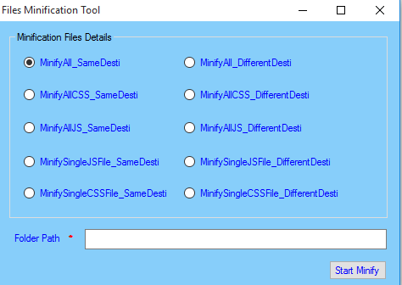

1. For running this tool some dll’s and .xml files are required, as shown below figure.

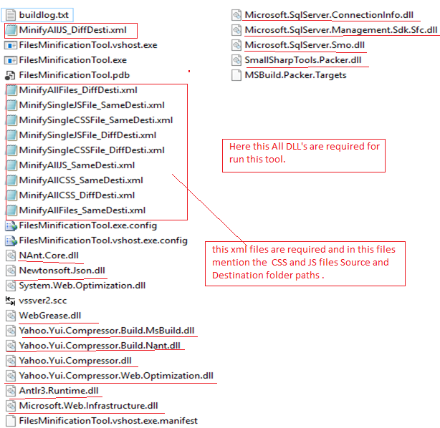

1. In this tool give the .exe file contains folder path, select any one radio button and mention the CSS and JS files source and destination paths in xml file with respective to selected radio button (condition) and click on “Start Minify” button.

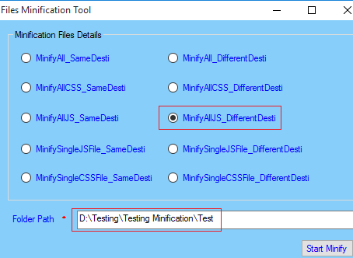

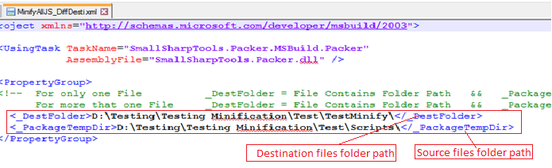

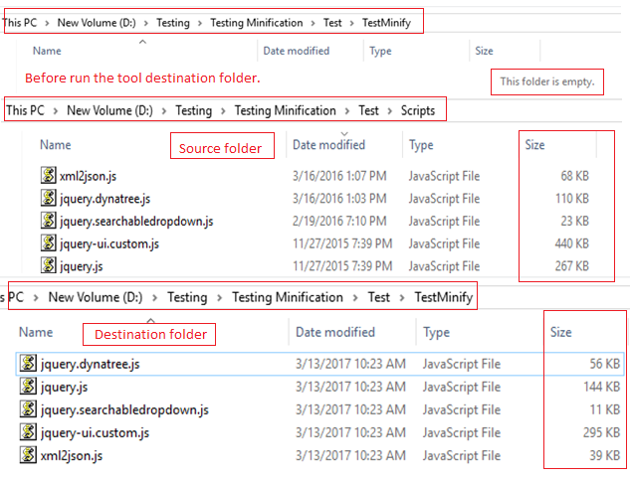

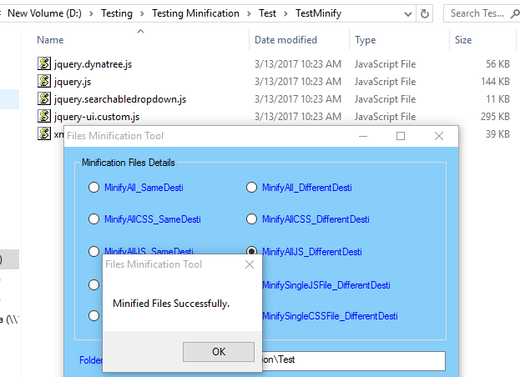

1. Like this minify the files in all this condition.