# SQLite3 Exercises: Employee Management System

**Employees:**

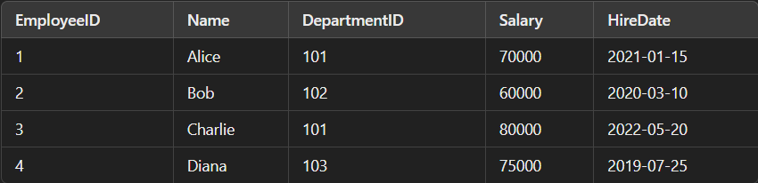

**Departments:**

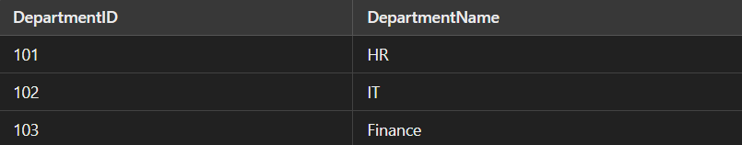

## Q1. Write a query to list the names of employees hired after January 1, 2021.

SQL Query:

SELECT Name FROM Employees WHERE HireDate > '2021-01-01';

Output:



## Q2. Write a query to calculate the average salary of employees in each department.

SQL Query:

SELECT DepartmentID, AVG(Salary) AS AverageSalary FROM Employees GROUP BY DepartmentID;

Output:



## Q3. Write a query to find the department name where the total salary is the highest.

SQL Query:

SELECT DepartmentName  
FROM Departments  
JOIN Employees ON Departments.DepartmentID = Employees.DepartmentID  
GROUP BY Departments.DepartmentID  
ORDER BY SUM(Employees.Salary) DESC  
LIMIT 1;

Output:



## Q4. Write a query to list all departments that currently have no employees assigned.

SQL Query:

SELECT DepartmentName  
FROM Departments  
LEFT JOIN Employees ON Departments.DepartmentID = Employees.DepartmentID  
WHERE Employees.EmployeeID IS NULL;

Output:

No output.

## Q5. Write a query to fetch all employee details along with their department names.

SQL Query:

SELECT Employees.*, Departments.DepartmentName  
FROM Employees  
JOIN Departments ON Employees.DepartmentID = Departments.DepartmentID;

Output:

