

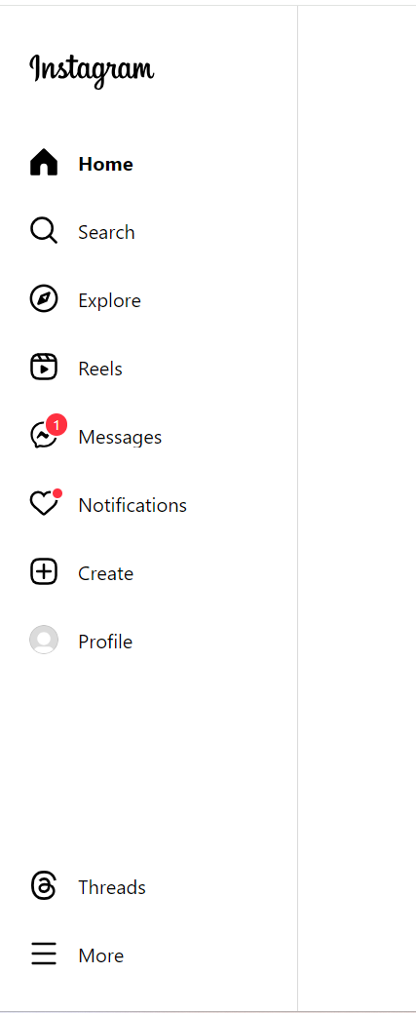





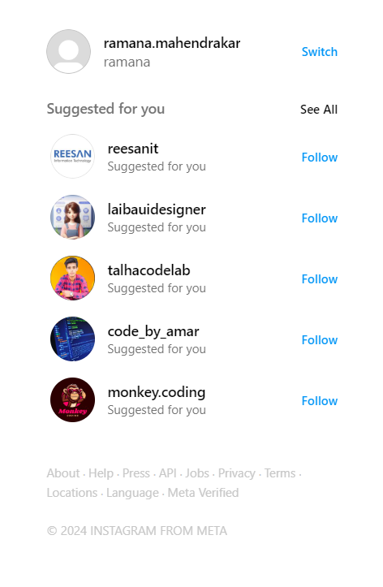

Icons

Send <i class="bi bi-send"></i> 

Heart <i class="bi bi-heart"></i> 

Chat <i class="bi bi-chat"></i> 

Bookmark <i class="bi bi-bookmark"></i> 

<i class="bi bi-three-dots"></i> 