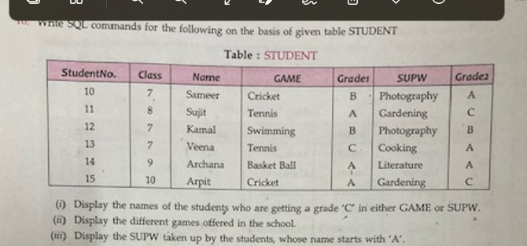

1. Select name from student where grade1=’C’ or Grade2=’C’;
2. Select distinct game from student;
3. Select supw from student where name like ‘A%’;

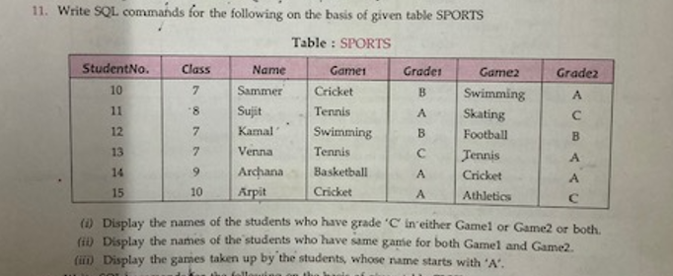

1. Select name from sports where Grade1=’C’ or Grade2=’C’;
2. Select name from sports where Game1=Game2;
3. Select Game1,Game2 from sports where name like ‘A%’;

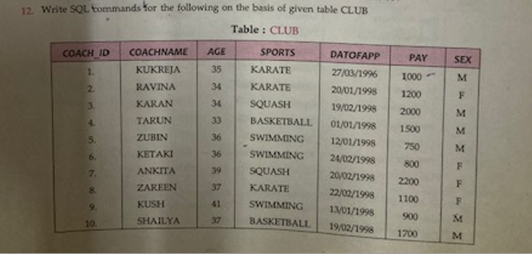

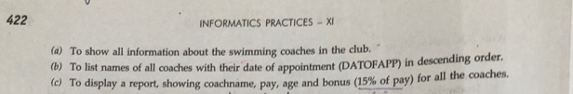

1. Select * from club where sports=’SWIMMING’;
2. Select coachname from club order by datofapp desc;
3. Select cochname,pay,age,0.15* pay from club;

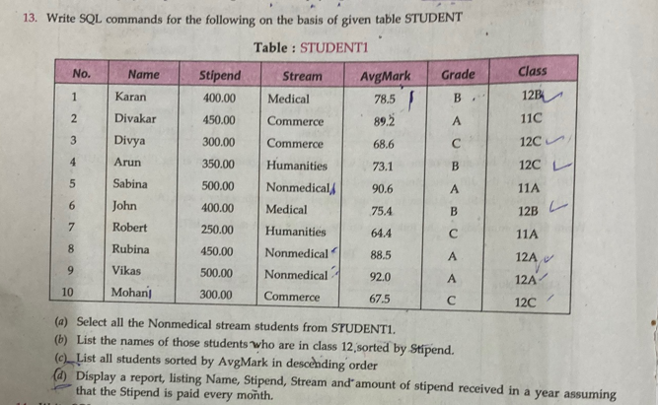

1. Select * from student1 where stream=’Nonmedical’;
2. Select name from student1 where class like ‘12A’ order by stipend;
3. Select * from student1 order by AvgMark desc;
4. Select name,stipend,stream, stipend*12 from student1;

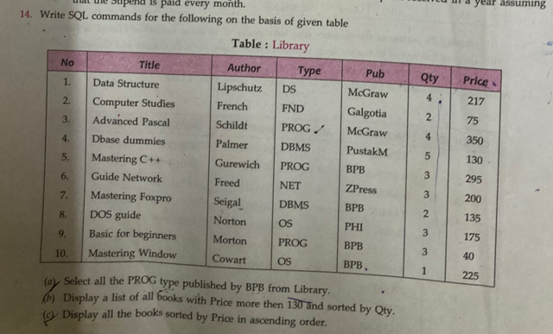

1. Select * from library where type=’PROG’ and pub=’BPB’;
2. Select * from library where price>130 order by qty;
3. Select * from library order by price;

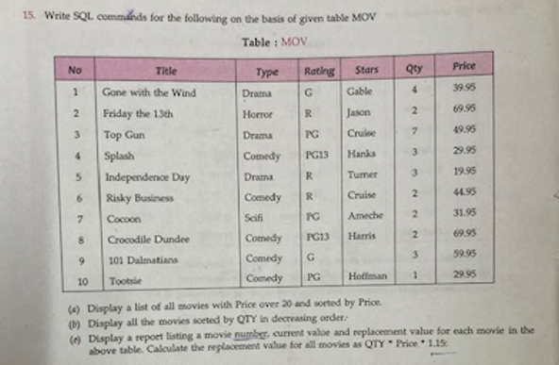

1. Select * from mov where price>20 order by price;
2. Select * from mov order by qty;
3. Select no,price,qty*price*1.15 from mov;

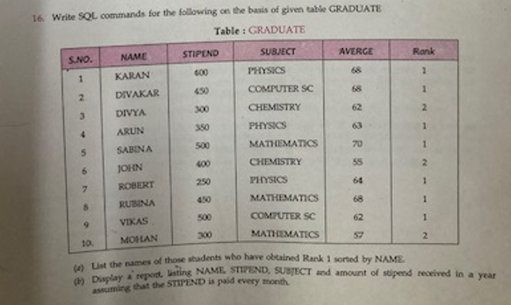

1. Select name from graduate where Rank=1 order by name;
2. Select name,stipend, subject, stipend*12 from graduate;

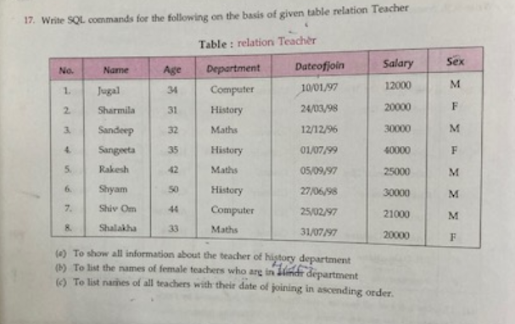

1. Select * from relationTeacher where department=’History’;
2. Select name from relationteacher where department=’History’ and sex=’F’;
3. Select name from relationteacher order by dateofjoin;

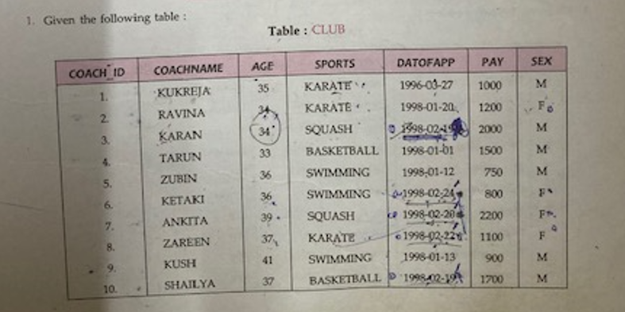

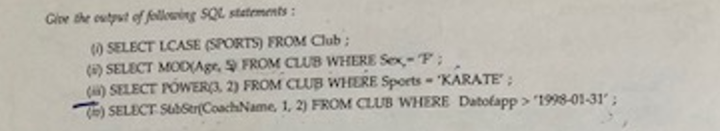

Answer a part

karate

karate

squash

basketball

swimming

swimming

squash

karate

swimming

basketball

Answer b part

4

1

4

2

Answer c part

9

9

9

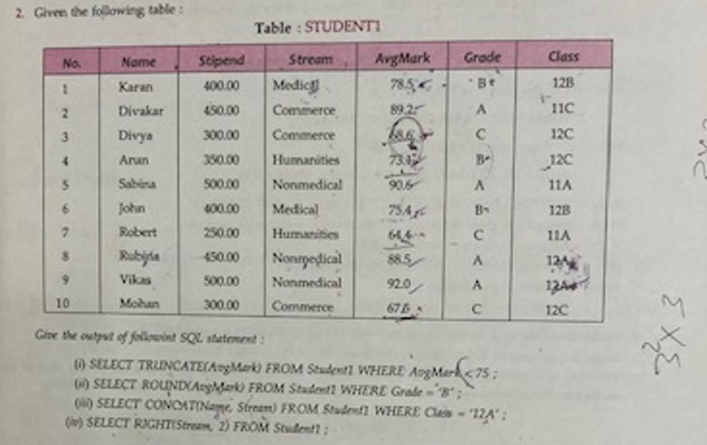

(a)

1. 68
2. 73
3. 64
4. 67

(b)

79

73

75

© RubinaNonmedical

VikasNonmedical

(d)

al

ce

ce

es

al

al

es

al

al

ce

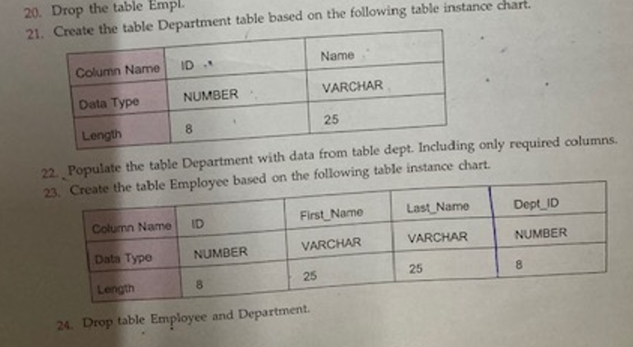

21.

Create table department(id int(8),varchar(25);

Insert into department values(1,’computers’);

Insert into department values(2,’electronics’);

Insert into department values(3,’mechanical’);

Create table employee(id int(8),first_name varchar(25),last_name varchar(25),dept_id int(8));

Drop table employee;

Drop table department

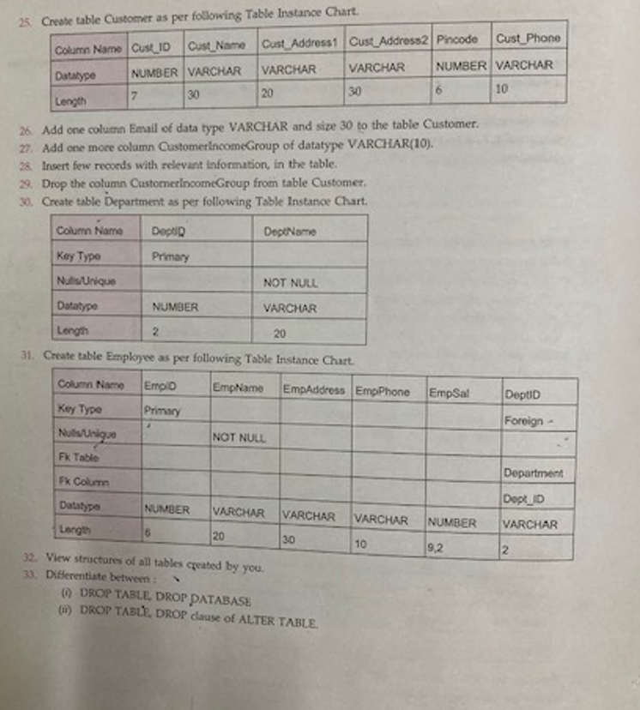

25.

Create table customer(cust_id int(7),cust_name varchar(30),cust_address1 varchar(20),cust_address2 varchar(20),pincode int(6),cust_phone varchar(10));

26. Alter table customer add column email varchar(20);

27. alter table customer add column customerIncomegroup varchar(10);

29. alter table customer drop column customerincomegroup;

30. create table department(deptid int primary key,deptname varchar(20) not null);

31. create table employee(empid int primary key,empname varchar(20) not null,empaddress varchar(30),empphone varchar(10), empsal decimal(9,2),deptid int references department(deptid));