Program to print Hello World in a Message Box on clicking on a button

Private Sub Command1_Click()
MsgBox ("Hello World")
End Sub

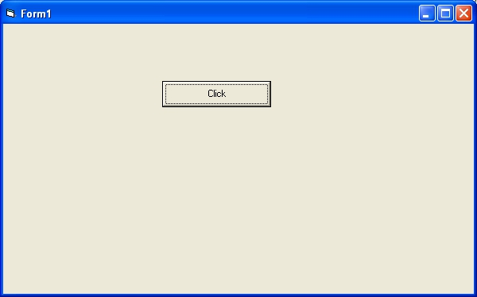
Program to add,subtract,multiply and divide two numbers

Private Sub Command1_Click()
Dim a As Integer
Dim b As Integer
Dim sum As Integer
a = CInt(Text1.Text)
b = CInt(Text2.Text)
sum = a + b
Label3.Caption = "Sum of Two Numbers is " & sum
End Sub

Private Sub Command2_Click()
Dim a As Integer
Dim b As Integer
Dim diff As Integer
a = CInt(Text1.Text)
b = CInt(Text2.Text)
diff = a - b
Label3.Caption = "Difference of Two Numbers is " & diff
End Sub

Private Sub Command3_Click()
Dim a As Integer
Dim b As Integer
Dim diff As Integer
a = CInt(Text1.Text)
b = CInt(Text2.Text)
product = a * b
Label3.Caption = "Product of Two Numbers is " & product
End Sub

Private Sub Command4_Click()
Dim a As Integer
Dim b As Integer
Dim quotient As Integer
a = CInt(Text1.Text)
b = CInt(Text2.Text)
quotient = a / b
Label3.Caption = "Quotient of Two Numbers is " & quotient
End Sub

Private Sub Command5_Click()
Dim a As Integer
Dim b As Integer
Dim remainder As Integer
a = CInt(Text1.Text)
b = CInt(Text2.Text)
remainder = a Mod b
Label3.Caption = "Remainder of Two Numbers is " & remainder
End Sub

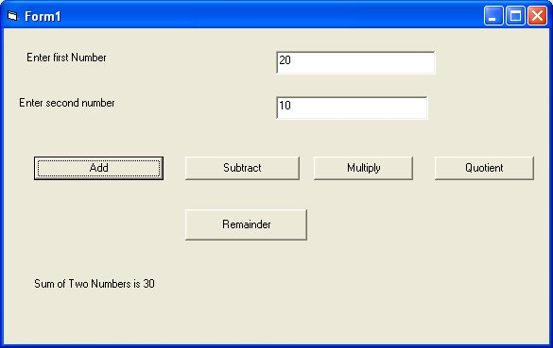

Program to find area and perimeter of square

Private Sub Command1_Click()
Dim side As Integer
Dim area As Integer
Dim perimeter As Integer
side = CInt(Text1.Text)
area = side * side
Label2.Caption = "Area of square is " & area
End Sub

Private Sub Command2_Click()
Dim side As Integer
Dim area As Integer
Dim perimeter As Integer
side = CInt(Text1.Text)
perimeter = 4 * side
Label2.Caption = "Perimeter of square is " & perimeter
End Sub

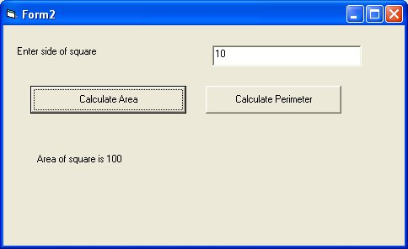

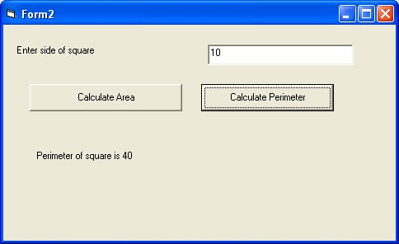
Program to find area and perimeter of rectangle
length and breadth are entered by user in textboxes

Private Sub Command1_Click()
Dim length As Integer
Dim breadth As Integer
Dim area As Integer
length = CInt(Text1.Text)
breadth = CInt(Text2.Text)
area = length * breadth
Label3.Caption = "Area of Rectangle is " & area
End Sub

Private Sub Command2_Click()
Dim length As Integer
Dim breadth As Integer
Dim perimeter As Integer
length = CInt(Text1.Text)
breadth = CInt(Text2.Text)
perimeter = 2 * (length + breadth)
Label3.Caption = "Perimeter of Rectangle is " & perimeter
End Sub

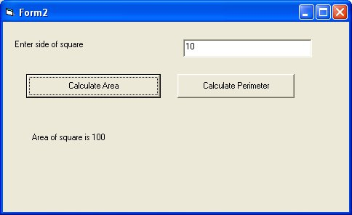
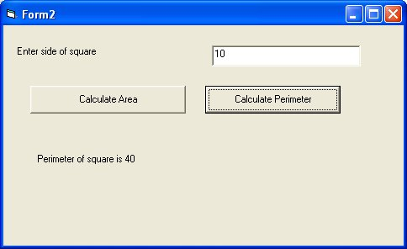

program to find volume of box
width, depth and height are entered by user in textboxes

Private Sub Command1_Click()
Dim width As Integer
Dim depth As Integer
Dim height As Integer
Dim volume As Integer
width = CInt(Text1.Text)
depth = CInt(Text2.Text)
height = CInt(Text3.Text)
volume = width * depth * height
Label4.Caption = "Volume of Box is " & volume
End Sub
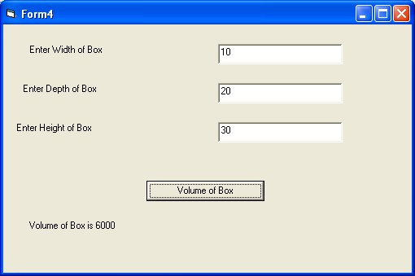

program to find area and circumference of circle
radius is entered by user in textbox

Private Sub Command1_Click()
Dim radius As Double
Dim area As Double
radius = CDbl(Text1.Text)
area = 3.14 * radius * radius
Label2.Caption = "Area of Circle is " & area
End Sub

Private Sub Command2_Click()
Dim radius As Double
Dim circumference As Double
radius = CDbl(Text1.Text)
circumference = 2 * 3.14 * radius
Label2.Caption = "Circumference of Circle is " & circumference
End Sub

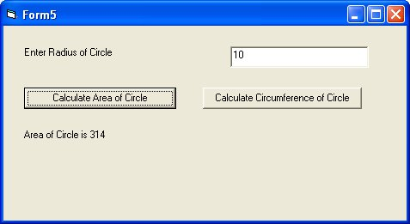
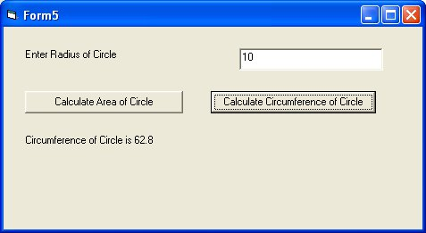
program to find simple interest based on principal amount , rate and time

Private Sub Command1_Click()
Dim principal As Double
Dim rate As Double
Dim time As Double
Dim si As Double
principal = CDbl(Text1.Text)
rate = CDbl(Text2.Text)
time = CDbl(Text3.Text)
si = principal * rate * time
Label4.Caption = "Simple Interest is " & si
End Sub

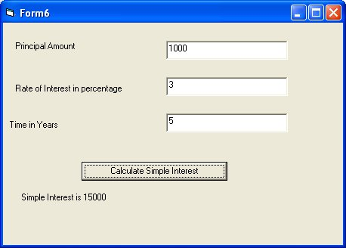
program to find 10% discount based on price entered by user in textbox

Private Sub Command1_Click()
Dim price As Double
Dim discount As Double
price = CDbl(Text1.Text)
discount = price * 0.1
Label2.Caption = "Discount is " & discount
End Sub

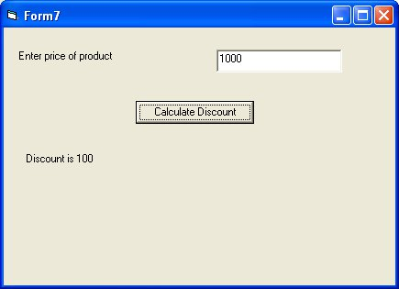

program to declare a constant pi with value as 3.14

Private Sub Command1_Click()
Const pi As Double = 3.14
Dim radius As Double
Dim area As Double
radius = CDbl(Text1.Text)
area = pi * radius * radius
Label3.Caption = "Area of Circle is " & area
End Sub

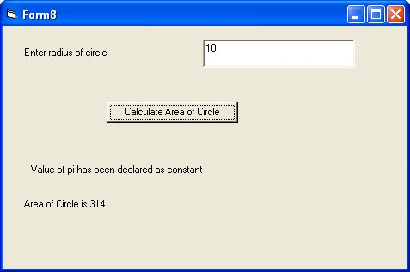

program to demonstrate if statement

Private Sub Command1_Click()
Dim a As Integer
a = CInt(Text1.Text)
If a = 10 Then
MsgBox ("Value of a is 10")
Else
MsgBox ("Value of a is not equal to 10")
End If
End Sub

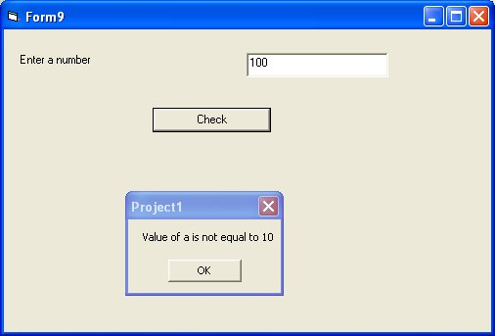
program to check whether number is greater than 10 or not

Private Sub Command1_Click()
Dim a As Integer
a = CInt(Text1.Text)
If a > 10 Then
MsgBox ("Value of number is greater than 10")
Else
MsgBox ("Value of a is less than or equal to 10")
End If
End Sub

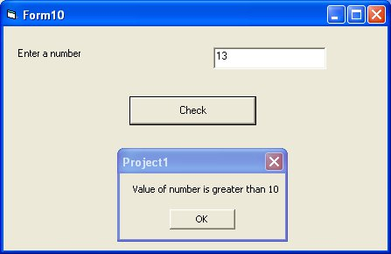

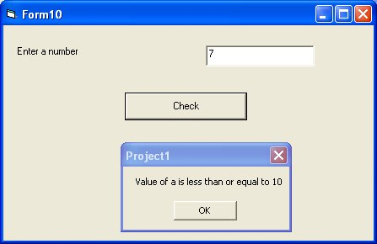
program to check whether a is greater than 10 or less than 10

Private Sub Command1_Click()
Dim a As Integer
a = CInt(Text1.Text)
If a < 10 Then
MsgBox ("Value of number is less than 10")
Else
MsgBox ("Value of a is greater than or equal to 10")
End If
End Sub

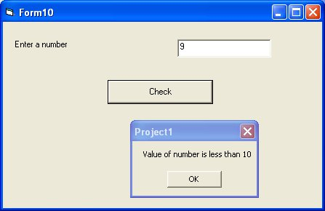
program to input temperature from user and check whether it is boiling point of water is not

Private Sub Command1_Click()
Dim a As Integer
a = CInt(Text1.Text)
If a < 10 Then
MsgBox ("Value of number is less than 10")
Else
MsgBox ("Value of a is greater than or equal to 10")
End If
End Sub

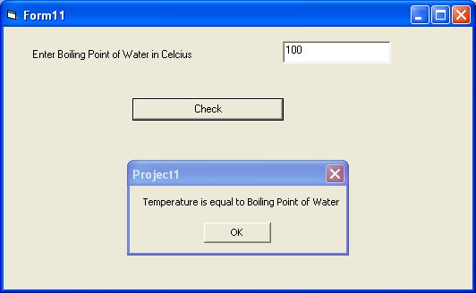
program to calculate check eligibility of person to vote based on age

Private Sub Command1_Click()
Dim age As Integer
age = CInt(Text1.Text)
If age >= 18 Then
MsgBox ("Person is eligible to vote")
Else
MsgBox ("Person is not eligible to vote")
End If
End Sub

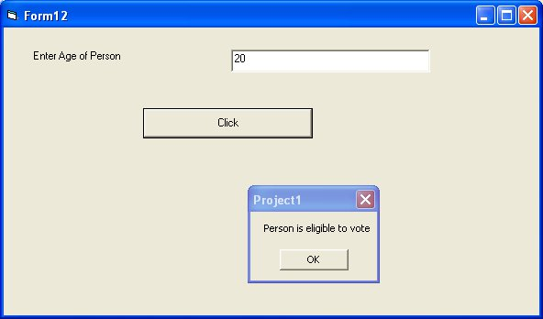

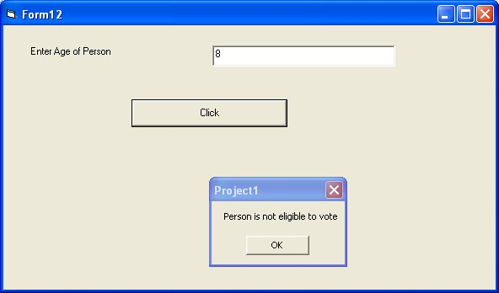
program to check whether number is even or odd

Private Sub Command1_Click()
Dim a As Integer
a = CInt(Text1.Text)
If a Mod 2 = 0 Then
MsgBox ("Number is Even")
Else
MsgBox ("Number is Odd")
End If
End Sub

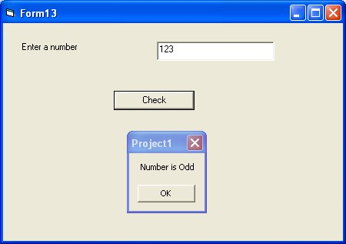
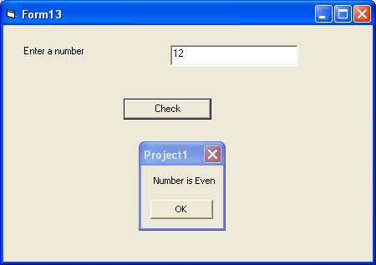

program to check an alphabet is vowel or not

Private Sub Command1_Click()
Dim a As String
a = Text1.Text
If a = "a" Or a = "e" Or a = "i" Or a = "o" Or a = "u" Then
MsgBox ("Alphabet is vowel")
Else
MsgBox ("Alphabet is not vowel")
End If
End Sub

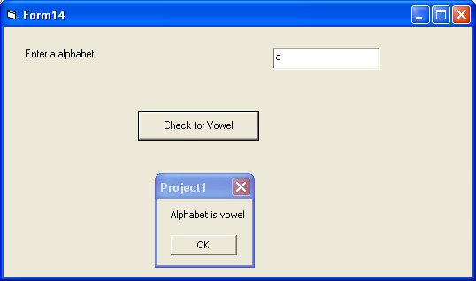
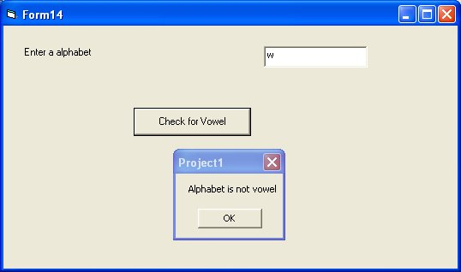
program to enter marks from user and check whether marks are between 80 and 90 using and operator

Private Sub Command1_Click()
Dim marks As Integer
marks = CInt(Text1.Text)
If marks >= 80 And marks <= 100 Then
MsgBox ("Marks are between 80 and 90")
Else
MsgBox ("Marks are not between 80 and 90")
End If
End Sub

