Program to display Hello World in a MessageBox

Private Sub Button1_Click(ByVal sender As System.Object, ByVal e As System.EventArgs) Handles Button1.Click
MessageBox.Show("Hello World")

End Sub

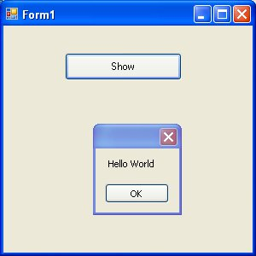
Program to add , subtract, multiply, divide and find remainder of two numbers

Private Sub Button1_Click(ByVal sender As System.Object, ByVal e As System.EventArgs) Handles Button1.Click
Dim a, b, sum As Integer
a = Convert.ToInt32(TextBox1.Text)
b = Convert.ToInt32(TextBox2.Text)
sum = a + b
Label3.Text = "Sum of Two Numbers is " & sum
End Sub

Private Sub Button2_Click(ByVal sender As System.Object, ByVal e As System.EventArgs) Handles Button2.Click
Dim a, b, diff As Integer
a = Convert.ToInt32(TextBox1.Text)
b = Convert.ToInt32(TextBox2.Text)
diff = a - b
Label3.Text = "Difference of Two Numbers is " & diff
End Sub

Private Sub Button3_Click(ByVal sender As System.Object, ByVal e As System.EventArgs) Handles Button3.Click
Dim a, b, product As Integer
a = Convert.ToInt32(TextBox1.Text)
b = Convert.ToInt32(TextBox2.Text)
product = a * b
Label3.Text = "Product of Two Numbers is " & product
End Sub

Private Sub Button4_Click(ByVal sender As System.Object, ByVal e As System.EventArgs) Handles Button4.Click
Dim a, b, quotient As Integer
a = Convert.ToInt32(TextBox1.Text)
b = Convert.ToInt32(TextBox2.Text)
quotient = a / b
Label3.Text = "Quotient of Two Numbers is " & quotient
End Sub

Private Sub Button5_Click(ByVal sender As System.Object, ByVal e As System.EventArgs) Handles Button5.Click
Dim a, b, remainder As Integer
a = Convert.ToInt32(TextBox1.Text)
b = Convert.ToInt32(TextBox2.Text)
remainder = a Mod b
Label3.Text = "Remainder of Two Numbers is " & remainder
End Sub

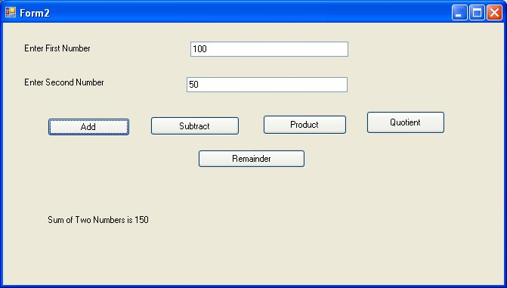

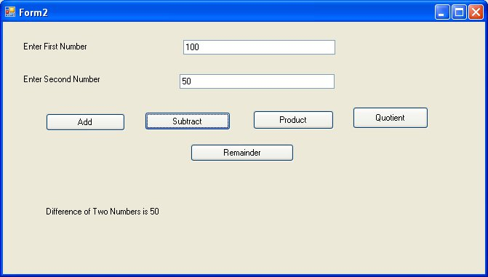
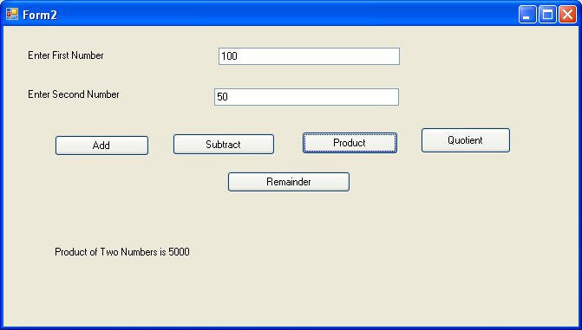

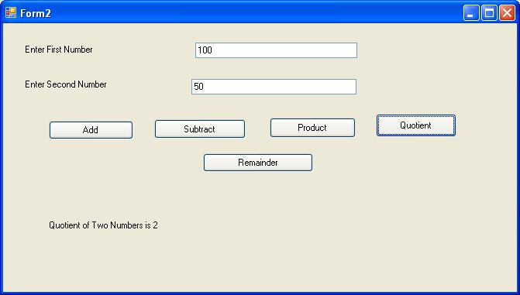
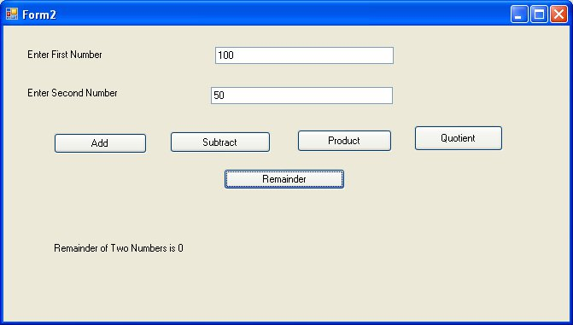
Program to find area and perimeter of square

Private Sub Button1_Click(ByVal sender As System.Object, ByVal e As System.EventArgs) Handles Button1.Click
Dim side, area As Integer
side = Convert.ToInt32(TextBox1.Text)
area = side * side
Label2.Text = "Area of square is " & area
End Sub

Private Sub Button2_Click(ByVal sender As System.Object, ByVal e As System.EventArgs) Handles Button2.Click
Dim side, perimeter As Integer
side = Convert.ToInt32(TextBox1.Text)
perimeter = 4 * side
Label2.Text = "Perimeter of Square is " & perimeter
End Sub

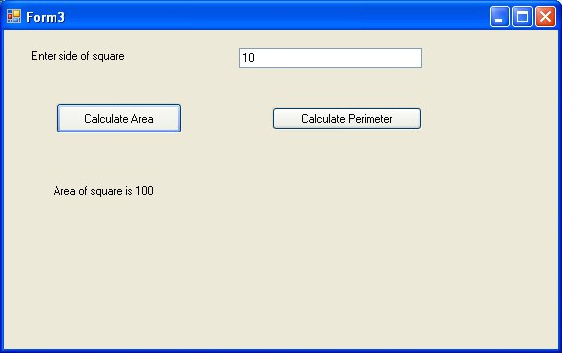
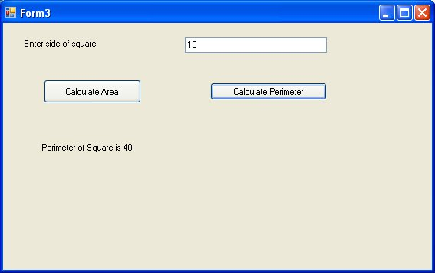
Program to Calculate Area and Perimeter of Rectangle

Private Sub Button1_Click(ByVal sender As System.Object, ByVal e As System.EventArgs) Handles Button1.Click
Dim length, breadth, area As Integer
length = Convert.ToInt32(TextBox1.Text)
breadth = Convert.ToInt32(TextBox2.Text)
area = length * breadth
Label3.Text = "Area of Rectangle is " & area
End Sub

Private Sub Button2_Click(ByVal sender As System.Object, ByVal e As System.EventArgs) Handles Button2.Click
Dim length, breadth, perimeter As Integer
length = Convert.ToInt32(TextBox1.Text)
breadth = Convert.ToInt32(TextBox2.Text)
perimeter = 2 * (length + breadth)
Label3.Text = "Perimeter of Rectangle is " & perimeter
End Sub

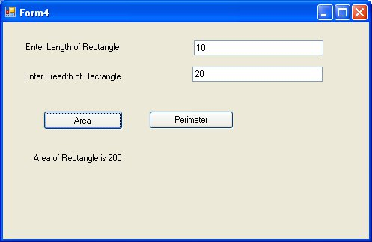
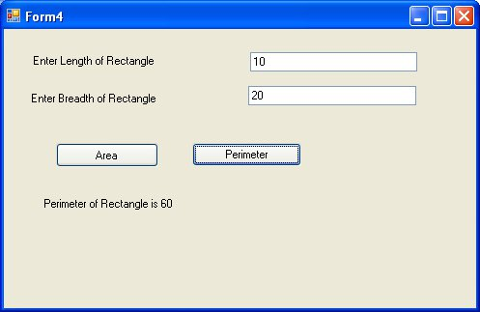
Program to area and circumference of circle

Private Sub Button1_Click(ByVal sender As System.Object, ByVal e As System.EventArgs) Handles Button1.Click
Dim radius, area As Double
radius = Convert.ToDouble(TextBox1.Text)
area = 3.14 * radius * radius
Label2.Text = "Area of Circle is " & area
End Sub

Private Sub Button2_Click(ByVal sender As System.Object, ByVal e As System.EventArgs) Handles Button2.Click
Dim radius, circumference As Double
radius = Convert.ToDouble(TextBox1.Text)
circumference = 2 * 3.14 * radius
Label2.Text = "Circumference of Circle is " & circumference
End Sub

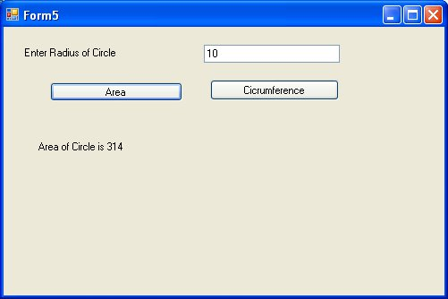

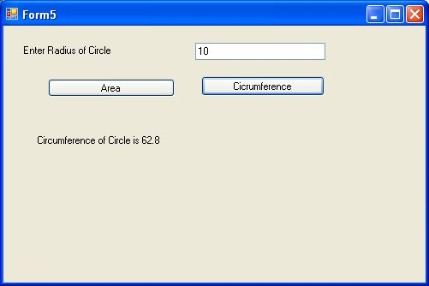
Program to find volume of box based on width depth and height

Private Sub Button1_Click(ByVal sender As System.Object, ByVal e As System.EventArgs) Handles Button1.Click
Dim width, height, depth, volume As Double
width = Convert.ToDouble(TextBox1.Text)
height = Convert.ToDouble(TextBox2.Text)
depth = Convert.ToDouble(TextBox3.Text)
volume = width * depth * height
Label4.Text = "Volume of Box is " & volume
End Sub

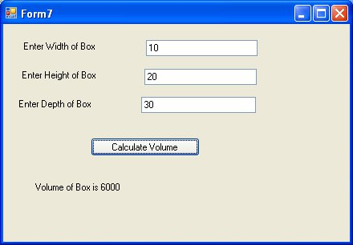

Program to demonstrate how to declare a constant

Private Sub Button1_Click(ByVal sender As System.Object, ByVal e As System.EventArgs) Handles Button1.Click
Const pi As Double = 3.14
Dim area As Double
Dim radius As Double
radius = Convert.ToDouble(TextBox1.Text)
area = pi * radius * radius
Label2.Text = "Area of circle is " & area
End Sub

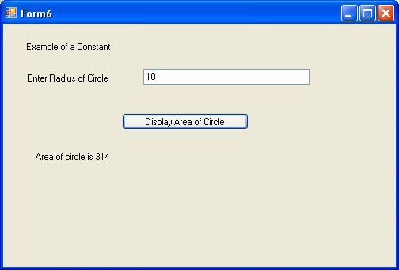
Program to demonstrate a Boolean Variable

Private Sub Button1_Click(ByVal sender As System.Object, ByVal e As System.EventArgs) Handles Button1.Click
Dim a As Boolean
a = True
Label1.Text = a

End Sub

Private Sub Button2_Click(ByVal sender As System.Object, ByVal e As System.EventArgs) Handles Button2.Click
Dim a As Boolean
a = False
Label1.Text = a
End Sub

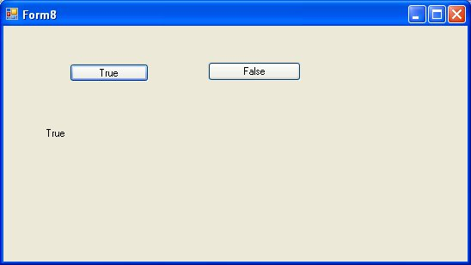
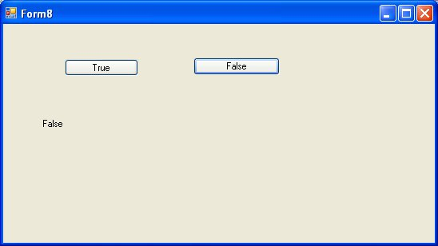
Program to Demonstrate if else statement

Private Sub Button1_Click(ByVal sender As System.Object, ByVal e As System.EventArgs) Handles Button1.Click
Dim a As Integer
a = Convert.ToInt32(TextBox1.Text)
If a = 10 Then
Label2.Text = "Value of a is 10"
Else
Label2.Text = "Value of a is not equal to 10"
End If
End Sub

