C# Course

Program 1

Program to Find Sum, Difference, Product, Quotient and Remainder

Code to find sum of two numbers

int a, b, sum;

a =Convert.ToInt32(textBox1.Text);

b = Convert.ToInt32(textBox2.Text);

sum = a + b;

label3.Text = "Sum is " + sum;

Code to find difference between two numbers

int a, b, diff;

a= Convert.ToInt32(textBox1.Text);

b = Convert.ToInt32(textBox2.Text);

diff = a - b;

label3.Text = "Difference is " + diff;

Code to find multiplication of two numbers

int a, b, product;

a = Convert.ToInt32(textBox1.Text);

b = Convert.ToInt32(textBox2.Text);

product = a * b;

label3.Text = "Product is " + product;

Code to find quotient of two numbers

int a, b, quo;

a = Convert.ToInt32(textBox1.Text);

b = Convert.ToInt32(textBox2.Text);

quo = a / b;

label3.Text = "Quotient is " + quo;

Code to find remainder of two numbers

int a, b, rem;

a = Convert.ToInt32(textBox1.Text);

b = Convert.ToInt32(textBox2.Text);

rem = a % b;

label3.Text = "Remainder is " + rem;

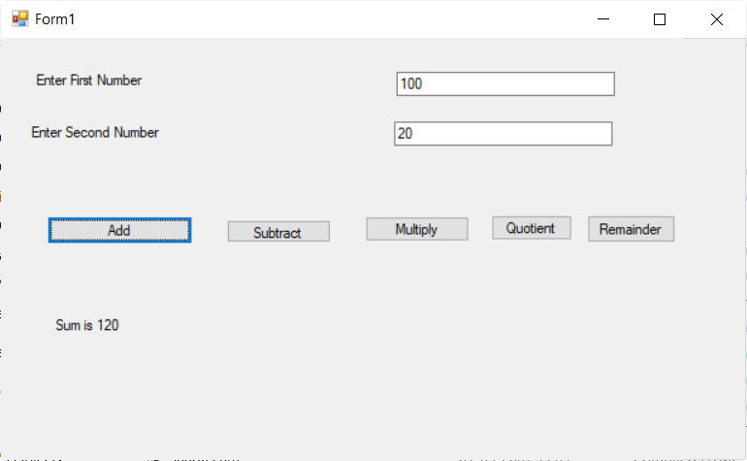

**Program to find Area of Square**

int side, area;

side = Convert.ToInt32(textBox1.Text);

area = side * side;

label2.Text = "Area of Square is " + Convert.ToString(area);

**Program to find Perimeter of square**

int side, perimeter;

side = Convert.ToInt32(textBox1.Text);

perimeter = 4 * side;

label2.Text = "Perimeter of Square is " + Convert.ToString(perimeter);

|  |
| --- |
|  |

Program to find Area of Circle

double radius, area;

radius = Convert.ToDouble("Enter Radius of Circle");

area = Math.PI * radius * radius;

label1.Text = "Area of Circle is " + radius;

Program to find Circumference of Circle

double radius, circumference;

radius = Convert.ToDouble("Enter Radius of Circle");

circumference = 2 * Math.PI * radius;

label1.Text = "Circumference of Circle is " & circumference;

|  |
| --- |
|  |

Program to find simple Interest

double p, r, t,si;

p = Convert.ToDouble(textBox1.Text);

r = Convert.ToDouble(textBox2.Text);

t = Convert.ToDouble(textBox3.Text);

si = (p * r * t)/100;

label4.Text = "Simple Interest is " + Convert.ToString(si);

|  |
| --- |
|  |

Program to find Volume of box

double d, w, h, volume;

d = Convert.ToDouble(textBox1.Text);

w = Convert.ToDouble(textBox2.Text);

h = Convert.ToDouble(textBox3.Text);

volume = d * w * h;

label4.Text = "Volume of Box is " + volume;

|  |
| --- |
|  |
|  |

Program to demonstrate if statement

int a, b;

a = Convert.ToInt32(textBox1.Text);

if (a % 5 == 0)

{

label3.Text="Number " + Convert.ToString(a) + " is divisible by 5";

}

else

{

label3.Text="Number " + Convert.ToString(a) + " is not divisible by 5";

}

|  |
| --- |
|  |
|  |

Program to demonstrate while loop

int a, b,i=0;

a = Convert.ToInt32(textBox2.Text);

b = Convert.ToInt32(textBox3.Text);

i=a;

while (i <= b)

{

textBox1.Text = textBox1.Text + Convert.ToInt32(i) + System.Environment.NewLine;

i++;

}

|  |
| --- |
|  |

Program to demonstrate switch Statement

int day;

String dayname="Enter a valid Day Name between 1 and 7";

day = Convert.ToInt32(textBox1.Text);

switch (day)

{

case 1: dayname = "Monday";

break;

case 2: dayname = "Tuesday";

break;

case 3: dayname = "Wednesday";

break;

case 4: dayname = "Thursday";

break;

case 5: dayname = "Friday";

break;

case 6: dayname = "Saturday";

break;

case 7: dayname = "Sunday";

break;

}

textBox2.Text = dayname;

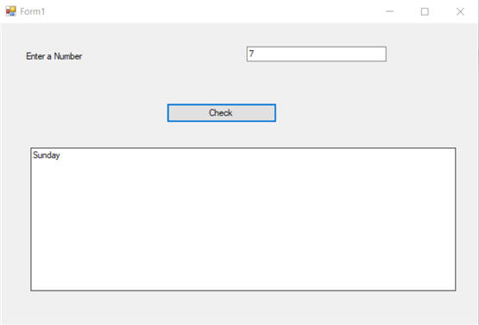

Program to find Result of Student based on Marks

Code :

int marks;

String result = "";

marks = Convert.ToInt32(textBox1.Text);

if((marks>=80) && (marks<=100))

{

result="Grade A";

}

else if((marks>=70) && (marks<80))

{

result="Grade B";

}

else if((marks>=60) && (marks<70))

{

result="Grade C";

}

else

{

result="Grade D";

}

textBox2.Text="Student Obtained Marks " + marks + " and Result of the student is " + result;

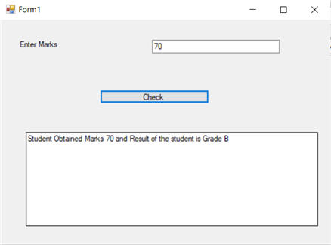

Program to create a function to calculate Simple Interest

public static double calcsi(double p, double r, double t)

{

double si;

si = (p * r * t) / 100;

return si;

}

private void button1_Click(object sender, EventArgs e)

{

double si;

double p, r, t;

p = Convert.ToDouble(textBox1.Text);

r = Convert.ToDouble(textBox2.Text);

t = Convert.ToDouble(textBox3.Text);

si = calcsi(p, r, t);

label4.Text = "Simple Interest is " + Convert.ToString(si);

}

|  |
| --- |
|  |
|  |