How to make a Java Web Application in Netbeans 8 using MySQL and Apache Tomcat version 7

First of all create a database with name studentsdata in Mysql server

Command is

Create database studentsdata;

Next command is

Use studentsdata;

Next command is

Create table students(rollno int,name varchar(20),marks int);

How to create a web application in netbeans

If Java Web option is not present in New Java Project, you need to add a plugin with the name as

JEE Base

You can go to Tool-> Plugins and go to Available Plugins and then check the box Java EE Base Plugin

Click on Install and Java EE Base plugin will be install after downloading the dependencies.

Now we will create a Java Web Application names as studentsservlet which add records in studentsdata, delete records from studentsdata, update studentsdata, search studentsdata, and read all records from studentsdata.

Go to New Project - > Java Web -> Web Application

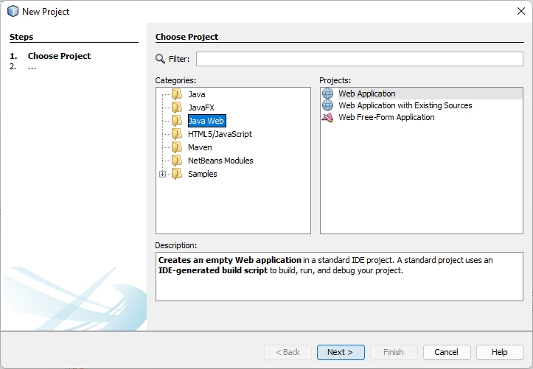

Now Click Next

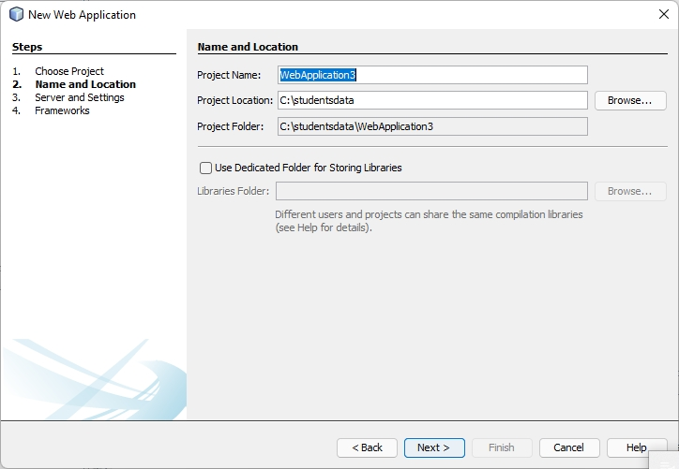

Click Next

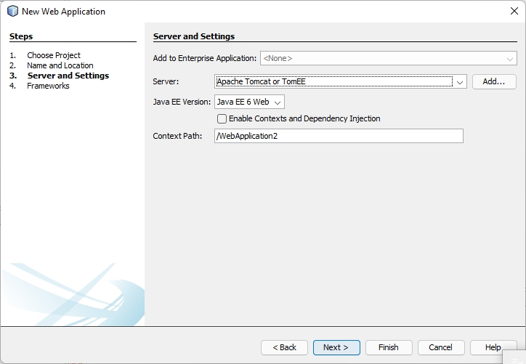

Now Click Next

Following Window will appear

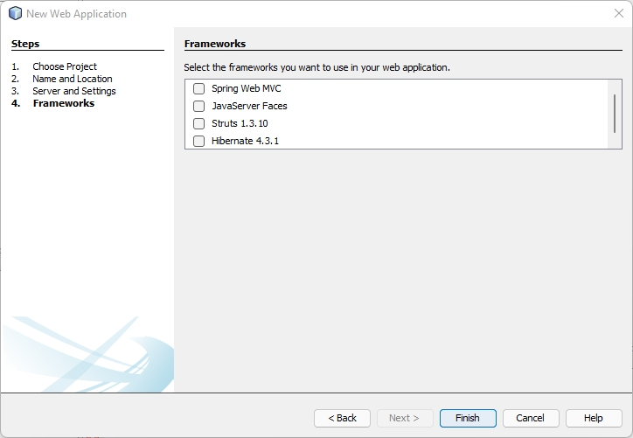

We will not use any Frameworks as these frameworks, Spring, Java Server Faces, Struts, Hibernate

We will only use servlets.

Click Finish

Now WebApplication2 will appear in Projects, there will be a file index.jsp.

Edit index.jsp file as

<%@page contentType="text/html" pageEncoding="UTF-8"%>

<!DOCTYPE html>

<html>

<head>

<meta http-equiv="Content-Type" content="text/html; charset=UTF-8">

<title>Add a Student Record</title>

</head>

<body>

<form action='addrecord' method='post'>

Roll No : <input type='text' value='1' name='rollnotxt'>

<br>

Name : <input type='text' value='Raman' name='nametxt'>

<br>

Marks : <input type='text' value='90' name='markstxt'>

<br>

<input type='submit' value='Add a Student Record'>

</form>

</body>

</html>

Run this file in Browser and following screen will appear