MongoDB is a NoSQL Database

NoSQL Database means you are not using SQL to manage the database.

Start MongoDB Compass to administrate a MongoDB Database.

Following window will appear

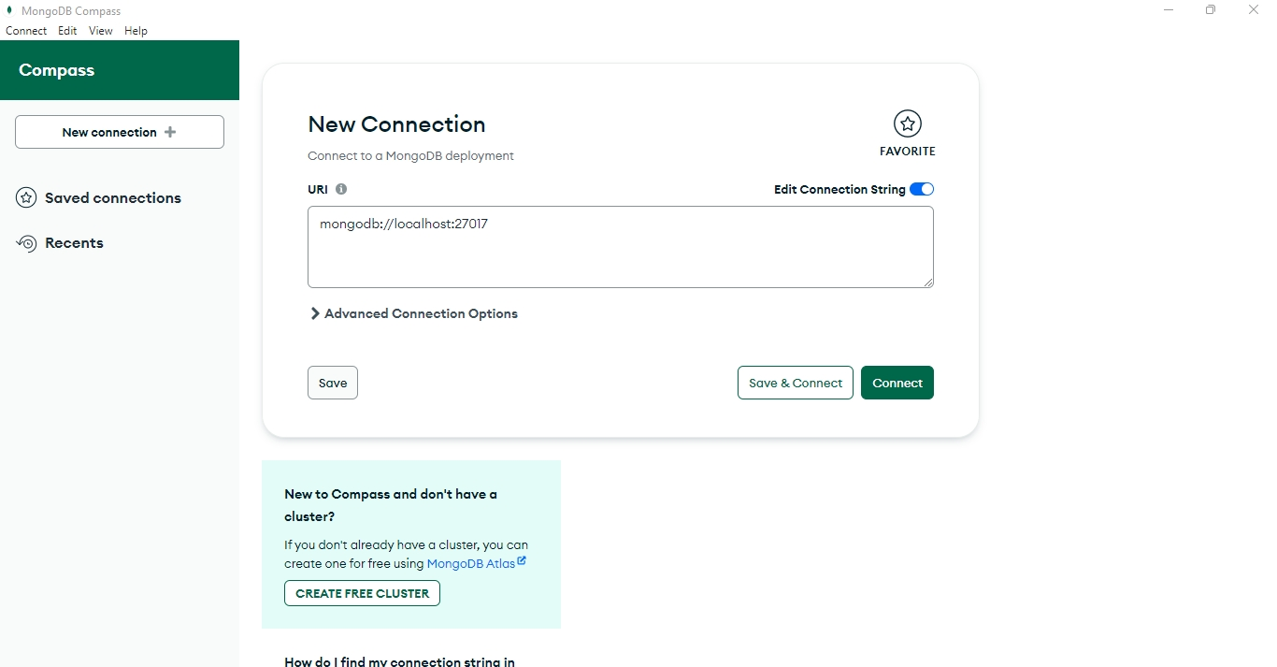

Click on Connect to connect to a default mongodb database

Following window will appear

Click on + sign to create a new Database

Give database name as raman

and collection name as students

collection is like a table

Click on Create Database and following window will appear

Click on Add Data -> Insert Document

Document in NoSQL is like a record

Add One Record

with rollno as 1 and name as raman and marks as 90

Following window will add one records

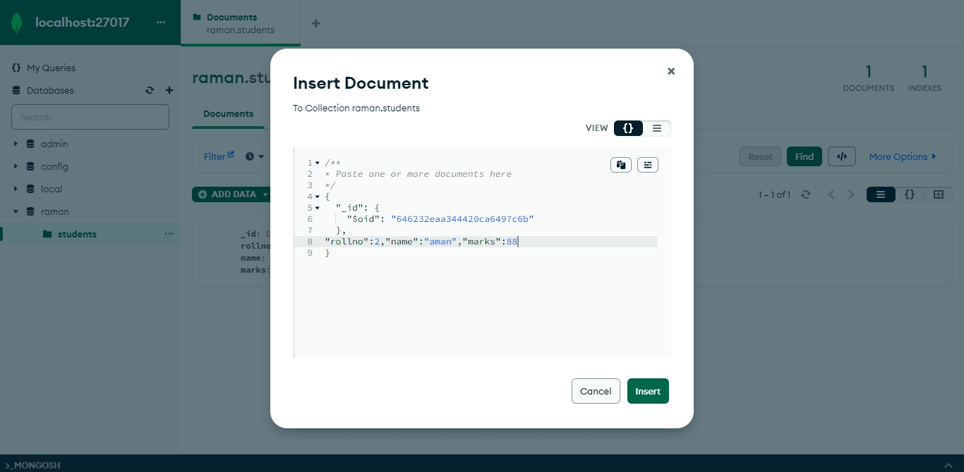

Click on Insert

and following window will appear

You can add more records like this

You can import data to a mongodb database from a csv or json file

You can export data from a mongodb database to a csv file or json file using mongodb compass.