How to make a Pyhton MySQL Project using Pycharm Edu

How to install MySQL and create a database

Install MySQL from [www.wampserver.com](http://www.wampserver.com)

Open MySQL Console

And type command

Create database studentfee;

Install Pycharm Edu from [Learn Python with PyCharm for Education (jetbrains.com)](https://www.jetbrains.com/pycharm-edu/)

Start pycharm edu and open a new project

Go to File -> Settings

Then Go to Pyhon: Project 2

Then Go to Python Interpreter

Click on + button

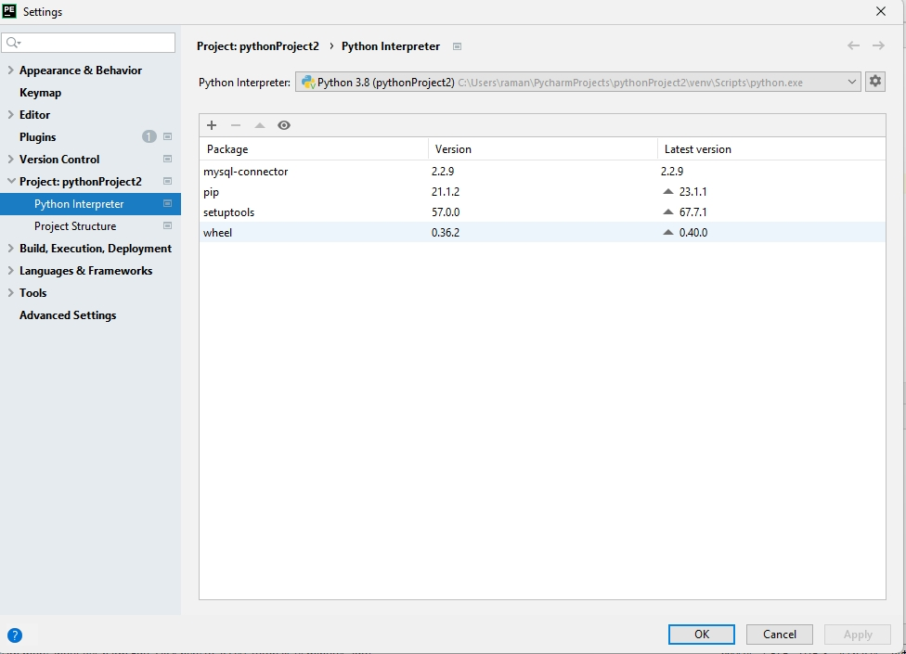

After Clicking on + Button

Following Screen will appear

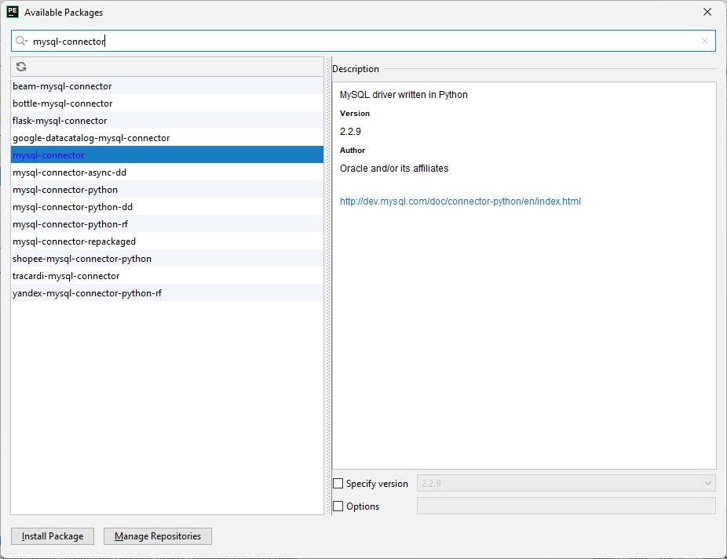

Click on Install Package

This Command requires Internet Connection

Following screen will appear now

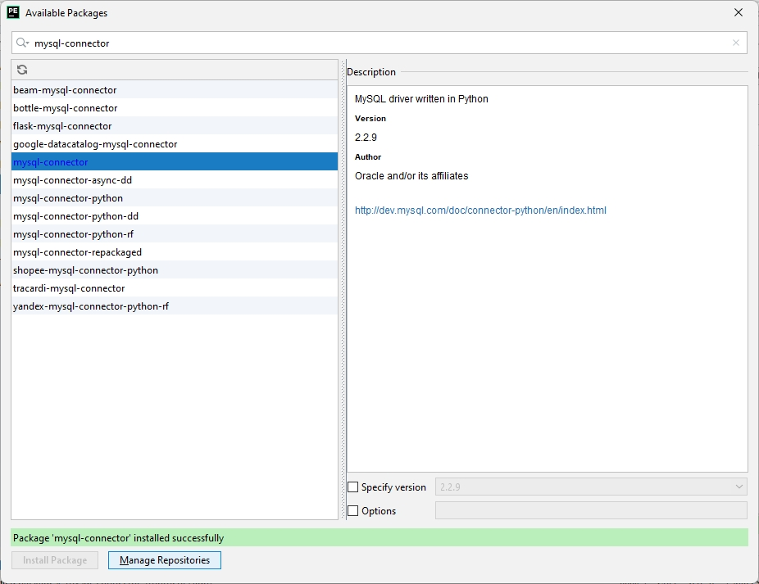

Now go to main.py and paste the following code

**import** mysql.connector;  
**def** createtables():  
  
 mydb = mysql.connector.connect(  
  
 host=**"localhost"**,  
  
 user=**"root"**,  
  
 passwd=**""**,  
  
 database=**"studentfee"** )  
  
 mycursor = mydb.cursor()  
  
 mycursor.execute(**"create table students(admno varchar(20),name varchar(20),fathername varchar(20),class varchar(20),admndate varchar(20));"**)  
  
 mycursor.execute(**"create table studentfee(admno varchar(20),name varchar(20),fee varchar(20),feedate varchar(20));"**)  
  
 print(**"Tables Created in Database"**)  
  
**def** droptables():  
  
 mydb = mysql.connector.connect(  
  
 host=**"localhost"**,  
  
 user=**"root"**,  
  
 passwd=**""**,  
  
 database=**"studentfee"** )  
  
 mycursor = mydb.cursor()  
  
 mycursor.execute(**"drop table students;"**)  
  
 mycursor.execute(**"drop table studentfee;"**)  
  
 print(**"Tables Deleted in Database"**)  
  
**def** showallstudents():  
  
 conn = mysql.connector.connect(  
  
 user=**'root'**,  
  
  
 password=**''**,  
  
 host=**'127.0.0.1'**,  
  
 database=**'studentfee'**)  
  
 cur = conn.cursor()  
  
 cur.execute(**"select * from students"**)  
  
  
 myresult = cur.fetchall()  
  
 **for** x **in** myresult:  
  
 print(x)  
  
  
 cur.close()  
  
 conn.close()  
  
**def** showallfeerecords():  
  
 conn = mysql.connector.connect(  
  
 user=**'root'**,  
  
 password=**''**,  
  
 host=**'127.0.0.1'**,  
  
 database=**'studentfee'**)  
  
  
 cur = conn.cursor()  
  
 cur.execute(**"select * from studentfee"**)  
  
  
 myresult = cur.fetchall()  
  
 **for** x **in** myresult:  
  
  
 print(x)  
  
  
 cur.close()  
  
  
 conn.close()  
  
**def** searchstudent():  
  
 conn = mysql.connector.connect(  
  
 user=**'root'**,  
  
 password=**''**,  
  
 host=**'127.0.0.1'**,  
  
 database=**'studentfee'**)  
  
  
 admnno=input(**"Enter admission number to search for"**)  
  
  
 cur = conn.cursor()  
  
 sql=**"SELECT * from students where admno='%s'"**;  
  
  
 cur.execute(sql,admnno)  
  
  
 myresult = cur.fetchall()  
  
 **for** x **in** myresult:  
  
 print(x)  
  
  
 cur.close()  
  
 conn.close()  
  
**def** searchfeerecord():  
  
 conn = mysql.connector.connect(  
  
 user=**'root'**,  
  
 password=**''**,  
  
 host=**'127.0.0.1'**,  
  
 database=**'studentfee'**)  
  
  
 admnno=input(**"Enter admission number to search for"**)  
  
 cur = conn.cursor()  
  
 sql=**"SELECT * from studentfee where admno='%s'"**;  
  
 cur.execute(sql,admnno)  
  
  
 myresult = cur.fetchall()  
  
 **for** x **in** myresult:  
 print(x)  
  
  
 cur.close()  
  
 conn.close()  
  
**def** addstudent():  
  
 mydb = mysql.connector.connect( host=**"localhost"**, user=**"root"**,passwd=**""**,database=**"studentfee"**)  
  
 mycursor = mydb.cursor()  
  
 admno=input(**"Enter Student Admission Number"**);  
  
 name=input(**"Enter Student Name "**);  
  
 fathername=input(**"Enter Student Father Name "**);  
  
 clas=input(**"Enter Student Class"**);  
  
 admndate=input(**"Enter Student Admission Date"**);  
  
  
 sql = **"INSERT INTO students(admno,name,fathername,class,admndate) VALUES (%s,%s,%s,%s,%s)"** val = (admno,name,fathername,clas,admndate)  
  
 mycursor.execute(sql,val)  
  
  
  
 mydb.commit()  
  
 print(mycursor.rowcount, **"record inserted."**)  
  
**def** addfeerecord():  
  
 mydb = mysql.connector.connect( host=**"localhost"**, user=**"root"**,passwd=**""**,database=**"studentfee"**)  
  
 mycursor = mydb.cursor()  
  
 admno=input(**"Enter Student Admission Number"**);  
  
 name=input(**"Enter Student Name "**);  
  
 fee=input(**"Enter Fee "**);  
  
 feedate=input(**"Enter Fee Date"**);  
  
  
  
 sql = **"INSERT INTO studentfee(admno,name,fee,feedate) VALUES (%s,%s,%s,%s)"** val = (admno,name,fee,feedate)  
  
 mycursor.execute(sql,val)  
  
  
  
 mydb.commit()  
  
 print(mycursor.rowcount, **"record inserted."**)  
  
  
**def** modifystudent():  
  
 admno=input(**"Enter Admission Number"**)  
  
 name=input(**"Enter Name"**)  
  
 fathername=input(**"Enter Father Name"**)  
  
 clas=input(**"Enter Class"**)  
  
 admndate=input(**"Enter Admission Date"**)  
  
  
 mydb = mysql.connector.connect(  
  
 host=**"localhost"**,  
  
 user=**"root"**,  
  
 passwd=**""**,  
  
 database=**"studentfee"**)  
 mycursor = mydb.cursor()  
  
 sql = **"update students set name=%s,fathername=%s,class=%s,admndate=%s where admno=%s"** val = (name,fathername,clas,admndate,admno)  
  
 mycursor.execute(sql,val)  
  
  
 mydb.commit()  
  
 print(mycursor.rowcount, **"record updated."**)  
  
**def** deletestudent():  
  
 admno=input(**"Enter Admission Number"**)  
  
  
 mydb = mysql.connector.connect(  
  
 host=**"localhost"**,  
  
 user=**"root"**,  
  
 passwd=**""**,  
  
 database=**"studentfee"**)  
 mycursor = mydb.cursor()  
  
 sql = **"delete from students where admno=%s"** val = (admno)  
  
 mycursor.execute(sql,val)  
  
  
 mydb.commit()  
  
 print(mycursor.rowcount, **"record deleted."**)  
**def** createtables():  
  
 mydb = mysql.connector.connect(  
  
 host=**"localhost"**,  
  
 user=**"root"**,  
  
 passwd=**""**,  
  
 database=**"studentfee"** )  
  
 mycursor = mydb.cursor()  
  
 mycursor.execute(**"create table students(admno varchar(20),name varchar(20),fathername varchar(20),class varchar(20),admndate varchar(20));"**)  
  
 mycursor.execute(**"create table studentfee(admno varchar(20),name varchar(20),fee varchar(20),feedate varchar(20));"**)  
  
 print(**"Tables Created in Database"**)  
**def** modifystudent():  
  
 admno=input(**"Enter Admission Number"**)  
  
 name=input(**"Enter Name"**)  
  
 fathername=input(**"Enter Father Name"**)  
  
 clas=input(**"Enter Class"**)  
  
 admndate=input(**"Enter Admission Date"**)  
  
  
 mydb = mysql.connector.connect(  
  
 host=**"localhost"**,  
  
 user=**"root"**,  
  
 passwd=**""**,  
  
 database=**"studentfee"**)  
 mycursor = mydb.cursor()  
  
 sql = **"update students set name=%s,fathername=%s,class=%s,admndate=%s where admno=%s"** val = (name,fathername,clas,admndate,admno)  
  
 mycursor.execute(sql,val)  
  
  
 mydb.commit()  
  
 print(mycursor.rowcount, **"record updated."**)  
  
**def** deletestudent():  
  
 admno=input(**"Enter Admission Number"**)  
  
  
 mydb = mysql.connector.connect(  
  
 host=**"localhost"**,  
  
 user=**"root"**,  
  
 passwd=**""**,  
  
 database=**"studentfee"**)  
 mycursor = mydb.cursor()  
  
 sql = **"delete from students where admno=%s"** val = (admno)  
  
 mycursor.execute(sql,val)  
  
  
 mydb.commit()  
  
 print(mycursor.rowcount, **"record deleted."**)  
  
**def** droptables():  
  
 mydb = mysql.connector.connect(  
  
 host=**"localhost"**,  
  
 user=**"root"**,  
  
 passwd=**""**,  
  
 database=**"studentfee"** )  
  
 mycursor = mydb.cursor()  
  
 mycursor.execute(**"drop table students;"**)  
  
 mycursor.execute(**"drop table studentfee;"**)  
  
 print(**"Tables Deleted in Database"**)  
  
**def** droptables():  
  
 mydb = mysql.connector.connect(  
  
 host=**"localhost"**,  
  
 user=**"root"**,  
  
 passwd=**""**,  
  
 database=**"studentfee"** )  
  
 mycursor = mydb.cursor()  
  
 mycursor.execute(**"drop table students;"**)  
  
 mycursor.execute(**"drop table studentfee;"**)  
  
 print(**"Tables Deleted in Database"**)  
  
**def** showallstudents():  
  
 conn = mysql.connector.connect(  
  
 user=**'root'**,  
  
  
 password=**''**,  
  
 host=**'127.0.0.1'**,  
  
 database=**'studentfee'**)  
  
 cur = conn.cursor()  
  
 cur.execute(**"select * from students"**)  
  
  
 myresult = cur.fetchall()  
  
 **for** x **in** myresult:  
  
 print(x)  
  
  
 cur.close()  
  
 conn.close()  
  
**def** showallfeerecords():  
  
 conn = mysql.connector.connect(  
  
 user=**'root'**,  
  
 password=**''**,  
  
 host=**'127.0.0.1'**,  
  
 database=**'studentfee'**)  
  
  
 cur = conn.cursor()  
  
 cur.execute(**"select * from studentfee"**)  
  
  
 myresult = cur.fetchall()  
  
 **for** x **in** myresult:  
  
  
 print(x)  
  
  
 cur.close()  
  
  
 conn.close()  
  
**def** showallfeerecords():  
  
 conn = mysql.connector.connect(  
  
 user=**'root'**,  
  
 password=**''**,  
  
 host=**'127.0.0.1'**,  
  
 database=**'studentfee'**)  
  
  
 cur = conn.cursor()  
  
 cur.execute(**"select * from studentfee"**)  
  
  
 myresult = cur.fetchall()  
  
 **for** x **in** myresult:  
  
  
 print(x)  
  
  
 cur.close()  
  
  
 conn.close()  
  
  
**def** deletestudentfee():  
  
 admno=input(**"Enter Admission Number"**)  
  
  
 mydb = mysql.connector.connect(  
  
 host=**"localhost"**,  
  
 user=**"root"**,  
  
 passwd=**""**,  
  
 database=**"studentfee"**)  
 mycursor = mydb.cursor()  
  
 sql = **"delete from studentfee where admno=%s"** val = (admno)  
  
 mycursor.execute(sql,val)  
  
  
  
 mydb.commit()  
  
 print(mycursor.rowcount, **"record deleted."**)  
**def** deletestudentfee():  
  
 admno=input(**"Enter Admission Number"**)  
  
  
 mydb = mysql.connector.connect(  
  
 host=**"localhost"**,  
  
 user=**"root"**,  
  
 passwd=**""**,  
  
 database=**"studentfee"**)  
 mycursor = mydb.cursor()  
  
 sql = **"delete from studentfee where admno=%s"** val = (admno)  
  
 mycursor.execute(sql,val)  
  
  
  
 mydb.commit()  
  
 print(mycursor.rowcount, **"record deleted."**)  
**def** deletestudentfee():  
  
 admno=input(**"Enter Admission Number"**)  
  
  
 mydb = mysql.connector.connect(  
  
 host=**"localhost"**,  
  
 user=**"root"**,  
  
 passwd=**""**,  
  
 database=**"studentfee"**)  
 mycursor = mydb.cursor()  
  
 sql = **"delete from studentfee where admno=%s"** val = (admno)  
  
 mycursor.execute(sql,val)  
  
  
  
 mydb.commit()  
  
 print(mycursor.rowcount, **"record deleted."**)  
  
ch=1;  
  
**while** ch!=0:  
  
 print(**"Welcome to Student Fee Management System"**)  
  
 print(**"1. Create Tables"**)  
  
 print(**"2. Add Student Record"**)  
  
 print(**"3. Modify A Student Record"**)  
  
 print(**"4. Show All Student Records"**)  
  
 print(**"5. Search Student"**)  
  
 print(**"6. Add Fee Record"**)  
  
 print(**"7. Show All Fee Records"**)  
  
 print(**"8. Delete Student Record"**)  
  
 print(**"9. Delete Student Fee Record"**)  
  
 print(**"10. Search for a Fee Record"**)  
  
 print(**"11. Drop Tables"**)  
  
 print(**"0. Exit"**);  
  
 ch=int(input(**"Enter your choice 1,2,3,4,5,6,7,8,9,10"**))  
  
 **if**(ch==1):  
  
 createtables();  
  
 **if**(ch==2):  
  
 addstudent();  
  
 **if**(ch==3):  
  
 modifystudent();  
  
 **if**(ch==4):  
  
 showallstudents();  
  
 **if**(ch==5):  
  
 searchstudent();  
  
 **if**(ch==6):  
  
 addfeerecord();  
  
 **if**(ch==7):  
  
 showallfeerecords();  
 **if**(ch==8):  
  
 deletestudent();  
 **if**(ch==9):  
  
 deletestudentfee();  
 **if**(ch==10):  
  
 searchfeerecord();  
 **if**(ch==11):  
  
 droptables();  
 **if** ch==0:  
 **break**;

Right Click on Source Code window and click on Run main

Following output will appear

