Vmware workstation player is a software which helps you create virtual machines on windows on linux.

Virtual machine means an operating system running within another another operating system like linux on windows

How to create a virtual machine on windows for opearating system CentOS which is a linux distribution.

Download vmware workstation player from [www.vmware.com](http://www.vmware.com)

Install VMWARE Workstation player on windows and start it.

You will find following window.

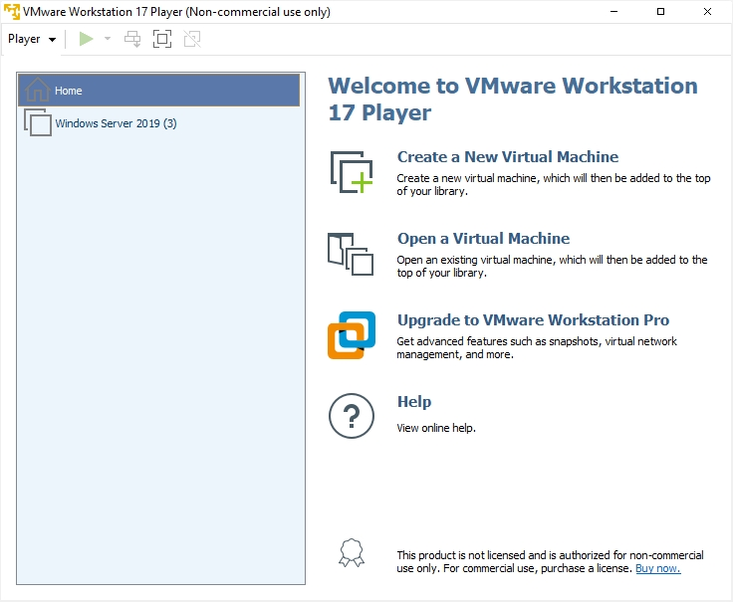

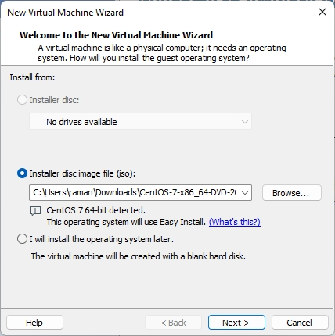

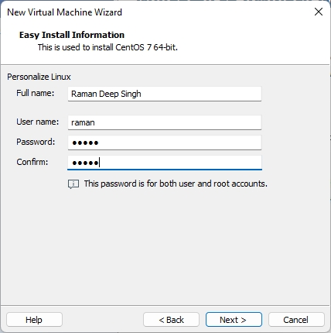

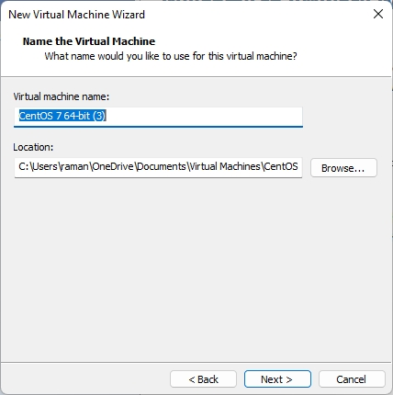

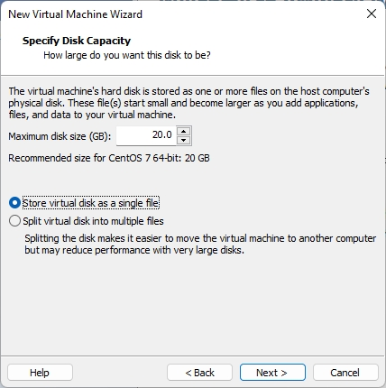

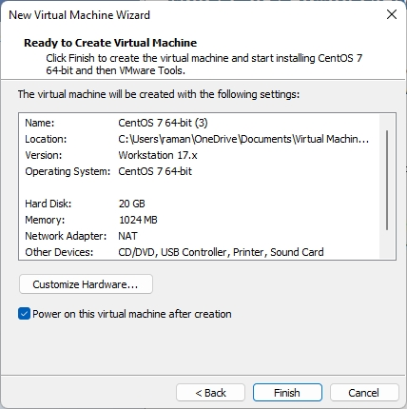

To customize hardware setting of virtual machine or virtual operating system click on Customize hardware and change the settings like ram, hard disk space, other devices.

After power on of this virtual machine you will find screen as below

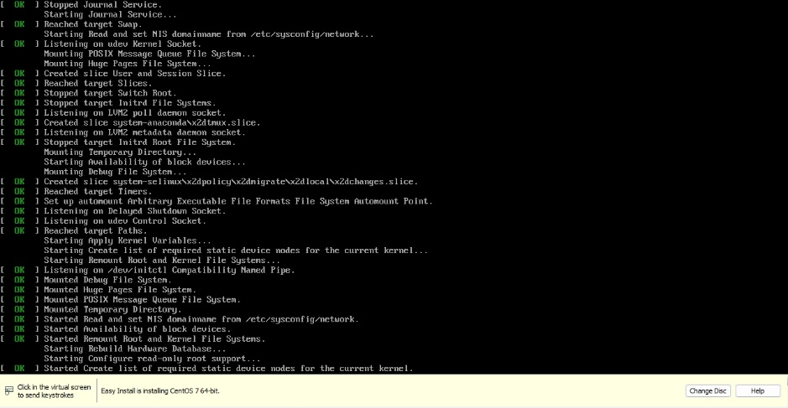

Below is the installation setup of CentOS which is a free Linux Distribution.

