WhatsApp Hanbook

Whatsapp is an instant messaging server and client that works on Android Phones and Apple Phones.

It can be opened also on computers.

This is the link to open whatsapp on computers.

<http://web.whatsapp.com>

Output will be

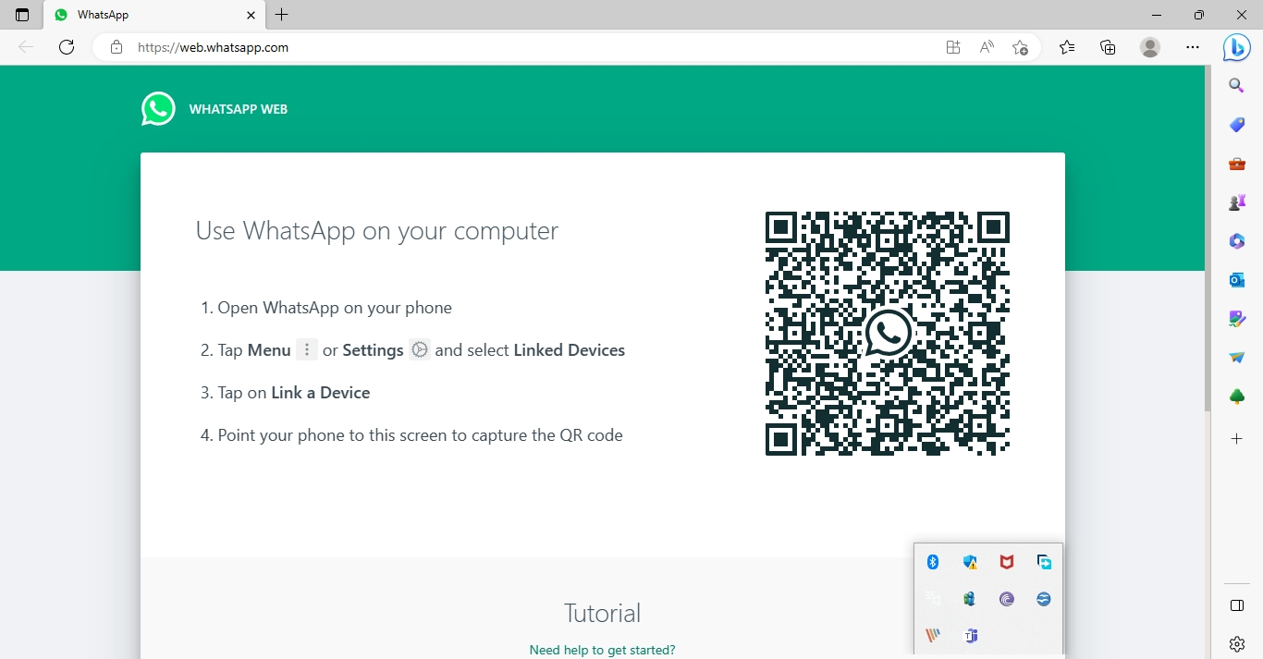

Follow the instructions on the above image and you can open whatsapp on your computer.