Vrinda Store Analysis

**Objective:**

Vrinda Store wants to a create annual sales report for 2022.So, that Vrinda can understand their customer and grow more sales in 2023.

**Interactive Dashboard:**

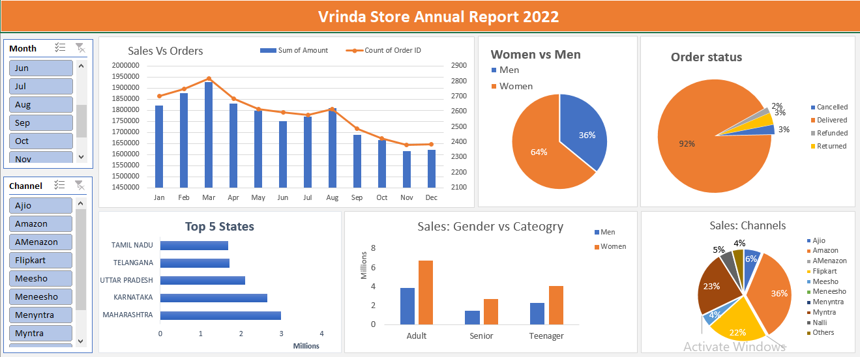

**Insights:**

* Women are more likely to buy compared to men (~65%).
* Maharashtra, Karnataka, Uttar Pradesh are the top 3 states.
* Adult age group (30-49 yrs) is max contributing (~50%).
* Amazon, Filpkart, Myntra are the max contributing (~80%).

**Final Conclusion to improve Vrinda store sales:**

* Target women customers of age group (30-49 yrs) living in Maharashtra, Karnataka and Uttar Pradesh by showing ads/offers/coupons available on Amazon, Flipkart and Myntra