Inter CRA Subscriber Shifting (ICSS) to KFintech

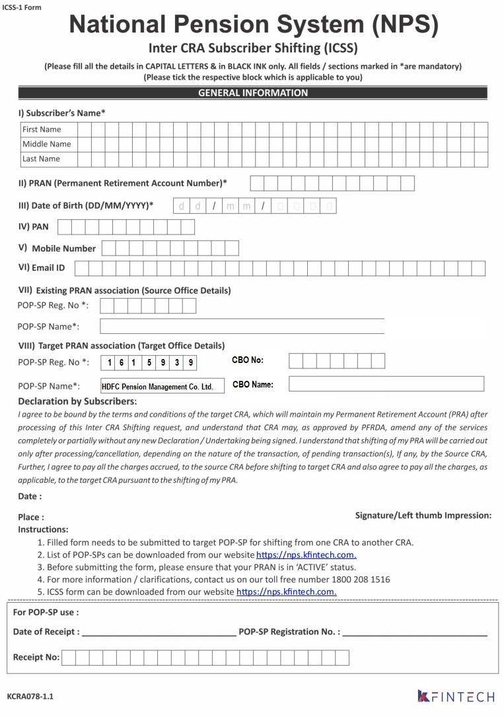

1 6 3 5 9 6 0

Brillio Technologies Private Limited