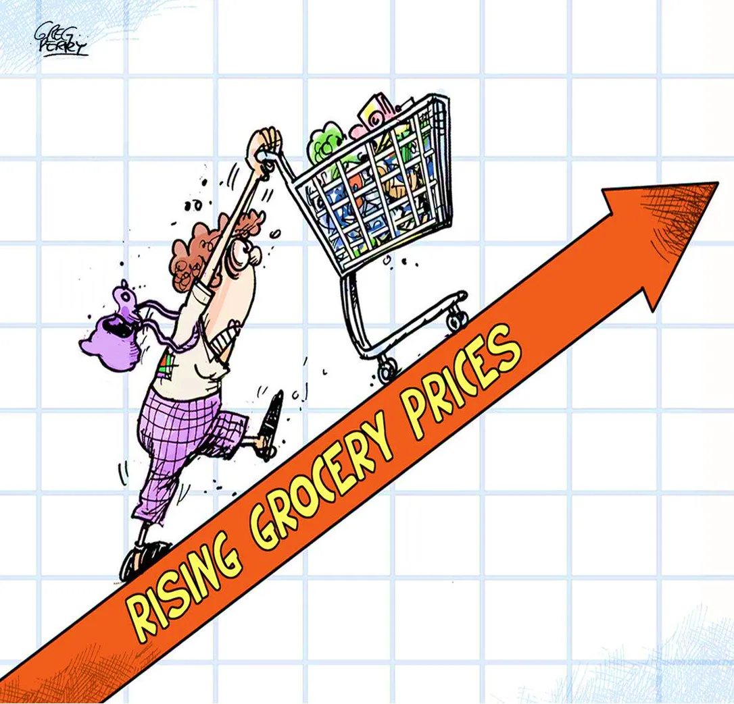

Time Series Team 16 (MSBA 2022/23)

Jingjing | Jeeny | Sam | Raman

Contents

**Introduction** **3**

1.1 Background and motivation 3

1.2 Methodology 3

**Time Series Forecasting** **4**

2.1 Overview of time series forecasting 4

2.2 Types of time series models 4

2.3 Data sources and collection method 4

2.4 Data cleaning and processing 4

2.5 Forecasting model selection 5

2.6 Accuracy measures and evaluation of forecast performance 5

2.7 Visualizing Forecasting Models 5

**Conclusion and Recommendations** **7**

3.1 Summary of the key findings 7

3.2 Recommendations for policy makers and stakeholders 8

3.3 Limitations and future research directions 9

**References** **10**

**Appendices** **11**

# **Introduction**

## **Background and motivation**

Food prices are a crucial component of a country's economy, as they have a direct impact on the cost of living and can influence inflation rates. Therefore, it is essential to forecast food prices accurately to plan policies that will ensure food security and maintain price stability. Different types of food commodities and their production, distribution, and consumption patterns. The main drivers of food are price inflation, such as supply and demand dynamics, weather conditions, energy prices, trade policies, and geopolitical risks (E.g., Ukraine – Russia Conflict). Food price inflation can have a significant impact on households' purchasing power and food security, especially in developing countries where a large share of income is spent on the food sector. Time series forecasting is a powerful tool to predict future values of time-dependent data. In this report, we will use time series forecasting techniques to forecast food prices and examine the trends and patterns in the food index time series. We will also analyze the data to identify any underlying trends or patterns that could impact food prices and consumers’ day-to-day lives.Chart

## **Methodology**

We have collected various food commodities data from governmental and nonprofit organizations such as the Bureau of Labor Statistics, Food and Agriculture Organization of the United Nations, IMF, FED, USDA. In R, we partitioned the original datasets and used different time series models to analyze, visualize and gain insight from the datasets. Furthermore, we found accuracy of models for each dataset and applied the best model to the original dataset to understand trends and seasonality of the complete data. By evaluating the results of our modeling, we made recommendations to consumers and public policy makers to help alleviate sudden food price shocks in the global food market.

# **Time Series Forecasting**

## **Overview of time series forecasting**

Time series forecasting involves predicting future values of a time-dependent data series. It is an essential tool for decision-making in various fields, such as finance, economics, and engineering. The accuracy of time series forecasts is influenced by several factors, such as the type of model, the data characteristics, and the forecasting horizon.

## **2.2 Types of time series models**

Time series models can be categorized into three main types:

* Simple models, such as moving averages and exponential smoothing
* Autoregressive models, such as AR, ARMA, and ARIMA
* Seasonal models, such as seasonal ARIMA (SARIMA) and seasonal exponential smoothing (SES)

## **2.3 Data sources and collection method**

The dataset consists of FAO (Food Price Index), which is the standard source for tracking global food prices. We pulled the data from the Food and Agriculture Organization of the United Nations (FAO) which publishes the Food Price Index and tracks the monthly changes in the international prices of a basket of food commodities. FAO has become the benchmark for tracking changes in international food commodity prices.

The index was first introduced in 1996 as a public good to help monitor developments in the global food commodity markets. The index tracks price developments of five broad food groups, namely cereals, vegetable oils, dairy, meats, and sugar using almost 100 price quotations taken from leading exporting countries. It covers 24 food commodities that together account for 40% of global gross agriculture commodity trade.

These food commodities are chosen for their high strategic importance and role in global food security and trade. Prices in the various sectors are combined using trade weights calculated from average export values over a chosen three-year base period.

We also forecasted and plotted price fluctuations for day-to-day food commodities such as Chicken, Eggs, Milk, and Rice on a granular level as they are most frequently purchased/used food commodities, and further analyzed their influence on the overall FAO data and plotted the results.

## **2.4 Data cleaning and processing**

The data is cleaned to remove any missing or invalid values and identify any outliers and handle them appropriately. We read in the monthly food price index data from a CSV file, cleaned the data by removing un-usable columns, and partitioned the data into a training and validation set. The training set contains all data up to the last 12 months (i.e., January 2019 to December 2022), while the validation set contains the last 12 months of data (i.e., January 2023 to January 2024).

## **2.5 Forecasting model selection**

We explore and apply different models to the food index data and evaluate their performance. The models used are:

* A linear regression model with a linear trend and additive seasonality (train_lm_trend_season)
* A Holt-Winters model using the ets function (train_hwin_R)
* A Holt-Winters model using the ets function with a specific model (train_hwin)
* An ARIMA model using the auto.arima function (train_arima)
* A seasonal naive method (snaive)
* Vector autoregression (var)

## **2.6 Accuracy measures and evaluation of forecast performance**

We applied different time series models to the food index data and evaluated their performance. The models are selected based on their ability to capture the underlying trends and patterns in the data and their forecasting accuracy. The best model is selected based on a combination of statistical measures and visual inspection of the forecasts. The accuracy of each model is computed using the accuracy function. We evaluated the accuracy of the forecasts using various measures, such as mean absolute error (MAE), root mean square error (RMSE), and mean absolute percentage error (MAPE).

After forecasting and plotting the best models with lowest forecasting error for each dataset, we forecasted and plotted against the validation data to generate a 12-month forecast. We also checked if the time series data has a random walk by computing the autocorrelation function of the first and seasonal differences of the training set.

## **2.7 Visualizing Forecasting Models**

We have used two major plots (line graphs) to understand which time series model works best on each training dataset, and use that model to further forecasts on the original dataset.

The first type (left below) of plot “Comparing Different Forecasting Models” compares the forecasts of the different models with the actual values on the validation set. This plot is useful for visually comparing the performance of the different models and identifying which model produces the most accurate forecasts.

The second type (right below) plot “12 Month Forecast…” shows the next 12-month forecast of the data. The plot is useful for visualizing the forecasted values and identifying any trends or patterns in the data. It can also be used to inform decision-making related to food pricing or related economic factors.

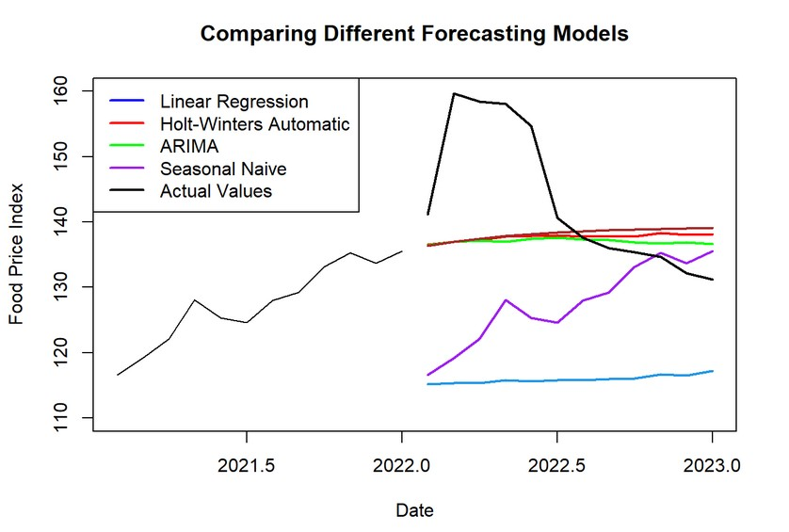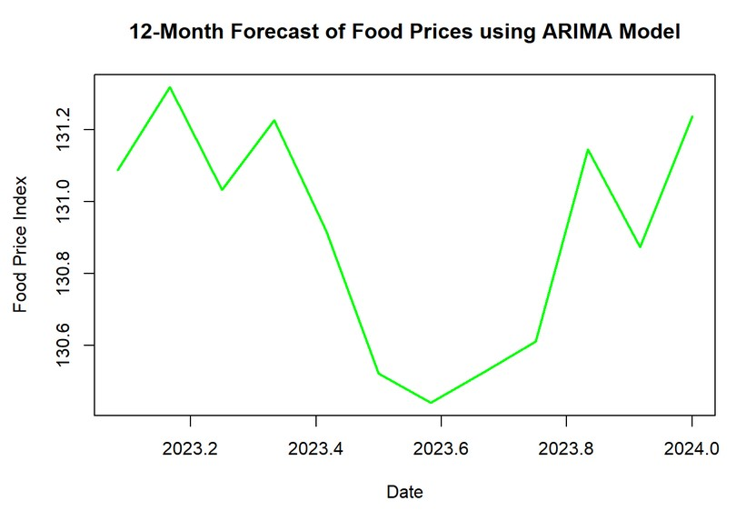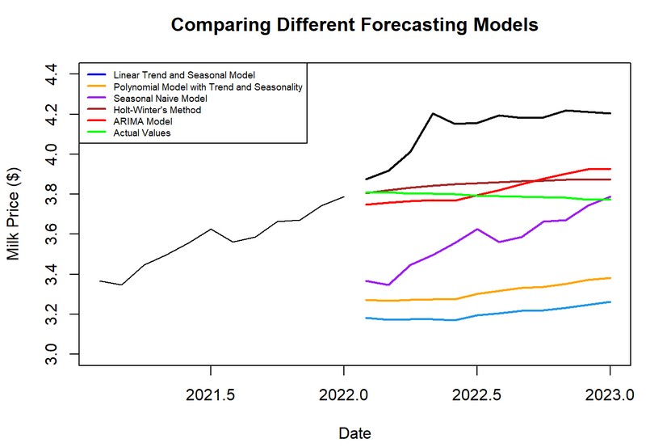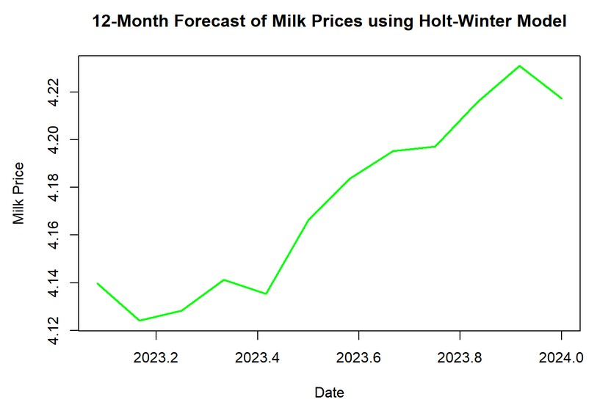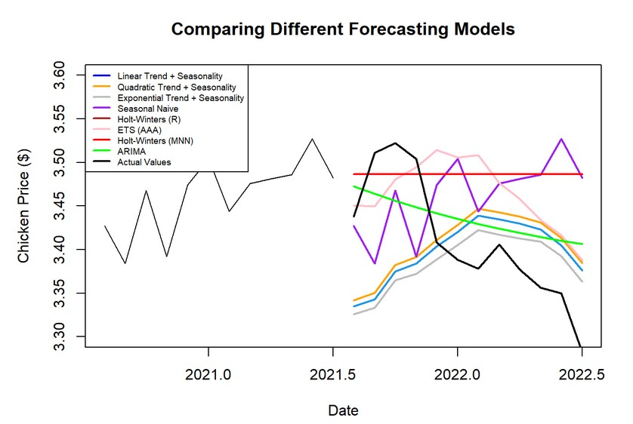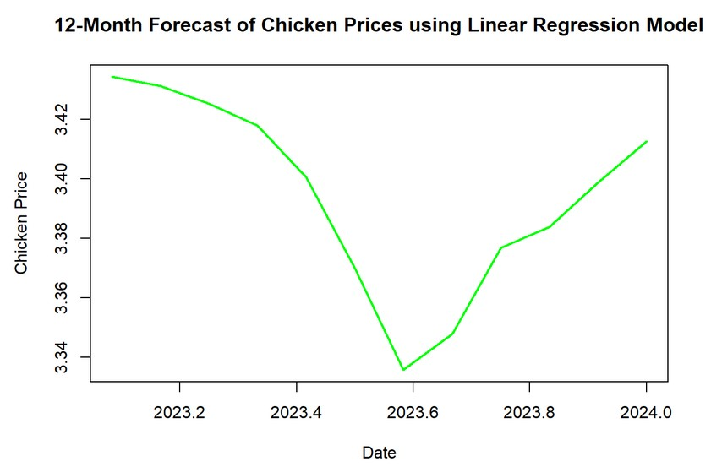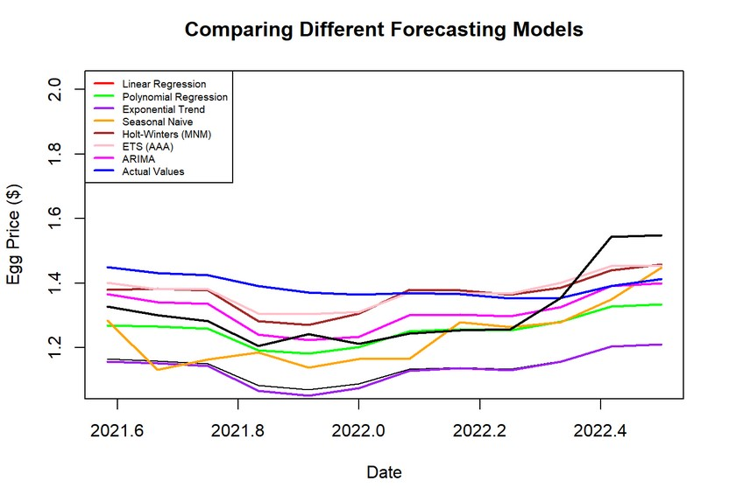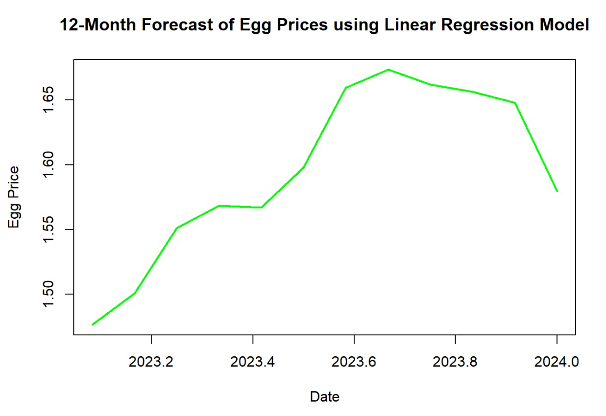

# **Conclusion and Recommendations**

## **3.1 Summary of the key findings**

As expected with the past pattern with the FAO (Food Price Index) dataset, we forecasted a net increase in the food price index for the next 12-months period, and the ideal time series model turned out to be the ARIMA model with RMSE, MAE, MPE, MAPE being 12.26, 8.78, 3.88, 5.76 respectively.

For the milk price data, the overall Holt-Winter model was the best at predicting the future with an RMSE of 0.454, MAE of 0.354, and MAPE of 8.736. When compared to the second-best model, ETS(M,Ad,N), Holt-Winters method had an RMSE and MAE that were about 0.02 lower and an MAPE that was 1% lower. As can be clearly seen from the time series plot of FPI and milk data, the milk price consistently increased and decreased along with the FPI, and now the price is higher than ever. Our Holt-Winter model expected the milk price to continue increasing over the next year, but around 2024, the price is expected to alleviate and come down a little.

An increase in milk prices can have a ripple effect on other industries that use milk or dairy products as ingredients, such as the bakery or ice cream industry, leading to an increase in their production costs and potentially higher prices for their products. Any increase in its price can lead to higher grocery bills, which can be difficult for families struggling to make ends meet. Since milk is a time-sensitive product that cannot last long, we cannot simply buy and stock it in the warehouse for bakery or ice cream production. Therefore, for the dairy industry, it is crucial to procure a good and steady supply of milk through prompt negotiation or exclusive contracts.

For the eggs prices dataset, the price of chicken, we examined a steady, linear increase. This is due to the many macroeconomic factors hiking the prices of all three, in recent years. In terms of our time series forecasts, a times series linear model fits best for the chicken price, and a polynomial model fits best for eggs.

When we investigated the relationship between the Food Price Index and other raw material prices, egg price is most sensitive to fluctuations in the Food Price Index. With one unit increase in the Food Price Index, egg price can respond by 15% increase around 25 months later.

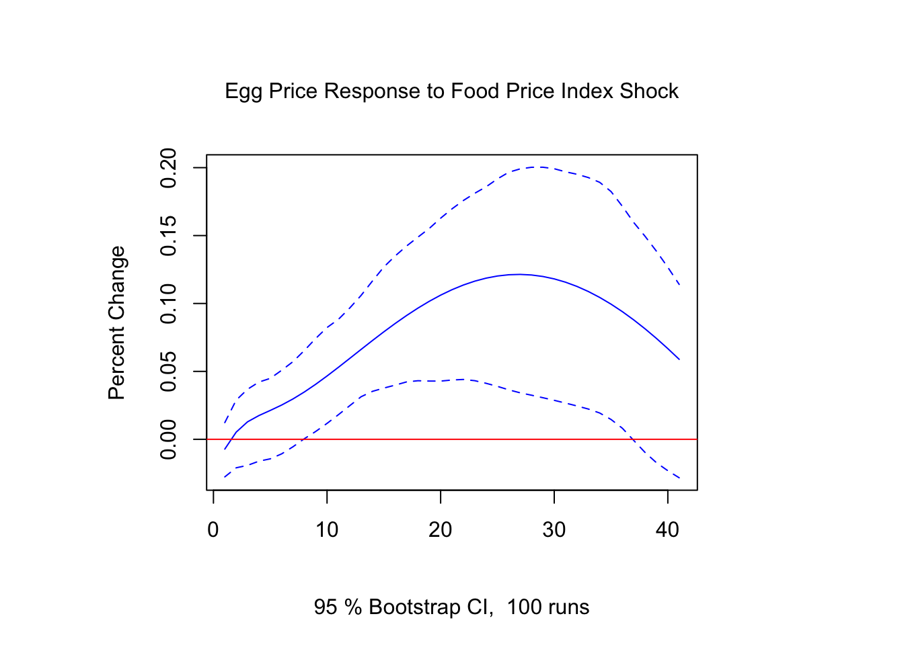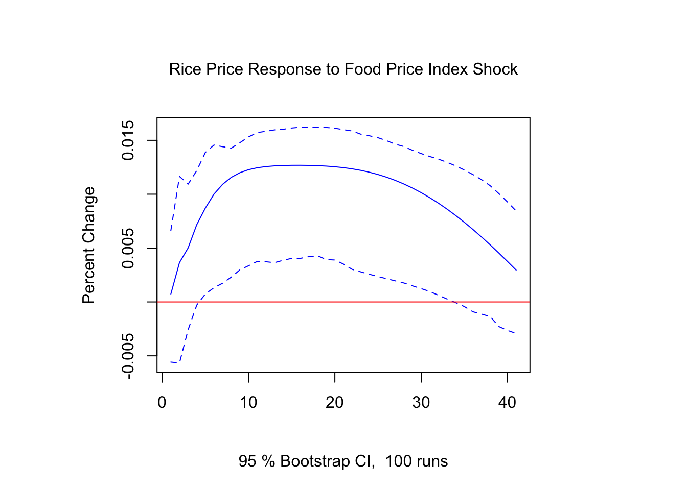

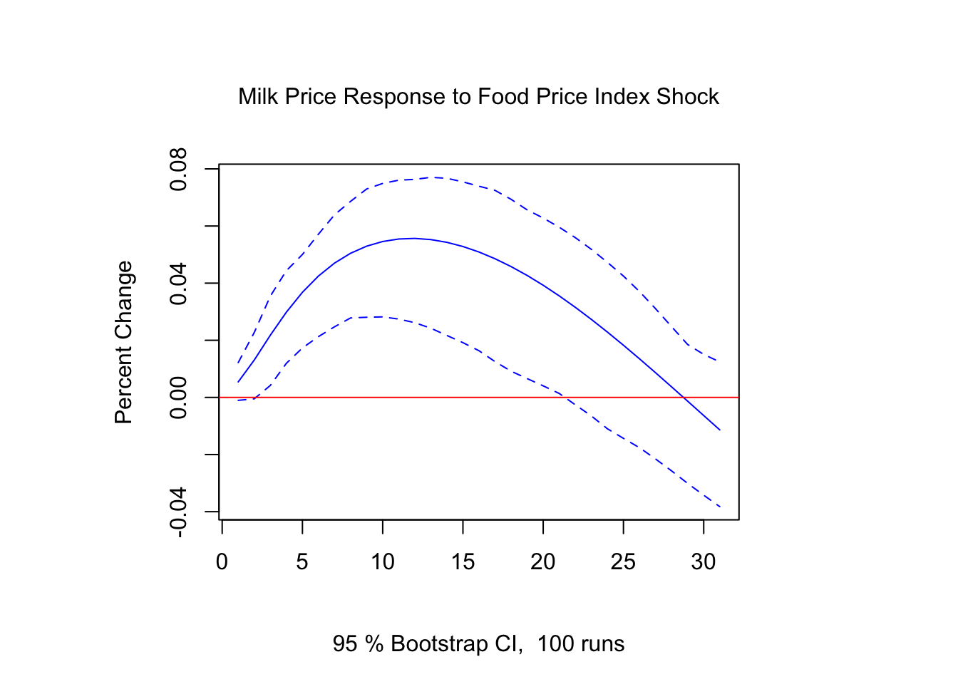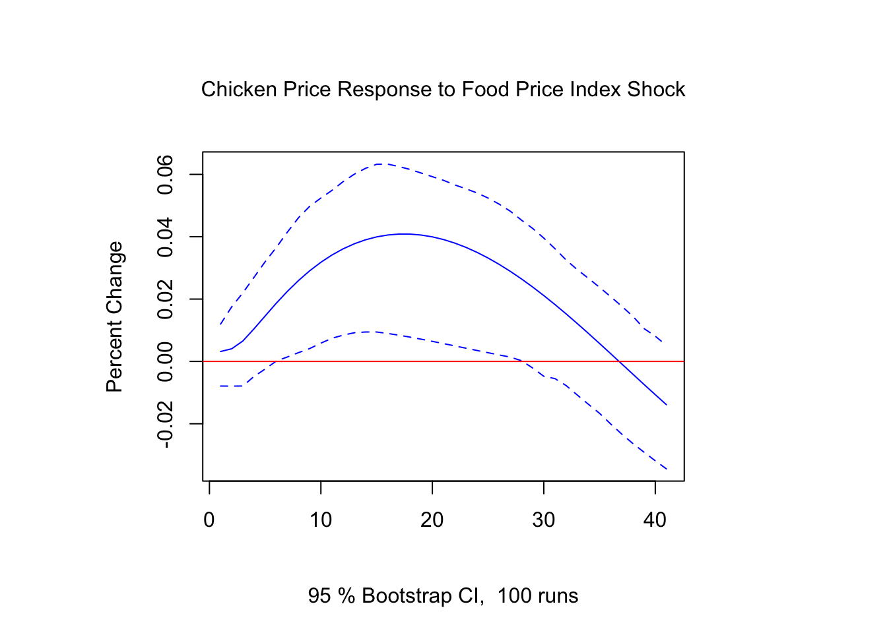

## **3.2 Recommendations for policy makers and stakeholders**

1. **For Policymakers:**

**a. Invest in food systems research and development:**

This can improve crop yields and promote the adoption of modern farming practices.

**b. Promote sustainable agriculture practices:**

Provide incentives for farmers to adopt sustainable practices to reduce production costs and improve the quality of food.

**c. Improve food labeling and transparency:**

Implement policies that require food labeling and increase transparency in the food supply chain.

**d. Manage trade policies:**

Policymakers can use tariffs and quotas to regulate the import and export of food, which can help stabilize domestic prices.

**e. Support small and mid-sized farms:**

Provide support such as funding for training and education, technical assistance, and marketing.

**f. Implement nutrition education programs:**

Invest in programs that promote healthy eating habits and help consumers make informed decisions about food.

**g. Provide food assistance programs:**

Food banks and SNAP can help low-income individuals and families access healthy and affordable food.

1. **For Consumers:**

**a. Plan your meals and make a grocery list:**

This can help you avoid impulse purchases and prevent food waste.

**b. Buy in bulk:**

Purchasing staple items in bulk can help you save money in the long run.

**c. Shop around:**

Compare prices at different stores to find the best deals on the foods you need.

**d. Buy seasonal and local:**

Foods that are in season and grown locally are often less expensive than imported or out-of-season produce.

**e. Cook at home:**

Cooking at home allows you to control the ingredients and portion sizes, while also saving you money.

**f. Use coupons and rewards programs:**

Many grocery stores offer coupons and rewards programs that can help you save money on your purchases.

## **3.3 Limitations and future research directions**

For future research direction, we would recommend a bottom-up approach rather than a top-down. This is in part due to the extensive size and characteristics when starting from a macro viewpoint. It is hard to derive impact, when the questions presented are too wide scale. Overall, data quality and accessibility were up to par, and has a vibrant community surrounding it. Food and agriculture for many first world countries can be subconsciously forgotten on how vital and impactful it can be. Recessionary indicators present a stout influence when it comes to the creation and research of the project.

# **References**

Bureau of Labor Statistics. “CPI Home : U.S.” *Bureau of Labor Statistics*, https://www.bls.gov/cpi/. Accessed 20 February 2023.

FAO. “FAO Food Price Index | World Food Situation.” *Food and Agriculture Organization of the United Nations*, https://www.fao.org/worldfoodsituation/foodpricesindex/en/. Accessed 18 February 2023.

IMF. “Global Food Prices to Remain Elevated Amid War, Costly Energy, La Niña.” *International Monetary Fund*, 9 December 2022, https://www.imf.org/en/Blogs/Articles/2022/12/09/global-food-prices-to-remain-elevated-amid-war-costly-energy-la-nina. Accessed 18 February 2023.

ST. LOUIS FED. “Price, Milk - Economic Data Series | FRED | St. Louis Fed.” *FRED*, https://fred.stlouisfed.org/tags/series?t=milk%3Bprice. Accessed 20 February 2023.

USDA. “USDA - National Agricultural Statistics Service - Surveys - Chickens and Eggs.” *USDA National Agricultural Statistics Service*, https://www.nass.usda.gov/Surveys/Guide_to_NASS_Surveys/Chickens_and_Eggs/index.php. Accessed 20 February 2023.

# **Appendices**

