List of Lab works

Lab no | Title/ Question | Submission Date | Signature | Remarks
1 | WAP to illustrate Caesar Cipher. | 2026/04/13
2 | WAP to illustrate Playfair cipher. | 2026/04/13
3 | WAP to illustrate Rail Fence cipher. | 2026/04/13
4 | WAP to simulate modular arithmetic operation. | 2026/04/13
5 | WAP to implement vigenere and vernam cipher. | 2026/04/13
6 | WAP to implement Hill cipher. | 2026/04/13
7 | WAP to find whether the given positive integer is prime or composite using Lucas Lehmer test. | 2026/04/13
8 | WAP to find the GCD of given two positive integers using Euclidean algorithm. | 2026/04/13
9 | Use the program [5] to find whether the given two integers are co-prime or not. | 2026/04/13
10. | Illustrate the Euler totient function. | 2026/04/13
11. | WAP that takes two integers as parameter and find out whether the first parameter is primitive root of second parameter or not. | 2026/04/13
12. | WAPto show how RSA generates the private and public key. | 2026/04/13
13. | Write a program to illustrate the Diffie Hellman Key exchange protocol. | 2026/04/13
14. | WAP to find the multiplicative inverse using extended Euclidean algorithm. | 2026/04/13
15. | WAP to implement the Elgamal cryptosystem. | 2026/04/13

Caesar Cipher Implementation

C-Program:

#include <stdio.h> #include <string.h> #include "helper.h"
static char encrypt(char ch, int key) {
if (ch >= 'A' && ch <= 'Z') return (char)((ch - 'A' + key) % 26 + 'A');
if (ch >= 'a' && ch <= 'z') return (char)((ch - 'a' + key) % 26 + 'a'); return ch; }

int main(void) {
string plain = get_string("Enter the plain text: ");
int key = ((get_int("Enter the key: ") % 26) + 26) % 26; int len = strlen(plain);
string cipher = (string)malloc(len + 1);
for (int i = 0; i < len; i++) cipher[i] = encrypt(plain[i], key); cipher[len] = '\0';
printf("Plain Text: %s\n", plain); printf("Cipher Text: %s\n", cipher); print_details();
free(cipher);
printf(“Lab No:1 by Rabin Moktan, Roll No:102, Section: C”); return 0; }

Output:
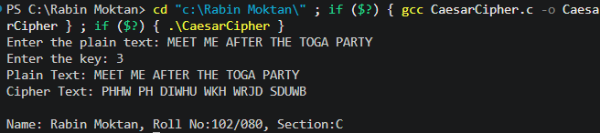

Playfair Encryption

C-Program:

#include <stdio.h> #include <string.h> #include <ctype.h> #include "helper.h" #define MX 5
int main(void) {
char matrix[MX][MX];
string key_in = get_string("Enter Key: "); string plain = get_string("Enter Plaintext: "); if (!key_in || !plain) return 1;
int used[26] = {0}; used['J' - 'A'] = 1;
int row = 0, col = 0;
string sources[] = {key_in, "ABCDEFGHIKLMNOPQRSTUVWXYZ"}; for (int s = 0; s < 2; s++) {
for (int i = 0; sources[s][i] != '\0'; i++) { if (!isalpha(sources[s][i])) continue; char c = toupper(sources[s][i]);
if (c == 'J') c = 'I';
if (!used[c - 'A']) { matrix[row][col++] = c; used[c - 'A'] = 1;
if (col == MX) { col = 0; row++; } } } } printf("\nKey Matrix:\n");
for (int i = 0; i < MX; i++) {
for (int j = 0; j < MX; j++) printf("%c ", matrix[i][j]); printf("\n"); }
int len = strlen(plain);
string cipher = malloc(len * 2 + 1); int p_idx = 0, c_idx = 0;
while (plain[p_idx] != '\0') {
if (!isalpha(plain[p_idx])) { p_idx++; continue; } char a = toupper(plain[p_idx++]);
if (a == 'J') a = 'I';
char b = 'X';
int next = p_idx;
while (plain[next] != '\0' && !isalpha(plain[next])) next++;
if (plain[next] != '\0' && toupper(plain[next]) != (a == 'I' ? 'J' : a)) { b = toupper(plain[next]);
if (b == 'J') b = 'I';

p_idx = next + 1; } int r1, c1, r2, c2;
for (int i = 0; i < 25; i++) {
if (matrix[i/5][i%5] == a) { r1 = i/5; c1 = i%5; }
if (matrix[i/5][i%5] == b) { r2 = i/5; c2 = i%5; } } if (r1 == r2) {
cipher[c_idx++] = matrix[r1][(c1 + 1) % MX]; cipher[c_idx++] = matrix[r2][(c2 + 1) % MX]; } else if (c1 == c2) {
cipher[c_idx++] = matrix[(r1 + 1) % MX][c1]; cipher[c_idx++] = matrix[(r2 + 1) % MX][c2]; } else {
cipher[c_idx++] = matrix[r1][c2]; cipher[c_idx++] = matrix[r2][c1]; } } cipher[c_idx] = '\0';
printf("\nPlaintext: %s\nCiphertext: %s\n", plain, cipher); print_details();
free(cipher); return 0; }

Output:
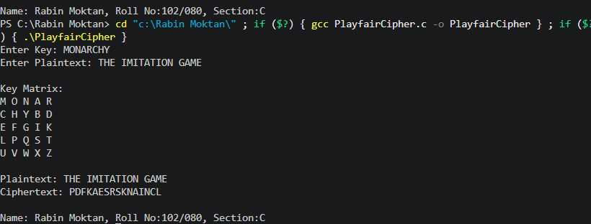

Rail fence Cipher

C -Program: #include<stdio.h> #include<string.h> #include "helper.h" int main(void) {
string plain = get_string("Enter the plain text: "); if (!plain) return 1;
int len = strlen(plain);
string cipher = (string)malloc(len + 1); if (!cipher) return 1;
int rail = get_int("Enter the number of rails: "); char matrix[rail][len];
for (int i = 0; i < rail; i++) for (int j = 0; j < len; j++) matrix[i][j] = '\n';
int dir_down = 0, row = 0, col = 0; for (int i = 0; i < len; i++) {
if (row == 0 || row == rail - 1) dir_down = !dir_down; matrix[row][col++] = plain[i]; row += dir_down ? 1 : -1; } int idx = 0;
for (int i = 0; i < rail; i++) for (int j = 0; j < len; j++) if (matrix[i][j] != '\n')
cipher[idx++] = matrix[i][j]; cipher[idx] = '\0';
printf("Plain Text: %s\n", plain); printf("Cipher Text: %s\n", cipher); print_details();
free(cipher); return 0; }

Output:
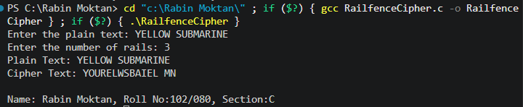

Modular Arithmetic Operation:

C Program:
#include <stdio.h> #include"helper.h" int main(void){
int a = get_int("Enter the first number: ");
int b = get_int("Enter the second number: "); int mod = get_int("Enter the modulus: "); if(mod <= 0){
printf("Modulus must be a positive integer.\n"); return 1; }
int sum = (a % mod + b % mod) % mod;
int sub = (a % mod - b % mod + mod) % mod; int mul = (a % mod * b % mod) % mod;
printf("The result of (%d + %d) mod %d is: %d\n", a, b, mod, sum); printf("The result of (%d * %d) mod %d is: %d\n", a, b, mod, mul); printf("The result of (%d - %d) mod %d is: %d\n", a, b, mod, sub); print_details();
return 0; }

Output:
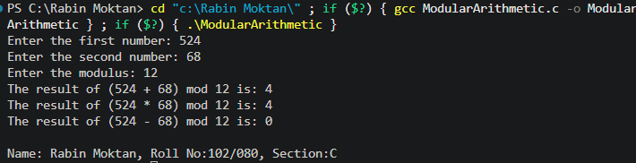

Vigenere Cipher and Vernam Cipher

C Program:
#include <stdio.h> #include <string.h> #include "helper.h"
void vigenere_cipher(string text, string key, char result[]) { int text_len = strlen(text);
int key_len = strlen(key);
for (int i = 0; i < text_len; i++) {
if (text[i] >= 'A' && text[i] <= 'Z') {
result[i] = ((text[i] - 'A') + (key[i % key_len] - 'A')) % 26 + 'A'; } else if (text[i] >= 'a' && text[i] <= 'z') {
result[i] = ((text[i] - 'a') + (key[i % key_len] - 'a')) % 26 + 'a'; } else {
result[i] = text[i];
}
}
result[text_len] = '\0'; }
void vernam_cipher(string text, string key, char result[]) { int text_len = strlen(text);
for (int i = 0; i < text_len; i++) {
result[i] = text[i] ^ key[i % strlen(key)]; } result[text_len] = '\0'; }
int main(void) {
string text = get_string("Enter the text: ");
string v_key = get_string("Enter Vigenere key: "); int text_len = strlen(text);
char result[text_len + 1]; vigenere_cipher(text, v_key, result); printf("Vigenere Cipher Result: %s\n", result);
printf("\nVernam Cipher requires a key of length %d.\n", text_len); string vernam_key;
do {
vernam_key = get_string("Enter Vernam key: "); if (strlen(vernam_key) != text_len) { printf("Invalid length! Try again.\n");
}
}
while (strlen(vernam_key) != text_len); vernam_cipher(text, vernam_key, result); printf("Vernam Cipher Result (Hex): "); for (int i = 0; i < text_len; i++) { printf("%02X ", (unsigned char)result[i]); }

print_details(); return 0;
}

Output:
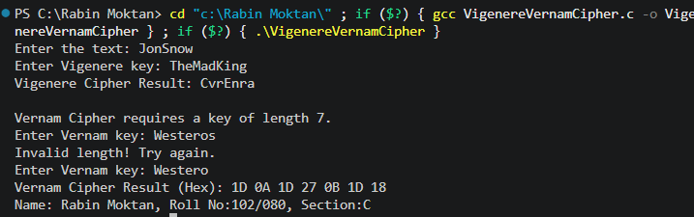

Hill Cipher

C Program:
#include <stdio.h> #include <string.h> #include <ctype.h> #include "helper.h"
void hillCipher(string text, int key[2][2]); static int mod26(int x){
int r = x % 26;
return (r < 0) ? r + 26 : r; } int main(void) {
string text = get_string("Enter the text to encrypt: "); int key[2][2];
printf("Enter the 2x2 key matrix (4 integers):\n"); for (int i = 0; i < 2; i++){
for (int j = 0; j < 2; j++){
if (scanf("%d", &key[i][j]) != 1) { printf("Invalid matrix input.\n"); return 1; } } }
int det = key[0][0] * key[1][1] - key[0][1] * key[1][0]; det = mod26(det);
if (det == 0 || det % 2 == 0 || det % 13 == 0)
printf("Warning: This key matrix is not invertible and cannot be decrypted!\n"); hillCipher(text, key);
print_details(); return 0; }
void hillCipher(string text, int key[2][2]){ int len = strlen(text);
char clean_text[len + 1]; int clean_len = 0;
for (int i = 0; i < len; i++) {
if (isalpha((unsigned char)text[i])) {
clean_text[clean_len++] = (char)toupper((unsigned char)text[i]); } } clean_text[clean_len] = '\0';
if (clean_len == 0){
printf("No alphabetic text to encrypt.\n"); return; }
if (clean_len % 2 != 0){ clean_text[clean_len++] = 'X'; clean_text[clean_len] = '\0'; } char encrypted[clean_len + 1];
for (int i = 0; i < clean_len; i += 2){ int x1 = clean_text[i] - 'A';

int x2 = clean_text[i + 1] - 'A';
encrypted[i] = mod26(key[0][0] * x1 + key[0][1] * x2) + 'A'; encrypted[i + 1] = mod26(key[1][0] * x1 + key[1][1] * x2) + 'A'; } encrypted[clean_len] = '\0';
printf("Encrypted text: %s\n", encrypted); }

Output:
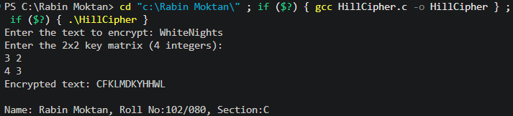

Prime number check using Lucas Lehmer test.

C Program:
#include <stdio.h> #include <math.h> #include <stdbool.h> #include "helper.h" typedef long long ll; bool is_prime(int n) { if (n <= 1) return false; if (n <= 3) return true;
if (n % 2 == 0 || n % 3 == 0) return false; for (int i = 5; i * i <= n; i += 6) {
if (n % i == 0 || n % (i + 2) == 0) return false; } return true; }
bool lucas_lehmer_test(int p) {
if (p == 2) return true; // 2 is prime ll s = 4;
ll m = (1LL << p) - 1;
for (int i = 0; i < p - 2; i++) { s = (s * s - 2) % m; }
return s == 0; } int main() {
int n = get_int("Enter a positive integer: "); if (n < 1) {
printf("Not a positive integer.\n"); return 1; }
if (is_prime(n)) {
printf("%d is a prime number.\n", n); if (lucas_lehmer_test(n)) {
printf("%d is a Mersenne prime.\n", n);
} else {
printf("%d is not a Mersenne prime.\n", n); }
} else {
printf("%d is a composite number.\n", n); } print_details();
return 0; }

Output:
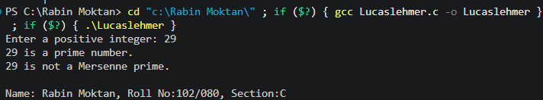

GCD by Euclidean Algorithm:

C Program:
#include <stdio.h> #include "helper.h" int main() {
int a = get_int("Enter the first positive integer: ");
int b = get_int("Enter the second positive integer: "); if (a <= 0 || b <= 0) {
printf("Please enter positive integers only.\n"); return 1; }
int result = gcd(a, b);
printf("The GCD of %d and %d is: %d\n", a, b, result); print_details();
return 0; }

Output:
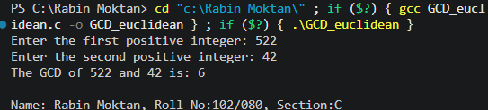

Co-Prime check

C Program:
#include <stdio.h> #include "helper.h" int main() {
int a = get_int("Enter the first positive integer: ");
int b = get_int("Enter the second positive integer: "); if (a <= 0 || b <= 0) {
printf("Please enter positive integers only.\n"); return 1; }
int result = gcd(a, b); if (result == 1) {
printf("%d and %d are co-prime.\n", a, b);
} else {
printf("%d and %d are not co-prime. GCD is %d.\n", a, b, result); } print_details();
return 0; }

Output:
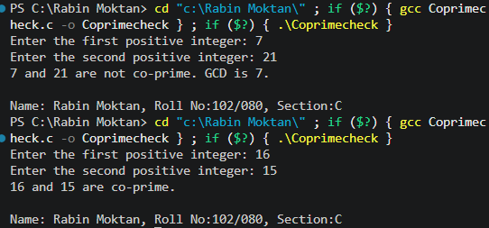

Euler Totient Function

C Program:
#include <stdio.h> #include "helper.h"
int euler_totient(int n) { int count = 0;
for (int i = 1; i < n; i++) { if (gcd(i, n) == 1) { count++; }
}
return count;
}
int main() {
int n = get_int("Enter a positive integer: "); if (n <= 0) {
printf("Please enter a positive integer.\n"); return 1; }
int result = euler_totient(n);
printf("The Euler totient function for %d is: %d\n", n, result); print_details();
return 0; }

Output:
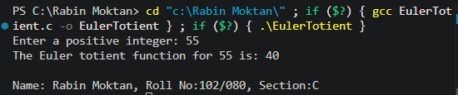

Primitive root or not?

C Program:
#include <stdio.h> #include "helper.h"
int is_primitive_root(int a, int p) { if (gcd(a, p) != 1) return 0;
int order = 1, value = a % p; while (value != 1) {
value = (value * a) % p;
if (++order > p - 1) return 0; } return order == p - 1; }
int main() {
int a = get_int("Enter the first positive integer (potential primitive root): "); int p = get_int("Enter the second positive integer (modulus): ");
if (is_primitive_root(a, p)) {
printf("%d is a primitive root modulo %d.\n", a, p);
} else {
printf("%d is not a primitive root modulo %d.\n", a, p);
}
print_details(); return 0; }

Output:
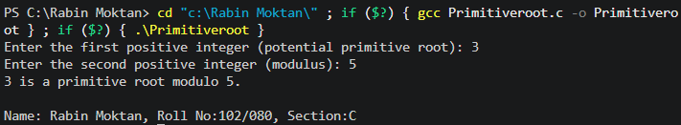

RSA Algorithm for public/private key generation.

C Program:
#include <bits/stdc++.h> using namespace std;
int power(int base, int expo, int m) { int res = 1;
base = base % m; while (expo > 0) { if (expo & 1)
res = (res * 1LL * base) % m; base = (base * 1LL * base) % m; expo = expo / 2;
}
return res; }
int modInverse(int e, int phi) { for (int d = 2; d < phi; d++) { if ((e * d) % phi == 1)
return d;
}
return -1; }
void generateKeys(int &e, int &d, int &n) { int p = 7919;
int q = 1009; n = p * q;
int phi = (p - 1) * (q - 1); for (e = 2; e < phi; e++) { if ( gcd(e, phi) == 1) break; }
d = modInverse(e, phi); }
int encrypt(int m, int e, int n) { return power(m, e, n); }
int decrypt(int c, int d, int n) { return power(c, d, n); }
int main() { int e, d, n;
generateKeys(e, d, n);
cout << "Public Key (e, n): (" << e << ", " << n << ")\n";
cout << "Private Key (d, n): (" << d << ", " << n << ")\n"; int M = 123;
cout << "Original Message: " << M << endl; int C = encrypt(M, e, n);
cout << "Encrypted Message: " << C << endl; int decrypted = decrypt(C, d, n);

cout << "Decrypted Message: " << decrypted << endl;
cout << "\nName:Rabin Moktan\tRoll No:102/080\tSection:C\t"; return 0;
}

Output:
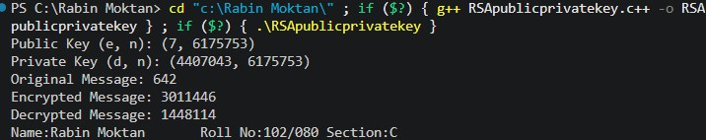

Diffie-Hellman Key Exchange Implementation

C Program:
#include <stdio.h>
long long power(long long base, long long exp, long long mod) { long long res = 1;
base = base % mod; while (exp > 0) {
if (exp % 2 == 1) res = (res * base) % mod; base = (base * base) % mod;
exp = exp / 2; } return res; } int main() {
long long p, g, a, b;
printf("Enter a prime number (p): "); scanf("%lld", &p);
printf("Enter a primitive root modulo p (g): "); scanf("%lld", &g);
printf("Enter Alice's private key (a): "); scanf("%lld", &a);
printf("Enter Bob's private key (b): "); scanf("%lld", &b);
long long A = power(g, a, p); long long B = power(g, b, p);
printf("\nAlice's public key (A): %lld", A); printf("\nBob's public key (B): %lld", B); long long secretA = power(B, a, p); long long secretB = power(A, b, p);
printf("\n\nAlice's shared secret: %lld", secretA); printf("\nBob's shared secret: %lld", secretB);
if (secretA == secretB) {
printf("\nSuccess: Shared secrets match!\n");
} else {
printf("\nError: Secrets do not match.\n"); } printf("\nName:Rabin Moktan\tRoll No:102/080\tSection:C\t"); return 0; }

Output:
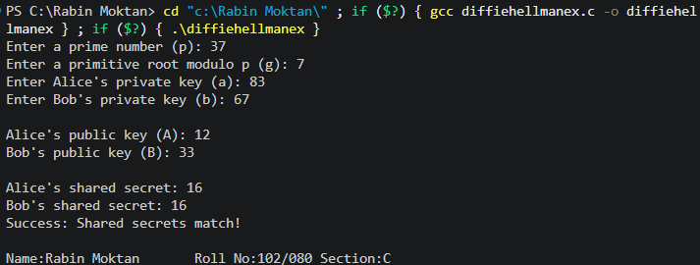

Multiplicative Inverse by Extended Euclidean

C Program:
#include <stdio.h>
int extended_gcd(int a, int b, int *x, int *y) { if (a == 0) {
*x = 0; *y = 1; return b; }
int x1, y1;
int gcd = extended_gcd(b % a, a, &x1, &y1);
*x = y1 - (b / a) * x1;
*y = x1; return gcd; }
int multiplicative_inverse(int a, int m) { int x, y;
int g = extended_gcd(a, m, &x, &y); if(g != 1) {
return -1; } else {
return (x % m + m) % m; } } int main() {
int a, m;
printf("Enter the number (a): "); scanf("%d", &a);
printf("Enter the modulus (m): "); scanf("%d", &m);
int inverse = multiplicative_inverse(a, m); if (inverse == -1) {
printf("Multiplicative inverse does not exist for %d modulo %d.\n", a, m);
} else {
printf("The multiplicative inverse of %d modulo %d is: %d\n", a, m, inverse); } printf("\nName:Rabin Moktan\tRoll No:102/080\tSection:C\t");
return 0; }

Output:
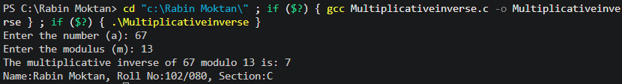

Elgamal Cryptosystem:
C Program:
#include <stdio.h>
long long power(long long base, long long exp, long long mod){ long long res = 1;
base = base % mod; while (exp > 0){
if (exp % 2 == 1)
res = (res * base) % mod; base = (base * base) % mod; exp = exp / 2; }
return res; } int main() {
long long p, g, a, b;
printf("Enter a prime number (p): "); scanf("%lld", &p);
printf("Enter a primitive root modulo p (g): "); scanf("%lld", &g);
printf("Enter Alice's private key (a): "); scanf("%lld", &a);
printf("Enter Bob's private key (b): "); scanf("%lld", &b);
long long A = power(g, a, p); long long B = power(g, b, p);
printf("\nAlice's public key (A): %lld", A); printf("\nBob's public key (B): %lld", B); long long secretA = power(B, a, p); long long secretB = power(A, b, p);
printf("\n\nAlice's shared secret: %lld", secretA); printf("\nBob's shared secret: %lld", secretB);
if (secretA == secretB)
printf("\nSuccess: Shared secrets match!\n"); else
printf("\nError: Secrets do not match.\n"); printf("\nName:Rabin Moktan\tRoll No:102/080\tSection:C\t"); return 0; }

Output:
