The **Collection in Java** is a framework that provides architecture to store and manipulate the group of objects.

Java Collections can achieve all the operations that you perform on a data such as searching, sorting, insertion, manipulation, and deletion.

Java Collection means a single unit of objects. Java Collection framework provides many interfaces (Set, List, Queue, and Deque) and classes (Array List, Vector, Linked List, Priority Queue, Hash Set, Linked Hash Set, and Tree Set).

**LIST:**

List interface is the child interface of Collection interface. It inhibits a list type data structure in which we can store the ordered collection of objects. It can have duplicate values.

List interface is implemented by the classes Array List, Linked List, Vector, and Stack.

**INTERFACE**

**CLASS**

**IMPLEMETS**

**EXTENDS**

SET:

Set Interface in Java is present in java.util package. It extends the Collection interface. It represents the unordered set of elements which doesn't allow us to store the duplicate items. We can store at most one null value in Set. Set is implemented by Hash Set, Linked Hash Set, and Tree Set.

**INTERFACE**

**CLASS**

**IMPLEMETS**

**EXTENDS**

**QUEUE:**

Queue interface maintains the first-in-first-out order. It can be defined as an ordered list that is used to hold the elements which are about to be processed. There are various classes like Priority Queue, Deque, and Array Deque which implements the Queue interface.

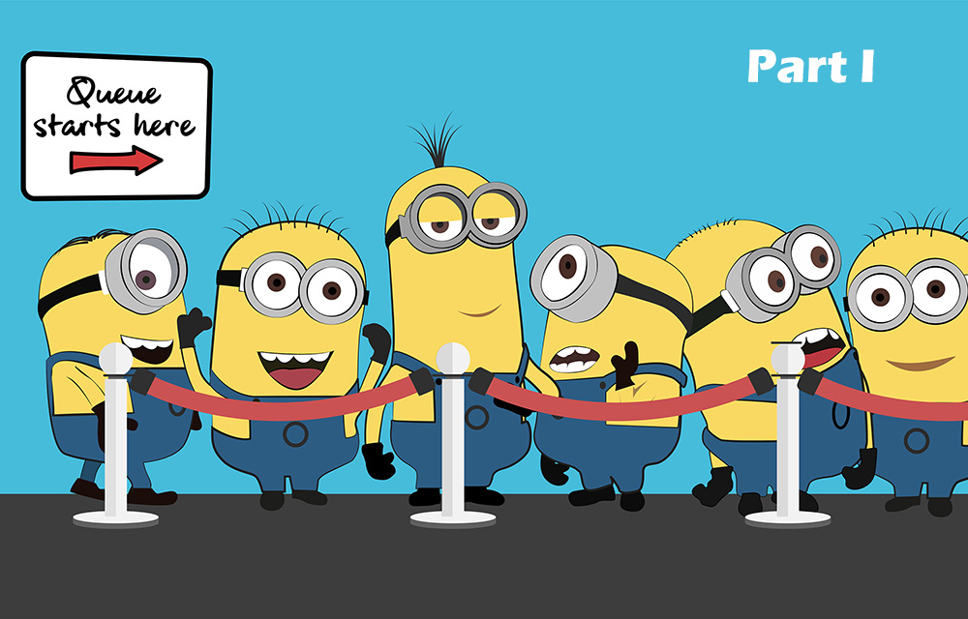

**QUEUE:**

**INTERFACE**

**CLASS**

**IMPLEMETS**

**EXTENDS**

**MAP:**

A map contains values on the basis of key, i.e. key and value pair. Each key and value pair is known as an entry. A Map contains unique keys.

A Map is useful if you have to search, update or delete elements on the basis of a key.

**INTERFACE**

**CLASS**

**IMPLEMETS**

**EXTENDS**