# Problem Statement

1. How to Import SAS XPORT files into R with the foreign package?

library(foreign)

data <- read.xport("D:\\BIG DATA\\DATA ANALYTICS WITH R, EXCEL & TABLEAU\\3 FOUNDATIONAL R PROGRAMMING-I\\SXQ_F.XPT")

View(data)

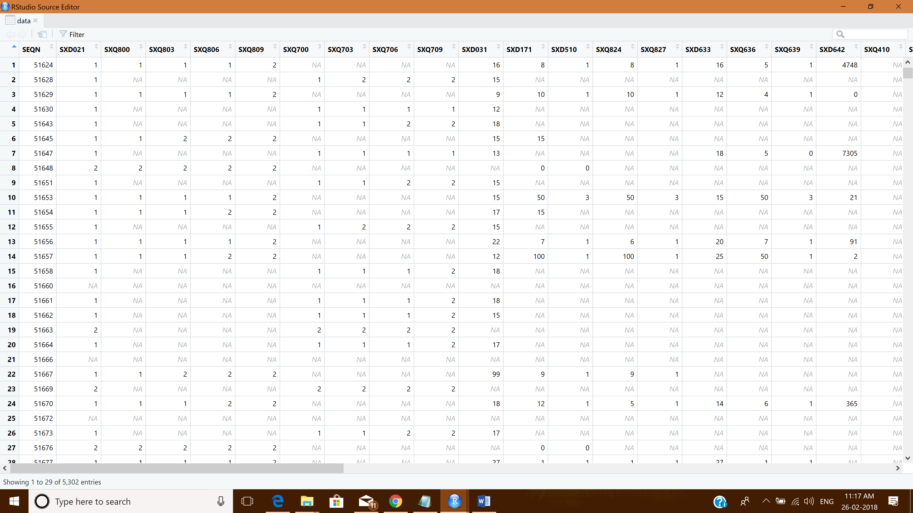

#Other Method

getwd()

setwd("D:/BIG DATA/DATA ANALYTICS WITH R, EXCEL & TABLEAU/3 FOUNDATIONAL R PROGRAMMING-I")

getwd()

library(foreign)

read.xport("SXQ_F.XPT")

1. How to Import SAS Files into R with the Haven package?

library(haven)

data <- read_sas("D:\\BIG DATA\\DATA ANALYTICS WITH R, EXCEL & TABLEAU\\3 FOUNDATIONAL R PROGRAMMING-I\\airline.sas7bdat")

View(data)

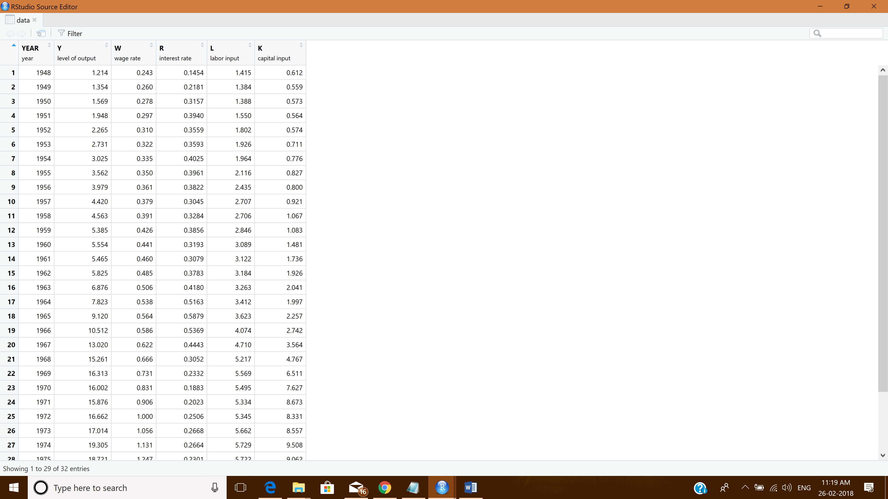

1. How to read Weka Attribute-Relation File Format (ARFF) files in R?

library(foreign)

data1 <- read.arff("D:\\BIG DATA\\DATA ANALYTICS WITH R, EXCEL & TABLEAU\\3 FOUNDATIONAL R PROGRAMMING-I\\iris.arff")

View(data1)

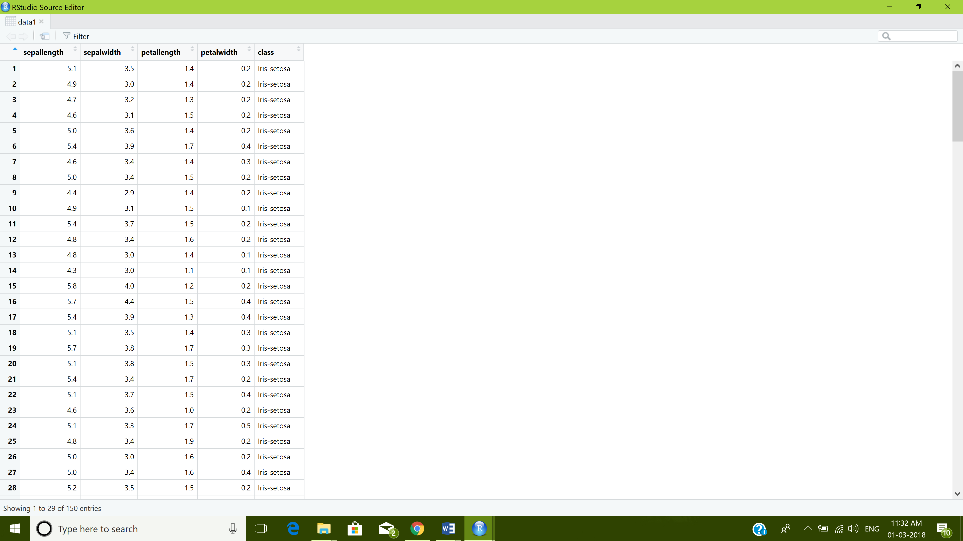

1. How to read a heavy csv/tsv file using readr package?

library(readr)

csvfile <- read_table("D:/BIG DATA/DATA ANALYTICS WITH R, EXCEL & TABLEAU/3 FOUNDATIONAL R PROGRAMMING-I/CSVFile.csv", col_names=TRUE)

View(csvfile)

