# Problem Statement

1. x <- c(‘data.science.in.R’, ‘machine.learning.in.R’) Perform the below string Operation:

* Replace the period character "." within each string with another character i.e. "-" minus sign.

**ANS**

x <- c("data.science.in.R", "machine.learning.in.R")

x

y <- gsub( "\\.","-",x)

y

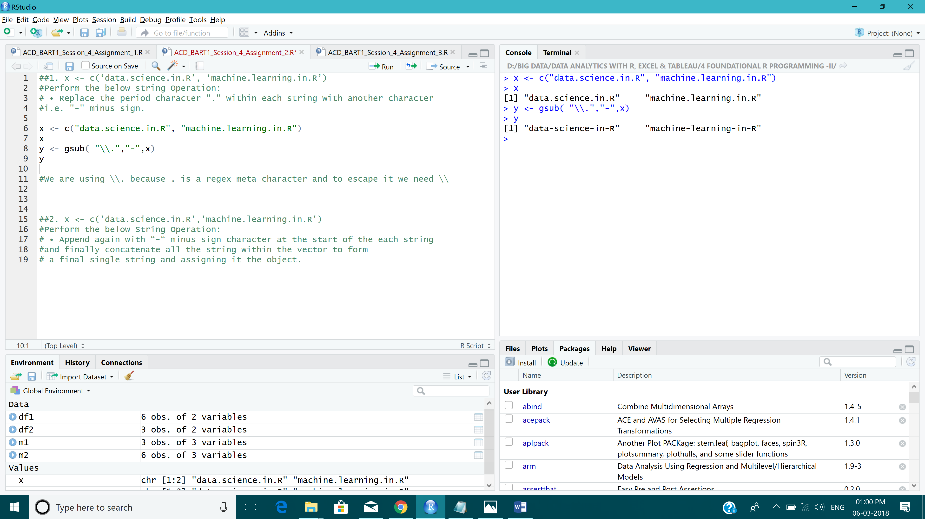

2. x <- c('data.science.in.R','machine.learning.in.R') Perform the below String Operation:

* Append again with “-“ minus sign character at the start of the each string and finally concatenate all the string within the vector to form a final single string and assigning it the object.

**ANS**

x <- c("data.science.in.R","machine.learning.in.R")

(y <- paste(paste0("-",x) , collapse = ""))

