# Problem Statement

1. States = rownames(US Arrests)

Get states names with ‘w’.

Get states names with ‘W’.

library(MASS)

data(USArrests)

States = rownames(USArrests)

View(States)

#Get states names with ‘w’.

States[grep(States,pattern = "w")]

#Get states names with ‘W’.

States[grep(States,pattern = "W")]

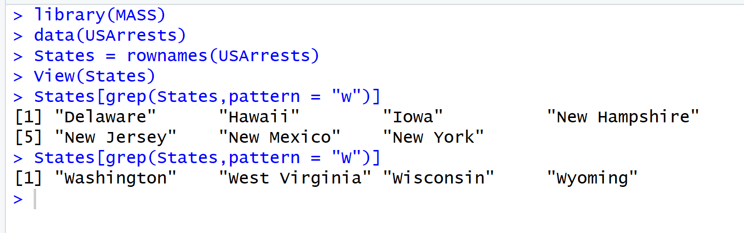

1. Prepare a Histogram of the number of characters in each US state.

|  |
| --- |
| > hist(nchar(States) , plot = TRUE, xlab = "Number of characters in State" , ylab = "Number of States") |
|  |
| |  | | --- | | > | |

