# Problem Statement

1. Import the Titanic Dataset from the link Titanic Data Set.

Perform the following:

library(titanic)

1. Preprocess the passenger names to come up with a list of titles that represent families and represent using appropriate visualization graph.

pass_titles <- ""

for(i in 1:891){pass_titles <- c(pass_titles,pass_names[[i]][2])}

pass_titles <- pass_titles[-1]

titles <- ""

for( i in 1:891){

temp <- strsplit(pass_titles[i],"\\.")

titles <- c(titles,temp)

}

titles[1] <- NULL

title_category <- ""

for(i in 1:891){

title_category <- c(title_category,titles[[i]][1])

}

title_category <- title_category[-1]

title_category <- as.factor(title_category)

levels(title_category)

#check for summary

summary(title_category)

others <- 0

for(i in 1:17){

if(i == 8 || i == 9 || i == 12 || i == 13 )

{

next()

}

else{

others <- others + summary(title_category)[i]

}

}

#grouping

# We have grouped small categories such as Capt , Col ,Don.....etc into 'others'

library(plotrix)

title_category <- c(summary(title_category)[8],summary(title_category)[9],summary(title_category)[12],summary(title_category)[13],others)

labelname <- c("Master","Miss","Mr.","Mrs.","Others")

pie3D(title_category,labels = labelname,main="List of Titles")

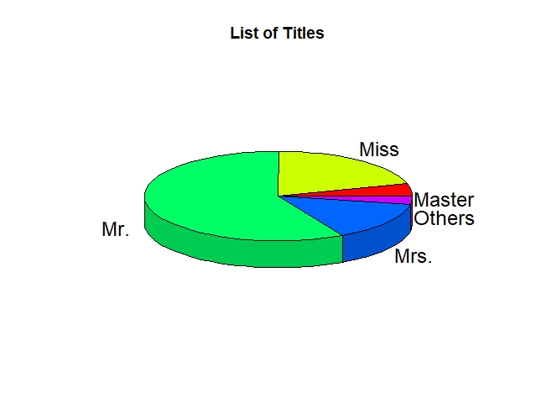

1. Represent the proportion of people survived from the family size using a graph.

pass_names <- ""

for( i in 1:891){

temp <- strsplit(titanic_train$Name[i],",")

pass_names <- c(pass_names,temp)

}

pass_names[[1]] <- NULL

pass_surnames <- ""

for(i in 1:891){

pass_surnames <- c(pass_surnames,pass_names[[i]][1])

}

pass_surnames <- pass_surnames[-1]

class(pass_surnames)

pass_surnames <- as.factor(pass_surnames)

pass_surnames_list <- levels(pass_surnames)

pass_surnames_list_count <- rep(0,times=667)

count <- 0

for(i in 1:667){

n1 <- pass_surnames_list[i]

for(j in 1:891){

n2 <- pass_surnames[j]

if(n1 == n2)

count <- count + 1

}

pass_surnames_list_count[i] <- count

count <- 0

}

pass_surnames_list_count <- as.factor(pass_surnames_list_count)

family_size <- levels(pass_surnames_list_count)

#check for summary

#summary(pass_surnames_list_count)

family_size_count <- table(pass_surnames_list_count)

titanic_survived <- data.frame(titanic_train$Survived,pass_surnames)

count<- rep(0,times=891)

titanic_survived <- data.frame(titanic_survived,count)

colnames(titanic_survived) <- c("survived","surnames","family_size")

for(i in 1:891){

n <- titanic_survived$surnames[i]

for(j in 1:667){

if(n == pass_surnames_list[j]){

titanic_survived$family_size[i] <- pass_surnames_list_count[j]

break

}

}

}

s1 <- table(titanic_survived$survived,titanic_survived$family_size)

barplot(s1,xlab="Family Size",col=c("red","green"),legend=c("Not Survived","Survived"),beside = T,main = "Proportion of People Survived")

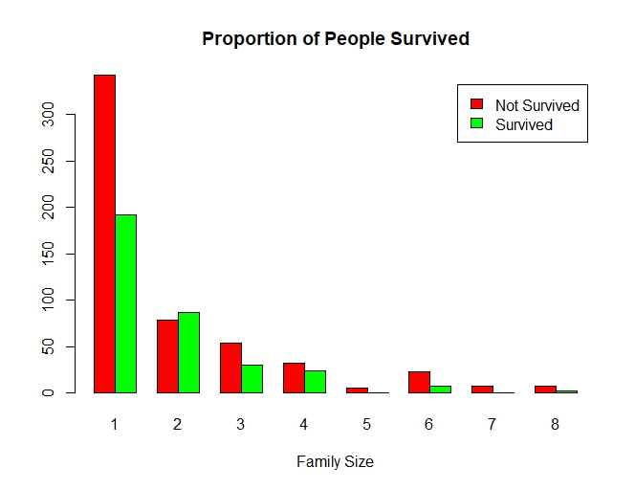

1. Impute the missing values in Age variable using Mice Library, create two different graphs showing Age distribution before and after imputation.

library(titanic)

sum(is.na(titanic_train$Age))

library(mice)

md.pattern(titanic_train)

# We found there are total 177 missing values in AGE attribute of titanic_train dataset

mice_imputes = mice(titanic_train, m=5, maxit = 40)

Imputed_data=complete(mice_imputes,5)

hist(titanic_train$Age, freq=T, main='Original Data of age ',

col='green')

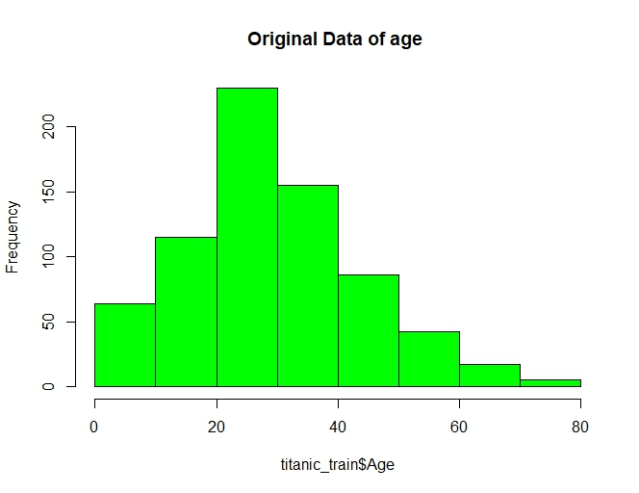

hist(Imputed_data$Age, freq=T, main='Imputed Data of age',

col="red")

