# Problem Statement

1. Write a program to create **barplots** for all the categorical columns in **mtcars**.

|  |
| --- |
| > View(mtcars)  > counts<- table(mtcars$cyl)  > barplot(counts ,main ="bar plot of cyl",xlab="cyl",ylab = "counts",col="blue")  > counts<- table(mtcars$carb)  > barplot(counts ,main ="bar plot of carb",xlab="carb",ylab = "counts",col="pink")  > counts<- table(mtcars$gear)  > barplot(counts ,main ="bar plot of gear",xlab="gear",ylab = "counts",col="yellow")  > counts<- table(mtcars$am)  > barplot(counts ,main ="bar plot of am",xlab="am",ylab = "counts",col="red")  > counts<- table(mtcars$vs)  > barplot(counts ,main ="bar plot of vs",xlab="vs",ylab = "counts",col="green")  > View(mtcars) |
|  |
| |  | | --- | | > | |

1. Create a **scatterplot** matrix by gear types in **mtcars** dataset.

|  |
| --- |
| > #scatter plot for dataset mtcars  > library(ggplot2)  > library(car)  Attaching package: ‘car’  The following object is masked from ‘package:purrr’:  some  > #I'm plotting some variables only but we can plot through others mtcars dataset also say wt,qsec etc  > scatterplotMatrix(~mpg+disp+drat+hp|gear,data=mtcars,  + main="Three Gear Options") |
|  |
| |  | | --- | | > | |

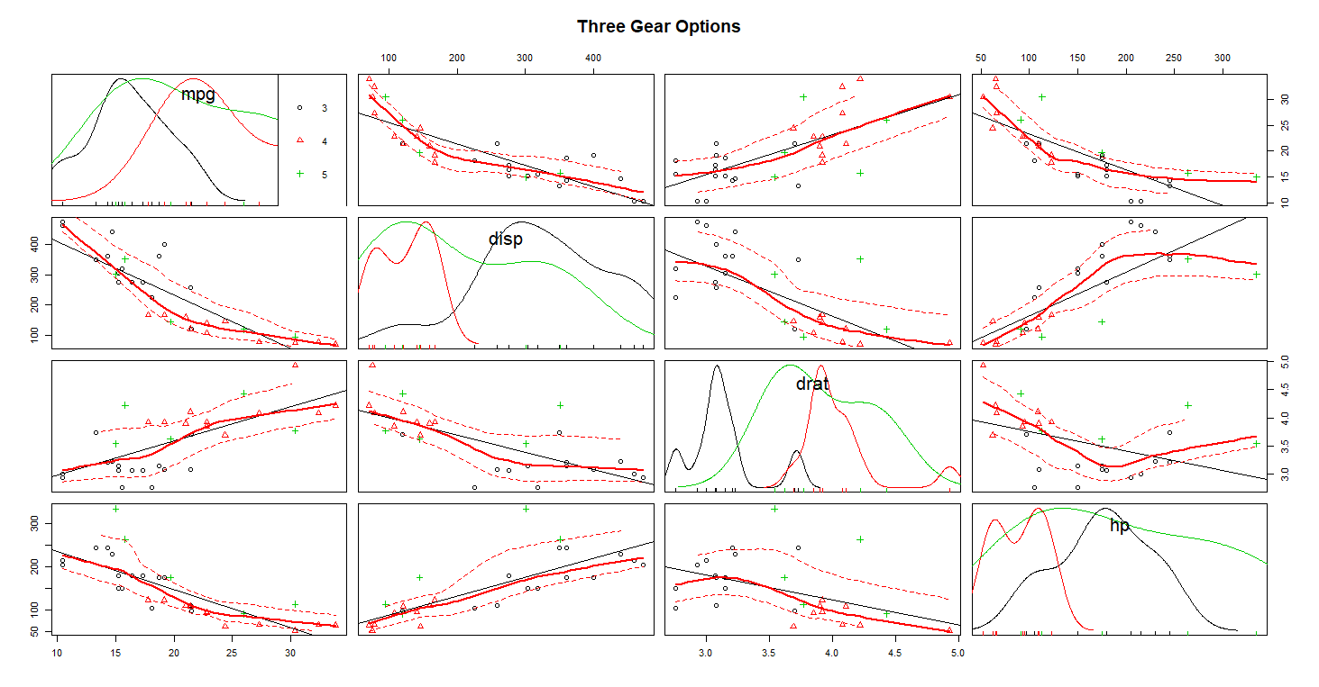

1. Write a program to create a **plot density** by class variable.

#As known as Kernel Density Plots, Density Trace Graph.

#A Density Plot visualises the distribution of data over a continuous interval

#or time period. This chart is a variation of a Histogram that uses kernel smoothing to

#plot values, allowing for smoother distributions by smoothing out the noise.

#Density plots are similar to histograms on a density scale,

#but instead of fixed bins or intervals with jumps at the boundaries,

#are smooth. The argument adjust to geom_density regulates how

#smooth the density estimate is, with larger values resulting in smoother graphs.

#there is no class variable

#i find in mtcars dataset so that unable to plot through mtcars dataset

#however i find other variable other than class variables in mtcars dataset hence i'm plotting that here

class(mtcars)

#plot density of mpg variable

d<- density(mtcars$mpg)

plot(d, main="kernel density of mpg")

polygon(d,col="blue",border ="black")

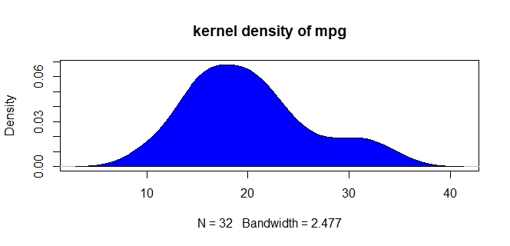

#plot density of disp variable

c<- density(mtcars$disp)

plot(c, main="kernel density of disp")

polygon(c,col="green",border ="red")

