# Problem Statement

1. Create a box and whisker plot by class using mtcars dataset.

#there is no class variable

#i find in mtcars dataset so that unable to plot through mtcars dataset

#however i find class variable in mpg dataset hence i'm plotting that here

#using mpg dataset to plot boxplot between variable class & hwy

library(ggplot2)

#using a different color for each group

ggplot(mpg, aes(x=class, y=hwy,fill=class, font.main=3)) +

ggtitle(toupper("Different Classes")) +

geom_boxplot(alpha=0.3) +theme(legend.position="none")

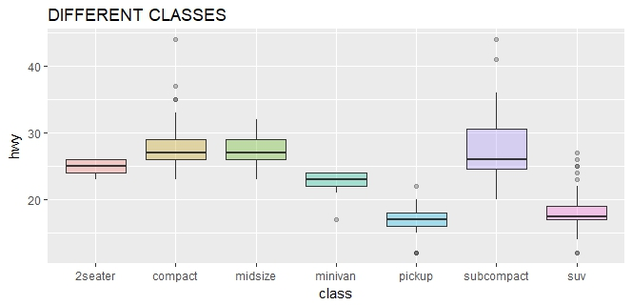

#one more example

boxplot(mpg~cyl, data=mtcars,

main= toupper("Fuel Consumption"), font.main=3,

col= topo.colors(3), xlab="Number of Cylinders",

ylab="Miles per Gallon")

