# Problem Statement

library(RcmdrPlugin.IPSUR)

data(RcmdrTestDrive)

Perform the below operations:

1. Compute the measures of central tendency for salary and reduction which variable has highest center?

library(RcmdrPlugin.IPSUR)

data(RcmdrTestDrive)

#Perform the below operations:

View(RcmdrTestDrive)

#1. Compute the measures of central tendency for salary and reduction

#which variable has highest center?

#first find the measures of central tendency for salary and reduction

#for salary

library(RcmdrPlugin.IPSUR)

x<- c(mean(RcmdrTestDrive$salary),median(RcmdrTestDrive$salary))

x

> x

[1] 724.5164 710.1500

#for reduction

y<- c(median(RcmdrTestDrive$reduction),mean(RcmdrTestDrive$reduction))

y

> y

[1] 139.500 223.631

#now since we are looking for variable which has highest center

#we can check for this by plotting histogram or

#by checking kurtosis which describes the amount of peakedness of a distribution.

library(psych)

kurtosi(RcmdrTestDrive$salary)

kurtosi(RcmdrTestDrive$reduction)

> kurtosi(RcmdrTestDrive$salary)

[1] 0.2006576

> kurtosi(RcmdrTestDrive$reduction)

[1] 10.01655

#thus we can see variable reduction has more kurtosis thus more peaked hence more highest center

#or by plotting histogram we can also check that

x<-RcmdrTestDrive$salary

h<- hist(x,breaks = 10,col = "red",xlab = "salary",main= "histogram of salary with normal curve")

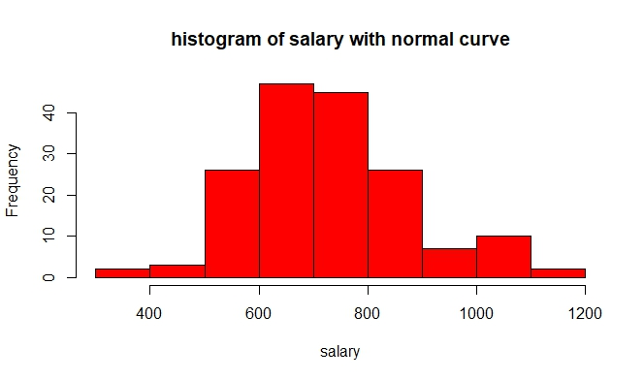

y<-RcmdrTestDrive$reduction

h<- hist(y,breaks = 10,col = "blue",xlab = "reduction",main= "histogram of reduction with normal curve")

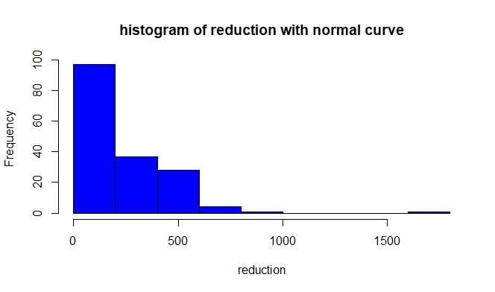

#however as reduction is not purely continous hence for center we cant see peak of this in from center

#in that manner salary is more peaked from center as it is purely continous

#howsoever variable reduction is more peaked if we talk about the peakedness from whole data

#by seeing histo curve overall as compare to salary variable

1. Which measure of center is more appropriate for before and after?

#If the distribution is fairly symmetric then the mean and median

#should be approximately the same

#by boxplot we can check for median where it lies

boxplot(RcmdrTestDrive$before,horizontal = T,col = "red",xlab="before",ylab="Boxplot")

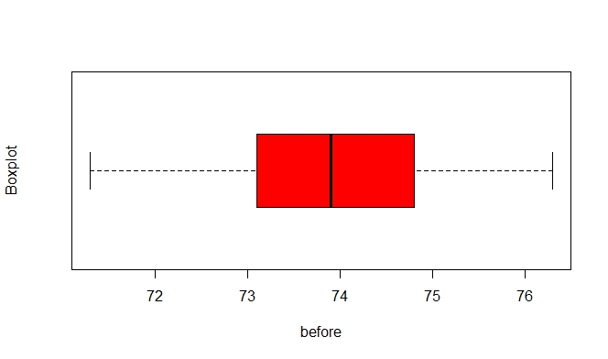

#normal distributed

boxplot(RcmdrTestDrive$after,horizontal = T,col = "red",xlab="after",ylab="Boxplot")

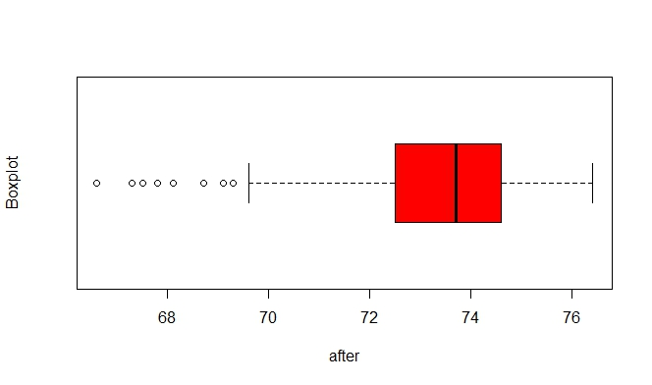

#left skewed as the data is assymetrical distributed

#if we check the skewness of variables

skew (RcmdrTestDrive$before)

skew (RcmdrTestDrive$after)

> skew (RcmdrTestDrive$before)

[1] -0.03510369

> skew (RcmdrTestDrive$after)

[1] -1.164056

#after more negative so data more on right side as compare to before variable

#thus, the median would likely be a good choice and it is more appropriate

#ps:dots in plots are outliers