Day 9 Practical Lab - A Simple MLOps Lifecycle on AWS
Duration: 4 hours
Audience: Cloud, DevOps, Platform and SRE engineers
AWS Region: Choose one region that supports SageMaker XGBoost training and real-time endpoints. Use the same region for the whole lab.
Starting point: An AWS account and permission to create the temporary resources in this guide. No SageMaker, S3, IAM, MLflow, EKS, ECR or Kubernetes resources are assumed to exist.

1. What participants will build
Participants will create a small, end-to-end MLOps workflow:
[1] Create an encrypted S3 bucket, a SageMaker execution role and a SageMaker Model Registry group using the included CloudFormation template.
[2] Upload a small prepared Iris dataset to the new S3 bucket.
[3] Create a SageMaker Pipeline with two steps: Train model and Register model.
[4] Run the same pipeline twice with a different max_depth parameter to create two model versions.
[5] Review and manually approve the two model versions in SageMaker Model Registry.
[6] Deploy version 1 to a real-time SageMaker endpoint.
[7] Update the endpoint to version 2 using SageMaker-managed blue/green deployment with all-at-once traffic shifting.
[8] Invoke the endpoint before and after the update, then delete the resources created by the lab.
The learning objective is the lifecycle, not data science: repeatable training -> model versioning -> approval -> controlled production release.

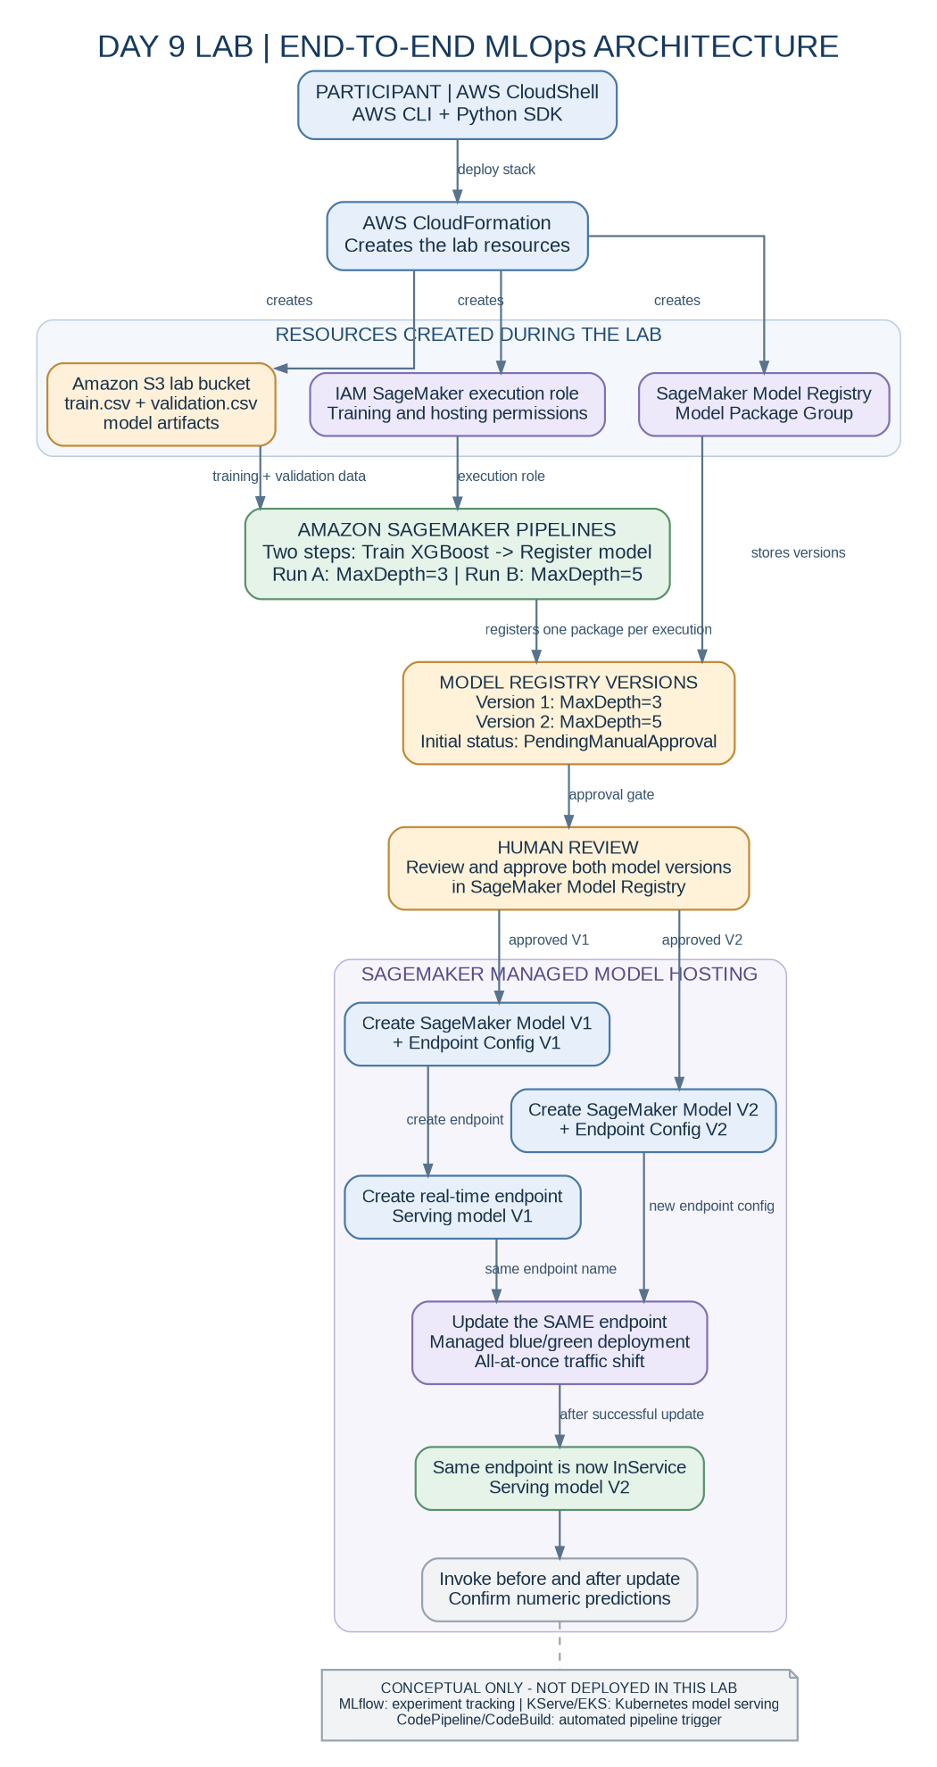

2. Deliberately excluded from the four-hour build
The Day 9 syllabus also names MLflow, KServe and CodePipeline/CodeBuild. To avoid infrastructure setup dominating a four-hour beginner-friendly practical, this core lab does not create those services:
• MLflow: an experiment-tracking option for recording parameters, metrics and artifacts. Participants do not create MLflow runs in this practical. They use SageMaker Pipeline execution history to compare the two parameterized runs and Model Registry to manage the resulting model versions.
• KServe: a Kubernetes model-serving option. Participants do not build an EKS cluster or install KServe. That deserves a separate Kubernetes lab.
• CodePipeline/CodeBuild: a source change can trigger the pipeline automatically. Participants manually start the pipeline in this practical so they can clearly observe its two steps.
The practical still teaches the core Day 9 MLOps idea and includes actual pipeline execution, model registration, manual approval and a blue/green endpoint update. It is intentionally not a full build of every technology in the broader Day 9 list.

3. What is and is not assumed

Starting requirements
• An AWS account in which participants are allowed to create the resources listed below.
• Browser access to the AWS Management Console.
• AWS CloudShell enabled for the account and region.
• Internet access from CloudShell to install the pinned SageMaker Python SDK and its dependencies.
• A region in which the selected SageMaker XGBoost built-in algorithm image and ml.m5.large training/hosting instance types are available.
• SageMaker quota for at least one ml.m5.large training job and enough real-time endpoint quota/capacity for the blue/green update. Blue/green may temporarily keep the old and new fleets running together; check the quota in the target Region before class.
• An AWS identity that is permitted to create the CloudFormation resources in this lab, pass the generated execution role to SageMaker, create/run SageMaker pipelines and training jobs, create/approve model packages, create/update/delete endpoints and models, upload/list the lab S3 objects, and invoke the endpoint.
No AWS resource is assumed to pre-exist. Participants create the lab S3 bucket, IAM execution role, Model Registry group, pipeline, model versions, endpoint and endpoint configurations during the exercise. CloudFormation is used to create the initial bucket/role/model-group resources consistently; it is not a pre-created environment.
Permission reality: the lab cannot grant permissions to the identity that is already signed in. In a dedicated disposable training account, the simplest cohort setup is a time-limited training permission set with sufficient administrative permissions. In a controlled enterprise account, the administrator must grant the caller the equivalent CloudFormation, IAM role creation/attachment, iam:PassRole, S3, and SageMaker actions before the session. Account SCPs and permission boundaries can still deny these actions. Do not use a production account.

Important permission note
For a time-boxed class, use a dedicated training account or a temporary training role with the necessary permissions. Do not use a production account. The CloudFormation template creates an execution role with AmazonSageMakerFullAccess plus explicit read/write access to the bucket created by this lab. The participant's own signed-in identity needs iam:PassRole for that generated role, because it passes the role to SageMaker when creating the pipeline and model. The role's trust policy allows the SageMaker service to assume it; it does not grant permissions to the participant identity.
If the account is governed by an organization SCP, permission boundary, permission set, or service control policy, those controls must permit the required actions. A script cannot bypass an account-level deny.

5. Participant instructions - follow in order

Step 1 - Open AWS CloudShell
[1] Sign in to the AWS Management Console.
[2] Select the AWS Region approved for the class from the region selector in the top navigation bar.
[3] Open CloudShell using the terminal icon in the Console navigation bar.
[4] Wait until the shell prompt appears.
Run:
aws --version
aws sts get-caller-identity
aws configure get region
python3 --version
aws sts get-caller-identity must return the account and identity you are meant to use. If the configured region is empty, set it to the same region selected in the Console. Example only:
export AWS_REGION=ap-south-1
Do not copy the example region blindly. Use the region chosen by the trainer.

Step 2 - Upload and unpack the lab ZIP
On your computer, download Day9_Simple_MLOps_Lab.zip. In CloudShell, choose Actions -> Upload file, upload the ZIP, and then run:
unzip Day9_Simple_MLOps_Lab.zip -d day9-lab
cd day9-lab/day9_simple_mlops_lab
If the extracted folder name differs, run ls and cd into the folder containing README.md, data, infrastructure and scripts.

Step 3 - Prepare Python 3.11 and install the SDK
SageMaker Python SDK V3 requires Python 3.10 or later. CloudShell's system Python can be older, so the following commands use the separately named Python 3.11 runtime and do not replace the system Python. CloudShell's Python packages and available versions can change; verify the command output rather than assuming a particular preinstalled interpreter.
Check whether Python 3.11 is present:
python3.11 --version
If the command is not found, install it in CloudShell:
sudo dnf install -y python3.11 python3.11-pip
Create and activate a virtual environment, then install the pinned SDK:
python3.11 -m venv .venv
source .venv/bin/activate
python -m pip install --upgrade pip
python -m pip install -r requirements.txt
python --version
python -c "import sagemaker, boto3; print('SageMaker SDK:', sagemaker.__version__); print('boto3:', boto3.__version__)"
Expected: Python 3.11.x and SageMaker SDK 3.28.0. Keep this CloudShell session and virtual environment active while doing the Python steps. The SDK V3 requires Python 3.10 or later; the current package metadata lists Python 3.10, 3.11 and 3.12 as supported test versions.

Step 4 - Create AWS resources
Set the region to the region selected in the Console and choose a unique stack name for your participant (especially when the class shares one AWS account). Use only lowercase letters, numbers and hyphens; the name must be 1-32 characters and start/end with a letter or number. Example values only:
export AWS_REGION=ap-south-1
export STACK_NAME=day9-learner01
Every participant using the same AWS account must use a different STACK_NAME. The stack name is also used to generate unique pipeline, endpoint and IAM role names.
Validate the CloudFormation template syntax and create the stack:
aws cloudformation validate-template \
--template-body file://infrastructure/day9-mlops-stack.yaml \
--region "$AWS_REGION"
bash scripts/01_setup.sh
The script creates these resources from scratch:
The stack creates three resources:
• S3 bucket: stores the prepared dataset and model artifacts.
• IAM execution role: gives SageMaker the permissions needed to read the input data and write model artifacts.
• SageMaker Model Package Group: stores the model versions registered by the pipeline.
The script creates a .env file containing the generated bucket name, role ARN, model group and S3 data paths. Do not share this file publicly; it contains resource identifiers for your account (not credentials).
Confirm the setup output shows all three resource names. If CloudFormation fails, inspect the stack events before retrying:
aws cloudformation describe-stack-events \
--stack-name "$STACK_NAME" \
--region "$AWS_REGION" \
--max-items 20

Step 5 - Upload the training data
Run:
bash scripts/02_upload_data.sh
Expected S3 objects:
s3://<your-generated-bucket>/data/train.csv
s3://<your-generated-bucket>/data/validation.csv
The data is a small, prepared, binary subset of the Iris flower dataset. Each row is a label followed by four numeric features. The label is in the first CSV column, as required by the XGBoost built-in algorithm in CSV training mode.
No Python data-science libraries are needed to generate the data; the CSV files are included in this lab package.

Understanding the Iris Dataset and How Model Training Works
For this lab, we use a simplified version of the Iris flower dataset containing two flower categories: Iris-setosa (label 0) and Iris-versicolor (label 1).
Each record contains five numerical values:
Column | Description | Purpose
1 | Label (0 or 1) | Target value to predict
2 | Sepal length | Input feature
3 | Sepal width | Input feature
4 | Petal length | Input feature
5 | Petal width | Input feature
The dataset is divided into two files:
- train.csv: 80 records used to train the model.
- validation.csv: 20 records used to evaluate the trained model.
How does training work?
During training, the XGBoost algorithm analyses the four flower measurements (features) along with their known labels (correct answers). It learns numerical patterns that help distinguish between the two flower categories.
Once training is complete, SageMaker saves the trained model as a model artifact in Amazon S3.
When a new flower is submitted for prediction, we provide only its four measurements. The trained model uses the patterns it learned to predict whether the flower belongs to category 0 or category 1.
Important: The CSV files do not contain column headers. This is intentional because the SageMaker built-in XGBoost algorithm expects the label in the first column, followed by the features in the specified order.

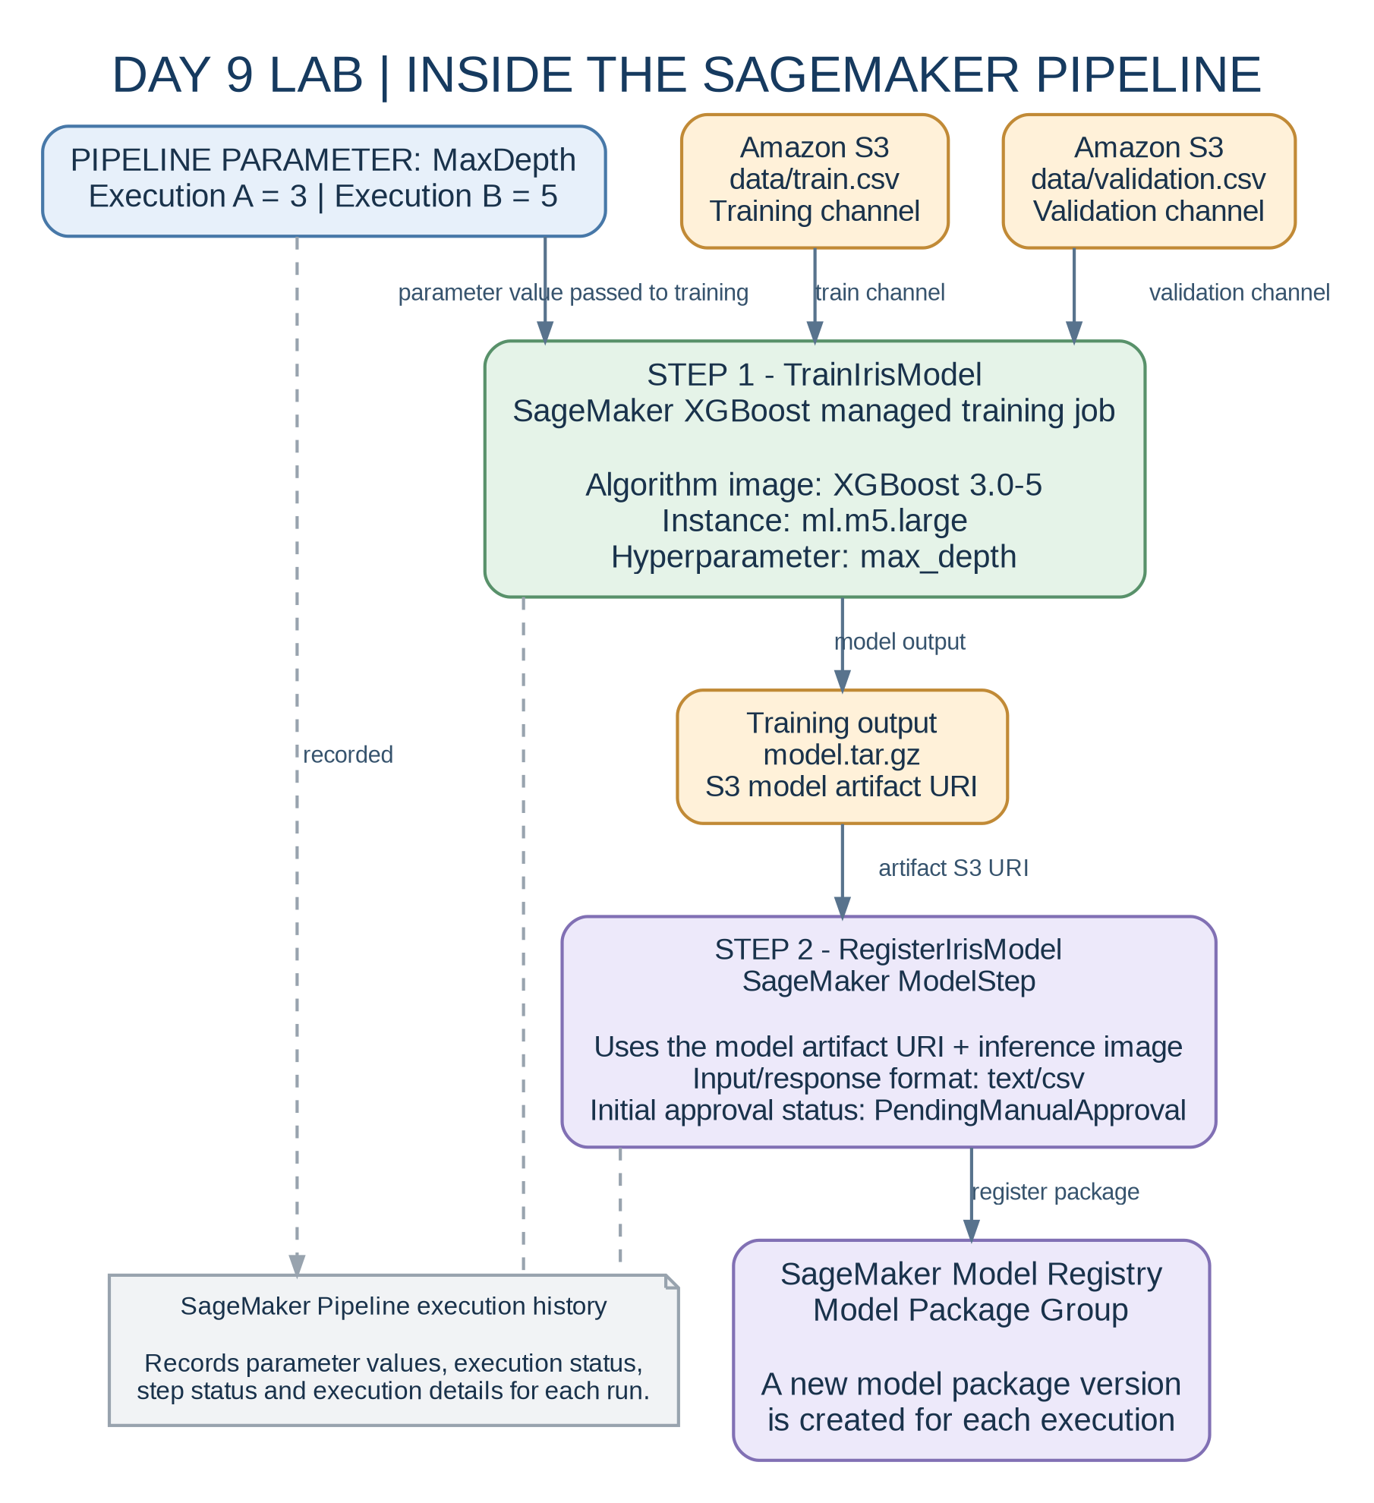

Step 6 - Create and run the SageMaker Pipeline
Make sure the virtual environment is active:
source .venv/bin/activate
python scripts/03_create_pipeline.py
What the script does:
[1] Checks that both S3 data files exist.
[2] Creates a pipeline with the MaxDepth parameter.
[3] Adds a TrainIrisModel training step using the SageMaker XGBoost built-in algorithm on one ml.m5.large instance.
[4] Adds a RegisterIrisModel step that registers the model in the Model Registry with status PendingManualApproval.
[5] Starts the pipeline twice: once with MaxDepth=3, and once with MaxDepth=5.
[6] Waits for both executions to finish and saves the model package ARNs to model_packages.json.
The pipeline is intentionally small. The two executions differ in one hyperparameter so participants can see how a repeatable pipeline creates separate model versions.
Expected result:
Pipeline created/updated: <your-stack-name>-pipeline
...
SUCCESS: two pipeline executions completed and two model versions were registered.
Version <n>: PendingManualApproval - arn:aws:sagemaker:...
Version <n+1>: PendingManualApproval - arn:aws:sagemaker:...
Exact version numbers depend on whether the model group has prior versions. In this lab, the CloudFormation stack creates a new model group.
IN AWS CONSOLE CHECK HERE :
SageMaker AI→ Training → Training jobs > XGBoost training jobs

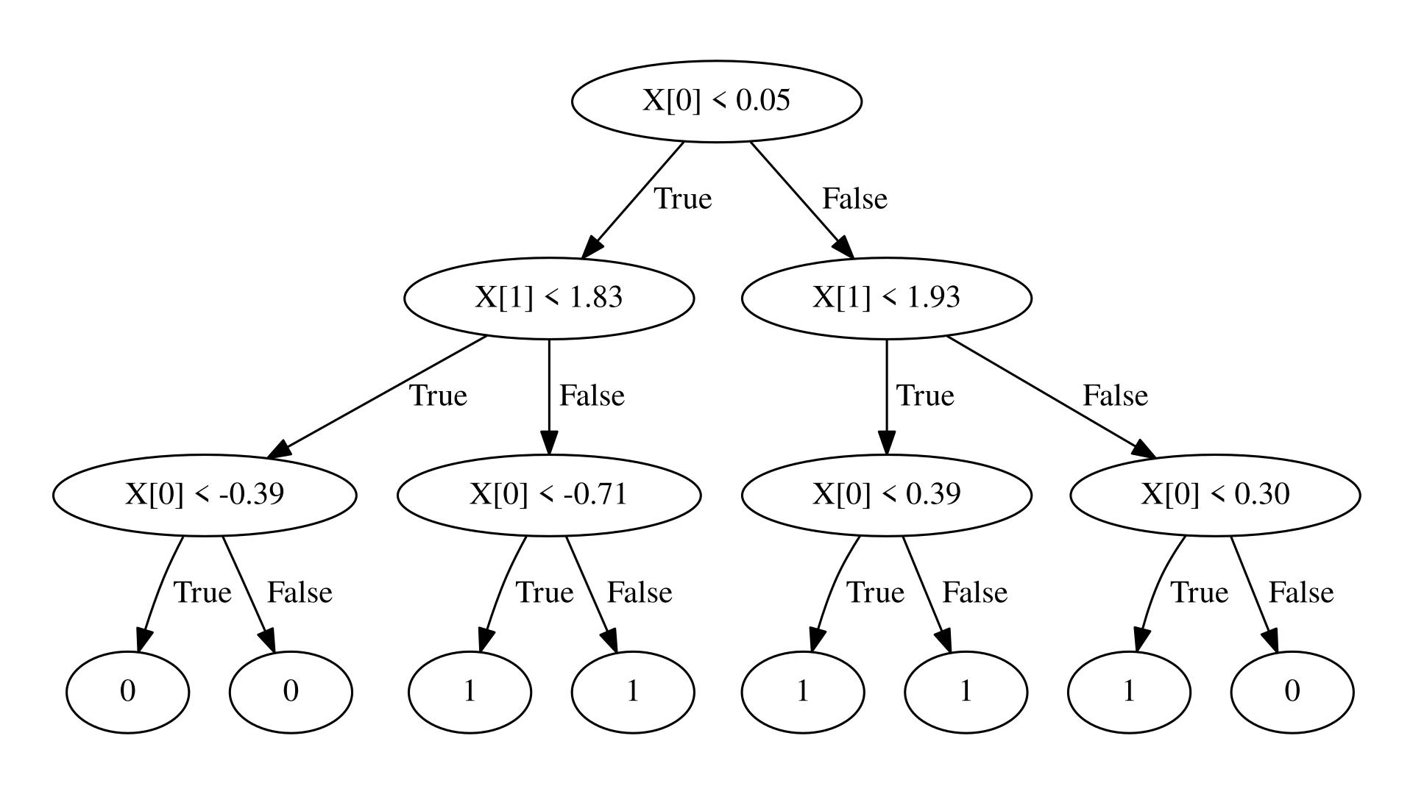

Step 7 - Review and approve the model versions
In the AWS Console, open Amazon SageMaker AI in the same region.

To see it from cli :

1. Run this command in your existing Git Bash terminal
Use your actual Model Group name and Region:
aws sagemaker list-model-packages \
--model-package-group-name test-day9-iris-models \
--model-package-type Versioned \
--region us-east-1 \
--query 'ModelPackageSummaryList[*].[ModelPackageVersion,ModelApprovalStatus,ModelPackageStatus,ModelPackageArn]' \
--output table

2. What should you see?
Expected result if registration succeeded
Version | Approval status | Package status
1 | PendingManualApproval | Completed
2 | PendingManualApproval | Completed
You should also see two Model Package ARNs.

3. What if you see no results?
Then we need to inspect the pipeline steps.
First, retrieve the two execution ARNs:
aws sagemaker list-pipeline-executions \
--pipeline-name test-day9-pipeline \
--region us-east-1 \
--query 'PipelineExecutionSummaries[*].[PipelineExecutionArn,PipelineExecutionStatus]' \
--output table
Then take one execution ARN and run:
aws sagemaker list-pipeline-execution-steps \
--pipeline-execution-arn "PASTE_EXECUTION_ARN_HERE" \
--region us-east-1 \
--query 'PipelineExecutionSteps[*].[StepName,StepStatus,FailureReason]' \
--output table
We specifically want to see:
TrainIrisModel Succeeded
RegisterIrisModel Succeeded

For your current account, use:
- Open Amazon SageMaker AI.
- Select Admin configurations → Domains.
- Click Create domain.
- Select Set up for single user (Quick setup).
- Complete the setup in US East (N. Virginia) – us-east-1.
- Wait until the Domain is ready.
- Open Studio using the generated user profile.
AWS documents these exact Quick Setup steps.
Amazon SageMaker AI+1
Once inside Studio, navigate to:
Models → Registered models → Model Groups

[2] In the navigation pane, open Model Registry.
[3] Open the model package group whose name is shown in .env as MODEL_PACKAGE_GROUP.
[4] Open each of the two model package versions.
[5] Confirm that both are associated with the Day 9 pipeline and have status PendingManualApproval.

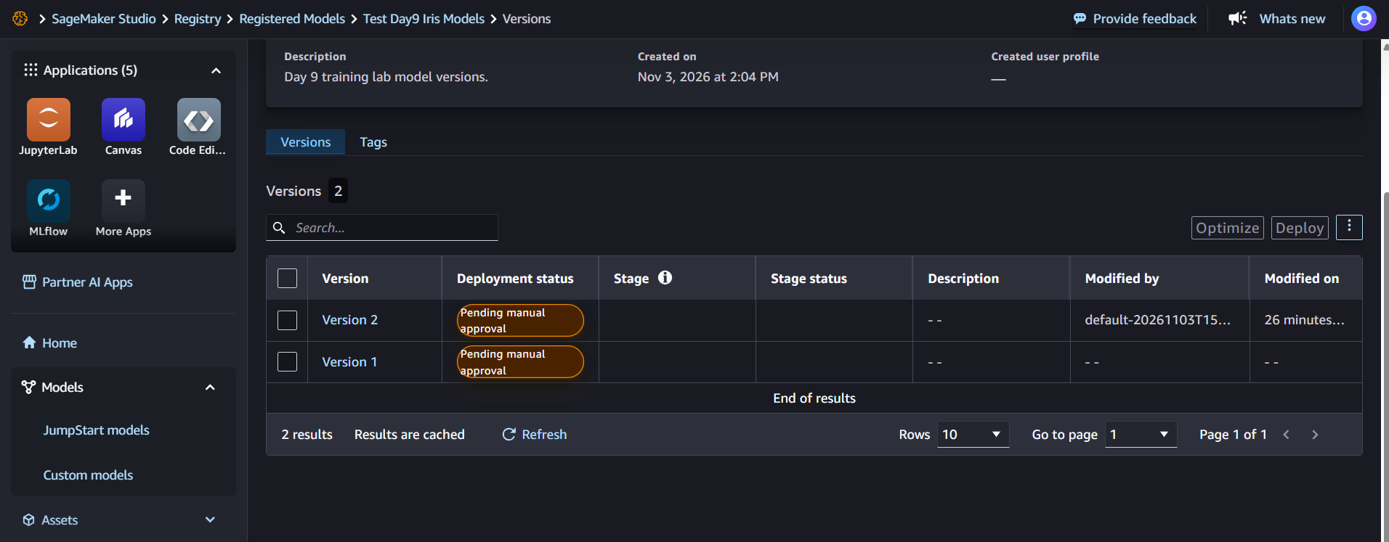
[6] For this learning exercise, choose Approve for both versions.
Why this matters: training a model does not automatically mean that it should be deployed. The registry creates a governance checkpoint where a person or a policy can review the model before release.
If the Console menu differs in the selected SageMaker experience, the equivalent API operation is UpdateModelPackage with ModelApprovalStatus=Approved. Do not approve packages until the two versions have been created by the lab pipeline.

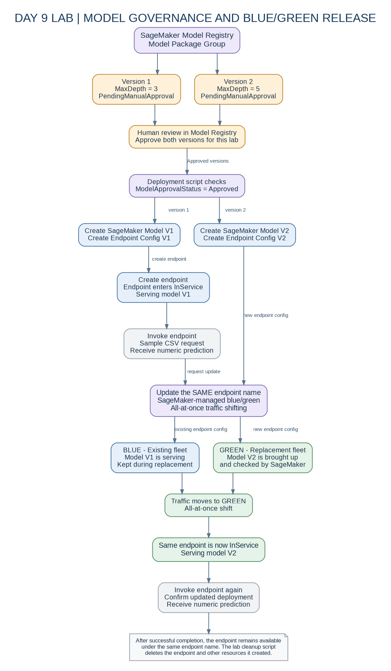

Step 8 - Deploy version 1 and test it

Back in CloudShell, ensure the virtual environment is active and run:
source .venv/bin/activate
python scripts/04_deploy_and_bluegreen_update.py

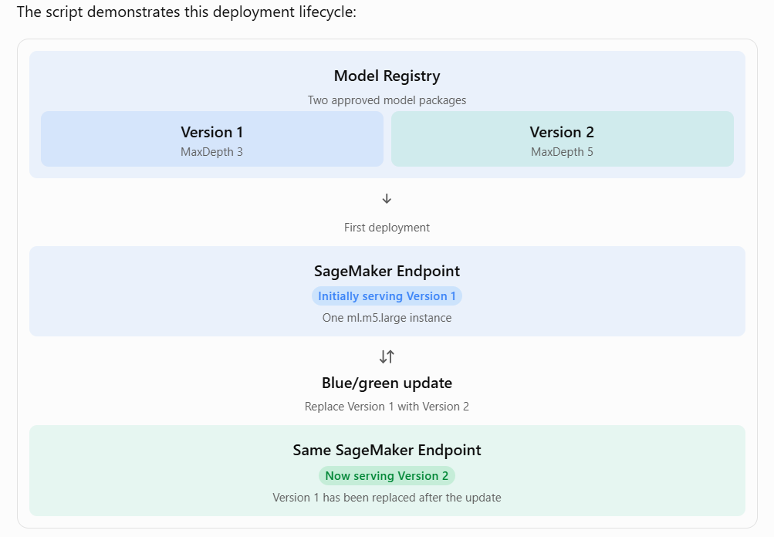
The script:
[1] Confirms that the two model package versions are approved.
[2] Creates a SageMaker model from the first package version.
[3] Creates an endpoint configuration using one ml.m5.large instance.
[4] Creates a real-time endpoint and waits for InService.
[5] Sends one sample CSV request to the endpoint and prints the model response.
The script then creates a second model and endpoint configuration from the second package version and updates the same endpoint using SageMaker's default managed blue/green deployment. When no custom DeploymentConfig is supplied, SageMaker defaults to blue/green with all-at-once traffic shifting.
It waits for the update to finish, invokes the endpoint again and records resource names in resources.json for cleanup.
What blue/green means here: SageMaker brings up a new (green) fleet while the old (blue) fleet remains available, shifts traffic to the new fleet according to the selected strategy, and then terminates the old fleet after the deployment wait period. The practical uses the SageMaker default blue/green update with all-at-once traffic shifting. It does not configure custom deployment guardrails, CloudWatch alarms or automatic alarm-triggered rollback. In production, configure and test CloudWatch alarms and an explicit rollback configuration before relying on automatic rollback.

Step 9 - Confirm success
A successful run shows:
• The initial endpoint entered InService.
• The first invocation returned a numeric prediction.
• The endpoint update completed.
• The second invocation returned a numeric prediction.
• resources.json contains the endpoint, models, endpoint configurations and model package ARNs.
The numeric prediction is model-dependent. Do not expect a specific exact decimal value.

An extended enterprise MLOps architecture

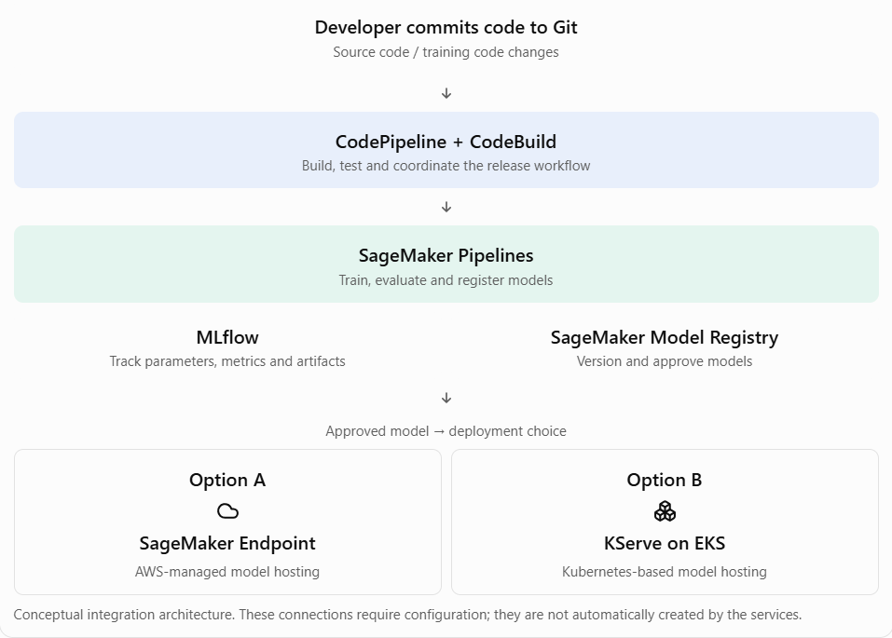

Step 10 - Clean up all resources created by the lab
Do not skip cleanup. A real-time SageMaker endpoint incurs charges while it is running.
Run:
source .venv/bin/activate
python scripts/05_cleanup.py
The cleanup script deletes the endpoint first, then endpoint configurations, models, pipeline, model package versions, model package group, S3 objects and finally the CloudFormation stack (which deletes the bucket and execution role). SageMaker training-job history may remain visible after cleanup, but completed training jobs do not keep compute running.
Wait for the script to print SUCCESS: lab-created resources have been deleted. Confirm the CloudFormation stack is gone:
aws cloudformation describe-stacks --stack-name "$STACK_NAME" --region "$AWS_REGION"
Expected after successful deletion: CloudFormation returns a ValidationError indicating the stack does not exist.
If a previous command failed before resources.json was written, use the SageMaker Console to delete any endpoint/model/endpoint configuration created by the failed attempt before deleting the stack. Do not delete the stack while SageMaker resources still reference its role or Model Registry group.

6. Troubleshooting
• Unable to locate credentials: CloudShell is not using the intended console identity. Run aws sts get-caller-identity and reopen CloudShell from the intended account.
• Region is blank: set AWS_REGION to the same Region selected in the Console.
• CloudFormation AccessDenied: the caller cannot create the stack resources or IAM roles. Check CloudFormation/IAM permissions, permission boundaries and organization SCPs.
• iam:PassRole denied: the caller cannot pass the generated execution role to SageMaker. Ask the account administrator to grant iam:PassRole on this lab role.
• S3 AccessDenied: check the bucket name in .env, the participant's S3 upload permission, and the inline policy on the stack-created execution role.
• SDK installation fails: check Python 3.11, pip output and CloudShell network controls.
• XGBoost image unavailable: confirm that the chosen Region supports the pinned algorithm image. Do not change image versions without retesting.
• Training job quota error: check SageMaker training quotas for ml.m5.large in the selected Region.
• Endpoint quota/capacity error: check real-time endpoint quota and regional capacity for the blue/green update. Do not repeatedly retry before resolving the capacity issue.
• Endpoint is Failed: inspect the endpoint failure reason in SageMaker Console and the associated CloudWatch logs.
• Model package is still pending: approve both versions in Model Registry before rerunning the deployment script.

7. Cost and safety notes
• The lab creates SageMaker training jobs, a real-time endpoint, S3 objects, IAM resources and a Model Registry group.
• The pinned XGBoost built-in algorithm image is 3.0-5. AWS lists its end-of-patch date as 17 November 2026. If the class takes place on or after that date, update the image version to a then-supported algorithm-mode release and repeat the end-to-end rehearsal before class.
• The endpoint is the most important resource to remove promptly. Billing depends on the selected AWS Region and instance type; check the current AWS pricing page for the region before class.
• Use a temporary training account or isolated sandbox. Do not deploy this broad training role in a production account.
• The CloudFormation template blocks public access and encrypts the S3 bucket with S3-managed encryption (SSE-S3).
• The stack is designed for deletion after the lab. The cleanup script empties the bucket before deleting the stack.

8. Knowledge check
[1] What problem does a SageMaker Pipeline solve compared with manually starting training jobs?
[2] What is the difference between a training job and a model package version?
[3] Why is a model registered as PendingManualApproval?
[4] What is the purpose of a Model Package Group?
[5] Why do we keep the old fleet while a blue/green update is happening?
[6] What would you add in production to support automatic rollback?
[7] Where would MLflow fit into this lifecycle?
[8] Where would KServe fit if the organization serves models on Kubernetes?

9. Expected architecture
Prepared CSV data
|
v
Amazon S3
|
v
SageMaker Pipeline
|
+--> Step 1: Train XGBoost model
|
+--> Step 2: Register model package
|
v
Model Registry
|
Manual approval
|
+---------+---------+
| |
v v
Model v1 Model v2
| |
v v
Endpoint config 1 Endpoint config 2
| |
+------ Blue/Green -+
|
v
SageMaker Endpoint
|
v
Prediction

10. Reference documentation
• SageMaker Python SDK V3 - end-to-end pipeline with Model Registry: https://sagemaker.readthedocs.io/en/stable/v3-examples/ml-ops-examples/v3-pipeline-train-create-registry.html
• SageMaker XGBoost algorithm and supported versions: https://docs.aws.amazon.com/sagemaker/latest/dg/xgboost.html
• SageMaker execution roles and passing roles: https://docs.aws.amazon.com/sagemaker/latest/dg/sagemaker-roles.html
• SageMaker Model Registry: https://docs.aws.amazon.com/sagemaker/latest/dg/model-registry.html
• SageMaker blue/green all-at-once deployment: https://docs.aws.amazon.com/sagemaker/latest/dg/deployment-guardrails-blue-green-all-at-once.html
• AWS CloudShell environment: https://docs.aws.amazon.com/cloudshell/latest/userguide/vm-specs.html

